PARISH PROFILE

ST JOHN’S WESTON, RUNCORN,

FRODSHAM DEANERY, DIOCESE of CHESTER
Part-time Incumbent
40% stipend plus house
Sundays plus 3 days

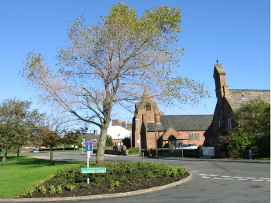

PERSON SPECIFICATION

We are a small, friendly and welcoming church that prays for a new vicar who will take us forward into a new chapter at St John’s. We are a dedicated congregation who are not averse to change, especially if this will bring growth. Although on the whole we are an ageing congregation we are young at heart, giving support to each other. We look forward to being shaped and learn from our new incumbent, hopefully in the near future.

We wish to appoint a vicar whose love of God will show itself in their love of, understanding and commitment to the Gospel, the congregation, and the community in which we serve.

We are seeking a vicar who will:

- build on and develop the vision and mission of St John’s particularly in making disciples, is gifted in biblical teaching, committed to prayer and ministry;
- aim to widen the reach of St John’s Church to a more diverse and younger group of people;
- build on our close links to Weston and Weston Point Schools as well as developing a relationship with Cavendish Farm Special School;
- extend further our well-established work amongst the elderly in the parish;
- assist in developing people to take over the operation of the church as well as nurturing and encouraging young people and lay people into all aspects of church life;
- encourage the congregation to live out their Christian faith in everyday life: Monday to Saturday, not just on a Sunday;
- provide leadership on safeguarding and encourage all to contribute toward creating a safer church;
- work closely with the PCC, churchwardens, lay reader and pastoral worker;
- be a team player with good management skills, who likes to work with others, delegates effectively, is computer literate, and recognises the importance of our online presence.

The part time nature of the vicar’s role is well established in the parish, as two out of the last three vicars have been part time and this is well accepted within the congregation.

Working Together in Runcorn
In addition, the successful candidate will minister more widely in a collaborative way across Runcorn. All the Anglican churches in the town have been working with the Diocesan Mission Adviser on exciting new ways of working together for the good of the whole of Runcorn. This involves using the special skills and gifts that each parish priest brings as part of who they are, for the good of Runcorn as a whole and not just their own parishes. Examples of such skills could include work with children and primary schools, engaging with local government bodies and other agencies, working with deprived communities, etc.

This will mean working positively and collaboratively with all eight Anglican parishes across Runcorn, to encourage them in the particular area of ministry concerned. It is envisaged that each parish priest will give some of their time to helping a particular area of mission and ministry flourish regardless of parish boundaries. Priests are envisaging spending half a day to a day per week on this cross-town working. Given the part-time nature of the post at St John’s, we would envisage the amount of time the new vicar would devote to this town-wide working would be perhaps half a day per week. Applicants are asked to indicate in their application form the potential area of ministry in which they would be interested in offering support of this kind. For more details, see the separate note on ‘Working Together in Runcorn’ outlining the proposals.

THE PARISH

The parish of St. John’s consists of a number of distinct areas of the western part of Runcorn, including the villages of Weston, Weston Point and Clifton plus Clifton Road housing estate. There is a mix of relatively affluent areas, a small provision of social housing and housing that was originally provided by ICI for its employees. This housing ranges from terraced to large detached houses, including bungalows and in age from 200years old to present day.

Weston Village has a distinctly rural, traditional feel to it as many of its buildings are constructed of local sandstone, and because it encompasses a significant amount of former farmland that is now used by a thriving equestrian community. This is in stark contrast to the large Ineos (formerly ICI Castner Kellner) chemical works that lies along the bank of the river Mersey and Weaver Navigation. The Heath Business and Technology Park is the other main employment zone in the Parish, attracting workshops and conferences from outside the parish. There are also many small businesses including a garden supplies centre, coach company, dance studio, hairdressers, two garage premises, two private day nurseries, a local general store, three public houses and a dentist.

The parish contains two primary schools, one secondary school and one special needs school. The church has close contacts with both primary schools with the previous incumbent taking part in assemblies and Christingle services are held each year with both schools. It is felt that possibly more could be done with the special needs school but as yet nothing is planned. The parish has provided support to all school leavers in the form of booklets presented to them as they leave school. The parish is also home to Hope Corner Community Church, and a Mormon congregation. The parish is also divided geographically by a golf course and a four-lane expressway. This unfortunately results in a curious, dispersed parish with no natural centre. The church attracts some people who live outside the limits of the parish to its weekly services.
.
The parish has endeavoured over recent years to organise fund raising events in order to secure its future and have held community concerts in church, with such artists as Simeon Wood and Adrian Plass, a highly successful Christmas market, again in church, with a full size nativity tableau. Other recent events include a summer garden party and a Christmas tree festival. The last two events have not taken place recently partly due to the pandemic but the Christmas market held in November is extremely well attended and attracts about 300 people and results in raising in the region of £3,000 per year. We have also produced some fundraising events with home produced entertainment. Other events include a Burns Night, a German-themed supper and a Harvest supper.

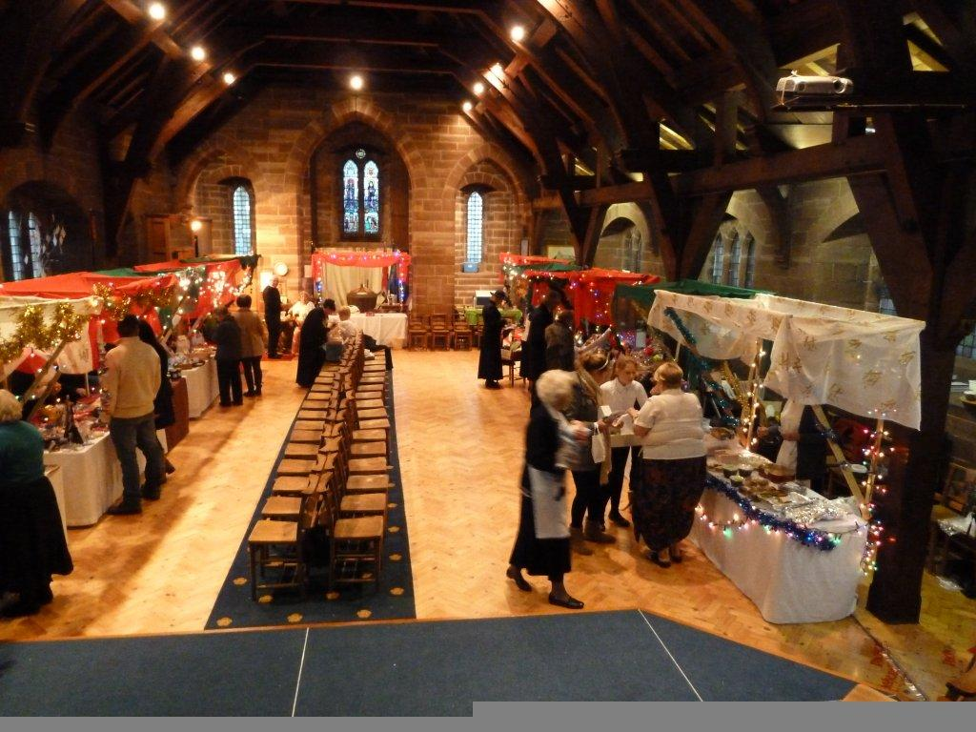

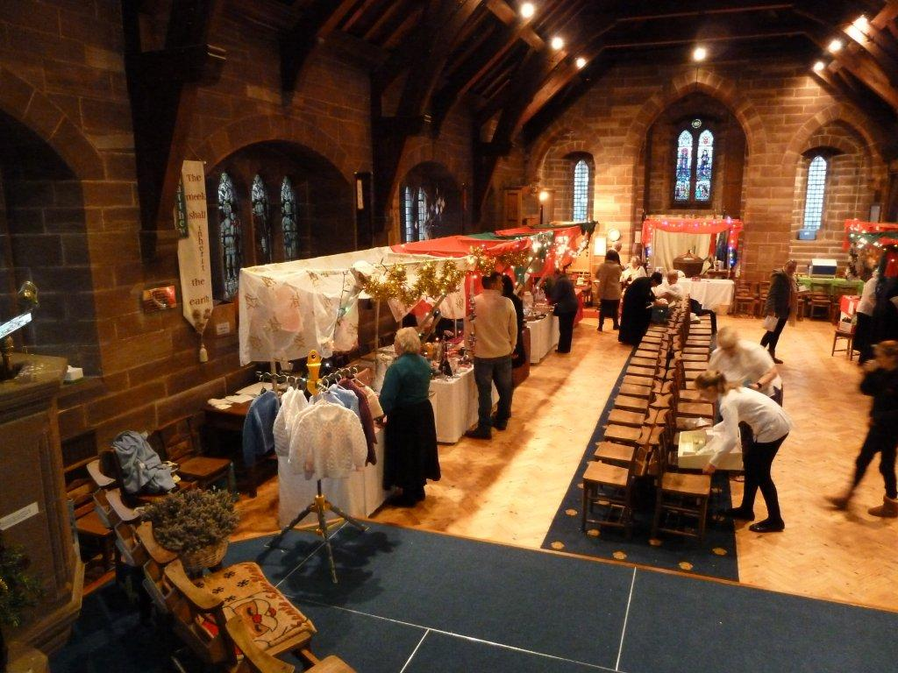

ST. JOHN’S
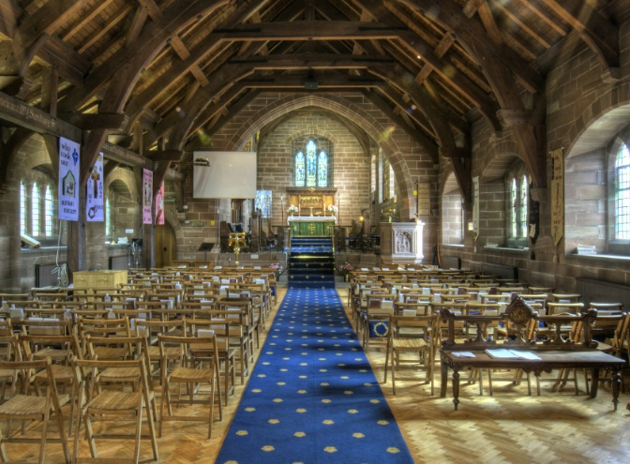
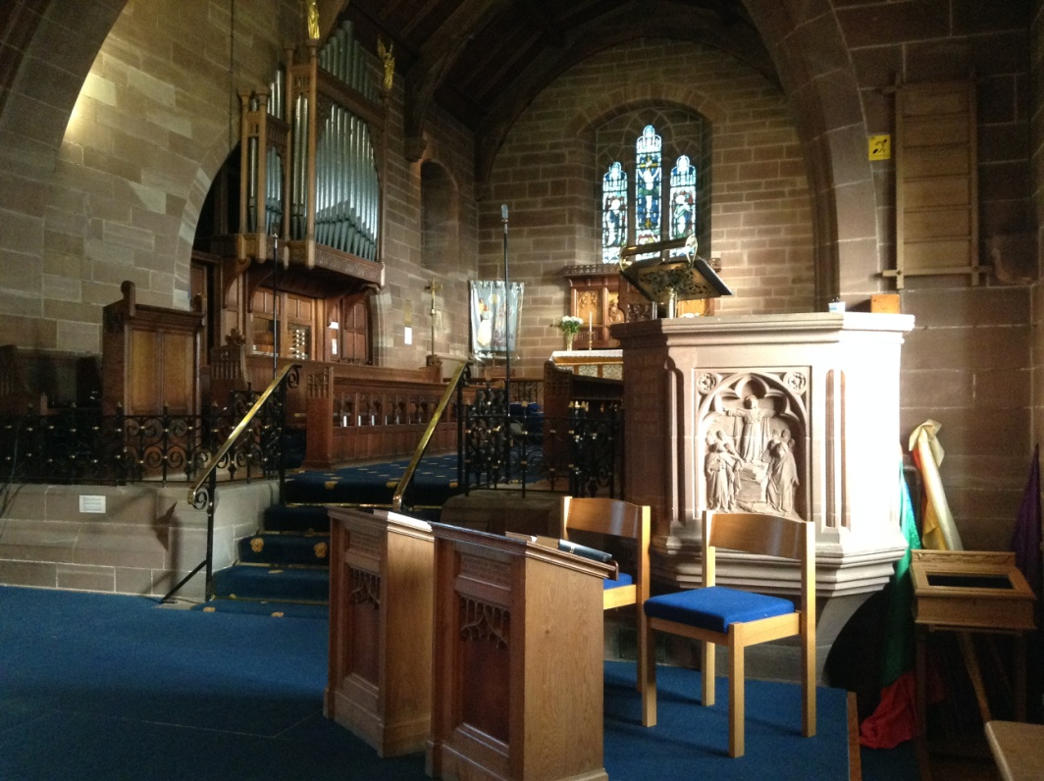

The main place of worship, St John’s, is late Victorian and is Grade 2* listed. It is generally in a good state of repair and has a relatively simple, homely feel to it. Despite the building being listed the congregation is receptive to reasoned change that is designed to improve facilities and make St. John’s a usable place of worship, rather than a museum.

Recent changes have included the installation of a projector and screen, a dais and a toilet / tea point and improved lighting. The original church (school style) chairs have been replaced by modern smart upholstered chairs. We have also installed improved LED lighting and glass inner church doors.

Although we are an ageing congregation, there has been some success with a breakfast club type church for families with small children. Whilst this is not currently active there is still a strong desire to encourage family friendly / child friendly worship at St. John’s. Where parents have requested it children have been prepared to take communion as a forerunner to confirmation. There is also a desire to see more organised outreach done locally, and for the re-establishment of home groups and bible studies. We have in the past tried Messy Church and Café style church but whilst there was some limited response we had a problem with resources to administer these.

In addition to the main church building, there is a church hall (Christ Church), which is licensed for services, located in Weston Point. This church hall is extremely well used by various community groups.

SERVICES

The pattern of public worship at St. John’s has changed over the years to reflect the needs of the congregation at the time. At the time of the retirement of the previous incumbent we held a breakfast church at 9:30am and Communion / Morning Prayer at 10:30am. together with a communion service in the Christ Church Chapel once per month. The latter service at Christ Church has been suspended during the interregnum due to problems with obtaining clergy to cover this service.

Generally our worship would be considered fairly central in tradition, neither high church nor evangelical. We do not have an organist but present music, video and slide presentations via an overhead projection system which in turn allows us to use a wide variety of music styles.

In addition, the parish organises an annual Living with Loss service for the recently bereaved and a service for recently baptised. We have also participated in the Back to Church programme for the last several years with some success.

Services that reflect the church calendar, such as Harvest, Carols by Candlelight and Maundy Thursday are also arranged. We also have a pop-up nativity in the streets of Weston Village which is very popular.

While we do not have a choir, we do have a small singing group which is supported by a dedicated rota of people to supply the music via our sound desk/projection equipment for all regular services. Organists can be supplied for funerals and weddings.

Parishioners assist in the administration of communion, lesson reading , intercession prayers etc.

Some parishioners have received training and can assist in leading Morning Prayer services in the absence of clergy and also delivering addresses to the congregation in support of the Reader.

The new incumbent would be expected to work with our Reader and encourage this participation by other members of the congregation. In addition, we have one licensed Pastoral Worker and another in training.

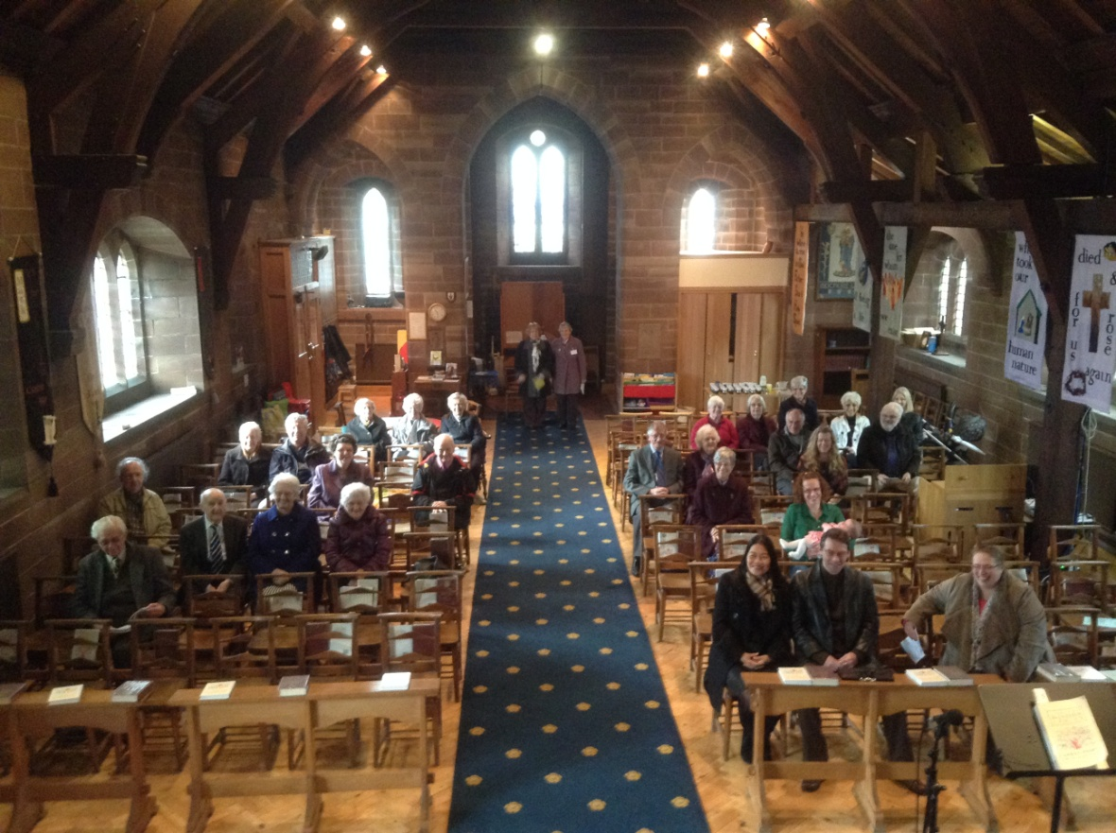

CHURCH ACTIVITIES AND GROUPS

These include:

Meet and eat luncheon club
This is a weekly lunch provided to senior members of the community at a low cost and staffed by volunteers. Generally attendance is about 25 people and includes a transport service for the less well able bodied attendees. This is very successful indeed and is run by very committed people and has run weekly for the past 17 years with the exceptions of Christmas and the Covid Pandemic.
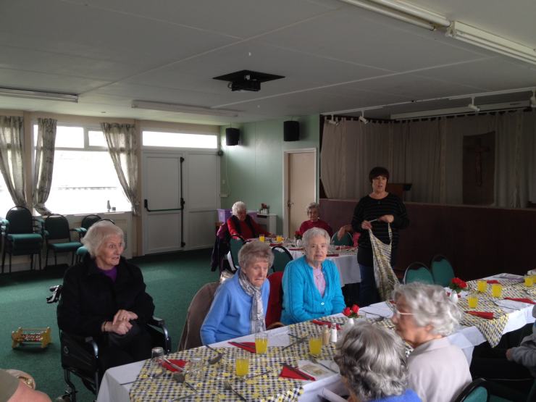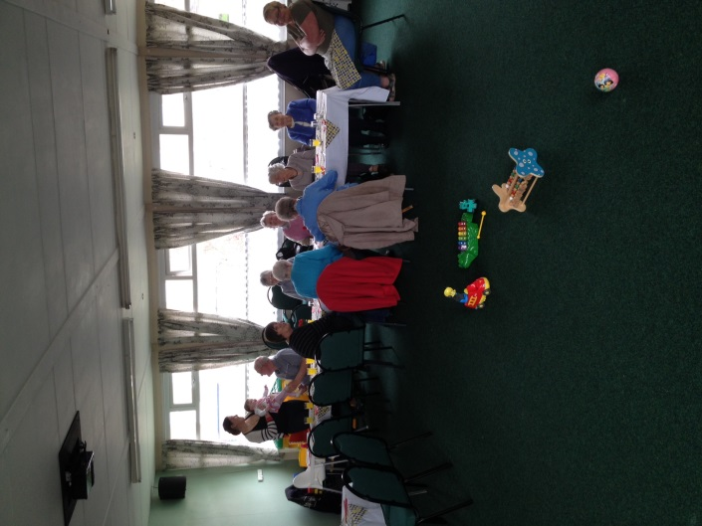

Christ Church Friends
This is senior citizens group meeting after the luncheon club on a weekly basis to socialise and enjoy each other’s company. Their activities includes talks, films, entertainment, and bingo.

Open House
A monthly meeting where participants can bring their own craftwork and have fellowship with others in a relaxed atmosphere with tea & cake

Brownies
A unit meeting in Christ Church Hall.

Bible study /Home groups
Before Covid we would have had Lenten courses held every year. In the last five years the parish has operated at least three Alpha courses as well as other Christian teaching courses. In the aftermath of Covid we plan to develop Christian education & home groups.

Ladies Group
A small group of women meeting at Christ Church hall on a monthly basis with speakers, social evenings, theatre trips etc

ACCOMMODATION

The diocese has recently purchased a modern property at 12 Tarvin Close, in the parish, which will be the new vicarage (pictured). The house has four bedrooms. Work is in hand to convert part of ground floor to provide a separate study and visitors’ WC. This will still leave ample reception space.

