 | St Pauls Church

PARISH PROFILE for the Parish of St Paul’s Church Helsby

Deanery: Frodsham Date: July 2022

The village of Helsby

Helsby is located on the A56 approximately 7 miles east of Chester, and is a linear village nestling along the slopes of the sandstone outcrop of Helsby Hill (NT) above the marshes to the Mersey estuary. The rural village of Helsby currently has a population of approximately 5500 and covers an area of some 548 hectares and is well served with transport links. Its close proximity to Junction 14 on the M56 offers convenient access to the motorway network which offers easy access to North Wales, Snowdonia and the Lake District. There is also a rail link offering a regular service to Chester, Frodsham, Warrington Manchester and Liverpool. There is also a bus service to Chester; Frodsham; Ellesmere Port; Runcorn and Warrington.

There is quite a mixture of housing types within the village from the traditional council house housing to the more modern developments that have sprung up within and around the village as its prosperity has grown. A new ongoing development at the bottom end of the village will significantly increase the population of the village when completed

There are three schools located within the village. There are two Primary Schools, Hillside Primary School which serves the ‘top end’ of the village and Horns Mill Primary School which serves the ‘bottom end’ of the village. There is also one Secondary School (Helsby High School) which serves the whole village and the surrounding area and which is frequently the top comprehensive in Cheshire in the national league tables. There is no Church School within the village.

Currently St Paul’s has good working relationships with all the schools and both primary schools use the Church for their Christmas services.

The village also has a Community Health Centre; a Library; a Community Centre ; a brand new Sports complex and three nursing homes/elderly persons’ homes. However, despite the best efforts of the Church and the Parish Council we have been unable to sustain a successful Youth Club in the village.

Helsby’s history goes back two thousand years when Iron Age tribesmen constructed a hill fort on top of Helsby Hill. In the early years Helsby was a very tiny farming village which grew very slowly. However this all changed in the late 1890’s when British Insulated Callender Cables (BICC) built a cable manufacturing factory in the village. This enterprise was very successful and quickly grew, attracting many new people who worked in the factory to come and live in the village and thus changing the emphasis from agriculture to engineering. During the 2nd World War through the 1960s, the BICC site in Helsby employed some 5000 people from the local area. From 1970 on there were a series of redundancy initiatives which reduced the number of employees to less than half that number. BICC finally stopped its main operations in Helsby in 2000 and the site finally closed altogether during the summer of 2002.

Since then the village has continued to grow but with an emphasis on professional and technically skilled people who commute out of the area in pursuit of their business.

These changes have had considerable impact upon the social and economic profile for the village. The population profile is now thought to be 40% professional/technical workers (mainly in the 30-40 age range) with a 25% of elderly people (over 65) who are mainly on fixed incomes.

St Paul’s Church
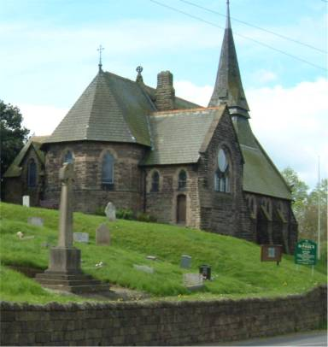
St Paul’s Church was built in 1869-70 and consecrated on 28th July 1870. The building was erected from funds donated by local subscription. Sited just at the foot of Helsby Hill the church has a commanding view over the lower expanse of the River Mersey. The presence of the Church in the village was greatly appreciated by the community to such an extent that the South Aisle, Lady Chapel and Porch were added in 1909 – the Lady Chapel being consecrated on 23rd January 1909. Once again funding for the build was by local subscription. Since then there have been made additions to the Church building funded by grateful parishioners.

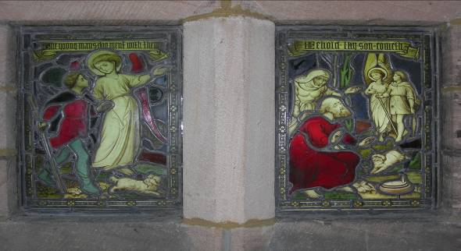
The Church possesses some beautiful stained glass windows of which the most notable are the “St. Raphael windows”. These two tiny windows are to be found in the porch of the Church and depict two episodes from the story of Tobias and the Angel from the book on Tobit in the Apocrypha.

St Paul’s Churchyard is a ‘closed Churchyard’ but there is a Cremated Remains burial plot which is now nearing its capacity. The Churchyard also contains the village War memorial at which 11 November commemorations take place. In addition to St Paul’s Churchyard there is a village cemetery close by which is the responsibility of Helsby Parish Council and which remains open for interments.
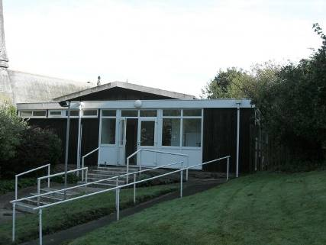
In addition to the main Church St Paul’s also has an adjacent timber Church hall which was erected in 1970 and which hosts many Church events as well as being well used by various groups within the community (TaeKwando ; Scottish Dancing ; Junior dancing tutorial classes; Yoga and Zumba classes; Baby classes) . The hall is also used for Funeral receptions, birthday parties, christening parties and various meetings by different organisations within the area. The Helsby Concert Band and the Come and Sing Choir both make use of the Church for their weekly practice sessions and concerts.

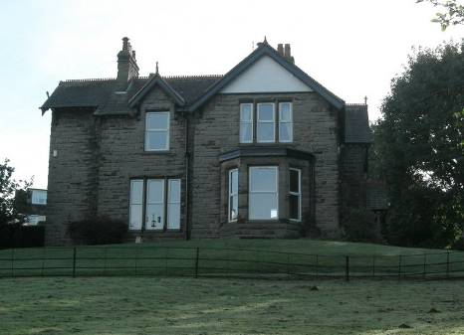
The parsonage house is a late Victorian dwelling with seven bedrooms, a large lounge and separate dining room, kitchen and study. Outside there is ample parking for several cars and garage accommodation. At the side of the parsonage is a large garden area laid mainly to lawn. To the front elevation the parsonage looks out across the ‘Vicarage meadow’ (which is a large expanse of grassed area renowned for its display of daffodils in early Spring) and has stunning views across the estuary. The house is in a generally good state of repair and good decorative condition.

Current Services at St Paul’s Helsby
St Paul’s is a ‘central’ church in terms of worship style with traditional use of the Eucharist vestments, coloured stoles and the use of scarf and hood as required. We use the Common Worship Order of Service (tailored to the main phases of the Church Year). In addition we also use a tailored Baptism Order of Service which was developed as one of our GAP initiatives.

Prior to the Covid pandemic we had a fairly healthy Sunday Gang for juniors aged 3yrs to 12yrs which was held as part of the Sunday 11am service. We are now in the process of trying to bring this activity back into being.

The main services held at St Paul’s are as follows:-
- Holy Communion (BCP) Service is held every Sunday morning at 08:00am.
- An ‘All Age/Family Service’ is held on the first Sunday in each month at 11:00am with a
Sung Communion Service being held on all other Sundays at 11:00am
- Morning Prayer- is said in St Paul’s Church on Tuesday, Wednesday, Thursday and Friday
mornings at 9am (about 20 minutes).
- The Church is also open for Silent Prayer from 8.30am.

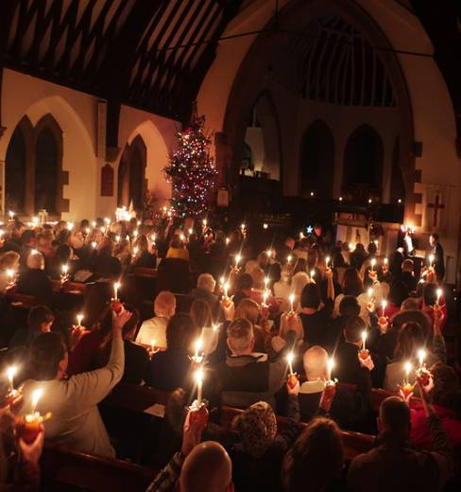
In addition we are accustomed to holding Healing Services and Memorial Services at appropriate times throughout the year. We are also accustomed to holding Holy Communion services through each day of Holy Week (including a ‘Walk of Witness’ service on Good Friday which is a joint service with the Helsby Methodist Church) and throughout Lent we also run a Lent Group. Remembrance Service being a Civic service, is attended by local Council representatives and members of the uniformed organisations ie. Scouts etc. is hosted by St Paul’s and shared with the Methodist Church and the whole village. Each Church takes alternative years to lead this service. Over the Christmas period we hold three additional services:- a Christingle service ; Midnight Mass service at 11:30pm on Christmas eve and a 10am Christmas Day service.

Refreshments are served at the end of each 11am service to allow social time.
Christingle service 2018

2019(full year) 2021(full year) 2022 (Jan thru July)

Easter Sunday 92 57 56 plus 2 U16

Harvest 125 85 n/a

Remembrance Sunday 200+(full church) 200+(full church) n/a

Carol service 220 n/a

Christingle 200+ (full church) 120(outside) n/a

Midnight Mass 46 33 n/a

Christmas Day 56 34 n/a

Average weekly attendance 73 63 45
(includes 8am and 11am services)

In addition to the above services we also hold services for baptisms, weddings and funerals and the numbers for these services are shown below:-

2019(full year) 2021 (full year) 2022(Jan thru July)
Funerals 16 church 9 Church 7 Church
12 crematorium 22 crematorium 1 crematorium
Baptisms 22 19 9
Weddings 1 1 0

Church Governance
There are currently 85 people on the electoral roll of St Paul’s of whom 18 live outside the parish. The average weekly congregation at St Paul’s Church is 70-75 which has been steadily increasing over the past 8 years (although it should be noted that the Covid pandemic has had a major influence on our current attendance figures with attendance dropping to 33-45 per week as at July 2022).

It would be fair to say that the congregation of St Paul’s is largely unrepresentative of the village of Helsby in that it has a high percentage of retired people who live on fixed incomes.

The Church is governed by eleven members of the PCC with the incumbent as the chairperson. The incumbent is assisted in carrying out any necessary duties by our two Church Wardens Ian Adams and Margaret Lambert.

The Church also benefits from the services of a small but dedicated band of members who carry out routine and essential maintenance and repairs to Church buildings and the surrounding grounds on a weekly basis.

Change Management
We are very supportive of change but also feel that change must be introduced in an appropriate manner. We have developed a good methodology for change that is based around wide discussion within the PCC, wide consultation (including the use of presentations etc) with the congregation and the disclosure of all relevant facts and figures at all times.

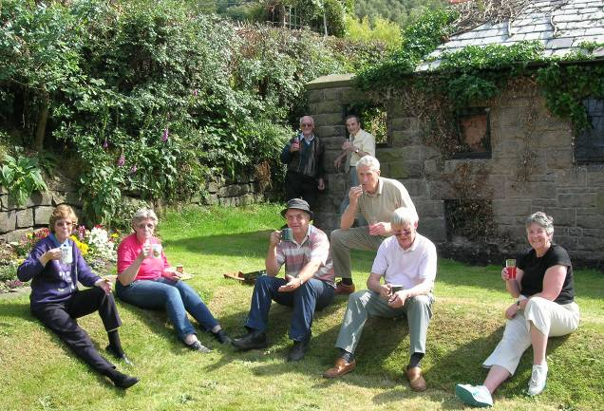
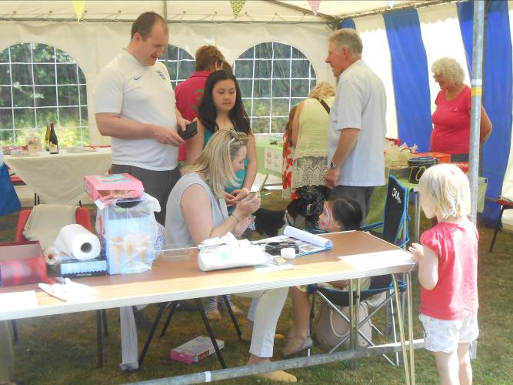
Some events held by St Paul’s Church :-

A welcome rest after taking down the Marque Face painting anyone?

BBQ Fete on Vicarage back lawn
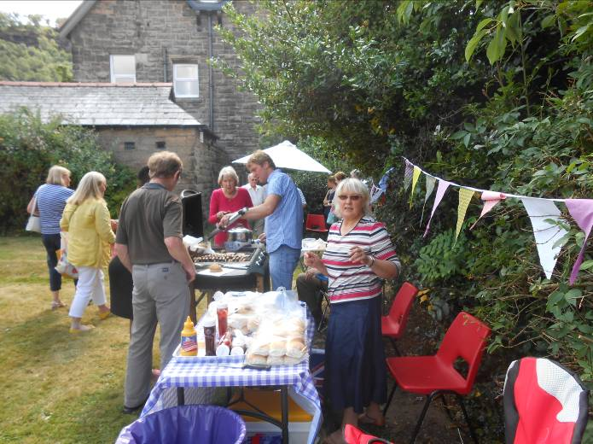

Queen’s Diamond Jubilee service
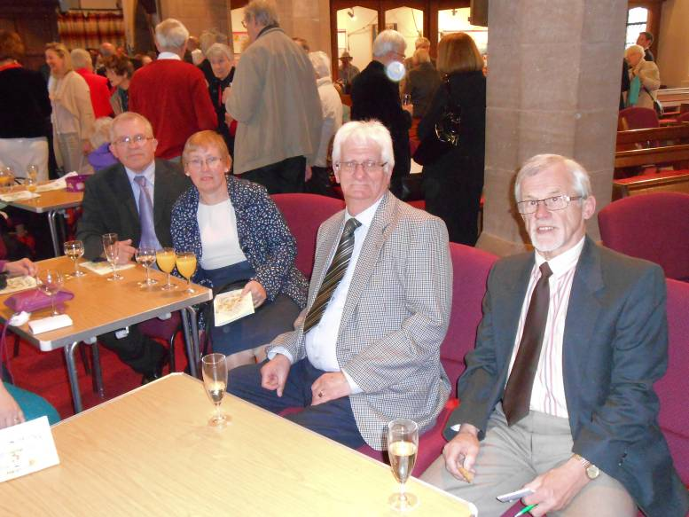

Who’s Who at Helsby St Pauls
Reader
Church Wardens Ian Adams Tele: 07884298696
Church Wardens Margaret Lambert Tele: 01928 733266
Organist Tony Green
PCC Treasurer David Johnson Tele: 01928 722182
(also editor of Parish Magazine)
PCC Secretary Heather Green Tele: 07943 373290
Gift Aid Secretary Joan Langton Tele 01928 723895
Church Hall Bookings Secretary Lynn Portis Tele: 07976 553893

Web site: http://www.stpaulshelsby.org.uk

We also have a very active Mothers’ Union membership which includes ladies from outside the Parish.
The MU holds monthly meetings with a suitable guest speaker and is a major source of support for running many of our functions - they also support the MU organisation’s projects around the world.

Church Finances

The annual ‘budget’ for St Paul’s Church is c£68,000 per annum and is agreed by the PCC at the beginning of each Financial year. The funds are raised by the following methods :-

- 45-50% Planned Giving via our FWO scheme
- 10% Fund raising – we hold a number of special fund raising events and concerts each year to help finances. Examples of the fund-raising events held include :- Vicarage fete; Harvest Lunch; Spring Fair and Christmas fair: various coffee mornings ; Soup & Sandwich lunches; Dinner outings; Musical/choral evenings etc.
- 10% Recoverable Income Tax via the Gift Aid Scheme
- 5% Plate money – although this is rapidly diminishing as we persuade people to move to our FWO scheme.
- 5% Donations
- 10-15% PCC fees
- 10% Church Hall income from bookings
- 1% Expense contributions from Dunham Hill. As a shared Benefice, St Paul’s and St Luke’s Dunham Hill have come to an arrangement whereby all the Incumbent’s expenses are split 75:15.
St Paul’s operates a monthly reimbursement of Incumbent expenses for postage and Mileage (currently 45p per mile) which are claimed through a special form. The only other costs that the PCC funds are - the Council Tax and the Vicarage Telephone Bill (although a contribution for Broadband costs etc are expected).

St Paul’s operates on an ‘Accruals’ basis and is currently meeting its full Parish Share.

Within the financial policy agreed by the PCC, support for the Church overseas and home missions and charities is a main Budget item with the final decision on the level of funding being determined at the end of each financial year.

In addition we make use of Harvest Gifts to provide charitable support to Save The Family and our local Foodbank (this support is also carried out throughout the year) and we support the Childrens’ Society through box collections and through our Christingle Service.

We also hold Charity Fund Raising events during Lent and Advent – normal recipients are Shelter. Water Aid and Halton Haven (a local hospice).

Church education

Within the church, Christian education is delivered through services and through our Healing and Prayer Group; our Lent services and our Wednesday Worship services (currently suspended) which take the form of discussions around a Bible text and its meaning.

In addition, the incumbent of St Paul’s has always maintained strong and regular contact with the local Schools (see opening paragraphs)

Ecumenical relations

We have a very good working relationship with the Helsby Methodist Church and together we hold Lent Lunches and Good Friday joint services each year – alternating them between the two Churches. We also have links with our joint-benefice partner church St Luke’s Dunham-on-the-Hill.

Outreach and mission
Our approach to outreach within the Parish is centred around the following aspects :-

- Baptism Linkup – sustained contact with each baptism family as they bring forward a candidate for baptism that includes the giving of a personally inscribed baptism candle and invitations to an Annual service in celebration of all the candidates baptised in the year

- House visits and hospital visits to call on the sick etc. which can also extend to the giving of Home Communion upon request

- Giving of Holy Communion to people in sheltered accommodation and care homes.

- The Parish Newsletter – this is a monthly magazine which has a circulation of some 880 copies which are distributed within the villages of Helsby and Dunham on the Hill. This provides details of all our services and details of what is going on in both St Paul’s Church and St Luke’s Church.

- Our ‘Come and Sing Choir’ which provides a forum for all those who just like to sing to come together within a Church environment.

In the past the Church has had very good relationships with such groups as the Scouts ; Guides ; Brownies; Rainbow etc. however over a number of years these links have fallen away to the extent that our only contact is at the Harvest and Remembrance Services.

Qualities and Skills in our new incumbent

The main issues facing St Paul’s at the present moment are connecting with the younger people and young/middle aged adults within the community and getting them to show a sustained commitment to the Church. We feel that we need a new incumbent who is able to address these issues whilst maintaining and developing the existing church congregation and who is therefore able to display the following skills and qualities:-

- A good spiritual leader and communicator – able to work with the full age range;
- Experienced in pastoral care and in leading worship;
- Capable of enabling parishioners to develop their skills and talents to their full potential for the overall benefit of the Church in both parishes;
- Capable of further developing the Lay Ministry within our churches;
- Able to delegate tasks as appropriate – to allow more time for Pastoral Care, Mission and Planning;
- Able to maintain and build on the links with other churches in the area;
- Capable of maintaining a visible presence within, and engaging with, all the communities (settled and traveller) of both parishes.
- Able to encourage the congregations in living out their faith in everyday life;
- Provide leadership on safeguarding and encourage all to contribute toward creating a safer church.

Taking our Church Forward

A few years ago the PCC looked at ways in which we could take the church forward and how we could further embed the Church within the community. It was agreed that the longer term objective should involve making the Church more visible within the community by enabling the main Church building to be used by community groups and events throughout the year.

The lack of any toilet facilities within the existing building was seen as a major block to this happening at that moment in time (currently people have to make use of the facilities within the Church Hall which is not always practical eg school events in the Church being disrupted by the need of children to use the toilet etc).

It is hoped that this will build upon the successful re-ordering of the South (phase 1 of which was completed in 2010 comprising the removal of pews from the South Aisle and their replacement by moveable chairs and the laying of carpet flooring. Phase two was completed in 2015 comprising the installation of a ‘hidden’ kitchenette at the rear of the South Aisle with hot water boiler and tea making facilities.

In 2019 a project was launched to extend the Church building to enable the provision of two toilet spaces. This is seen as the ‘starter’ project for a long term plan to re-order the inside of the Church to facilitate greater use of the building throughout the week. Unfortunately the Covid outbreak has stopped this project in it’s tracks and whilst there still a very strong desire to complete the project the financial implications of a huge drop in attendances etc means that we currently do not have the finances at our disposal to drive this project forward.
Addendum - The History of St Paul’s

All through Helsby’s long and fascinating history there is evidence of worship and several chapels were in use before St Paul’s was built. The Kelly’s Directory of 1882 tells us of the site of an ancient chapel erected by one Catherine Arderne circa 1650- this, and the discovery of a Roman altar at the top of Vicarage Lane in 1959, bears witness to acts of worship over the past years.

So that a Church for the worship of Almighty God could be built in Helsby, a portion of land on a fine eminence overlooking the River Mersey was given by the Marquis of Cholmondeley. A letter from the Land Agency and Estate’s Office stated that in addition to agreeing the use of the land to build a church, the Marquis also donated the building stone which was from a local quarry, known locally as Ben’s Quarry. The quarry, then owned and worked by Thomas Brandreth, was well known at the time for the superiority of it’s stone quality and also provided stone for the building of the churches at Ince, Upton and Saltney as well as repair works on Chester Cathedral.

The stone was “to be free of charge – the constructor to pay for the getting of the stone only” and the farmers who carted the stone from the quarry were paid 7/- for one horse and cart and 10/- for two horses and cart per day. The marquis further stipulated that all steps should be made of York stone.

The original design for Helsby church was carried out by John Douglas of Chester. Originally trained in Lancaster, he soon set up his practice in Chester and was responsible for the design of many buildings in Cheshire, North Wales and Northwest England, in particular in the estate of Eaton Hall. He restored old churches, built new churches and large houses, and many smaller properties. His most popular designs are those for the black and white half-timbered buildings on the East side of St Werburgh Street, Chester and the nearby Eastgate Clock. Pevsner described him, without qualification, as "the best Cheshire architect".

On the 8th January 1869, the contract for building Helsby Church was signed appointing John Thomas of Gwespyr, near Holywell as the constructor. The contract price was to be £1,720 (including the pews) and this was to be paid in seven instalments as the building progressed. A further bill for £503 was added later for raising the floor one foot higher than the contract stated. Unfortunately the builder got into financial difficulties and on the 7th January 1870 he was declared bankrupt.
In February 1870, the Reverend William Charles Cotton MA of Frodsham signed an agreement with H.Booth and J.Richards of South Tranmere to complete the construction of the Church for £850.
In May 1870, the Bishop of Chester wrote from St. John’s, Dukinfield saying that he “considered a permanent font essential but that it would be possible to make do with a temporary lectern”. Meanwhile public subscriptions were being received towards the cost of the Church which had reached the grand sum of £1,914 9s 11d by the time that the Church had been completed. The perimeter wall around the Church and the Churchyard was completed in August 1870.
The Church was consecrated on Thursday the 28th July 1870 by the Bishop of Chester William Jocobson D.D. At the time of consecration the official seating accommodation was 301 and this number was calculated as follows :-
Adults @ 20 inches 229
Children @ 14 inches 72
On Sunday the 31st July 1870, the first baptism service was held at which seven children were baptised.
At this time the Church was under the jurisdiction of the Vicar of Frodsham, the Reverend William Charles Cotton MA and the Curate in charge of Helsby was the Reverend Thomas Woodrox Dix who apparently lived in Manley.
An instrument dated the 10th June 1875, transferred the right of the Reverend William Charles Cotton to nominate and present a Minister for Helsby to James Reynolds of Fox Hill. The patron of the living is now the Bishop of Chester.
Records show that the first Vicar of Helsby was John David Havard and he was inducted in July 1876. On the 28th December 1876, the first marriage was solemnised in the Church – and it was between John Wright and Emma Britland – both of whom signed their assent in the Marriage register by making a cross.
The South Aisle, Lady Chapel and Porch of the Church were added in 1908 and were built by J.G.Davies & Co. of Frodsham at a cost of £1,209 4s and the whole of this amount was raised by public subscription. The Lady Chapel was consecrated on 23rd January 1909 by the Bishop of Chester.
The present wrought iron Screen was installed in 1909 and it came from Hawarden Church and cost £85. In April of that year John Barrow of Frodsham was paid £2 15s for “Blacking and Gilding the Screen”.
In 1918 the New Churchyard was opened and in 1920 the War Memorial was unveiled.
The Children’s Corner in the Church was instituted in memory of Miss Bate, who had been a very popular head teacher of the old Church of England School and who had devoted her life to the children of the village.
Since the initial building of the Church many items in the Church have been donated by grateful parishioners and these include :-
- The East Window of the Church was presented by the Vicar of Frodsham, the Rev William Cotton,
who worked so hard to have the building of the church completed.
- The Pulpit was in memory of James Reynolds of Fox Hill
- The Lectern was given by Mrs James Reynolds in memory of her husband
- The Organ was reconstructed and enlarged and the outer door to the vestry was added in 1907 - the
cost was borne by William Griffiths of Windcliffe
- The oak panelling in the side chapel was given by public subscription in remembrance of Reverend
EW Evans the Vicar of Helsby from 1903 to 1924
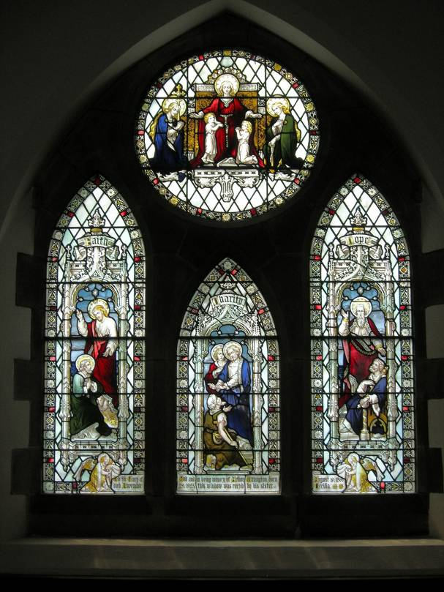

The three windows on the south side of the Lady chapel depict “Faith, Charity and Hope” and were given by Celia Withington in 1924 in memory of her brother Arthur.

- The original installation of Electric Light was given by Arthur Rundit in June 1920 and installed
in 1921. This was updated in 1953 in memory of Celia Withington and also to commemorate the Coronation of Queen Elizabeth the Second. The current lighting system was installed in 1991 in memory of Bert Woodcock (former verger at St Paul’s)
- The main Lych Gate was built in 1911 and was given by James Taylor of Heathercliffe. The
other two Lych Gates were given by Arthur and Celia Withington of Brackenhurst in November 1923.
- In 1980 the organ was moved from it’s former position next to the vestry down into the body of
the church. At the same time the organ bellows and pipe-work were moved to the rear of the church and sited in a newly constructed organ loft. The cost of this work was raised by public subscription.
- The current sound system was installed in 1991 in memory of Albert Wild - churchwarden for
many years.
- The runners for the pews and carpeting for the Choir stalls were kindly donated by the Ladies of
St Paul’s in 2003.
- The disabled access facilities via the rear of the lady Chapel were installed in 2006
- Phase one of the re-ordering of the South Aisle was completed in 2010. This comprises the
removal of pews from the South Aisle and their replacement by moveable chairs and the laying of carpet flooring.
- Phase two of the re-ordering of the South Aisle was completed in 2015. This comprised the installation of a ‘hidden’ kitchenette at the rear of the South Aisle with hot water boiler and tea making facilities.

Elsewhere

- A new Cremated Remains plot was consecrated by Bishop Keith in October 2010
- A new access ramp was installed to improve access to the Church Hall in 2012
- Disabled Toilet facilities were installed in the Church hall in 2013
- All the sets of concrete steps leading up to the Church Hall were reformatted if 2018
- Church hall kitchen underwent a full refurbishment in 2019

