|  |  |
| --- | --- |
|  |  |
|  |  |
| C:\Users\Andy Stinson\AppData\Local\Microsoft\Windows\INetCache\Content.Word\crest logo.png |  |
| C:\Users\Andy Stinson\AppData\Local\Microsoft\Windows\INetCache\Content.Word\IMG_0177.jpg | **Parish Profile:**  **St Oswald with  St Thomas of Canterbury,  Chester** |
|  | C:\Users\Andy Stinson\AppData\Local\Microsoft\Windows\INetCache\Content.Word\IMG_0171.jpg |
|  |  |
|  |  |

## Introduction

The Parish of St Thomas of Canterbury is situated in the heart of the historic city of Chester and serves the Garden Quarter of the city centre. We are prayerfully seeking a new incumbent to serve the church family and the wider community. We are excited to share this opportunity with you and ask that, as you read this profile, you pray for us and the growth of the Kingdom here as we pray for all those seeking to discern if God might be calling them to this role.

The Dean and Chapter of Chester Cathedral, and the Bishop of Chester together with representatives from the parish, are seeking to appoint a missional priest with energy and initiative, skilled in collaborative leadership and in nurturing and encouraging the gifts of others to serve in this urban, modern Anglo-Catholic parish. The post is 50% stipend plus house in return for ministry of Sundays plus 3.5 days per week. Applications are welcome from both male and female priests.

## The Parish and Surrounding Area

The parish comprises the North of Chester and includes the Garden Quarter, Chester University, and the Countess of Chester Hospital. It has a population of 9,296 (2018 Census) and between the university and the hospital includes two of the biggest employers in the city centre.

The Church of St Thomas of Canterbury is situated on the edge of the Parkgate Road Campus of Chester University and a significant proportion of the surrounding housing is rented accommodation for university students. This makes the average age in the parish relatively young with 49% of the local population aged between 18-30. The area draws people from around the world who come to live, work and study here with a wide range of people for whom English is not their primary language.

The Garden Quarter

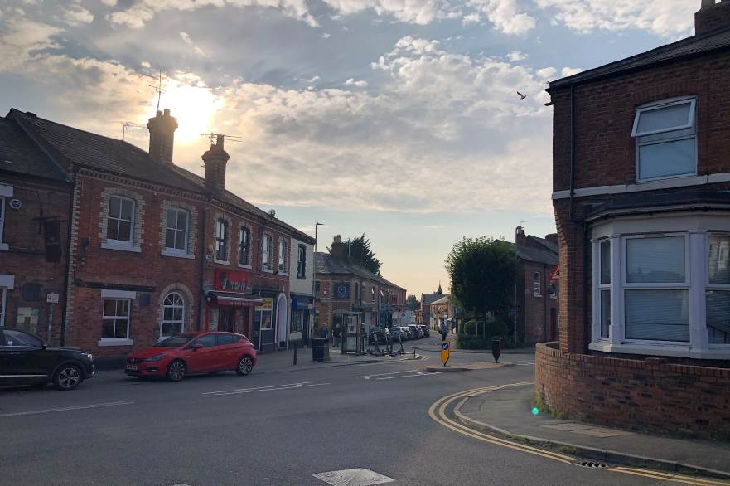

The Garden Quarter of Chester is an area with its own strong sense of identity and community life. Stretching from the city walls north of the centre of Chester with the Shropshire Union Canal running through its centre. The natural geography of the area defines its boundaries and active community groups seek to build up the shared community life. Served by the shops and businesses that are located on Garden Lane is a part of the city centre which has its own centre of gravity and there would be opportunities for the church to build on by becoming more involved in community life. The Church already hosts the annual Christmas Market and the Carol Service is very well attended by the local community.

The main campus of Chester University is located within the parish and has seen very significant development across the last few years together with a significant increase in the number of students and staff studying and working on the Campus. It is served by its own Chapel and has a chaplaincy team who run a multi-faith chaplaincy service on campus. There have been close working relationships between the parish and the chaplaincy team in the past and a warmth and openness to developing deeper links in the future. The University Choir rehearse in the parish church and a number of the members of the congregation work and study at the university.

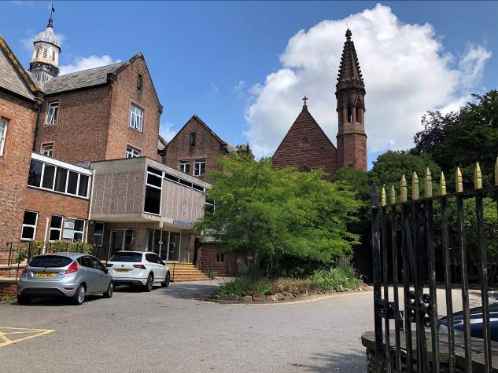

Chester University Campus

The parish’s location on the edge of the historic walled city of Chester offers the best of city centre living with nearby and accessible countryside. The walled city centre is packed with history from its Roman roots, unique Rows and fabulous cathedral. It is culturally rich with museums, theatres, cinemas, restaurants and bars. Surrounding the city is the beautiful Cheshire Countryside with rolling fields and sandstone ridges. The city’s transport links are good with Chester Station having regular trains to London and Liverpool and Manchester Airports nearby.

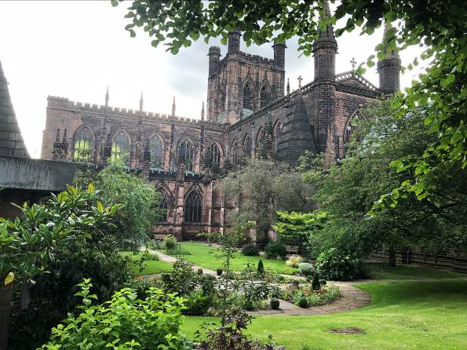

Chester Cathedral

## Schools

The Blue Coat Church of England Primary School is an Aided Primary School located adjacent to St Thomas of Canterbury Church. It is dual form entry primary school housed in a modern building and has strong links with the parish. It is served by foundation governors appointed by the PCC and it is anticipated that the next Incumbent at the parish will become a governor at the school. The strong Christian Ethos at the school offers many opportunities for links with the church and there is a great openness at the school for how this might grow. The school have regular school services in the church and have contributed to the Sunday services at the church as well. In the past, the school have taken part in School Ventures weekends and it is hoped that this will continue in the future but is dependent on the school supporting this work. This gives room for pupils in the church to explore Christian Faith across a residential weekend and is a great opportunity for strong links to be forged.

The parish is also home to Queen’s Lower School, a private girl’s primary school linked to the Queens School in Chester City Centre. The school have welcomed previous parish priests to the school and make use of the church building for some of their end of term services.

## Worship

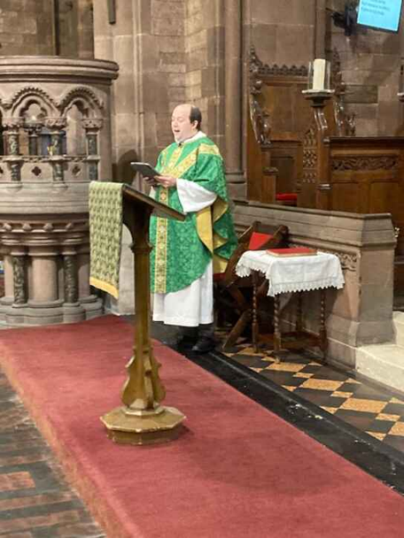The celebration of the Mass is the heart of the worshipping life of St Thomas of Canterbury church. We are confidently rooted in the Modern Anglo-Catholic Tradition of the Church of England and enjoy celebrating the feasts and festivals of the church year. Priests wear full Eucharistic Vestments for each celebration of the mass and we make use of incense during Principal Feasts and for certain seasons of the year. The rhythm, colour and beauty of this way of worshipping is at the heart of our shared life together as we seek to meet with Christ and be changed by his presence.

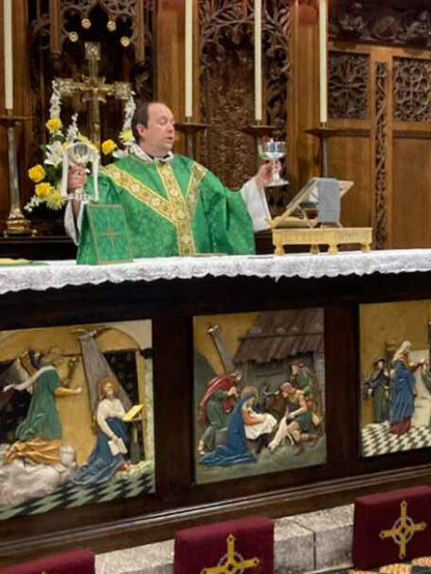We make use of the rich variety of liturgy offered within Common Worship and follow the lectionary through the year. The liturgy is displayed on the screens of our recently installed Audio Visual system and this system enables worship to be streamed. PowerPoint slides are put together by a team of volunteers together with a printed order of service for people who find accessing the service via the screens challenging. We offer printed copies of the Bible readings each week using Redemptorist sheets and we print the parish notices and prayer requests on the back.

Our worship is supported by a significant group of volunteers who help to make the Sunday by Sunday worship happen smoothly. This comprises of a sacristy team, Bible readers, intercessors, chalice assistants, AV and refreshment teams. The sense in which many hands make light work is certainly true and this offers priests who serve the community space to greet people and chat to people at the end of the service.

## Music

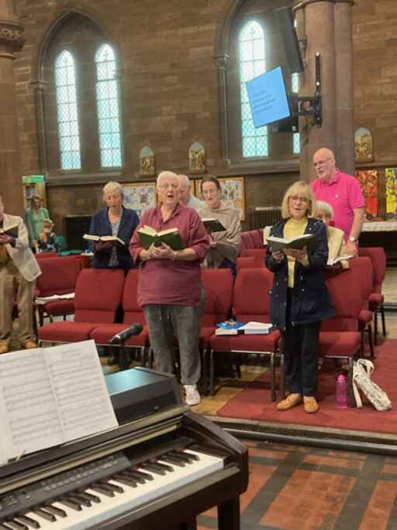Our worshipping life is enhanced enormously by our large Church Choir who sing every week for mass. They are led by our Director of Music, Matt Baker and our Deputy Director of Music Ian Thomas. The choir sing in four part harmony offering a sung setting for the mass, an anthem and a wide selection of hymns spanning both traditional and contemporary music week by week. The music is led on the organ, piano and features other musicians from the church who play orchestral instruments to enhance our worship. The high quality of the musicians helps to offer space to reflect on Bible readings and season of the church’s year. The choir has also been a way that people have chosen to join our worshipping community.

Matt Baker is a very talented musician, choir director and composer. He is the Musical Director of the Chester Mystery Plays and several other choirs within the city. His work enables him to engage with children, adults and community groups across the city and he is a huge asset to the life of the church and the wider community. His connections within the garden quarter offer a particularly valuable link with the local area and he is well known within the city.

## The Church of St Thomas of Canterbury

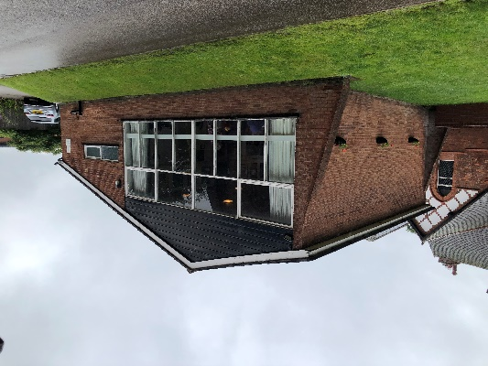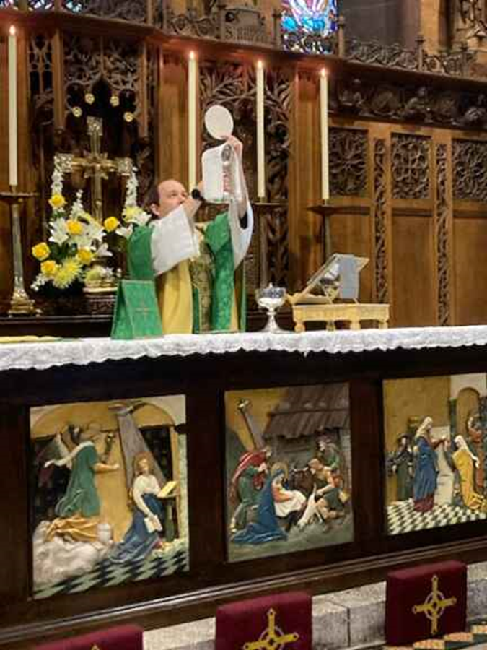The church building was completed in 1872 but serves the parish of St Oswald which dates back much further. It is a beautiful grade II listed building made of red sandstone and designed by Sir George Gilbert Scott. Across the years it has been well maintained and includes facilities to make refreshments after the service. There is a plan, with faculty approved, to build a toilet in the church and provide better disabled access to the building. We hope that this project will be started soon and will offer better facilities to those who use the building. The Church building is used by local choirs, music groups and a theatre company which helps to balance some of the running costs. It is hoped that further use of the church building will be made possible once the building work has been completed.

The Parish Hall is a more modern building situated on the south side of the church. It has a main meeting area, kitchen and toilets. It is used by a variety of community groups throughout the week and hired out for some private functions.

## Social and Fellowship Groups

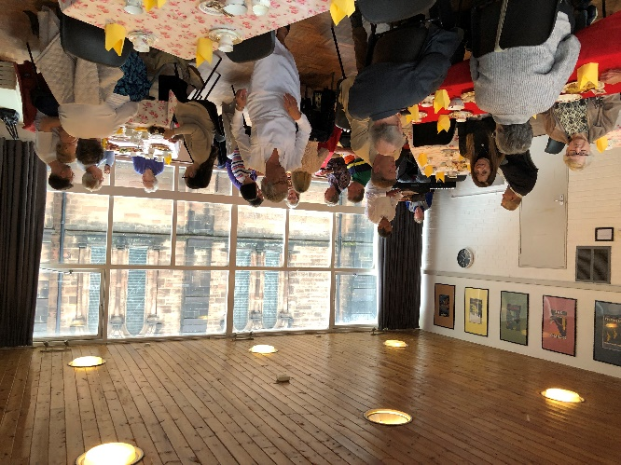The church run a series of social events throughout the year. These are attended by a combination of congregation members and their friends and are often held in the Parish Hall. We love to eat and chat together, raising a glass and enjoying one another’s company. Recent events have included an Afternoon Tea and Spanish Night. As well as offering a valuable chance to see one another, these events help to raise money to support the work of the parish.

We are part of the Chester Branch of the Mother’s Union, a group which will celebrate its 50th anniversary later this year. Members gather for a cup of tea and to listen to interesting talks as well as joining in with the regular MU events such as the Wave of Prayer. The group was formed when the parish used to be part of the now disbanded Chester Team Parish so members attend a range of different Anglican churches in the city centre.

## Governance

At present, the church is served by two Church Wardens, a PCC Secretary, Treasurer and a full complement of PCC members. The duties of Parish Safeguarding Officer are carried between the PCC Secretary and one of our Churchwardens. The PCC tends to meet on Sundays after mass as this offers a good opportunity for everyone to be gathered together.

## Children and Young People

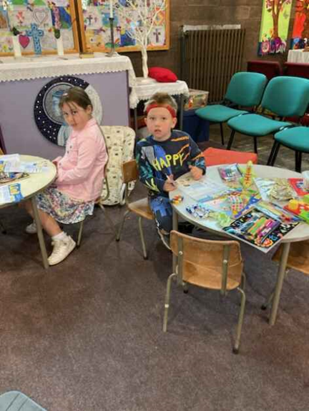We regularly welcome children to our celebrations of mass on a Sunday. To support them in the service, we have a dedicated children’s area with carpet and toys and Sunday sheets to help them engage with the themes of the service. At present the children who attend church are all primary school age or younger. As the Eucharist is the centre of our worshipping life, the PCC has passed a resolution to admit children to communion to enable them to participate in our services fully. We are at the beginning stages of exploring restarting our Sunday School to help support children to grow in their faith and recognise that this is a priority for us.

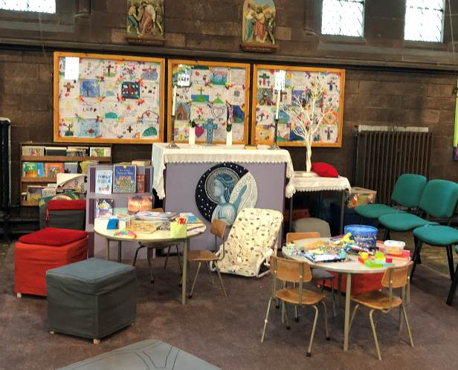

## Eco Church

The parish is a proud recipient of a Bronze Award in the Eco Church scheme run by A Rocha UK. This involves taking stock of the parish’s activities and seeing their impact on the environment as well as starting to change how we behave and care for our local environment. We have enjoyed having elements of teaching on this subject in our Sunday services and would like to develop our work in this area further.

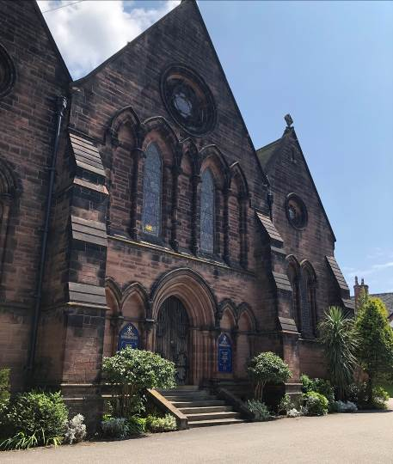

The Garden of Remembrance

## Foodbank

We recognise the blessings we have as a community and want to be able to support those who, particularly in the present financial climate, do not have enough. As such, we have a Food Bank Donation point supporting the work of West Cheshire Foodbank in our church. This is regularly used by members of the congregation who contribute generously.

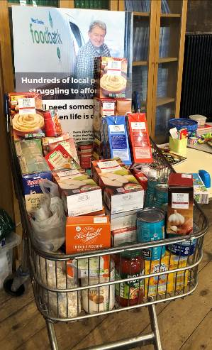

The Foodbank donation point in church

## Finance

The church’s finances are well managed and in the last financial year a small surplus was generated. The income is generated from planned giving, which is increasingly made by standing order, hall and church lettings and fund raising. The church has a reserves policy to hold three months working expenditure to enable fluctuations in income to be balanced with outgoings but presently has more reserves than the policy requires. In addition, we have a charitable trust given to support the development and long term maintenance of the fabric.

We have recently explored ways of helping people to give to the church and have made use of QR codes to enable online gifts to be offered and a chip and pin donation station allowing people to offer gifts. This enables visitors to the church to support the church’s work and will help to maintain giving as fewer people carry cash.

## Welcome

The idea of everybody being welcome at St Thomas of Canterbury church is very important to us. We seek to make everyone who visits or worships the church feel very welcome here. As Christ welcomes us, we want to welcome everyone to be a part of our community regardless of their disability, economic power, ethnicity, gender, gender identity, learning disability, mental health, neurodiversity, or sexuality. As such our new incumbent should feel comfortable working with a diverse congregation. All are welcome in this place!

## Vicarage

The vicarage for our parish is a pleasant, spacious home within walking distance of Chester city centre. It comprises of four bedrooms, two reception rooms, kitchen with breakfast room and an office. It is situated on a quiet residential street within walking distance of St Thomas of Canterbury Church.

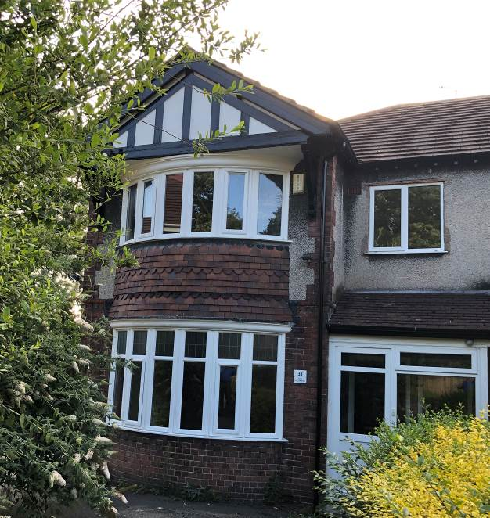

The property is well maintained by the diocesan properties team and their contractors.

The Vicarage

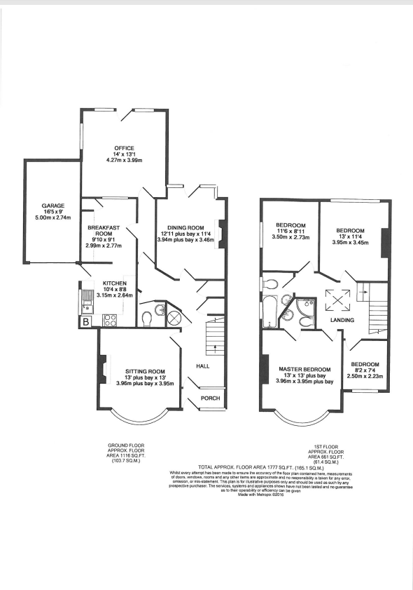

Layout of the Vicarage

## Person Specification

### We are looking for:

* A priest with liturgical presence and creativity, able to enrich Eucharistic worship with a breath of music and to expand the range of services and other activities to appeal in particular to younger generations
* A pastor who will exercise care of the established diverse congregation and reach out to the wider parish through the occasional offices, and in particular the local schools and community organisations. See visiting residential homes ministry regularly as an important part of our role in the community, particularly post Covid. Support parishioners in the work they are doing within the church. Support our crucial fundraising and encourage volunteering within the congregation
* Someone who is an enabler of the ministry of others, strengthening the local church community’s capacity for mission and encouraging closer partnership in mission and ministry.
* The parish is at a stage in its life where it is needing to look to discern a vision for its future life and witness and therefore is seeking a priest who will encourage the congregation to live out their faith in everyday life, Monday to Saturday, not just on a Sunday

As you discern whether you are called to minister here, you will need a healthy dose of enthusiasm about being part of this fluid landscape, anchored around a community formed around the Eucharist. You will need to come with considerable emotional and cultural intelligence, deep spiritual resilience, and a demonstrable passion for issues of social justice

### We would like our new Vicar to:

* Continue with Eucharist based Worship
* Help to unite and integrate all generations
* Grow our outreach (Ecumenical links, Care Homes, Schools, University and Other groups)
* Encourage growth within the church through engagement and active participation.
* Be an enabler and overseer
* Be open and honest
* Be a good listener who engages with their parishioners and community.
* Support parishioners in the work they are doing within the church.
* Work with the wardens and safeguarding officers to foster a good safeguarding culture in the parish ensuring that the church is a safe space for everyone.

### Skills we hope they can bring:

* Approachability
* Work well with others
* Broaden our outreach and congregation

### What we offer to our new Vicar:

* A willingness to grow and expand
* A welcoming, non-judgemental and supportive church fellowship
* A beautiful church to worship in
* A pleasant spacious vicarage to make your home, within walking distance of the city centre
* A caring community who see clergy well-being as a priority