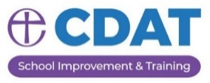
Chester Diocese School Improvement
Support Package 2023/24
School Improvement Order Form

Please indicate the services required for the academic year 2023/24
Completed forms should be returned by e-mail to Emma Furlong: emma.furlong@cdat.co.uk

SCHOOL
HEADTEACHER
NUMBER ON ROLL
LEVEL OF SERVICE | Number of sessions / units | COST  (all prices subject to VAT) | Please tick service(s) required
School Improvement Partner* 3 x ½ day sessions (one each term) from SIP |  | £1,250
School Improvement Partner 2 x ½ day sessions (one Autumn, one Spring 2 visit) from SIP |  | £835
School Improvement Partner for small schools*  1 x ½ day session (one each year) from SIP |  | £425
School Improvement Support – half day  Leadership support tailored to school’s needs |  | £425
School Improvement Support – full day  Leadership support tailored to school’s needs |  | £650
Headteacher Performance Management*  1 x ½ day annual review and target setting  (optional mid-year review can be arranged at an additional charge) |  | £425

School Improvement Partner / HT Performance Management
Please indicate your choice of SIP/ HTPM in order of preference
1
2
3
4

