**Job Description**

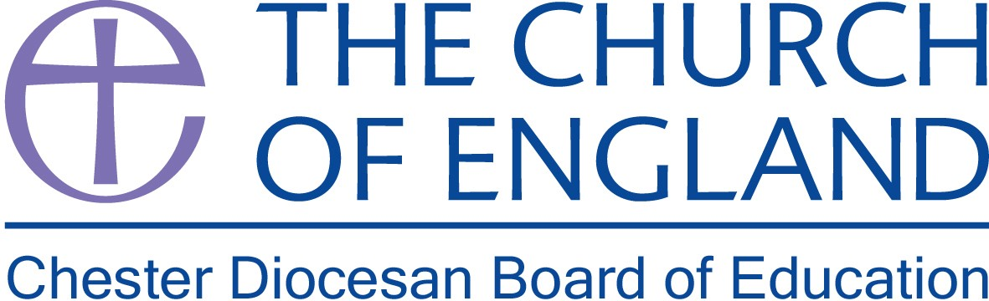

**Job Title:**  Board of Education Administrator

**Hours of Work:** Part Time – 28 hours per week

**Reporting to:** The Director of Education

**Normal Place of Work:** Church House, Daresbury Park, although a consultation is currently underway to consider some hybrid working.

**Job Profile**: To provide administrative and secretarial support to the schools’ team of the Board of Education.

**Main Duties:**

* To prepare the agenda and take the minutes for the Board of Education and the sub committee meetings.
* To oversee and administer face to face Education meetings and courses at Church House, including room bookings, registration and the hospitality of visitors/delegates.
* To maintain and update the Schools’ database.
* To oversee, coordinate and update the Foundation Governor database, including administering the appointment of Foundation Governors to schools in the Diocese, including monitoring terms of office and ensuring vacancies are filled.
* To undertake the administrative tasks involved in running training programmes and courses to support schools in the Diocese.
* To collate information for the monthly schools bulletin and distribute it electronically.
* To undertake general administrative tasks to support the DBE officers including;
  + Printing, copying and dispatching documents;
  + Answering telephone and e-mail queries;
  + Organising mail and responding to mail when appropriate;
  + Other secretarial, financial and administrative tasks as required.

Such other duties and tasks as the management may from time to time require.

**Dated**: January 2022

Note – this Job Description does not form part of your Contract of Employment