**DIOCESE OF CHESTER**

**PARISH PROFILE**

**HALLWOOD ECUMENICAL PARISH, RUNCORN**

**St.Mark’s and Bethesda Churches**

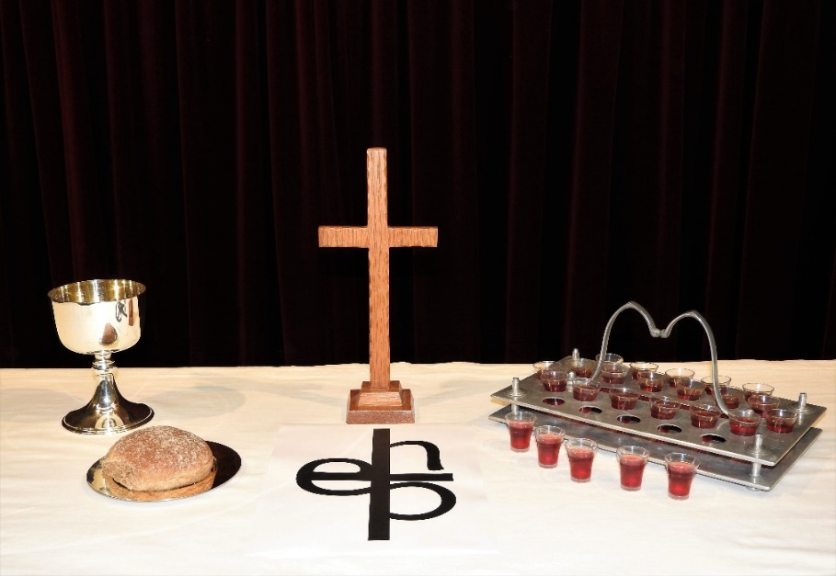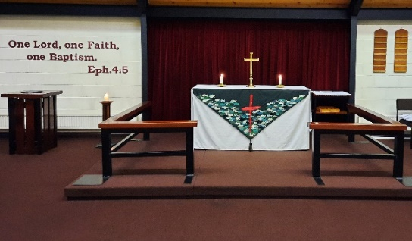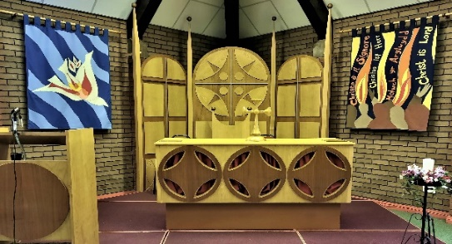

**‘One Lord, one faith, one baptism’**

**Ecumenism at the heart of Runcorn**

**Introduction to Hallwood Ecumenical Parish**

Hallwood Ecumenical Parish is a single congregation LEP comprising two worship centres:-

Bethesda Church – a shared building, owned by the URC

St. Mark’s Church – a shared building, owned by the C of E

The Partnership is a Church of England Parish in the FrodshamDeanery and Chester Diocese, a Methodist Church within the North Cheshire Circuit and a United Reformed Church within the Mersey Synod.

Our Parish comprises Palacefields, Brookvale, Sutton Park and Beechwood estates within the Runcorn New Town. The congregations at both worship centres are made up of Anglican, Methodist and URC members along with those who hold joint membership of the three denominations. We are a friendly, welcoming and inclusive parish with a diversity of parishioners from different socio-economic backgrounds who have a heart for worship and sharing the gospel. Although generally structured, services tend to be relaxed in style accommodating both members and others who join us. We are committed to serving our local communities, alongside our members, through our worship and weekday activities, providing practical and spiritual support for all.

**Staffing and leadership**

The LEP has a staff team of two, being the full time Anglican Vicar (post vacant) and part time URC Minister providing ministry for one Sunday a month and one day a week. There has been no regular Methodist clergy input into the parish for some considerable time.

There are four Anglican Readers, one Methodist Local Preacher and a licensed Pastoral Worker assisted by a small Pastoral Team.

There is a voluntary Parish Administrator who deals with most of the day to day administration in the Parish and acts as secretary to the ECC among other things.

**Skills and attributes of our new incumbent**

**Our new vicar should: -**

* Be committed to working ecumenically and leading worship using Methodist and URC liturgy as well as Common Worship.
* Be passionate about proclaiming the Gospel of the Love of God.
* Be an inspired teacher who will help us to apply our faith to everyday life.
* Be a team player, encouraging the ministry and talents of members of the parish to help us grow individually and together.
* Be someone who would value what we already do and help us develop our ministry to the community.
* Be someone who can lead and inspire us to identify new ways of reaching out.
* Be able to help foster a good safeguarding culture in the parish.
* Have a particular skill needed in the churches in Runcorn and be willing to work co-operatively with other clergy in the town.
* Have a good sense of humour and the patience of Job.
* And, most importantly, must be someone who feels a sense of God calling them here and able to demonstrate their passion and enthusiasm to fulfil that calling.

In addition, the successful candidate will minister more widely in a collaborative way across Runcorn. All the Anglican churches in the town have been working with the Diocesan Mission Adviser on exciting new ways of working together for the good of the whole of Runcorn. This involves using the special skills and gifts that each parish priest brings as part of who they are, for the good of Runcorn as a whole and not just their own parishes. Examples of such skills could include work with children and primary schools, engaging with local government bodies and other agencies, working with deprived communities, etc.

This will mean working positively and collaboratively with all eight Anglican parishes across Runcorn, to encourage them in the particular area of ministry concerned. It is envisaged that each parish priest will give some of their time (1/2 – 1 day per week on average) to helping a particular area of mission and ministry flourish regardless of parish boundaries. Applicants are asked to indicate in their application form the potential area of ministry in which they would be interested in offering support of this kind. For more details, see the separate note on ‘Working Together in Runcorn’ outlining the proposals *[See appendix 1]*

Given the explicitly ecumenical character of Hallwood Parish, we would envisage that in offering this additional town-wide specialism, the minister would be willing to open conversations with churches of other denominations as well as Anglican ones, to explore the scope for further ecumenical working.

**Church Government and Organisation**

Because Hallwood is an Ecumenical Parish, the organisation and government does not exactly reflect the pattern that any of our parent denominations would immediately recognise, although it seems to be a pattern that works for us and has their formal approval.

The main decision-making body of the Parish is the Ecumenical Church Council (ECC) which is also the Trustee body. Membership of the ECC consists of the clergy, the Parish Treasurer and 6 elected members from each congregation (forming the individual Church Councils) made up of the three denominational Officers - Anglican Church Warden, Methodist Steward, URC Secretary, plus 3 other elected members.

The ECC is responsible for all matters affecting the general life and work of the Parish and for appointing representatives to denominational bodies, where appropriate. As the parish holds a shared purse, the ECC is also responsible for all financial matters.

The individual Church Councils are responsible for the maintenance of individual Church membership rolls and other matters specific to each church or delegated by the ECC. All matters relating to finance are referred to the ECC.

On occasion, general Church Meetings are held, especially to consider any matters which affect the whole parish, other than routine organisation.

a. The AGM: - to confirm the appointment of the Ecumenical Church Council, to receive the accounts and reports from Parish organisations and to elect representatives to the parent denominations, where appropriate.

b. General Meetings:- called as necessary for consultation and decisions by the general membership. Notice of three weeks must be given and should be announced in church.

There are a number of teams / committees, e.g. Ministry Team, a Pastoral Team, a Mission Committee, which meet to assist in the running of the parish and report to the ECC.

As an Ecumenical Parish, our Anglican Church Wardens: Anita Ventham and Christopher Roberts, our Methodist Stewards: Mr Alan Ventham (+1 vacancy) and our URC Secretaries: Mrs Claire Pitts (+1 vacancy), form the team of Denominational Representatives for the Parish.

**Description of the parish**

**Runcorn**

Runcorn is on the southern bank of the [River Mersey](http://en.wikipedia.org/wiki/River_Mersey). Directly to the north across the Mersey is the town of [Widnes](http://en.wikipedia.org/wiki/Widnes), 8 [miles](http://en.wikipedia.org/wiki/Mile) (12.9 [km](http://en.wikipedia.org/wiki/Kilometre)) to the northeast is [Warrington](http://en.wikipedia.org/wiki/Warrington) and [Liverpool](http://en.wikipedia.org/wiki/Liverpool) is 16 miles (26 km) to the west. Both Chester and Manchester are within easy reach.

Runcorn was a small, isolated village until the coming of the [Industrial Revolution](http://en.wikipedia.org/wiki/Industrial_Revolution). In the late 18th and early 19th centuries it was a health resort. It developed into a port towards the end of the 18th century. During the 19th century industries developed, particularly the manufacture of soap and alkali, quarrying, shipbuilding, engineering, and tanning. In the early 20th century, the prime industries were chemicals and tanning. Except for chemicals, all the old industries have disappeared and there has been diversification, especially in the development of warehousing and distribution centres. This has been aided by excellent transport links - the [A533 road](http://en.wikipedia.org/wiki/A533_road) passes through the town from the south and links to the east - west M56 and the north - south M6. [Runcorn railway station](http://en.wikipedia.org/wiki/Runcorn_railway_station) is on the [main railway line](http://en.wikipedia.org/wiki/West_Coast_Main_Line) from Crewe to Liverpool, providing frequent services to [London (Euston)](http://en.wikipedia.org/wiki/Euston_railway_station), [Liverpool](http://en.wikipedia.org/wiki/Liverpool_Lime_Street_railway_station), and [Birmingham](http://en.wikipedia.org/wiki/Birmingham_New_Street_station). Runcorn East station provides east - west links, Chester to Manchester. Manchester and Liverpool (John Lennon) airports are within an easy journey. Local bus services in Palacefields are good. An Expressway links the main areas of Runcorn. This is a dual carriageway which has no direct access to residential areas.

A [New](http://en.wikipedia.org/wiki/New_town#United_Kingdom) Town was built to the east of the existing town in the late 1960s and early 1970s and, further to the east, areas of private housing have been established. This resulted in a doubling of the population from around 30,000 to the latest estimate of 62,000 in 2021.

Runcorn is part of the Borough of Halton which comprises Runcorn and Widnes and had a total estimated population of 128,000 in 2021.

**Hallwood Parish**

Hallwood Parish, on the southern side of Runcorn, grew from greenfield land, unlike some New Town-type developments that embraced older communities, and contains a rich mixture of people and backgrounds. Within it, Palacefields and Brookvale began as Liverpool overspill in the 1970s and still have much rented housing, plus a few local amenities, but they are close to the ‘Shopping City’ (a medium-sized indoor shopping centre). Beechwood and Sutton Park / Brookvale East are later mainly private housing developments with little in the way of local amenities. The latter area is geographically separated from the main parish, accessible only via the Expressway. Both churches are in the older part of Runcorn New Town and could be classed as suburban.

The parishisbisected diagonally by the London - Liverpool main railway line and the Expressway. To the north-east are the Palacefields, Brookvale and Sutton Park estates, and the Beechwood estates are to the south west.

Part of the parish to the north east of the railway is an Urban Priority Area (UPA), split between private and mainly public housing. The part of the parish to the south west of the railway is a mixture of private and rented housing. The population is a mixture of retired, middle-aged and families.

The whole of Brookvale and over a half of Palacefields fall within the Urban Priority Area and there is a high incidence of unemployment and single parent families. Being an UPA, a high proportion of families are on low or very low income although income in the Beechwood area probably falls into the medium income category. Intermittent vandalism is an issue throughout the parish and the wider local area.

The population of the Parish is in the region of 12,000 people (although it may be higher). It is mainly white, with ages across the whole spectrum and is fairly static in numbers although the population itself is very mobile.

The congregation could probably be said to be representative of the parish as a whole. Approximately 25 members live outside the geographical parish.

There are four primary schools within the Parish and one Roman Catholic Primary School. There are no secondary schools in the Parish, but there are four in Runcorn as a whole one of which is a joint Roman Catholic/Church of England School. Many students cross the official catchment areas and none of these schools is far away.

There are Community Centres in Palacefields and Beechwood and a Community Centre / Children’s Centre in Brookvale.

There are a number of residential facilities, mainly catering for the elderly, within the parish with one of the care homes being situated next to Bethesda Church.

*[See appendix 2 for map of the parish]*

**Church History**

Bethesda Church was opened in October 1976, as a replacement for the old URC church in Runcorn Old Town which was compulsorily purchased when the busway was built. At that time the elders had the foresight to transfer the congregation to the New Town and act as a nucleus for the new congregation in Palacefields, which was always ecumenical in nature.

The congregation at St. Mark’s originated in peoples’ homes on Beechwood West, before moving to a builders’ hut and then the Community Centre when that opened in October 1976. The membership has always been of an ecumenical nature and continued to be so when St. Mark’s was opened in October 1981.

The Local Ecumenical Partnership between the C of E, Methodists and URC officially came into being in July 1987, which formalised what was already happening.

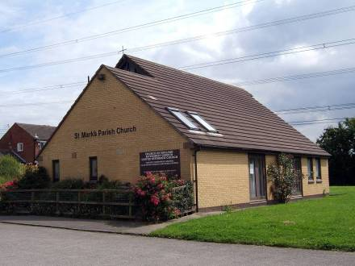

St. Mark’s Church stands in open ground next to Hill View School. It is one of three churches built in Runcorn New Town to the same design, although the interior of each is different. It has a kitchen, a vestry and a worship area which is adaptable for meetings and some community group use. The recent Quinquennial Inspection reported that ‘the structure in general appears sound, well maintained with minor repairs required.’

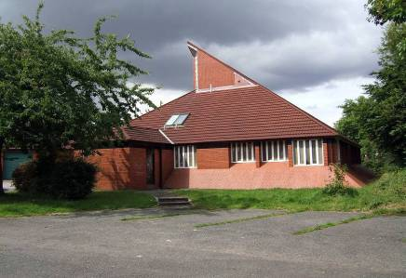

Bethesda Church is a multi-purpose building, with separate rooms downstairs, which can be opened up by sliding back partitions. The building is used by both church and community groups because of its versatile nature. Next to Bethesda is The Lapwing Centre – a hall originally intended for Youth Groups. It is now used as our base for a well-used Baby Clothes Exchange. The Bethesda site is situated next to the row of shops on Palacefields, which means that many people pass it each day.

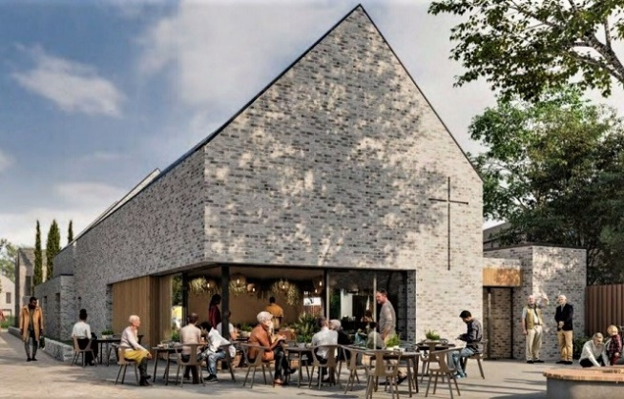

As part of a major regeneration scheme for the Palacefields area, plans are well advanced to demolish the existing Bethesda and Lapwing buildings, and build a new church on an adjacent site. This will require Bethesda relocating to temporary accommodation while building work takes place. We are committed to maintaining an active presence in Palacefields for the 13-18 months between moving out of the present buildings, and moving into the new church.

*Visualisation of the new church building*

**Vicarage**

The vicarage is an early 70’s brick built, double glazed, detached property with garage and a good sized garden. There are two floors, with large lounge, dining room, kitchen and utility room, study and toilet downstairs. On the second floor there are four bedrooms and a family bathroom.

**Church services and worship**

**Electoral roll and attendance**

The LEP is probably unique in the way it works together. The Parish worships utilising the services of the three denominations. It is one fellowship belonging to three parent denominations.

The total membership and number on the electoral roll at the last annual return was 65, a decrease of 2 from 2021. Members are confirmed and admitted into membership of all three denominations and even those who have transferred from one of the parent denominations do not necessarily have any strong denominational allegiance.

The average Sunday attendance across the parish reported on the 2022 annual return was 33 adults and 1 under 16. It should be noted that numbers attending worship have not returned to the pre-COVID level but pastoral contact is maintained with them.

There is no real focus for the community as a whole, particularly around St Mark’s Church in Beechwood and this makes contact with people rather difficult. Many people see their links and their communities as being elsewhere and because a large part of the Parish is UPA many of the services and facilities that people might look to the church to provide are provided instead by the local council and other agencies. There is also a sizeable Roman Catholic population, especially in Palacefields, which affects how people use and view the LEP.

**Church tradition**

The Parish as a whole could be described as ‘Open Evangelical’. The theology of the two Worship Centres is similar, although the ‘feel’ of them is different. The teaching of the Bible is taken seriously. There is an openness of some members to the Charismatic movement and healing ministry. We strongly believe in every person ministry, with lay people being involved in all areas of parish life. There is, generally, openness to learning different ways of doing things.

**Worship style**

The theological outlook of the Parish is reflected in its contemporary worship style. In Anglican terms it could be described as ‘Low’. Services tend to be relaxed, although generally structured. The congregation is drawn into the services, with lay people taking part in them in various ways. There is openness to a variety of forms of worship and a willingness to explore further ones.

Bethesda uses a small organ for traditional hymns and some older worship songs and recorded CDs and Worship Lyric Videos for more recent songs.

St. Mark’s has a small worship group (consisting of pianist, singer, and a recorder player) who lead the worship. They are happy to play both traditional hymns and a wide variety of worship songs and introduce new music to the congregation.

At Parish services the St Mark’s worship group usually leads worship.

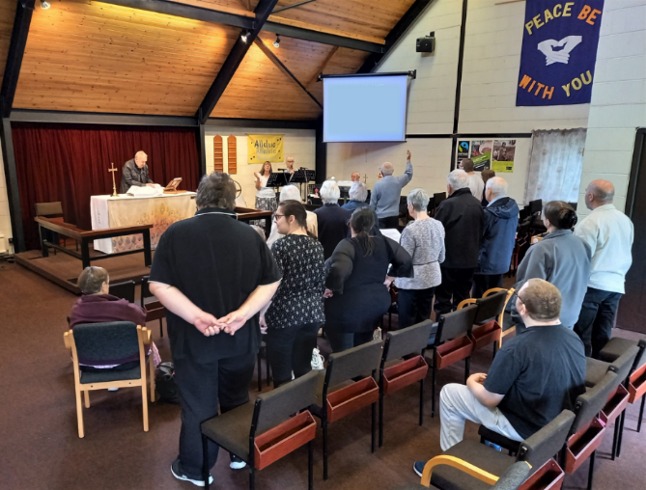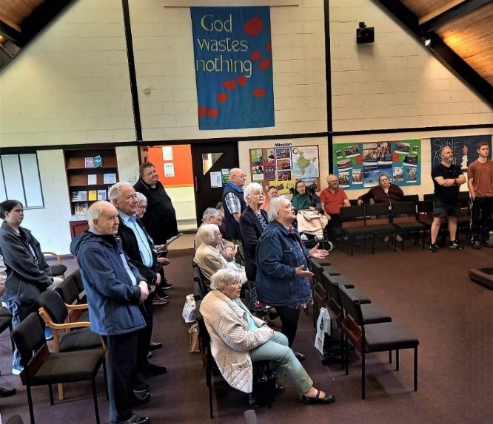

*Parish Holy Communion Service at St Mark’s*

**Strengths of the Congregations**

Apart from Sunday worship, nearly everything that happens is done as a whole Parish, rather than by the individual Worship Centres.

Both congregations have a small faithful core of members who are always there on Sundays, but an increasing pattern in recent years, and more evident following the COVID outbreak, has been that some do not attend worship every week.

**Bethesda** has a small congregation, with members who are loyal, faithful and welcoming.

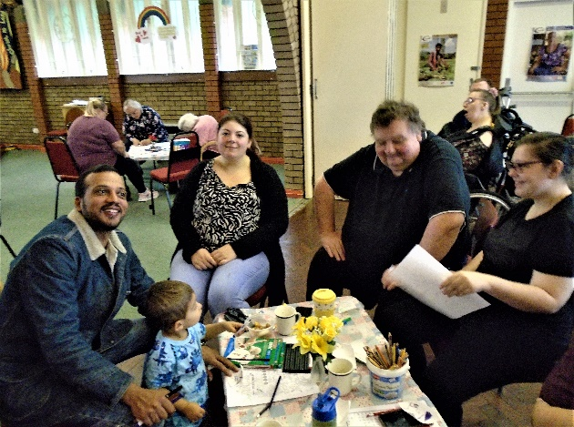

There has been some growth recently, partly due to the larger numbers attending Café Church which attracts other people, particularly families, who may not attend other services.

The church building is very versatile, which means that it is used for many of the parish activities, as well as being rented to community groups on occasion.

*Café Sunday*

Weekly activities include a Baby Clothes Exchange and Baby and Toddler Group on Tuesdays and a Warm Space / Coffee Morning followed by a simple lunch and discussion group or activity sessions on Wednesdays.

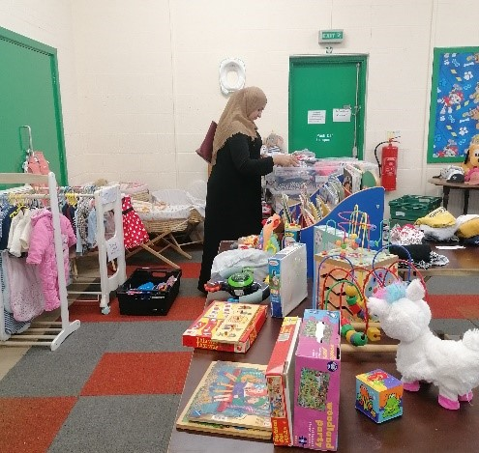 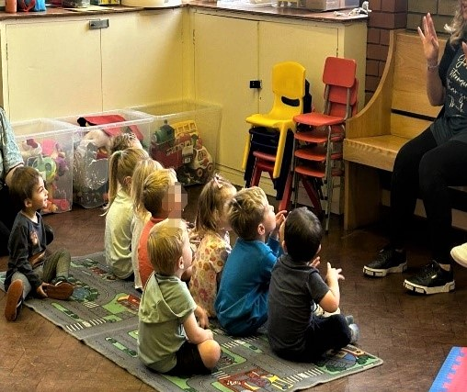

*Baby Clothes Exchange Baby and Toddler Group*

The parish acts as a Foodbank distribution centre on Saturday mornings at Bethesda with members from both congregations plus the local community providing the teams.

**St. Mark’s** is a small, welcoming, faithful congregation with an enthusiasm for singing and worship and welcoming newcomers. Numbers attending fell during the pandemic and some members, although keeping in contact, have not yet returned to church.

The church building is very small and therefore nowhere near as versatile as the Bethesda building making it less suitable for some activities.

**Sunday Service pattern**

**Joint Holy Communion Services – 10.30am**

On the first Sunday of each month our congregations meet together in one of our churches, usually alternating monthly.

## St. Mark’s Church - Sunday Worship

1st Sunday 10.30am Joint Holy Communion Service

2nd Sunday 10.30am Morning Worship or Holy Communion

3rd Sunday 10.30am Morning Worship or Holy Communion

4th Sunday 10.30am Holy Communion

## Bethesda Church - Sunday Worship

1st Sunday 10.30am Joint Holy Communion Service

2nd Sunday 10.00am Morning Worship or Holy Communion

3rd Sunday 10.00am Morning Worship or Holy Communion

4th Sunday 10.00am Café Church

Where there is a 5th Sunday in the month, services are held in both churches. One of these would normally be a communion service.

At the Joint service in January we always hold our Methodist Covenant Service. The congregations also worship together for Joint morning Holy Communion services on Easter Sunday at one of the churches, on Christmas Day at St.Mark’s and on the Sunday after Christmas at Bethesda. Occasional mid-week parish services are normally held during the year on Ash Wednesday and Maundy Thursday plus a Vigil on Good Friday. Over the Christmas period, Christingle services are held in both churches. A joint Carol Service is held on a Sunday evening in December.

**Prayer and Hymn books**

We use liturgy from ‘Common Worship’, ‘The Methodist Worship Book’ and ‘Worship from the United Reformed Church’ plus other sources e.g. Wild Goose Publications.

Ministers conduct services in the style of each denomination, so, for example, the Anglican Vicar may find him/herself presiding at a Methodist or URC Communion Service in either church.

St Mark’s and Bethesda both hold CCL licences and hymns and worship songs are taken from a wide range of sources.

A digital projector is used at both churches and large print paper copies of liturgy and hymns are available where required.

**Baptisms, confirmations, weddings and funerals**

**Baptisms and Thanksgivings**

|  |  |  |  |  |  |
| --- | --- | --- | --- | --- | --- |
|  | 2018 | 2019 | 2020 | 2021 | 2022 |
| Infant | 4 | 4 | 0 | 0 | 0 |
| Believers | 0 | 4 | 0 | 0 | 0 |

There is a Parish Baptism Policy. The Parish regards infant and believer’s baptism as equally valid. Infant baptism is always integral to the main Sunday Service after preparation for the family. Initial visits are usually carried out by lay members and the final visit by the officiating Minister. Baptism is never refused to those living in the parish and families are encouraged to come to Church. Families are always offered the choice between Thanksgiving, Dedication or Baptism but all families have asked for baptism in recent years.

**Confirmation and Admission to Membership**

Children over 8 years old (of church families) may be admitted to Communion before Confirmation at a joint service (often the annual Covenant Service) following appropriate preparation.

A Joint service of Confirmation and Admission to Membership is held for those over 16, after preparation, when the Bishop, URC Minister and if available the Methodist Superintendent / Methodist Minister jointly lay hands on the candidates.

**Weddings**

|  |  |  |  |  |  |
| --- | --- | --- | --- | --- | --- |
|  | 2018 | 2019 | 2020 | 2021 | 2022 |
| Church/adherent | 1 | 0 | 1 | 0 | 0 |
| Non-church | 0 | 0 | 0 | 0 | 0 |

Few weddings are held in the parish, and in recent years, these have all been Anglican. The churches tend not to be attractive to local people planning their wedding because they would prefer a church that has a more traditional appearance.

**Funerals**

|  |  |  |  |  |  |
| --- | --- | --- | --- | --- | --- |
|  | 2018 | 2019 | 2020 | 2021 | 2022 |
| Total | 4 | 5 | 8 | 0 | 4 |

There are fewer funerals than one might expect from a parish this size. Some funerals conducted by the ministers go directly to the Crematorium or Cemetery. One of our Anglican Readers also conducts funerals in other Anglican churches on occasion.

**Robing**

Parish clergy do not normally robe when leading worship but would usually do so for funerals and weddings.

**Finances**

**Giving**

The Parish depends almost entirely on the giving of its members for income. Giving is taken seriously, with an annual review. The majority of the giving is planned, and gift aided. The parish benefits from very generous regular donations from a small number of people, while others are able to make only small financial contributions, or no contribution at all.

During 2021 the General Fund showed a deficit of £4565but in 2022 there was a surplus of £6807, resulting from a number of donations for which we had not budgeted. Spending is tightly controlled but we have not been able to pay our full Parish Share for some years; the small annual payment to the URC has been paid in full. We have increased our Parish share for 2023, but not to the full amount requested.

At the end of 2022 the Parish had the following liquid assets available:

* £33,279 in bank accounts available for general purposes.
* £5190 in a restricted fund in a deposit account for expenses and improvements on St Mark’s building.

The ECC’s Policy is, where possible, to agree a balanced budget. During 2022, the parish benefitted from fixed contracts for our fuel bills. In 2023, we expect our heating costs to be significantly higher, but the Parish should be in a position to cope with the increases.

*[See Appendix 3 for extracts from 2022 accounts]*

**Capital and other projects**

There is no parish funded capital or other project on-going at the present time.

However, the local Riverside Housing Association plans for a major regeneration of the Palacefields area are progressing.We have been involved in the initial design of a new multi-purpose church building at Bethesda, and the community consultation around the total development. This is helping us to build new community relationships and to consider how the building could support a whole range of activities - engaging with the wider community.

At this stage we do not know what costs we might incur for internal fixtures and fittings: we will need to investigate grant funding, as well continuing to control our current expenditure, to meet these expenses.

**Support for the Church overseas, home missions and charities**

In 2022, we donated £1162 and a further £1000 was donated early in 2023, a payment which should have been made in 2022.

**Clergy expenses**

Clergy submit an expenses claim to the Parish Treasurer at the end of each month and are reimbursed by cheque from the General account.

**Outreach and mission**

**Approach to evangelism, outreach and welcome**

After meeting and prayer the Parish produced the following statement: -

**‘God’s purpose for us’**

We believe that God is calling us to be active and visible witnesses for the Gospel as his faithful people who are prepared to move forward.

This means that we should be:

* active and visible witnesses for the Gospel to all people by what we do and say by the way we live in our community.
* God’s faithful people, shown in our wholehearted commitment to him, in our worship and prayerfulness and in our lives together.
* prepared to move forward, listening to God and to other people. In this we need to be ready to take risks, to learn new things and continue to be groundbreaking ecumenically.

At present, this is being pursued in the following ways:-

**Mission and outreach**

* We aim to provide relevant and varied Sunday worship appropriate for ecumenical congregations in an urban parish with a high amount of social need.
* There is a ministry team that supports the vicar planning worship and other church activities.
* In one of our worship centres, once a month, we have Café Church which attracts people who do not normally attend worship. We hope to develop a nurture group to support new attendees who have little knowledge of faith issues.
* Following worship, we serve refreshments to create opportunities for fellowship.
* Once a month our two congregations worship together; this is sometimes followed by a shared meal.
* On Wednesdays, we hold a coffee morning. There are activities available and a simple lunch is provided, followed by an informal Everyday Faith discussion. In the cold weather, the coffee morning became a registered Warm Space and stayed open until 3 p.m.
* On Saturday morning, there is a Trussell Trust Foodbank distribution centre at one of our churches, staffed by church members and people from the local community. The parish is authorized to issue vouchers to enable people to access the Foodbank.
* Two of our members do chaplaincy work as part of The Sanctuary team in the local enclosed shopping centre.
* Two home groups meet each week, one ‘in person’ and the other via Zoom.
* Our Pastoral Team works to support those in need in the parish.
* Home Communion services are provided as needed.
* In the parish funeral ministry, the vicar is supported by one of our Readers.

**Work with children and young people**

* On Tuesdays, a baby and toddler group meets, and linked with this is a baby clothes exchange which is much valued, given the poverty in the area.
* In recent years, we have had very few requests for baptisms. When it is required, preparation of the families is usually carried out by a lay team before a visit by the minister, and follow-up work encourages the families to continue links with the church.
* Assemblies are taken in local primary school in the parish, none of which is a church school. Contribution to the religious education teaching in one of the schools has become regular.
* There is potential for work among young people in the community.
* One of our members is actively involved in the local Youth Justice Service.

**Other areas of mission, outreach and co-operation**

* Christingle services are held in both our churches, attracting people who might not come at other times.
* Under 5’s services for Easter, Harvest and Christingle are usually held in St Mark’s for Hill View Playgroup. Invitations for these have normally also been sent to baptism families.
* We have good links with the local Community Association.
* Harvest gifts from both churches and two of the local primary schools are given to the Runcorn and District Foodbank.
* Christmas hampers are provided for the needy.
* The church supports ACTS 435 to help the needy in the community.
* A parish group is working with the Riverside Housing Trust to support the development of the local area around Bethesda Church.

**DEVELOPING OUR CHURCH LIFE**

**Our vision for the future**

In the future, we hope to work with our vicar to:

* Make our worship centres even more friendly, welcoming centres of worship and community activity.
* Reach out to the community to increase attendance at both of our worship centres.
* Increase our provision of informal learning groups to help people deepen their faith and to relate it to everyday life
* Build on the progress we have already made in enabling people of all abilities and ages to engage in worship and church life to their full potential.
* Develop on-line ways of making worship and learning available during the week – something which was much valued during the pandemic lock-downs.
* Help our members to identify their gifts and to use them in God’s service.
* Help us to use social media to reach out to people in the area.
* Develop our contacts with local schools.
* Develop ways of attracting young people and families into the life of the church
* Increase the support we provide for local people, particularly in parts of the parish where there are high levels of social deprivation.
* Restart the provision of lunches which were valued when we were able to provide them.

Appendix 1

**Working Together in Runcorn**

The Anglican Church in Runcorn is at an exciting time in its journey. Runcorn currently has one of the lowest church attendance figures in England. But at the moment there is a significant number of current or imminent vacancies among parochial posts in the town. This provides a unique opportunity to imagine a different approach to ministry.

The approach we are following combines the pastoral strength of local ministry with the missional potential of cross-parish activity. In outline, parish clergy will continue to be licensed in the usual way to their parishes, and remain responsible for their own churches and congregations. But there will also be an expectation that they will use a proportion of their time (between half a day to a day per week on average) to help support all eight parishes in Runcorn in delivering a particular area of ministry. This expectation will be written into clergy job descriptions, and will require all clergy to be willing to work positively across the different traditions represented by the churches in Runcorn.

When applying for a role as an incumbent or priest-in-charge in the town, applicants will be invited to indicate the area of ministry in which they would be willing to offer this wider support to the Runcorn parishes. The current mix of skills we are looking for are (in no particular order):

1. Children and primary schools
2. Young people and secondary schools *(intended to be filled**by the incoming priest-in-charge of Norton, St. Berteline’s)*
3. Young adults (18 – 35)
4. New ways of being church *(already filled by incumbent of Grange, St. Andrew’s)*
5. Caring for older people
6. Engaging with local government bodies and other agencies
7. Working in deprived/marginalised communities

You may have other skills to bring, and we would welcome anything that enhances the mission and ministry of the churches across Runcorn. While some parishes may more naturally ‘fit’ with some skills, this is about facilitating ministry across the whole of Runcorn, so we are not linking particular parishes with particular skills. We are not averse to having several people with similar skills across Runcorn either, as long as people can work creatively together.

Being able to support the wider ministry to Runcorn is a requirement of the post. To help facilitate this, it is likely that a Bishop’s Mission Order will be created in the near future to which all clergy and licensed ministers will be licensed. This will provide a more formal structure to encourage the mission of the churches across the whole of Runcorn, and also give the diocese some mechanism for supporting the project.

The churches across Runcorn are looking forward to this next chapter in their life together with hope and enthusiasm, and we are confident that this collaborative approach will bear fruit as churches work together for the good of God’s mission across the town.

For more details about this, please contact John Hellewell, Mission Adviser, on [john.hellewell@chester.anglican.org](mailto:john.hellewell@chester.anglican.org) or phone 01928 718834 ext. 235, or Mike Gilbertson, Archdeacon, on [michael.gilbertson@chester.anglican.org](mailto:michael.gilbertson@chester.anglican.org) or phone 01928 718834 ext. 253

Appendix 2

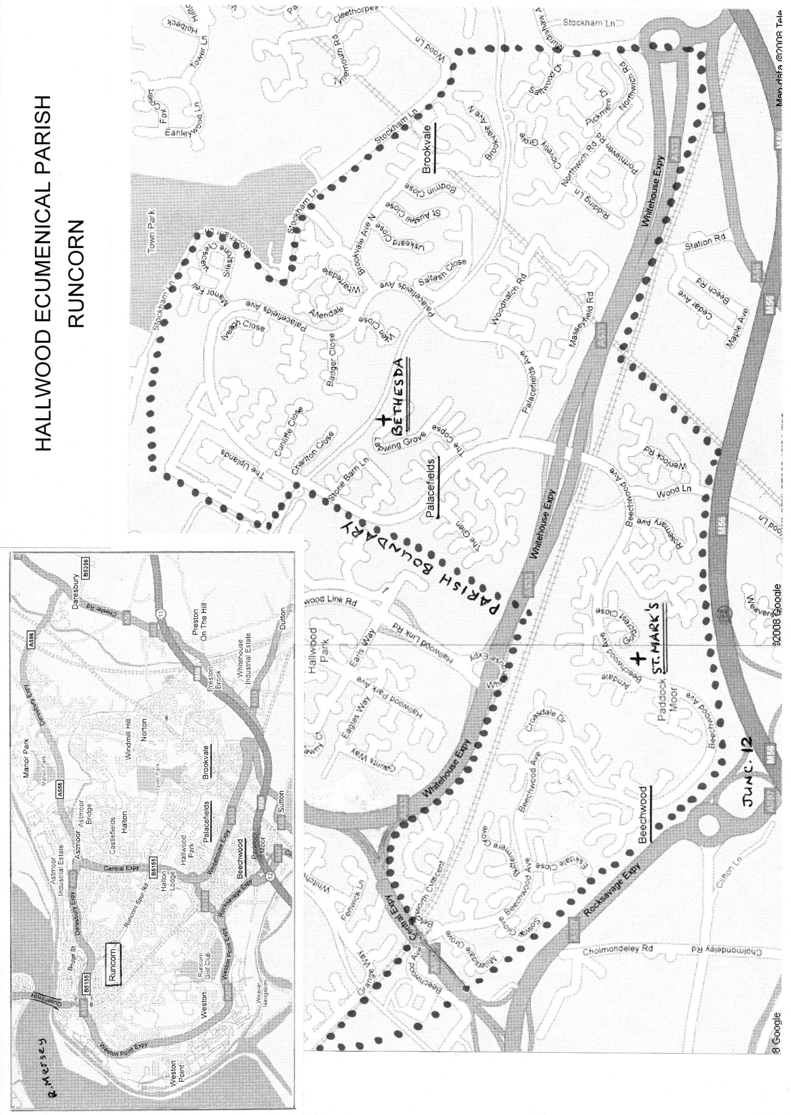Appendix 3

