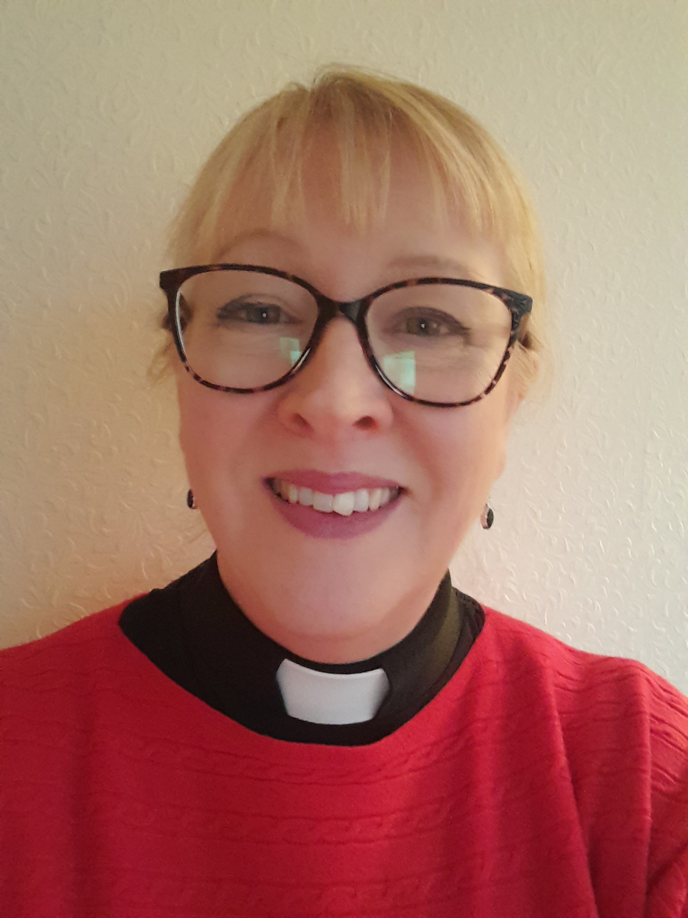 |  | Rev’d Jane Proudfoot  Candidate for election to General Synod
Profile  I have lived in Cheshire for the last 30 years and served my curacy in Stockton Heath. I have been the Rector of Grappenhall in South Warrington for the last 11 years and Rural Dean of Great Budworth Deanery since 2020.  In September I became an assistant Archdeacon for the Archdeaconry of Macclesfield, which has been a unique opportunity to widen my understanding of the workings of the Diocese and the senior team.  Prior to ordination I was a secondary school teacher and have sat on SACREs in both a lay and ordained capacity. I have degrees in Religion and Theology from Lancaster and Leeds Universities. I’m married to Danny and have with two grown-up daughters.  The Rectory, 17 Hill Top Road, Grappenhall, Warrington. WA4 2ED.  01925 261546  revdproudfoot@hotmail.co.uk  Proposed by  The Venerable Dr Michael Gilbertson  Archdeacon of Chester  michael.gilbertson@chester.anglican.org  SECONDED BY  Rev’d Canon Elaine Chegwin-Hall  petera.hall@care4all.net |  | Why am I standing?  I believe the good news of Jesus Christ is a message for all. For the church to flourish and grow there must be a genuine and fully inclusive spirit of welcome. Our integrity as the established church is challenged whenever we see marginalized groups within it excluded and ignored. I am also standing because only one of our six clergy places is filled by a woman, and I believe that there should be better representation of women in our Diocese.  I long for a confident and growing church that speaks to everyone, in language we can all understand, with a message of truth and love. I would engage with Synod by honouring the rich legacy and tradition of our church heritage while moving towards the future God calls us to. I look forward to a time when the church is no longer involved in internal dispute and can give its full energy to mission, climate change and global justice. I encourage you to give me your first preference vote in this election and to consider my colleague Jenny Bridgman as your second preference.  Experience  I am an experienced and effective church leader who has lived and worshipped in the diocese for 30 years. I am a member of Diocesan Synod, a training incumbent and a Deanery Vocations Advisor. I was a member of the Diocesan Advisory Group for Living in Love and Faith, and in 2019 chaired the triennial Chester Clergy Conference. I took a lead in involving our parish as a pilot for the Everyday Faith initiative from the Renewal and Reform Group. We were the pilot church for the Vision Café, the results of which are feeding into the strategic phase of the Diocesan Vision process. I taught on the Reader and Pastoral Workers Training courses and undertook research into funeral ministry which fed into the national Life Events initiative. I initiated and lead the ‘We are The Church’ mission to the Creamfields Festival, working ecumenically with churches throughout Cheshire and surrounding DiocesesI am the joint author of a resource pack entitled Wellbeing in the Parish: Helping PCCs THRIVE, part of the Church of England’s resources for wellbeing.  “Jane has served in this diocese for many years as a parish priest and rural dean, and more recently as interim assistant archdeacon. She is very effective, approachable, and highly respected by her colleagues and the community. She would bring energy and wisdom to General Synod, and I am delighted to commend her to you”.  Venerable Dr Michael Gilbertson  Rev’d Dr Mark Hart

Important matters for the Church:
Mission, leadership and discipleship
It has already been proved that growth in the church is the product of good leadership, both lay and ordained. As there is no ‘one size fits all’ solution to the decline in church numbers, the solutions are as broad as the church itself. A recognition of the power of the local, contextual ministry, and the value of place and belonging is essential. We need a new-found confidence in who we are and what we stand for.
The Church of England needs to modernize, rationalizing the structures at the center of our church and making sure that those structures give good value and work efficiently. As our Diocese looks next to the strategy that will grow from the visioning process, we need to have the humility to say that we’ve got it wrong and need to look to new ways to proclaim the Gospel afresh. The good discernment of who God is calling into this crisis is vitally important. I’d like to see greater collaboration at a Deanery level, high expectations, greater accountability, and better support for clergy. We must be simpler, bolder and humbler and be courageous enough to try new approaches, trusting God for the growth.
I believe that the church is able to adapt and change, reaching new people in new ways. The immense learning that has happened over the few years must be harnessed, valued, and built on as we go forward. Working with, empowering and enabling the laity is essential, not as substitute leaders but as true leaders and disciples with amazing God-given gifts and talents. Growing Faith, Everyday Faith and other initiatives deepen discipleship, enabling evangelism, grow confidence and equip us all to live out our faith, so that the whole of our lives give glory to God.
Clergy Wellbeing
The ongoing work on the reform of CDM is imperative if clergy are to be properly supported, valued, and treated professionally. The pandemic and its aftereffects have highlighted the extreme pressure the clergy are under. The wellbeing of church leaders is of paramount importance if we are to see growth, as are the moves to restore the value of clergy pensions.

Eco Church
We need to see the Church speaking into the climate crisis with the perspective of faith at a national level. Our credibility and relevance are at stake if we fail to convey a clear message supported by decisive action. Management of our carbon footprint and a concerted effort by every Diocese towards net zero carbon is a priority. As stewards of creation, embracing the 5th mark of mission, we must do all that we can to protect God’s amazing gift to us.

Inclusion
I am committed to equality for everyone, at all levels and roles within the church, regardless of gender, disability, age, ethnicity, socio-economic status, mental health or sexuality. I welcome the Prayers of Love and Faith and look forward to the outcome of the discussions around pastoral guidance. It is essential that all in the church, whatever their stance on this subject, know that they are loved and valued. I believe that we will be a healthier church when we all learn to live with disagreement gracefully. To this end I commit to work with others who hold views different from my own. I believe in, and am the product of, a broad church which lives within the creative tension that comes from valuing unity but not uniformity. I long for a church which is a braver, safer and more honest place for all people to find welcome and identity in Christ as we learn to live with each other.

“I have had the privilege of knowing Jane from her training days as an ordinand and have watched her grow into a confident, competent and dynamic leader. She is keen to listen, to explore and to consider the opinions of others and to find different ways of approaching subjects and situations which she may not have encountered before. She is open, honest and approaches life with an open heart and mind and engages with people from all ages and backgrounds and makes them feel respected, cared for and loved. She has much to offer the General Synod at this time”.
Rev’d Canon Elaine Chegwin Hall

If you would like further information before reaching a decision on where to place me in the vote, please contact me on 01925 261546 or email me at revdproudfoot@hotmail.co.uk

