HOLY TRINITY CHURCH, CAPENHURST

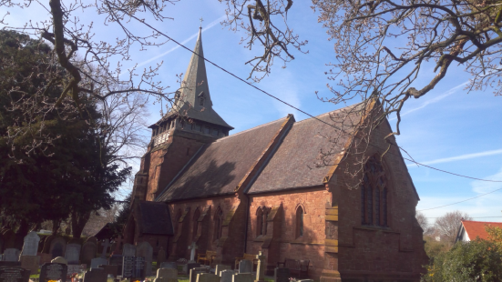

Church and Community,
Growing Together in Faith and Love


We are seeking a priest-in-charge for the benefice of Backford and Capenhurst. This is a part-time post, carrying a 15% stipend and house, in return for ministry on Sundays plus two days per week. Please see also the related parish profile for Backford, which is uploaded alongside this profile.

We are seeking a minister who:
- is willing and able to reach out and widen our links with the community
- will build on our existing strong connection with Capenhurst CofE Primary School
- Be an active School Governor
- Lead services as scheduled in the school
- will show strong pastoral skills in helping people through changes, challenges, grief and conflict
- will encourage the congregation to live out their faith in daily life – Monday to Saturday and not just on Sunday
- will encourage good safeguarding practice and culture, to ensure the church is a safe space for everyone
- will be a team leader who listens, engages, and encourages the congregations of the joint benefice of Holy Trinity, Capenhurst and St Oswald’s, Backford, to thrive and grow ever closer.

OUR IDEAL CANDIDATE

 |  |  | ENCOURAGES US TO
 |  |  | WORSHIP & BE
 |  |  | WITNESSES FOR JESUS
ENGAGES WITH PEOPLE OF ALL AGES &  ENCOURAGES THEIR PARTICIPATION IN  WORSHIP |  |  | ENGAGES |  |  | MAKES REGULAR VISITS TO
 |  |  | IN PASTORAL CARE |  |  | CAPENHURST CE PRIMARY SCHOOL
 |  |  | SUPPORTS US ON OUR
 |  |  | SPIRITUAL JOURNEY
 |  |  | EMPOWERS US TO USE OUR
 |  |  | TALENTS TO PLAY AN ACTIVE
 |  |  | ROLE IN WORSHIP &
 |  |  | PASTORAL CARE
 |  |  | ENGAGES WITH FAMILIES &
 |  |  | ENCOURAGES THEIR
 |  |  | PARTICIPATION IN WORSHIP
The PCC is supportive of the ministry of women at all levels in the Church.

CHESTER DIOCESE
Parish of HOLY TRINITY, CAPENHURST

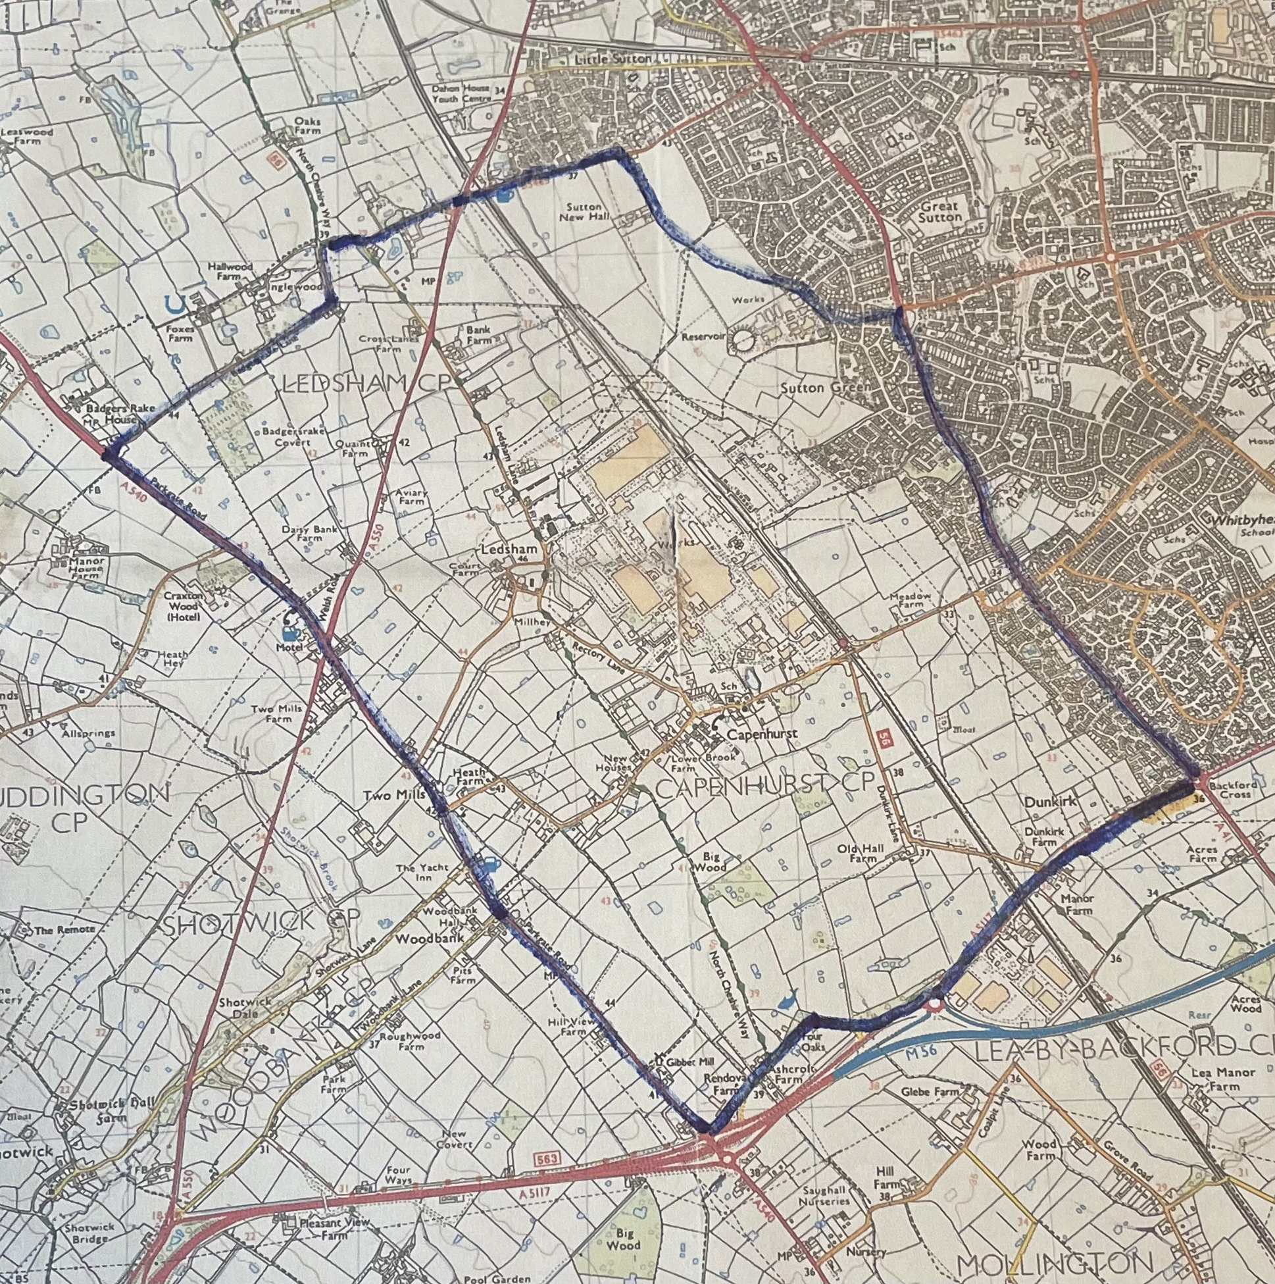

Overview

Church: Holy Trinity
Parish: Capenhurst
Deanery: Wirral South
Diocese: Chester

Number of CofE churches in the parish: 1
Churchwarden: Roy Duncan
PCC: 4 members

Electoral Roll: 26

Mission in the heart of our community

Introduction to the Parish
Holy Trinity Church is situated in the village of Capenhurst. The village is approximately four miles from the historic city of Chester. Ledsham Village is the adjoining village when going towards the Wirral. Capenhurst has a mixture of farmland and industrial areas. Capenhurst Technology Park, which is owned by Urenco UK Limited, is situated in the village. The parish has a population of approximately 3,300 which is rising. There are two new private house developments in the parish. The nearest shopping areas are in Chester and Ellesmere Port.
Capenhurst has good transport links and has a busy train station. Motorway networks are within easy reach as are both Manchester and Liverpool airports. Cheshire Oaks Outlet Village, the Blue Planet Aquarium and Chester Zoo attract many visitors. North Wales offers good walking and many opportunities for outdoor pursuits.
We value, very highly, our links with Capenhurst CofE Primary School, which is opposite the Church. There is an act of worship in church once a week and school services and events are held there several times a year, to which members of the wider community are invited.
Capenhurst Pre-school is in the Capenhurst & Ledsham Village Hall next to the Primary School.
The Old Rectory Nursing Home is a specialist dementia care nursing home based in the village close to the church.
We have strong links, and a very good relationship, with St Oswald’s Church, Backford.

Pattern of worship

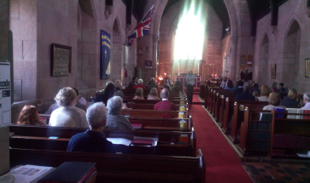

11.15am Main Morning Worship
1st Sunday: Parish Communion
2nd Sunday: Parish Communion
3rd Sunday: Parish Communion
4th Sunday: Parish Communion
5th Sunday – shared Communion (alternate, Capenhurst, St Oswald’s)
Last year there were 4 baptisms, no weddings, 2 funerals and 3 memorial services following cremation. There are committed teams of flower arrangers, and after-service refreshment providers.
There are 26 people on our Electoral Roll, approximately half living outside the parish. An average Sunday sees about 12 Worshippers with Family services and School services boosting attendance. There is a PA/loop system in the Church and a small team of organists support us. An Audio Visual system, kindly provided by Urenco UK Limited, has recently been installed in the Church and is used when an organist is not available.
Bell Ringers There are two bellringers ringing before the main Sunday service, and for weddings and funerals by arrangement, and for special occasions by request.

PCC
We have a small but dedicated PCC who are passionate about our Church and it’s future.

Short History of Holy Trinity, Capenhurst

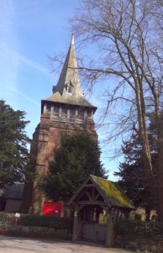

In 1790 Richard Richardson purchased the estate of Capenhurst (extending to more than 1200 acres), and two years later built Capenhurst Hall.

Holy Trinity was built between the years of 1857 and 1858, the land was donated by the Squire, Richard Richardson who also paid for the church to be built.

The sandstone for the church coming from the quarry in the village of Ledsham.
Prior to the building of Holy Trinity, the parishioners of Capenhurst were served by the church in Shotwick village and the parishioners of Ledsham were served by the church in Neston.

In 1868 the area of Capenhurst and Ledsham , served by the new church was designated a parish in its own right.

Holy Trinity was designed with a seating capacity of 120 and was more than adequate for the needs of the local population, which at the time was around 225.

In 1889 plans were drawn for a bell tower to be add-ed and permission was granted by the faculty.

Over 40 men from Capenhurst and Ledsham who served in the First World War were killed or died of wounds. There is a memorial to these men carved into the sandstone wall inside the church.

The Vicarage

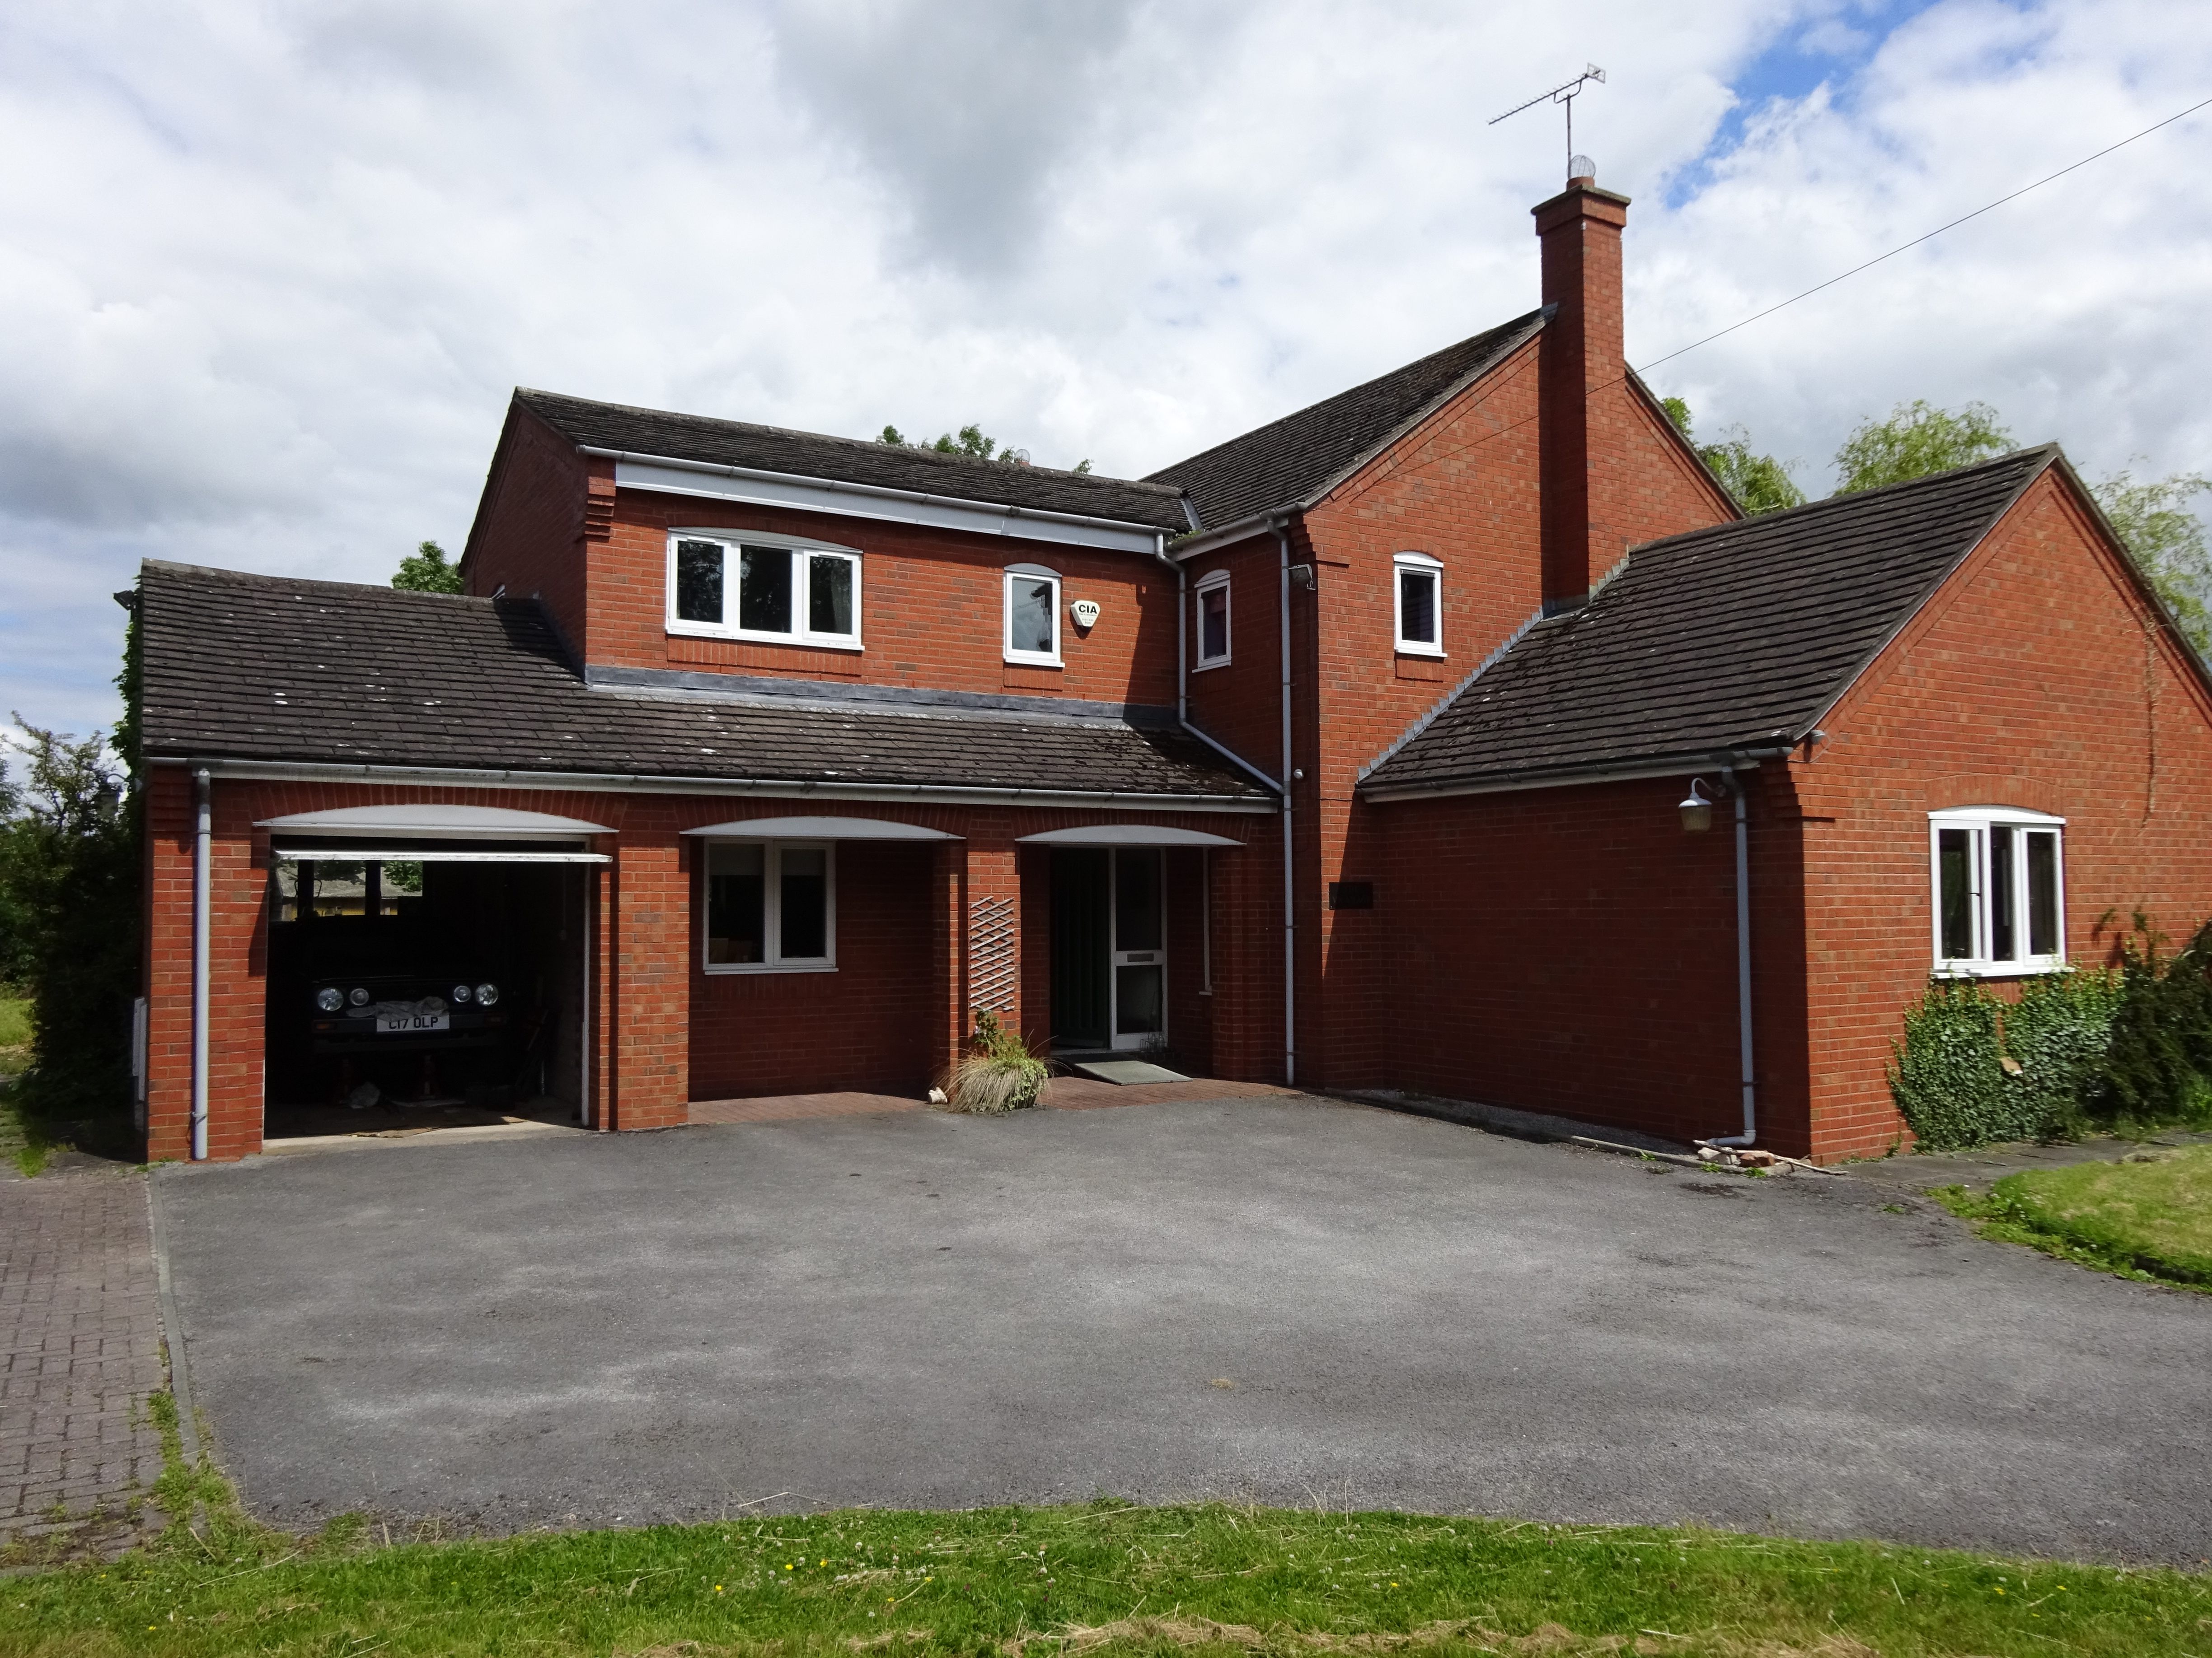

The vicarage is a spacious, five-bedroomed, 1980s-built house at Mollington in Backford Parish.

Capenhurst CofE Primary School

We have strong links with Capenhurst CofE Primary School, which is opposite the Church. There is an act of worship in church most weeks, during term time, and school services and events are held there several times a year, to which members of the wider community are invited.

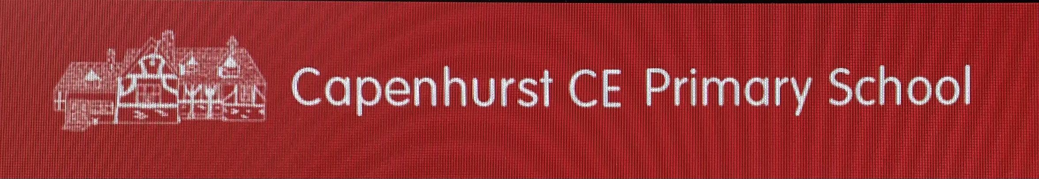

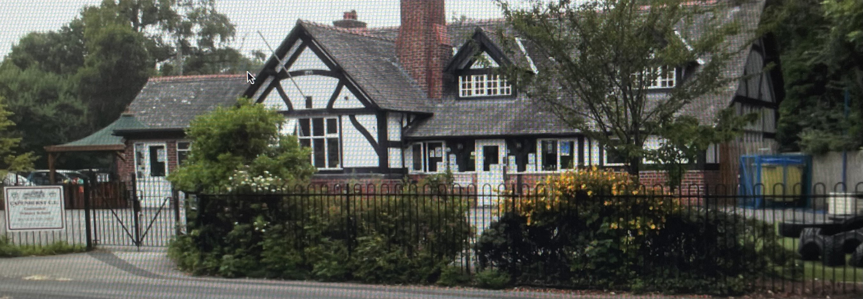

The current Headteacher, Mrs Claire Green, has been Headteacher since 2012.
We encourage all our children to be curious, resilient and compassionate and have developed a curriculum through which these three key character traits are threaded.

The school is currently graded ‘GOOD’ by OFSTED (February 2022) and was graded ‘OUTSTANDING’ at the last SIAMS inspection in 2016.
Our Christian Vision:

We are a nurturing, inclusive, learning community, that celebrates all possibilities, through a journey of curiosity, compassion and resilience, nourishing each other spiritually, emotionally, intellectually and physically with God as companion.

We use the following Christian values – thankfulness, celebration, faith, forgiveness, community service, respect, awe and wonder, compassion, joy, hope, friendship, peace and love – to form the basis of our worship and RE teaching. Focussing on one value each half term enables everyone at school to deepen their own understanding of their own faith and beliefs. We welcome people of all faiths, those without a faith and those exploring their own idea of what faith means to them.

Claire says:

“Our relationship with Holy Trinity is long-standing. We enjoy being close enough to visit church almost weekly and share worship together there as a school community. Over the years, we have been invited to lead community worship and the previous incumbents have been close friends of school, visiting and supporting school spiritually and pastorally.

Personally I have been the headteacher for 11 years. It is a privilege to be the head of Capenhurst and serve the school and wider community. I am proud of the school community we have built in school and amongst its wider family.”

Summary

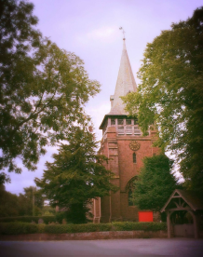

Holy Trinity Church is the spiritual heart of the Capenhurst and Ledsham community. We are committed to growing our church family through effective outreach.
I trust in you, Lord; I say, ‘You are my God’. – Psalm 31 v14

