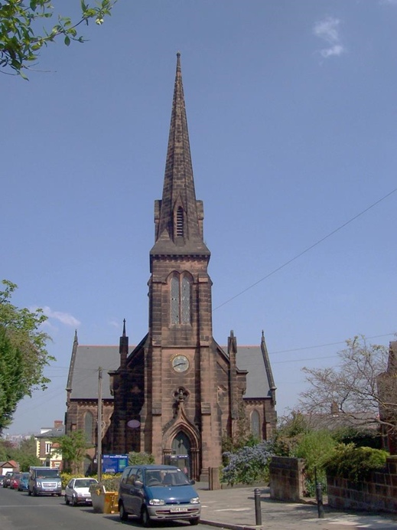
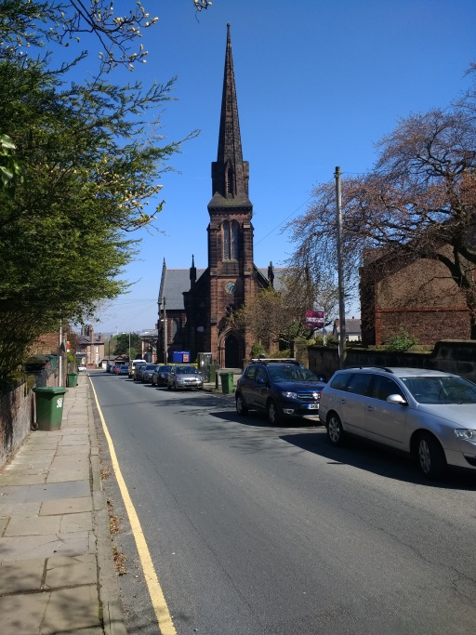

Introduction
We are delighted that you have asked for a copy of this profile of Christ Church, Birkenhead and we thank you for considering this opportunity to serve God with us.
We are a church committed to ‘Worshipping God, sharing Jesus, and serving the community’.
We have written this profile to give you an overview of who we are, what we do, and why we do it. God has blessed us so much through the few past years and in so many ways. We have had the joy of seeing people come to know Christ, and we enjoy fellowship together as we read God's Word and rejoice in it.
We prayerfully trust in the Lord to guide us and give us wisdom and discernment of His purpose for our church. Our prayer would be that this document would be helpful for you, as you discern God’s plan for your future ministry.

Yours in Christ
PCC of Christ Church, Birkenhead
November 2023

Vision Statement
Our vision is to see an effective Church, one that puts Christ first, focuses on its purpose, makes wise choices and does things well.

The Church
We see the church in the following words:
- Being a welcoming church family offering mutual friendship and support. A family that is committed to each other and to the entire parish. We are rooted in the love of the Lord and the teaching of the Bible

- Taking part in Sunday services we are reverential, prayerful, and worshipful, following the traditions of the Church of England.

- Offering a Christian-based outreach to children, families and the elderly; for example, through our Tots Spot, “ Sacred Grounds” Coffee Mornings and “Krafty Krew”

- Having concern for mission: for the needs of the less well-off and disadvantaged in our town, our country and overseas, and making contributions as we are able.

- Engaging with and organising community activities such as Oxton Secret Gardens, Heritage Days. Needing to review the whole operation of the church and the individual activities within it, to create a common unified focus on its mission

- Being aware of the need to improve our finances. Over recent years, the parish has had difficulty in meeting its parish share. However, recent legacies mean that the parish is now able to meet its share in full for the next few years, and is committed to doing so.

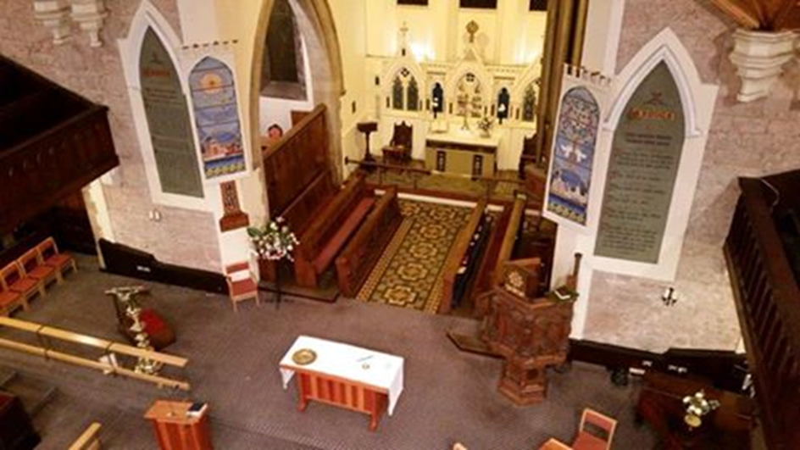

- LOCATION
- THE PARISH
- THE CHURCH
- OUR WORSHIP
- COMMUNITY ROOMS
- OUR SCHOOL
- THE VICARAGE
- OUR FINANCES
- OUR PRIEST
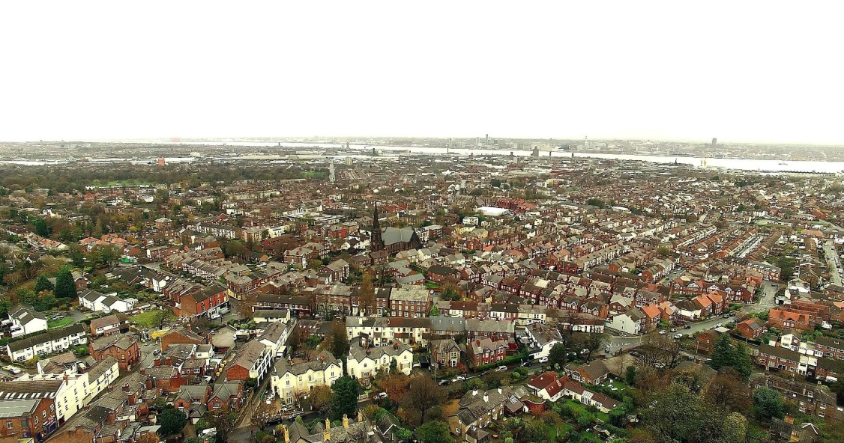

Location

Historically in Cheshire but now in Merseyside, Birkenhead is on the Wirral Peninsula, on the west bank of the River Mersey, opposite the city of Liverpool. Two road tunnels, a railway and a ferry provide excellent connections with Liverpool. Birkenhead itself is mixed: the medieval Priory, a shopping precinct, the oldest municipal park in the world, and areas of redeveloped dockland. The Wirral boasts two art galleries, the Lady Lever at Port Sunlight and the Williamson just a stone’s throw from the church. We are fortunate to be within easy reach of beautiful countryside, Country Parks at Thurstaston and Eastham, the seaside, New Brighton and West Kirby, and of course the hills of North Wales.

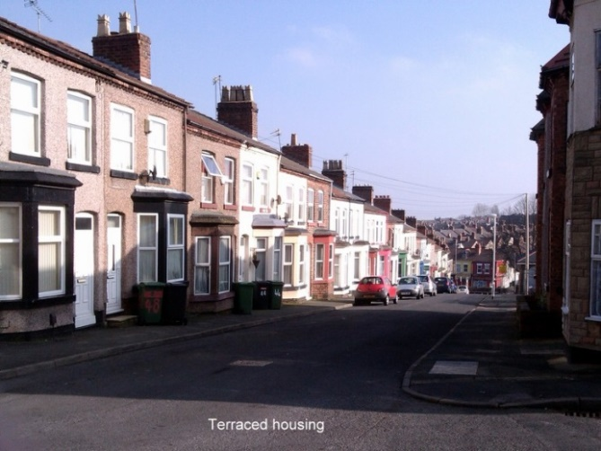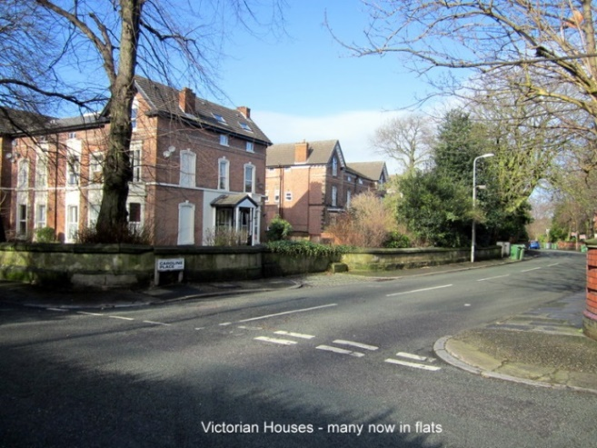

The Parish

Christ Church itself is located on the edge of the urban village of Oxton where there are pockets of affluence, and Birkenhead itself which has significant areas of deprivation. The CUF website concludes that the parish “is among the most deprived in the country”. Birkenhead is ranked 51 out of 12,382 in terms of overall deprivation, 1 being most deprived. The nearby village has a number of restaurants, shops and two pubs and is situated in a conservation area. The community hosts ‘ The Secret Gardens of Oxton’ every year and funds raised go towards helping local charities. The church is involved with this by providing refreshments and hosting two short organ recitals on our famous Willis organ. The parish has a number of mixed properties including large Victorian houses, smaller cottage type and modern houses of which 50% are owner occupied, 11% are local authority housing or Housing Association and 39% privately rented. A lot of the larger properties have been converted into flats and bedsits and there is also a large number of local housing association properties. There is high unemployment in the area, which can carry its own issues regarding alcohol and drug problems among its inhabitants. Due to changes in the benefit system there are agencies which assist those that struggle day to day living. There are a number of schools in the Parish, Christ Church C of E Primary [VA] , Woodchurch Primary, St Anselms and Birkenhead Independent Day School. There is a Health Centre and Art Gallery and Museum in the Parish and within a short walking distance from the Church a Lidl Supermarket, and Tesco Express.
Within the parish boundary there is the Wirral Christian Centre, a Friends Meeting House and a Carmelite Monastery; and just outside the boundary is the Wirral Deen Centre [Muslim] and the Buddhist Centre. The Parish consists of mainly 93% white Ethnicity, with 7% of global majority heritage.

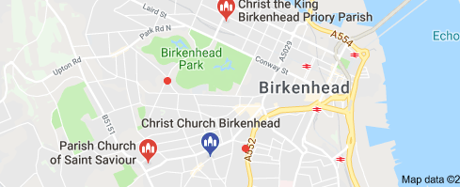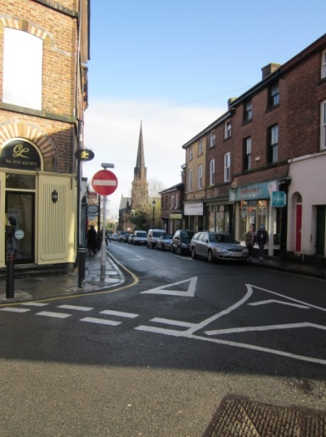

The Church

Christ Church has been used continually for worship since 1849. Originally built 'on spec' it was taken over some five years later by the Church of England and dedicated to 'the preaching of Evangelical and Protestant Truth in perpetuity.' The original 1209 sittings have now been reduced in number, and indeed our galleries are little used today. In the 1880s, the east end was extended and the historic Willis organ moved from the west gallery to its present position in the chancel. Beneath the church was a schoolroom that had accommodation for 760 children. It now forms our community rooms. The church was given a new roof in 1992 and had its imposing spire rebuilt after storm damage on Christmas Eve 1997.
Recently the high level stonework on the church tower underwent some repair and our clock was refurbished. Work to a number of windows in the church and the vicars vestry has also been carried out..
Many eminent people have worshipped here at Christ Church, including Rev. R.P. Blakeney, founder of the ‘Church Association’, Cyril Scott [Composer] and Wilfred Owen, the War Poet. The longest serving Vicar was Rev. W.H.F. Robson who served here for 36 years and made many changes to the interior of the building. An orphanage and church school were started during his incumbency.
Our present Ministry Team comprises of an Associate Minister, a Reader, and Pastoral Worker [Emeritus]. Many of our congregation live outside the Parish and are mostly mature females.

Last year the church hosted three choral concerts and is already booked for four performances this year.
A number of people have also booked the church for filming. One a local singer as a backdrop to her latest song and the other a University student studying at Liverpool.

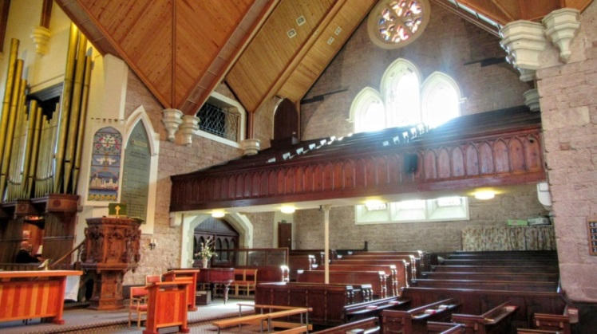

Our worship

9am. A traditional said Holy Communion service based on the Book of Common Prayer. [Twice a month]

10.30am. A monthly sequence of Holy Communion, and Morning Prayer using Common Worship. This is our main service in which we seek to balance the loveliness of the Church of England liturgy with innovation that is attractive to all. The readings and intercessions are taken by members of the congregation. We sing hymns to the accompaniment of our fine Willis organ.

We follow the Liturgical Calendar; and also have services for Christingle, the Crib, All Souls Remembrance and other occasions. Christ Church Primary School attends for various services including end of term and leavers services, and outside organisations have used the church for other services eg: Scouts services etc.

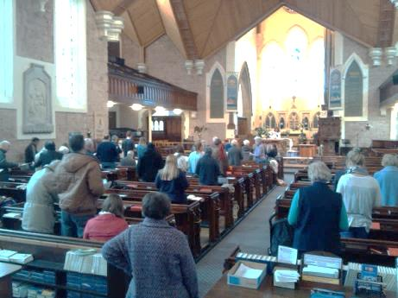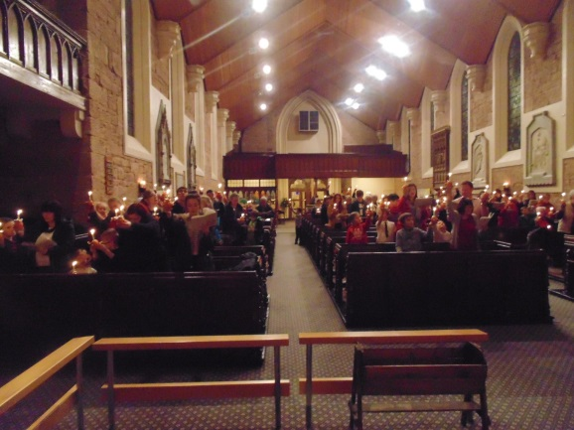

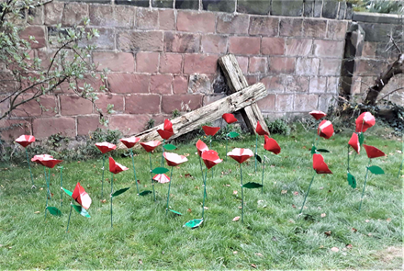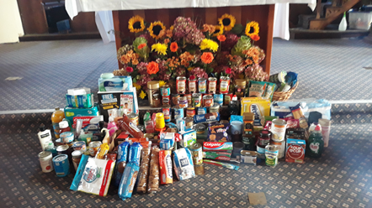

The Community Rooms

The former schoolroom beneath the church has been divided up into three community rooms. The school room has been used as a Sunday school room but now houses equipment for a Mums and Toddlers group. The spacious main hall accommodates 70 for lunch, and St Michael’s Room provides an excellently-lit space with access to a pleasant south facing garden The former Lower Vestry is now the Wilfred Owen Room which seats around twenty-five;

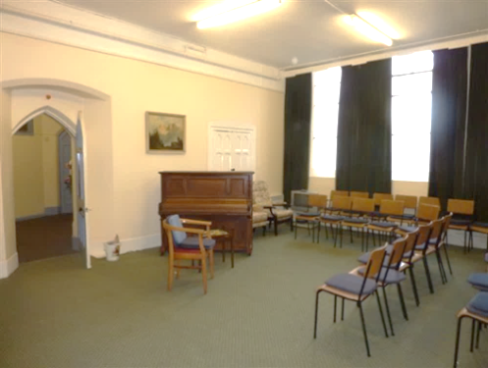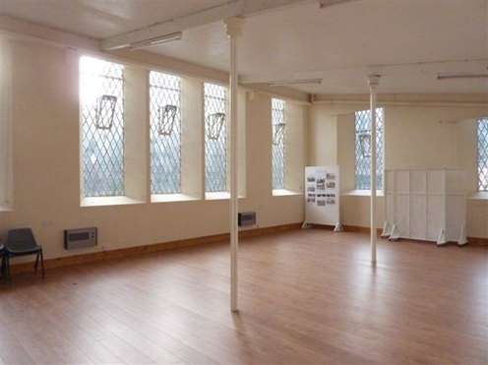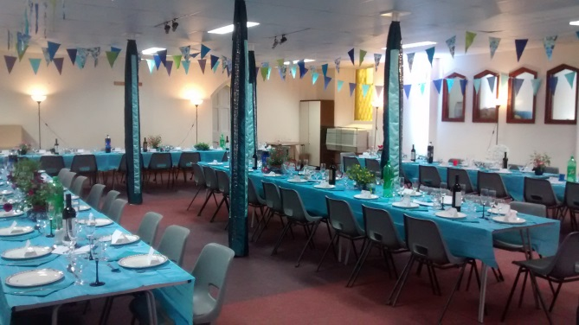

These community rooms provide accommodation for “Krafty Krew”, and “Sacred Grounds” coffee mornings, Afternoon teas and other fundraising events. Recently the rooms were used to provide English lessons for Ukrainian Refugees. Tots Spot meets on Wednesday and Thursday mornings during term time.

The Church uses the rooms for social occasions such as Christmas meals, Harvest suppers, Bring and Share events and the annual Agape meal. The rooms are rented out regularly to such groups as the Woodcraft Folk, Art classes, Pilates, and “Over the Water” Community Choir.
Our fully equipped kitchen enables us to host wedding receptions, baptism parties and funeral receptions. The rooms are also used yearly as a Polling Station.
The Church Office is also based downstairs and is staffed by the administrator for two days a week

There is a small car park outside and on street parking nearby.

There is a grassed area to the south side suitable for barbecues, picnics etc.

Our School

Christ Church Primary School [VA] currently has about 200 pupils and has done well in its inspections. The school has six foundation governors on its Governing body—including the vicar. Links with the church are lively and exist through assemblies, individual class visits to church and whole-school services in church.
“Our commitment to the whole child is reflected in our vision, values and aims. We believe our children have the right to a fulfilled and happy life. We want to provide every opportunity through a curriculum that offers opportunities for growth; spiritually, morally, socially, emotionally and academically, so our children experience life in all its fullness.”
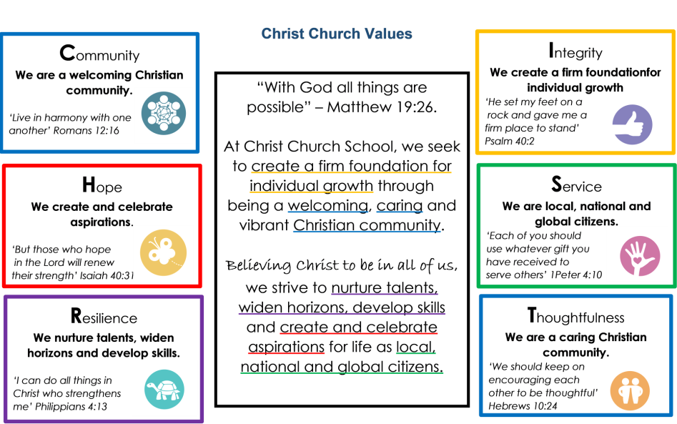

The vicar is also a trustee of the Christ Church Children's Fund which makes grants to disadvantaged families with young children for basic items such as beds and white goods. It meets quarterly at the school.

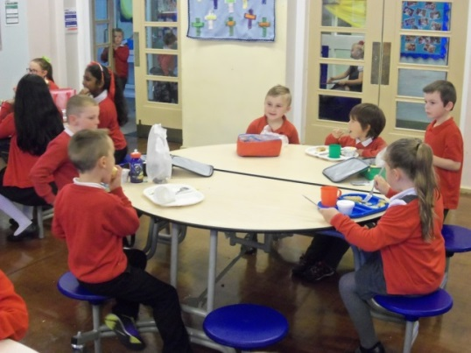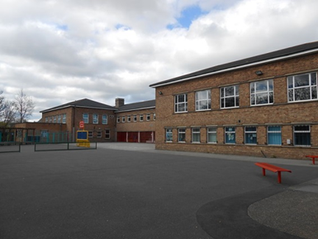

The Vicarage

The vicarage is at 7 Palm Grove, some ten minutes’ walk from the church. There are four bedrooms, a study and two reception rooms. The garden is of a good size and there is off-road parking for two cars. It is in good order. New double glazed windows were installed a few years ago, a new kitchen and shower room were installed approx. four years ago.
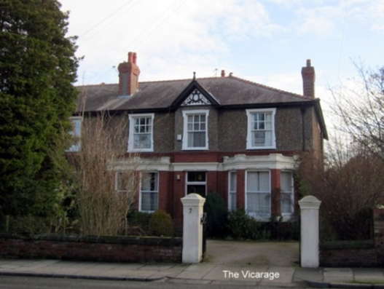

Our Finances

The financial accounts provide details of our current position.

Person Specification: We are seeking a priest with the following qualities:

Leadership | - Able to offer an example of faith and discipleship which is inspiring to others and witnesses to the servanthood of Christ.  - Have the capacity to discern, along with others, the needs of the parish within the wider context of mission  - Able to encourage the congregation in living out their faith in everyday life, Monday to Saturday and not just on a Sunday
Working collaboratively | - Able to motivate collaborative working towards achieving mission  - Able to manage change and show an ability to conciliate difficult relationships.
Communications | - Be able to communicate effectively in a range of settings : interpersonally, written word, social media.  - Able to be decisive yet delegate to / engage others in the leadership of the church
Parish management and organisation | - Able to analyze current position and identify necessary changes to move the church forward in mission.  - Have good time-management and self-organisation skills and a possible understanding of financial issues and procedures  - Able to encourage a good safeguarding culture in the parish
Outreach | - Able to show commitment in outreach in a deprived inner city parish  - Committed to working with other presences in the parish such as the school, community groups
Worship | - Able to lead formal liturgical worship such as BCP and Common Worship yet open to initiating creative fresh expressions  - Commitment to the ministry of the whole people of God
Preaching and Teaching | - Committed to biblically based preaching and teaching  - Confident in formal settings yet open to develop informal approaches to preaching
Pastoral Care | - A strong pastoral instinct who will be active in the church and the local community
Spirituality/ Personal Development | - Committed to developing their own spiritual discipline, which involves individual and corporate prayer and worship.  - Recognise their own development needs and able to strike a balance between rest and work

Looking Forward

Key development areas are:

- To identify how the church can be effective in its mission.
- To maintain and strengthen the love within the church
- To engage further with the community and school
- To encourage children and families in the community
- To share Bible study and discipleship
- To follow up Baptism families

