**St Oswald’s Church, Bidston**

**A Parish Profile**

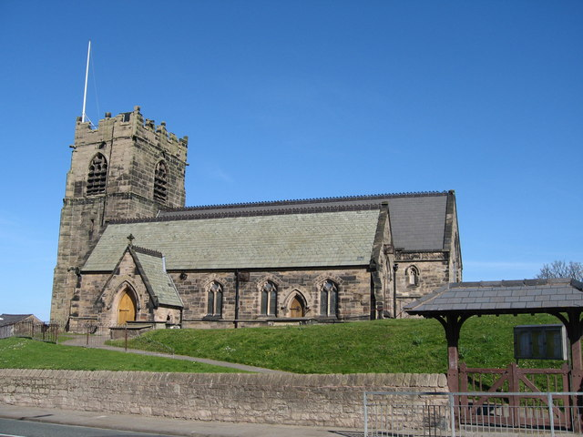

**About us**

We are a welcoming, friendly church, with committed Christians of all ages. We recognise that faith is not always at the forefront of people’s lives, yet we find ourselves growing slightly over the past few years. We are committed to our relationships with all who live in the parish and are eager to continue to build upon these. The parish is made up of both leafy and deprived areas and the church serves Bidston Village, (including Eleanor road and Statham Road, Beechwood estate and the north of Birkenhead). Beechwood is a housing estate situated between Bidston and Noctorum, to the west of Birkenhead on the Wirral Peninsula in England. The estate was built in the 1960s as the Ford Estate and completed in the mid to late 1970s, to house people moving from the North End of Birkenhead and providing a better standard of living. The estate is now separated into three sections, these being Upper Bidston Village, Beechwood and Greenfields. In recent years the estate has seen significant redevelopment of the former wooded area at 6th Avenue with the construction of new affordable homes by private investors. The parish is sitting in one of the most deprived and disadvantaged areas in the UK.  (Bidston & St. James is the 7th most deprived ward in the country). We have excellent links with the community and the church school.

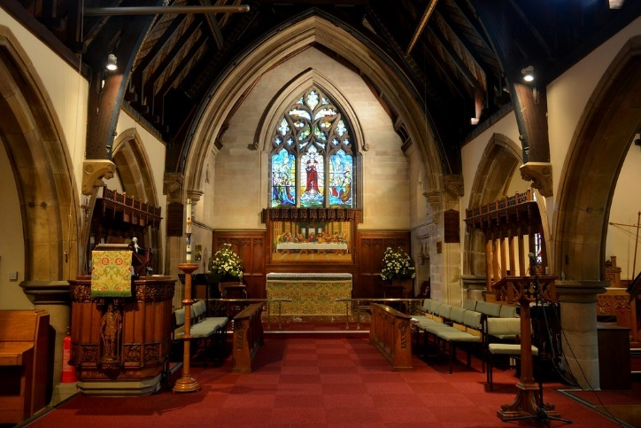Within the parish there is much to build on.

We pray:

* To be a constant beacon of light for our communities
* To be welcoming and see our church filled with people of all ages
* To live out God’s plan
* To be led and renewed by the Holy Spirit
* For the person for whom God leads to us.

**We are looking for:**

***Someone who loves God, loves people and who is:***

* 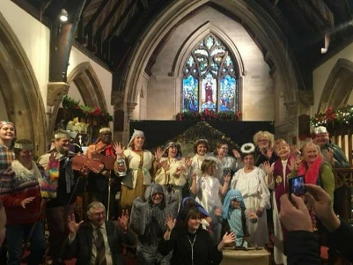Secure in their faith with a clear vision for our parish
* Passionate about sharing their love of Christ within a deprived area
* Approachable, friendly, pastorally sensitive, and able to relate to all sorts of people
* Able to preach with clarity and relevance for today
* Sensitive to existing traditions of worship and able to embrace diversity whilst leading change
* Keen to continue to build upon community spirit and links with other churches
* Encouraging in the use of gifts in all aspects of ministry
* Energetic, dynamic and a good sense of humour

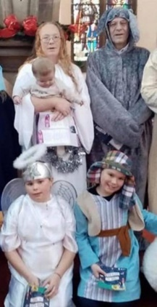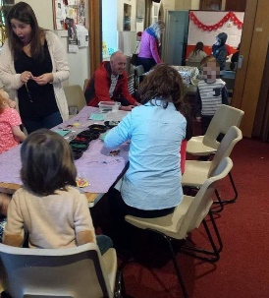Our Children and Young People need:

* Someone who will look after and care for us
* Someone who will grow our faith
* Someone who is lively and fun
* Someone who will listen to our points of view
* Someone who has a good sense of humour
* A warm welcome at all times
* Joy in our fellowship and worship
* A commitment to change and a willingness to try new things
* An eagerness to serve through different styles of service, to suit our community
* Strong relationships and growing links within our parish community
* Two church wardens, a dedicated PCC with a number of specific roles assigned, two experienced, committed Readers and a number of volunteers with many talents
* A dedicated Foundation Governor, who works within our church school, a Head Teacher who is committed to promoting a Christian Ethos within the school and to supporting Church. A relationship with the school that is committed to working together to continue to build upon the strong relationships already in place.
* Energy and enthusiasm through our school children and young people
* Recognition that a vicar balances strength and weakness as we all do: a respect for time off, family responsibilities, personal interests and the occasional problem that we all experience from time to time.
* A united congregation of varied traditions, broadly evangelical in outlook, and with worship that is informally formal.
* A committed Ladies’ Fellowship group.

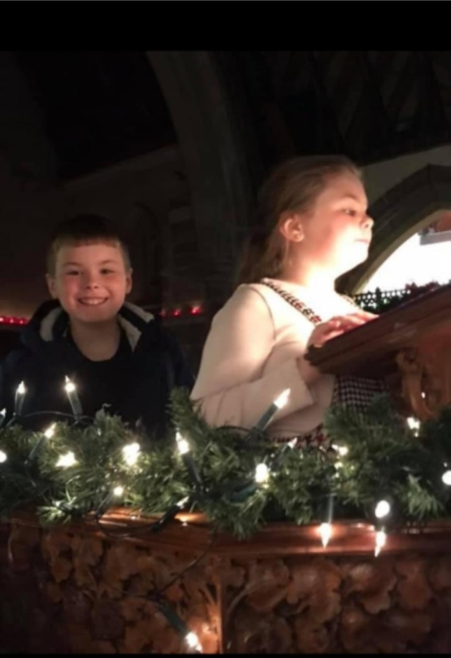

**WE**

**OFFER**

In our Parish we strive to provide a warm welcome to everyone, whatever their background. Church has a cheerful, friendly atmosphere and after services people stay for refreshments and a chat. Laughter and love can be heard filling the church building. Our services are:

**Our Services**

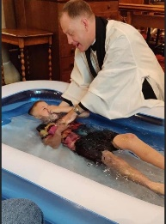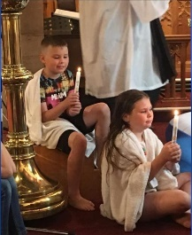1st , 3rd and 5th Sunday: A service of Holy Communion. 10:30am

2nd Sunday: A service of Morning Prayer or Baptism

4th Sunday: café church style. 10:30am

Evening service every Sunday at 6pm.

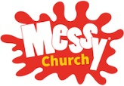3rd Sunday. 4:00pm

Average attendance at morning services is around 30/35 people, however this can fluctuate from week to week. We have two licensed Readers and one reader in training. Members of the congregation assist with Bible readings and prayers of intercession. We have a rota of people to assist with the element of Holy Communion services. We have an organist and several musicians who play regularly. Festivals such as Harvest, Remembrance Sunday, Christingle, Carol services, Good Friday, Palm Sunday and Easter Sunday are usually well attended.

All services have service booklets available as well as hymn books.

We also have a Sunday school for children of all ages which we hope can be built upon. The children learn about the gospels through Bible readings and craft, which they then share with the congregation at the end of the service.

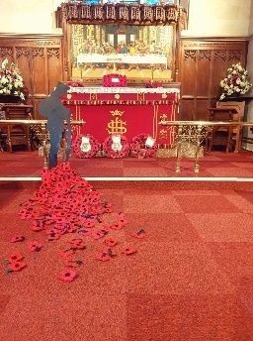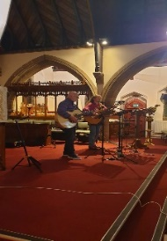

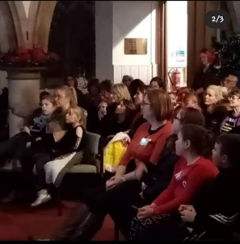

Growing in Faith

At St Oswalds all our ministry is rooted in prayer. Currently due to COVID-19 we are holding nightly prayer meetings via zoom. During normal times we offer monthly prayer meetings and a Bible study group. We have in previous years taken part in worship weekends away. This has enabled adults to build upon their relationships with each other and with their own faith, away from the hustle and bustle of their daily lives. Our adults are always encouraged to take part in all aspects of church life, especially in work with children. This has enabled generational relationships to be built.

We encourage all ages to be involved in services, from welcoming at the door to administering the chalice to presenting the offertory plate. The children are starting to lead prayers during services.

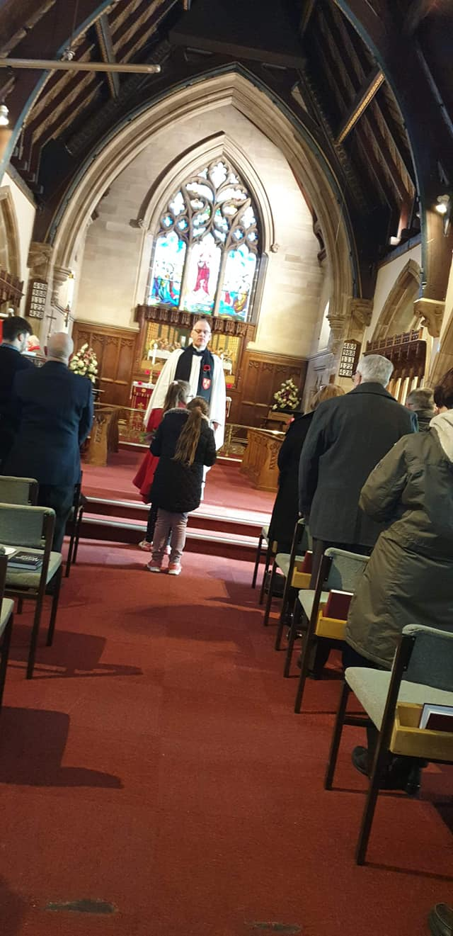 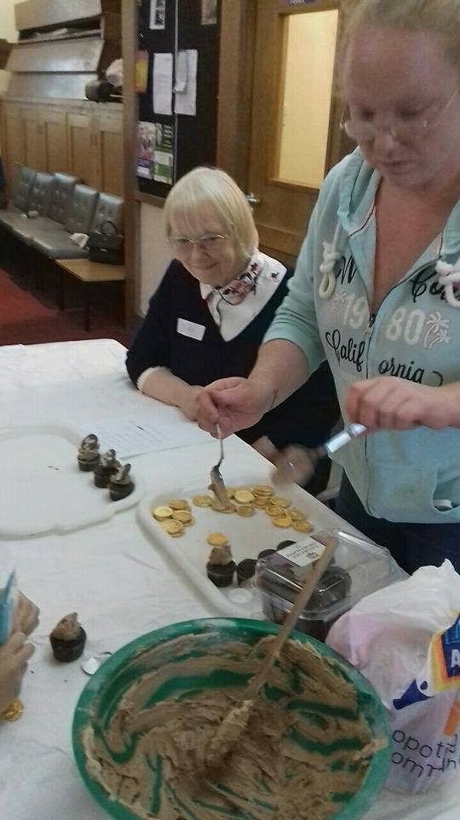 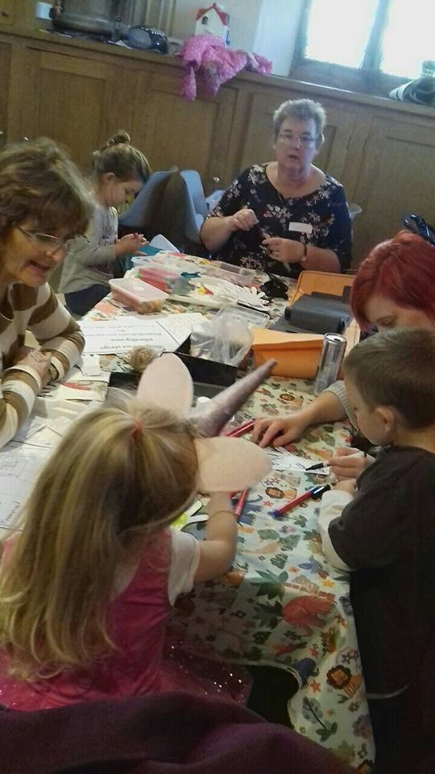 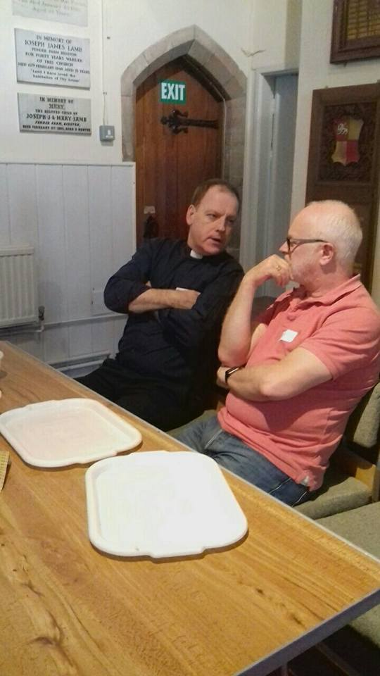

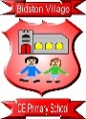

**Bidston Village CE Primary School**

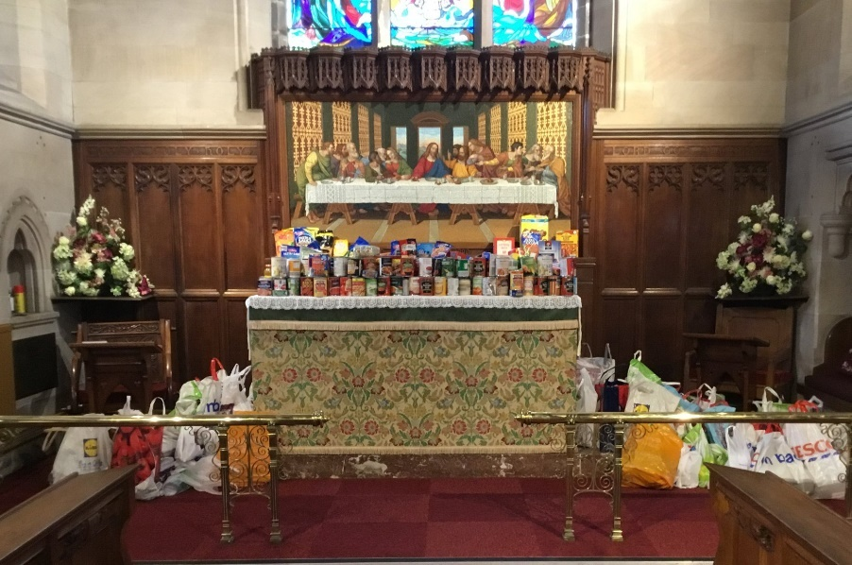

We have excellent links with all schools in the parish, including our church school, Bidston Village CE Primary, which hosts a nucleus of young people eager to learn about living in Christ. The staff are committed to living the Christian ethos and values of the school. We have dedicated Foundation Governors who are committed to ensuring the Christian ethos of the school is evident on a daily basis. Our Parish Safeguarding Officer is a member of the school staff and is also the Religious Education/Worship lead. This has helped to encourage the young people to come to church. Our previous vicar attended school to deliver a weekly worship assembly, to which parents were invited. This is something we would want to continue. He also attended events within school, to celebrate achievements, year group parties etc, as well as being a visible presence through his role as Chair of Governors. We are certain that the relationships built between staff and the previous vicar wil continue to be built upon. The school visits church for Easter, Christmas, harvest and end of year servies. Parents are always invited to attend and our harvest gifts from the school have been extremely generous. The church and the school work closely for the good of the community and each other.

**The Church Building**

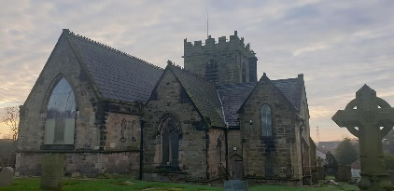

St Oswald's Church is in [Bidston](https://en.wikipedia.org/wiki/Bidston), an area of [Birkenhead](https://en.wikipedia.org/wiki/Birkenhead), [Wirral](https://en.wikipedia.org/wiki/Metropolitan_Borough_of_Wirral), [Merseyside](https://en.wikipedia.org/wiki/Merseyside), England. It is recorded in the [National Heritage List for England](https://en.wikipedia.org/wiki/National_Heritage_List_for_England) as a designated Grade II [listed building](https://en.wikipedia.org/wiki/Listed_building#England_and_Wales). It is an active [Anglican](https://en.wikipedia.org/wiki/Anglican) [parish church](https://en.wikipedia.org/wiki/Parish_church) in the [diocese of Chester](https://en.wikipedia.org/wiki/Diocese_of_Chester), the archdeaconry of Chester and the deanery of Birkenhead.

**History**

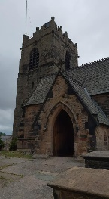The original church dates back to the 13th century. The tower was built in 1520. The rest of the church was rebuilt in 1855–56 by W. and J. Hay in [Gothic Revival](https://en.wikipedia.org/wiki/Gothic_Revival_architecture) style. An extension was made to the [chancel](https://en.wikipedia.org/wiki/Chancel) in 1882 by [G. E. Grayson](https://en.wikipedia.org/wiki/George_Enoch_Grayson).

**Architecture**

**Exterio**r

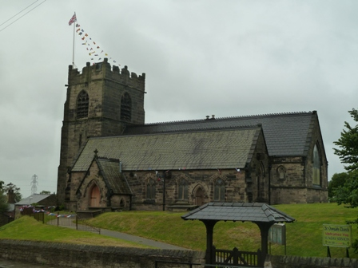The church is built from coursed and squared [rubble](https://en.wikipedia.org/wiki/Rubble) in large blocks with a roof of [Westmorland](https://en.wikipedia.org/wiki/Westmorland) slate with ridge [cresting](https://en.wikipedia.org/wiki/Cresting_(architecture)). Its plan consists of a west tower, a nave, north and south aisles with [gable](https://en.wikipedia.org/wiki/Gable) roofs, a south porch, and a chancel. [Heraldic](https://en.wikipedia.org/wiki/Heraldry) shields over the west door date it between 1504 and 1521. The tower is in three stages with angle [buttresses](https://en.wikipedia.org/wiki/Buttress) and an embattled [parapet](https://en.wikipedia.org/wiki/Parapet).

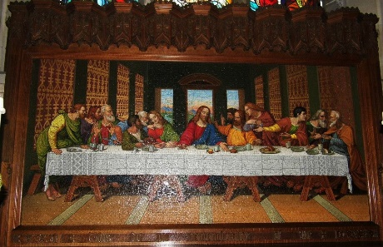**Interior**

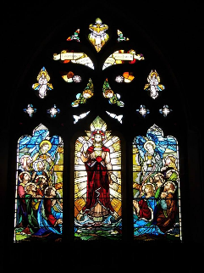In the chancel is a [sedilia](https://en.wikipedia.org/wiki/Sedilia) dated 1882. The [reredos](https://en.wikipedia.org/wiki/Reredos) is a [mosaic](https://en.wikipedia.org/wiki/Mosaic) depicting [The Last Supper](https://en.wikipedia.org/wiki/Last_Supper) by [Salviati](https://en.wikipedia.org/wiki/Salviati_(glassmakers)" \o "Salviati (glassmakers)) over which is a wooden [canopy](https://en.wikipedia.org/wiki/Canopy_(building)) [frieze](https://en.wikipedia.org/wiki/Frieze). The stained glass includes windows by [Morris & Co.](https://en.wikipedia.org/wiki/Morris_%26_Co.), [Robert Anning Bell](https://en.wikipedia.org/wiki/Robert_Anning_Bell), [H. Gustave Hiller](https://en.wikipedia.org/wiki/H._Gustave_Hiller), H. Hughes, Powell and [Frank O. Salisbury](https://en.wikipedia.org/wiki/Frank_O._Salisbury). The organ dating from 1929 is by [Henry Willis & Sons](https://en.wikipedia.org/wiki/Henry_Willis_%26_Sons). There is a [ring](https://en.wikipedia.org/wiki/Ring_of_bells) of six bells by Robert Stainbank of the [Whitechapel Bell Foundry](https://en.wikipedia.org/wiki/Whitechapel_Bell_Foundry), five of which are dated 1868 and the other 1882. The [parish registers](https://en.wikipedia.org/wiki/Parish_registers) begin in 1679 and the [churchwardens](https://en.wikipedia.org/wiki/Churchwarden)' accounts in 1767.

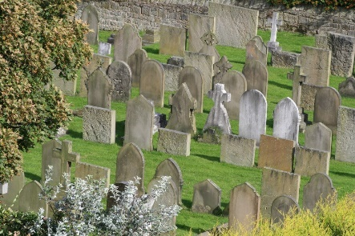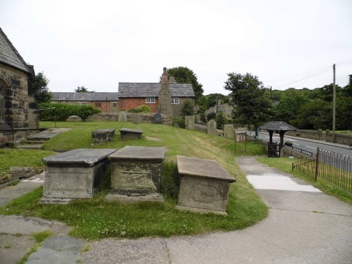**External features**

The churchyard contains four war graves, each of which represents a different service; a [British Army](https://en.wikipedia.org/wiki/British_Army) Colonel of [World War I](https://en.wikipedia.org/wiki/World_War_I), and a [Royal Air Force](https://en.wikipedia.org/wiki/Royal_Air_Force) officer, a [Royal Navy](https://en.wikipedia.org/wiki/Royal_Navy) and a [Merchant Navy](https://en.wikipedia.org/wiki/Merchant_Navy) sailor of [World War II](https://en.wikipedia.org/wiki/World_War_II).

The cenotaph is across the road from church and is engraved with the names of the fallen soldiers from Bidston.

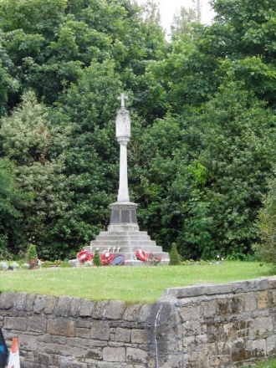

**A few words from the congregation:**

**Who we’re looking for**

* Someone with a heart for God, and a heart for the people. Someone who will journey with the church family and parish community and grow disciples within both.

* A fellow ‘cracked pot’ – someone who can belong to a church family with all its imperfections.

* Someone with experience in leading a community through challenging times.
* Someone who is used to working in a community that has a large proportion of its parish sitting in one of the most deprived and disadvantaged areas in the UK.
* For me on a personal level I would not want anyone to “teachy” I need someone who can interpret in simple language so that I understand the Lords teachings. Too theoretical and I start to nod off.
* We need a person who has a great love for Jesus, a great preacher of God's word, some modern hymns and choruses and who has great vision and plan for the future of St Oswalds.
* We need someone dynamic as it will be a hard task to bring the people back into church after the affects of lockdown.
* Someone who is willing to delegate encouraging members of the congregation to take on more tasks for example we need regular home groups to explore the bible and support each other in our journey with God and bible and prayer groups if we could train members of the congregation to do this.
* God knows the person who is right for the post and we must pray he/she will come to St Oswalds.
* Loves God but also fears Him.
* Lives for Jesus.
* Full of the Holy Spirit.
* Has a vision for our church and an enthusiasm to move our church forward in whichever way God is leading us.
* A good preacher who will challenge and stretch our understanding of the scriptures.
* A person of prayer who is reliant on God’s promptings and is biblical in their approach and philosophy.

* An enthusiastic, good leader with a willingness to listen and involve the whole team with decisions.
* A desire to equip and enable the congregation to participate in God’s work in our church and community.
* Has a heart for the poor, needy, vulnerable, isolated and elderly of our difficult and challenging parish.
* A person who wants to engage with the young families of our parish especially through the church school and schools in the wider community and continue the Messy Church, Cafe church and Sunday school work.
* Enjoys children’s and youth work and wants the church to grow in this aspect.
* A good communicator and speaker.

**What we are like**

* Friendly and welcoming to all people.
* A warm family church with Anglican traditions.
* A united congregation of varied traditions, broadly evangelical in outlook, and with worship that is informally formal.

**What we offer**

* A huge challenge ahead, both in community rebuilding post-COVID-19, and in addressing our financial future.
* We are a friendly unstuffy congregation down to earth and welcoming.
* The village itself is a conversation zone and I wonder if we make the most out of that.  A village show once a year would be great and we could play a part in that, perhaps we link into NW in bloom again with the RHS?