S
ST BARTHOLOMEW’S CHURCH
BARROW
PARISH PROFILE APRIL 2022
Photo by Stephen Bell
Introduction
We are seeking to appoint an enthusiastic priest for this part-time post to serve a small rural community. The appointment is for Sunday duties plus two days a week, and carries a 15% stipend plus the provision of a house. There is a long history in the parish of part-time incumbents who have shared the role with different diocesan posts. This appointment is for a stand-alone part-time role.

The Parish
Barrow lies off the A51 Chester to Northwich Road, on a sandstone ridge looking towards Chester to the south-west and the Welsh hills beyond. The Parish includes the village of Great Barrow and the outlying hamlets of Little Barrow, Hollowmoor Heath, Long Green, Stamford Bridge and the area around the Barrowmore Estate. Although quiet and largely untroubled by traffic, communication links are exceptional: Chester station is 15 minutes’ drive, with fast links to London; the A51 is one mile away and the M56 within 10 minutes’ drive, putting Liverpool and Manchester within easy reach.
The Parish has been for most of its existence a tight-knit farming community and this is still reflected in a feeling of independence and an array of local societies and activities. Employment now includes a typical mix of commuters and the self-employed, with a number of carpentry and service businesses housed in an enterprise zone on the Barrowmore Estate.

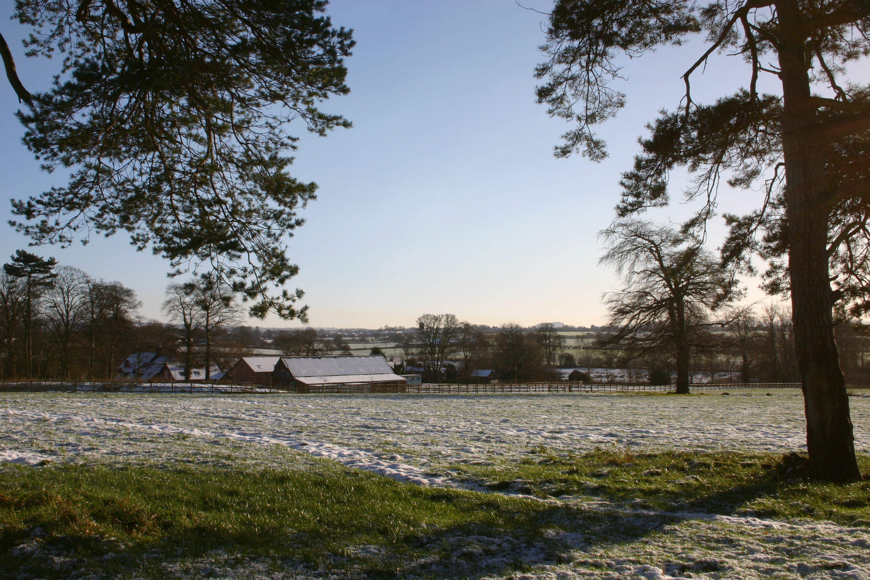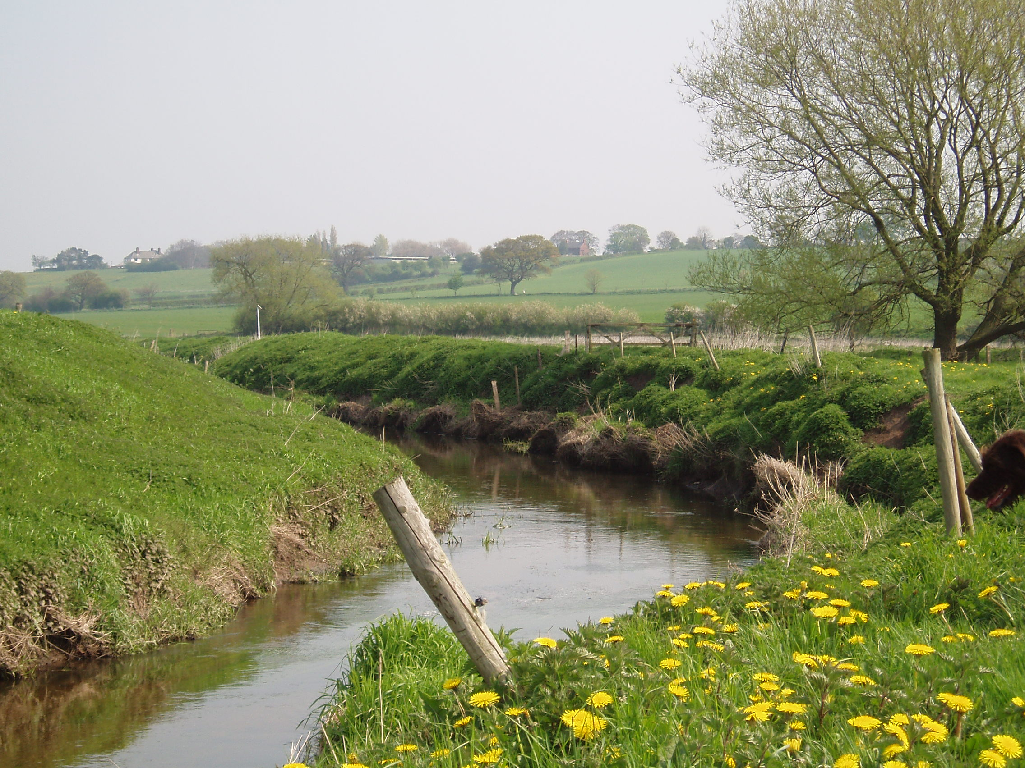
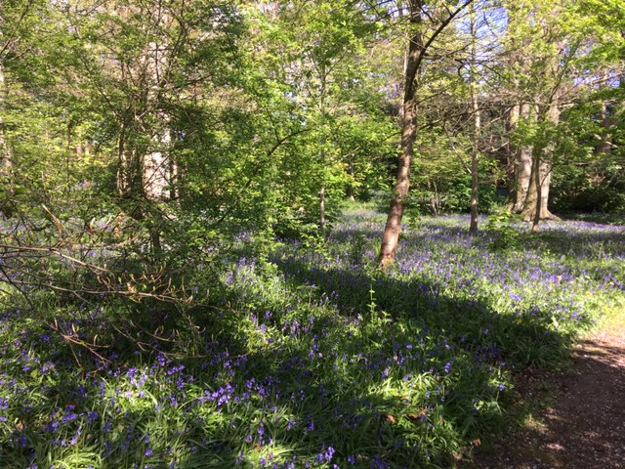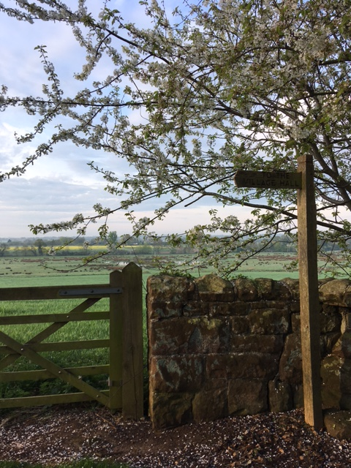
The population is only around 940 but the community has great vigour, with past awards for Community Spirit and Best Kept Village. There is a small primary school, a village hall and a social club. There are two pubs and a cafe. Recreation facilities include a bowling green, a cricket pitch, football pitches and a children’s play area with new sports pavilion. There are many other activities, an amateur orchestra, several competitive table tennis teams, a WI, craft group, an informal running group, a Lunch Group and societies for those interested in horticulture, art, history the environment and much more.
Most secondary school children commute by bus to the well-regarded High School in Christleton, although there are other options in Helsby and Chester.

Barrowmore Estate
Barrowmore occupies a large area not far from the centre of the village. It started out after the First World War as a TB hospital and rehabilitation centre for service men with the introduction of light industry to provide support and employment for the recovering patients. The hospital was then taken over as a cottage hospital by the NHS and when that closed the old wards were turned into light industrial units. Following the closure of the TB unit Barrowmore continued to support men with disability and today has a hostel providing accommodation and care for 40 people with disability (mainly men).
The estate has supported a social club (now privately run) and other facilities for the residents. The church has had strong links with Barrowmore with residents attending services, bible study and other events. Our incumbents have also provided pastoral support to both staff and residents.
As an income generating initiative Barrowmore runs the excellent Bluebell café which is well supported by village residents.

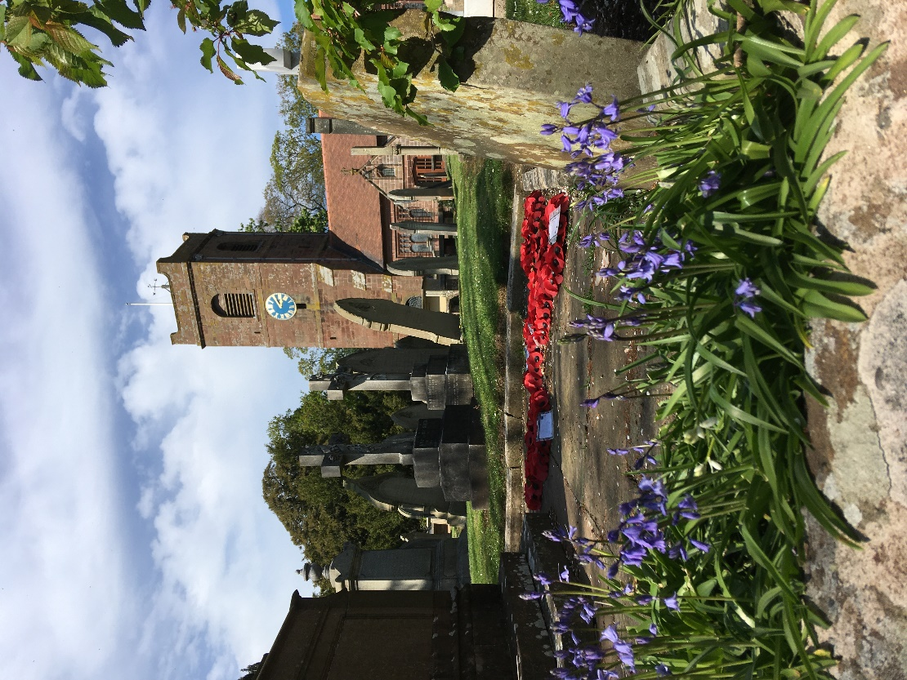
Church and Churchyard
St Bartholomew’s is an attractive Grade II* sandstone building with internal elements dating from the fifteenth century, but largely rebuilt and refurbished in the late nineteenth century. The first recorded appointment as Rector was in 1313.
The church is in excellent repair and, although still a traditional rural church in appearance, has benefited from modernisation projects over the years. A major fund-raising exercise in 2000 allowed us to create a crèche and toilet extension and to build a new church hall. In 2019 we carried out an extensive repointing of the south side of the church and undertook repair to the church tower roof in 2021. The church has both electronic and pipe organs. There are linked projection screens and sound system.
The original churchyard is closed to new openings but the ‘new’ churchyard around the church hall has space for 10-15 years use. We have been donated a piece of land for a new graveyard and are currently completing the legal transfer, this will provide burial space well into the future. Both current churchyards are well-maintained by long-standing contractors

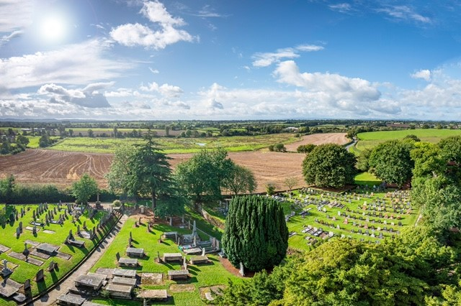
Photo by Stephen Bell

Mission
St Bartholomew’s is now the only church of any denomination in the Parish. Pre-pandemic attendance at the morning services on an average Sunday totalled 30-37 with a further 15-20 parents and children in our Sunday School, Jellies. Modern lifestyles lead to irregular attendance and we believe that around 150 individuals would regard themselves as part of our congregation. Our congregation numbers are gradually recovering as confidence increases post lock-down. There is a great deal of goodwill towards the church from the wider community, which is reflected in attendance at the great seasonal services and in participation in outreach activities.
We aim to recognise these realities by encouraging as wide a range as possible of the community to engage with and feel welcomed by the church, helping the committed Christian to a deepened and invigorated faith while seeking to maintain a positive interaction with the whole community. Before the pandemic we were able to offer a variety of services to appeal to the different ages and preferred worship styles. We provide services attractive to a wide range of Christians. We wish our Incumbent to lead us as a friendly, open and inclusive church, and to show understanding of personal circumstances and situations.
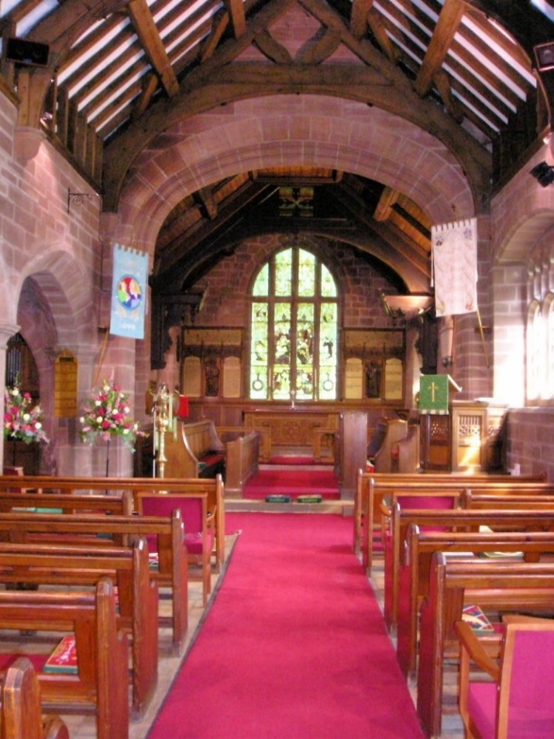
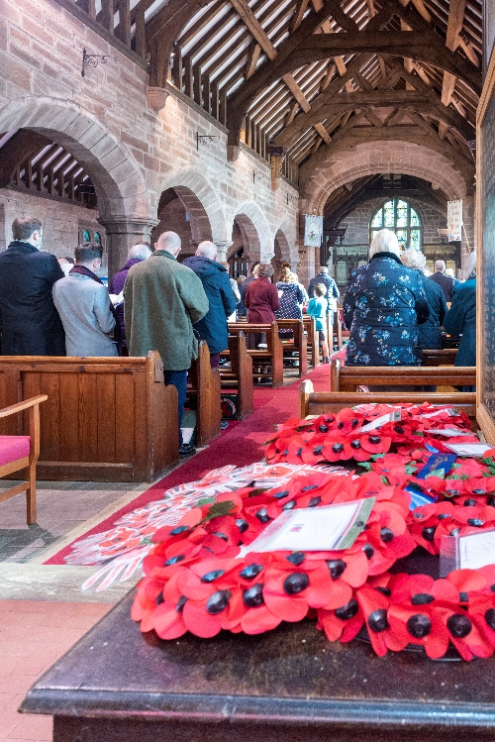
Photo by Stephen Bell
Barrow Church

Church Activities
Our regular church activities normally include:
- Our children’s group Jellies which currently has 15 children 1-11
- Twice termly Pram service for pre-school children and their carers
- Bible study group
- A weekly coffee morning
- Weekly zoom prayer meeting
- Fortnightly craft group
- Input into a fortnightly Lunch Group for people living on their own, particularly to support the bereaved.

There is a Parish website, Facebook page and a monthly church magazine which is printed on our own photocopier and includes a range of features on church and community activities. The magazine is currently distributed to every household and the Parish Council gives an annual cash grant to facilitate this. The church also distributes a Welcome Brochure to each new household, giving information on facilities and activities available in the Parish.
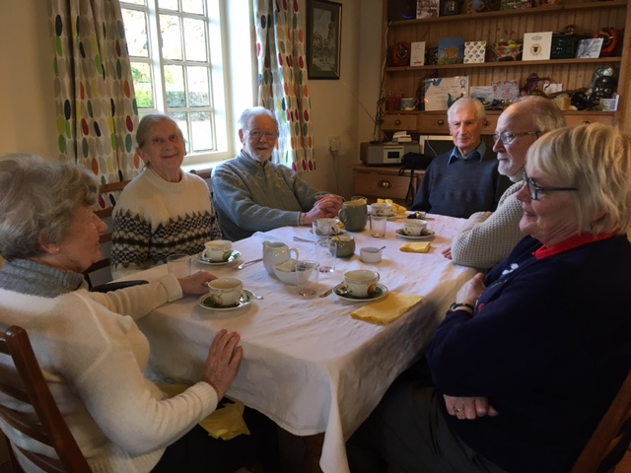
Village Lunch Group

The Incumbent
For many years the role of the priest of Barrow was divided between parish duties and a series of diocesan appointments. The Diocese have reduced the number of diocesan posts and are no longer offering a shared post for the parish. The PCC sees this as an opportunity for a part-time post without the pressures of a diocesan role.
The PCC wants the Incumbent to give equal time to expanding the spiritual life of the congregation and to involvement with the community. We are keen to see growth in the church and a reengagement with the community particularly following the pandemic. We would value spiritual nurture and teaching through the encouragement of small groups. In addition, there are specific outreach events such as the Harvest Supper, the Barn Dance, the Memorial Service for the bereaved, and other one-off services, but visibility at village venues and events is very important. The Incumbent should have an open and friendly style, a sense of humour and an ability to get on with people of all ages and backgrounds.
Support
We have a very dedicated Reader who has taken on considerable responsibility during the vacancy leading and preaching on 2 Sundays each month, a Pastoral Worker beginning her work in the parish, two churchwardens and a supportive PCC. We also have a very enthusiastic group of parents who run our children’s work.
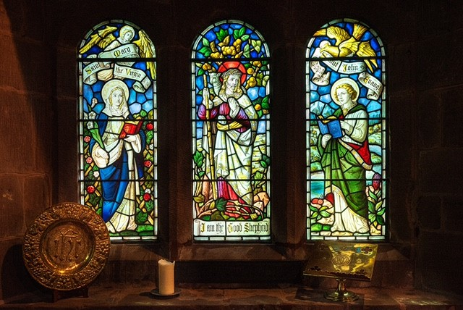
Photo by Stephen Bell
Children
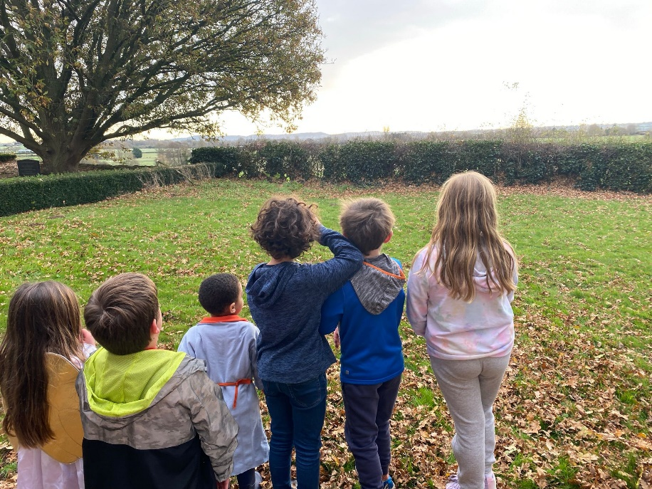
Some of our children

We are very proud of our children’s work. Our Jellies children’s group usually meet on Sunday mornings during term time. We have 15 children aged 1-11 attending, thanks to our team of very dedicated parents. The first Sunday of the month is a family friendly service and our children take part in the service, another session of the month starts with Jellies breakfast which is a great way to welcome new families in an informal way. This term our Sunday children’s activities are being offered through 2 groups to better meet the needs of the differing ages of the participants. The church has good involvement with children through these children’s groups, but has difficulty in maintaining contact with teenagers once they move to secondary schools outside the Parish. We would like to explore opportunities to increase the involvement of children and the school in church activities and to strengthen links with older children.
The School
The Church of England primary school is thriving and very well regarded. Numbers are currently around 38. A new school Head has just been appointed and we look forward to welcoming him and hope to keep the close links the school has with the church. The school holds four services a year in church and has involvement at other services. The Rector has in the past been a school governor and taken regular assemblies. Since a member of our church is a Foundation Governor the new appointee may not feel the need to take on the role of Governor. We are keen to continue the strong link between church and school but appreciate the level of commitment may need to be reduced. We would hope that the appointee would be able to take assemblies even if on a less frequent basis.

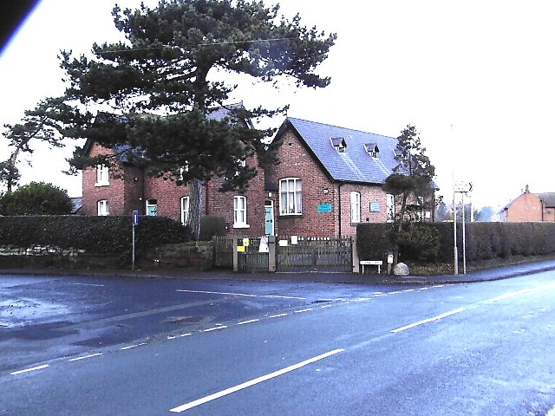
Barrow C of E Primary School

Finance
The church has substantial reserves, including the long-standing Churchwardens’ Fund for expenditure on church fabric and churchyard, most of these funds are in restricted accounts. Recent years have seen a reduction in our day-to-day general giving which has led us to feel a need to reduce our Parish Share and consequently level of clergy cover to keep our income and expenditure in balance and we are therefore looking to offer House for Duty. We are keen for our requirements to be financially sustainable in the medium term and to allow for investment in the mission initiatives we hope to roll out once the vacancy is filled. We appreciate that some activities may need to be reduced to fit the new incumbent’s time but would like to make these decisions jointly with the new appointee.
The long-term effect of the pandemic on our overall giving is yet to be seen. The full impact of church closure was somewhat buffered by the number of our church members who give by standing order but of course attendance at both Sunday and festival services severely impacted on our plate collections. Looking ahead, we hope that it will be possible to persuade more young parents to include meaningful support for the church among their priorities.

Chester Deanery
Barrow Parish is part of Chester Deanery which is made up of 20 churches, ranging from city, suburban and rural parishes. Deanery Synod meets 3 times a year, with a special focus on specific issues concerning the Church of England, Diocese, or parishes, often with a guest speaker.
Due to the many churches that make up the Deanery, Chapter is made up of 3 demi chapters that meet up every other month for fellowship and prayer, and then we get together on the other months again usually focussing on a particular issue, such as mission and ministry.
Chester Deanery/chapters are well attended and supported by Clergy and Lay.
Revd Hennie Johnston, Rural Dean

The Rectory
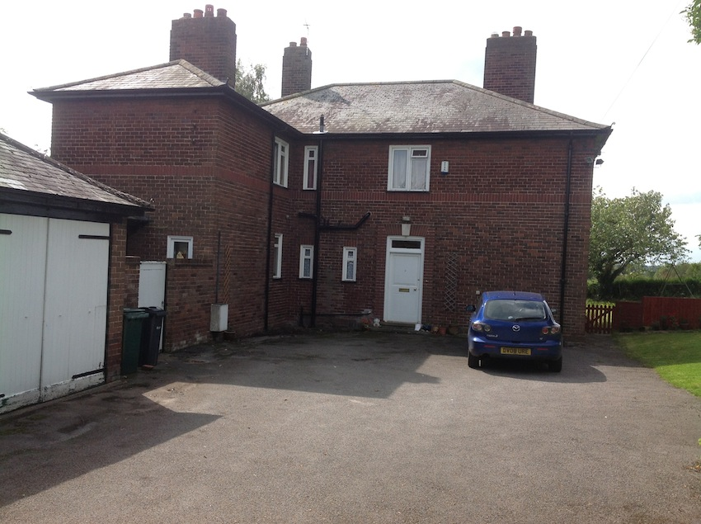

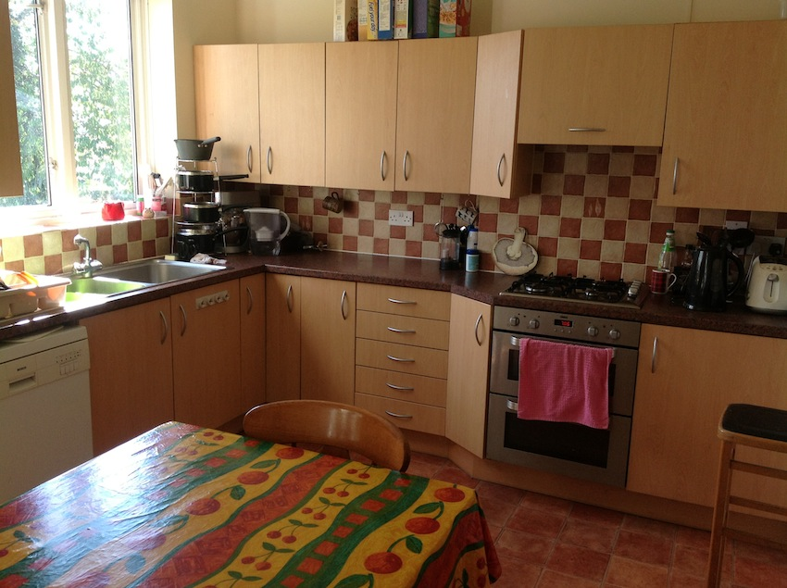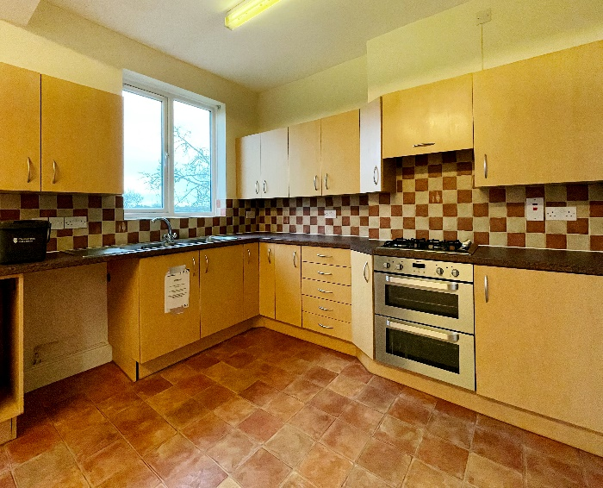

The Rectory occupies a central position in the village but is very private, overlooking fields and farmland. It is only a short walk from the church. Barrow has a large network of well-marked footpaths to both local areas and further afield to adjacent villages that can be accessed straight from the house (a Barrow footpath book is available). It has a large but easily maintained garden which is secure at the rear for small children and dogs with fencing and two side gates. There is tarmac space for three vehicles, a single garage.
Following a substantial upgrade in 2009 the Rectory is an attractive, modernised family home. It has a spacious entrance hall with built in coat cupboard, a study (which can be accessed without entering the main house), two reception rooms, one with double doors onto the garden. The reception rooms and study have gas fires allowing the rooms to be heated independently of the central heating. There is a good-sized well-equipped kitchen/breakfast room with built in hob and oven, a utility room with sink and access to outside toilet and storage area. There is also a downstairs cloakroom. Upstairs there are three good sized double bedrooms with spectacular views across the countryside and a further two single bedrooms. There are two large bathrooms both with showers, one over the bath and the other with a separate shower cubicle. The second bathroom has a separate toilet. The landing has some useful built-in cupboards and there is an access ladder to the loft. The gas central heating system is in good order and the house is double-glazed and carpeted throughout. The house has a full alarm system and outside security lights.

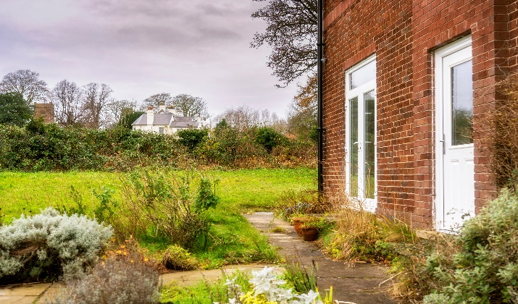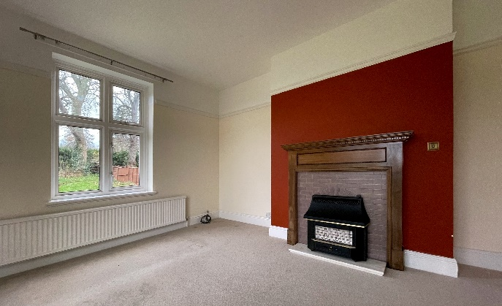
Garden and sitting room

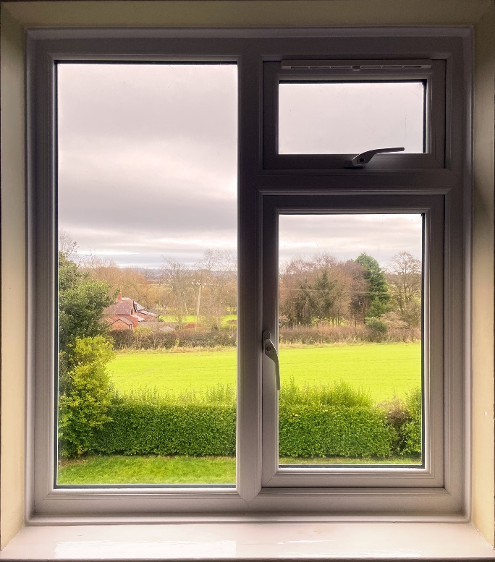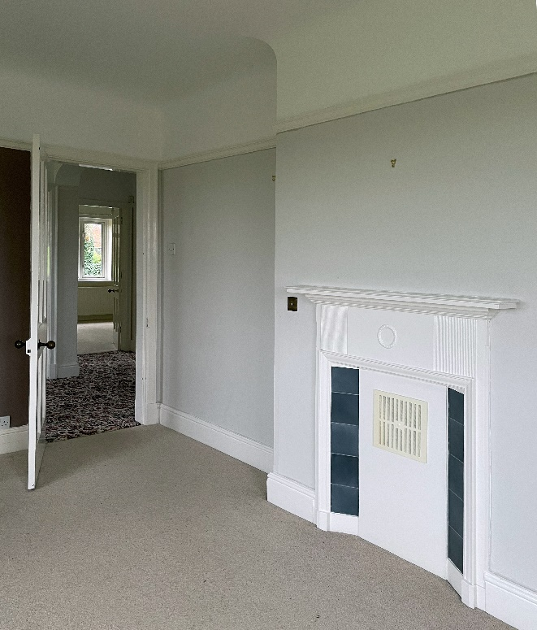
Upstairs bedroom and views
Photos by Stephen Bell

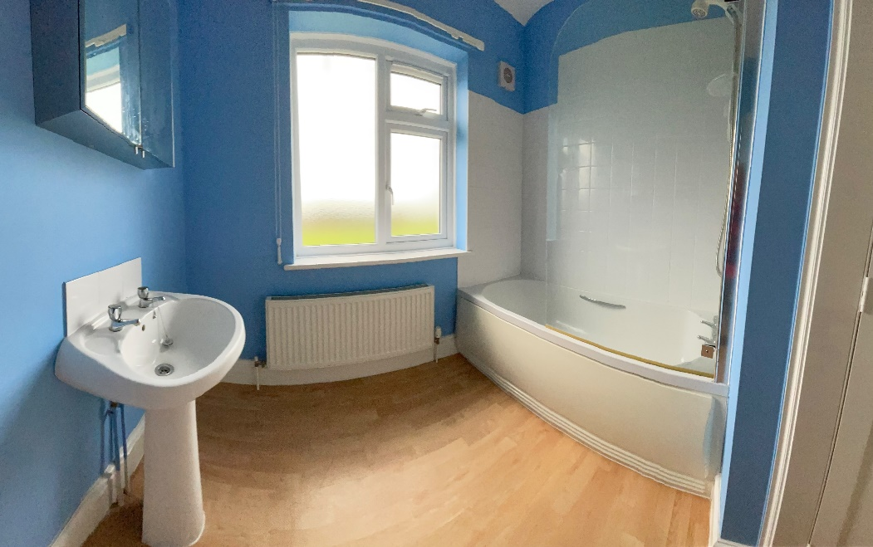
Photo by Stephen Bell

More Information
The Welcome Brochure and a Church History & Guide are available at https://www.barrowchurch.co.uk/church-history/ and www.stbartholomewbarrow.co.uk. The village website is at www.greatbarrow.com and the school is www.barrowcofeschool.com .

Activity During Covid Pandemic
We are facing the continuing challenges of the easing of Covid restrictions and planning how to move forward. Like all parishes Barrow has suffered during the pandemic and we are now facing the difficulties of opening up and reconnecting with the community which makes it a difficult time to begin a vacancy. Many of our parishioners have been unable to connect to the online worship that was made available. It is difficult to know at this stage how many people will return to church and activities.
In an effort to keep connected with the community we were keen to deliver our Parish magazine which we used to advertise useful information on support available in the village. When we had to suspend our usual team of volunteers but our local postmen stepped in to ensure the magazines reached people. The church together with the support of the village set up a Care group so that people could ask for help and we quickly got a large list of volunteers who were able to help out. Due to the supportive nature of the village few requests were needed as people looked out for their neighbours.
We started a village WhatsApp group and village Facebook page to keep people connected and informed. Both continue to be used, the WhatsApp group has become a community chat and we use both the village and our own church Facebook pages to communicate our church activities and services.
In addition to our weekly online Sunday service podcast, we continued our regular bible study online and a church member started a weekly online prayer group which is continuing. Zoom services were later introduced providing a more interactive Sunday service and allowing us to gather for zoom coffee and chat before the service. In addition, we introduced a zoom Afternoon Tea with the Rector.
We marked the seasons with ‘yarn bombing’ the village with knitted angels at Christmas, delivering 70 daffodil posies for Mothering Sunday, 35 packets of homemade biscuits to the elderly, and a children’s Easter trail. Church members who are normally involved with our Lunch Group delivered 20 meals a fortnight to our Lunch Group members for the year and were delighted to welcome the group back together in person in September 2021. During the pandemic thanks to our children’s work leaders, Jellies our children’s group has met weekly via zoom since the beginning of lockdown last year apart from a few weeks break over the summer holidays. They also produced an online Nativity Play which involved individually videoed parts from all the children and cameo contributions from many members of the community.
Going forward we are looking forward to being able to fully reconnect with church members and our community under the leadership of a new incumbent.
The PCC’s Vision
The PCC, church members and village are keen to appoint a person who will take an active part in village life and be keen to be seen out and about in the village meeting both church and non-church members. The PCC are keen for an outgoing person who will provide strong leadership. This will enable us to encourage church growth through spiritual nurture of our existing church community, outreach into the wider village through the development of relationships with the community. We would like to have someone who will give good support to our children’s leaders and their work, and to see nurture of our young families particularly their parents.

Role Description
We are looking for a suitable candidate to fill the post of House for Duty in our parish and the role description below takes into consideration the working hours attached to this type of appointment. We are looking for someone who will be an enthusiastic leader of the parish but there is an expectation for the need of delegation. The incumbent will be well supported by our Reader who is happy to lead on services, and the Churchwardens and PCC who are very active in the administration of the church and familiar with the parish. It is intended that the laity will continue to take the lead on the children’s activities and bible study groups, take an active role in services and assist in pastoral work. With this in mind, in addition to the usual responsibilities of a parish priest we are particularly looking for a priest who:
- Will encourage the congregation to live out their Christian faith in everyday life.
- Feels led by the Holy Spirit and is keen to share their faith and knowledge with others.
- Is enthusiastic about worship.
- Enjoys village life and will be a visible presence to help re-connect with the community.
- Will build our mission to children and families, especially in partnership with our church school.
- Will care pastorally for the village.
- Enjoys visiting parishioners who are housebound, sick or in hospital.
- Will give leadership to our PCC and church.
- Will support our children’s work, bible study and prayer group leaders.
- Will provide leadership on safeguarding and encourage all to contribute toward creating a safer church.
We can offer:
- A warm welcome!
- A friendly and welcoming rural village community.
- Good local schools.
- A well-appointed Rectory in the centre of the village.
- Supportive Churchwardens, Pastoral Worker and PCC.
- Keen Reader who is able to offer support preaching and leading services.
- Good support from local clergy in nearby parishes.

If you would like any further information we would be delighted if you would contact our churchwardens:
Hilary Fergusson 01244 300334
Anne Law 01829 741972

