Parish profile

The parishes of Christ Church, Barnton and St. Luke, Winnington

[www.christchurchbarnton.org.uk](http://www.christchurchbarnton.org.uk) (Christ Church)[www.achurchnearyou.com/church/12682](http://www.achurchnearyou.com/church/12682) (St Luke)

We are serving churches at the heart of our communities, working together to share God’s love.

Christ Church Barnton

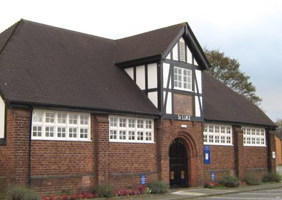

St Luke Winnington

# Welcome

The Parishes of Christ Church Barnton and St Luke Winnington sit to the north-west of the market town of Northwich, Cheshire and are separated by the Weaver navigation. Over the past 4 years, the parishes have shared a vicar and ministry teams, working well with each other and learning much, whilst each retaining their own identity.

Christ church serves the villages of Barnton and Anderton with a combined population of approximately 6000. The parish is a mainly residential area in the Deanery of Great Budworth. The population is broadly stable and the housing consists of approximately 60% owner-occupied housing with the remainder being either social housing or privately rented.

St Luke serves the area of Winnington, particularly its urban village. The parish is now a mainly residential area sitting in the Deanery of Middlewich. The population has grown in the past four years to its current level of approximately 10,000 with more growth to come as the previous brown-field sites continues to be developed. The housing in Winnington is predominantly owner occupied with some rental property. Within the next 4 years Winnington will have a population of approximately 14,000 people, giving a combined population of the two parishes of some 20,000. This population is predominantly white, spanning a broad age range and social class.

The parishes each have a large community primary school.

[Google Maps](https://www.google.co.uk/maps/@53.2682758,-2.5259586,15z)

# Where we are now

We have a very collaborative approach in terms of our services where our ministry teams can best be shared across the 2 churches.

We have a 9.30 service on Sunday Morning at St Luke Winnington which alternates between Morning Prayer and Holy Communion. The Sunday service at Christ Church is held at 10.45 which is either Morning Prayer or Holy Communion. In addition, Christ Church has a café church on the third Sunday of each month and there is a joint service for both churches on every 5th Sunday. There is also an Evensong at Christ Church on the 3rd Sunday and a BCP Holy Communion on Wednesdays at 10.00 a.m. Congregations vary and consist mainly of retired adults but average approximately 25 adults at St Luke and 35 mainly adults at Christ Church with the addition of several young families at the café church.

Our churches are gospel focussed which leads to a worship style where we use both traditional and modern liturgy. We also use a mix of modern and traditional music played on either an organ (or keyboard) or on CD’s. Both churches use projectors and screens to display the worship material and, although very different in terms of the buildings, our congregations are very similar in terms of worship style.

In terms of occasional services, there are very few weddings at either church although the reading of banns is very common. Recently there has been an increase in baptisms at Christ Church which we find encouraging. There is a normal level of funerals.

On the subject of finance, we pay a joint parish share where Christ Church contributes 65% which they expect to pay this year. St Luke contributes 35% but the financial position here at the moment is not strong, particularly as the congregation is required to rent the current church building from a large Recreation Club. As part of our mission plan, we have identified and agreed a financial plan to deliver a full parish share by 2024 (Appendix 1).

In addition to a capable ministry team, we have the following groups:-

* Prayer groups
* House/study groups
* Small but capable worship band
* Puppeteers
* “Craft & Chat” group gatherings
* Mothers Union
* Church Women’s Fellowship (formerly A.C.F.)
* Bowls club
* A regular programme of social events

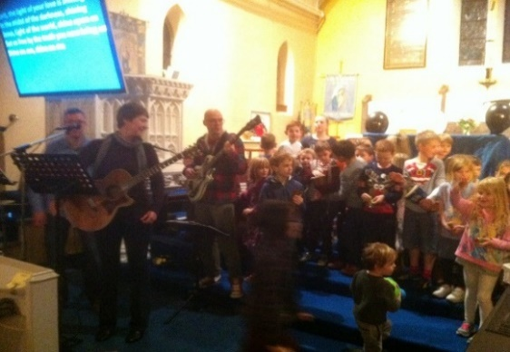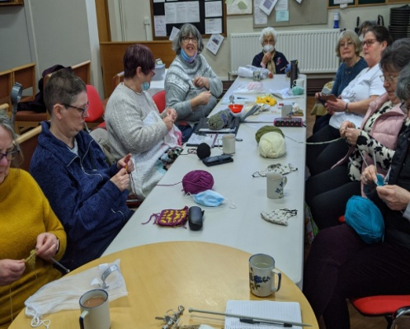

# Our Vision & Mission

We have a clear vision to make our churches more relevant to our communities and have already enjoyed success in this respect with several of the initiatives in our Mission Plan (Appendix 2). We have established a regular pattern for prayer outside our Sunday services which we see as the cornerstone for all our plans leading to the following successful outcomes:

* Joint Lent group where we studied “Embracing Justice” by Isabelle Hamley.
* ”Experience Easter” at St Luke, engaging with Winnington Primary School.
* Café Church at Christ Church which is now held in Barnton Community and Nursery Primary School during term time.
* Monthly Parish lunch at Christ Church.
* Weekly Toddler Group at Christ Church.

Leading on from our successful outcomes, we plan to hold “Experience Harvest” and “Experience Christmas” at St Luke as well as continuing our popular Christingle and Crib services at Christ Church. We are aware that we are still 2 parishes sharing a vicar and with that in mind we are committed to exploring the possibility of joint PCC’s as well as reviewing the current Deanery boundaries.

A huge mission field has sprung up in the parish of Winnington and this is the main focus of mission for St Luke. Relationships have been established with the local primary school and the church is committed to future outreach initiatives outside the existing church building.

At Christ Church, the focus is on reordering to provide disabled access to the Church. Plans are well advanced and are almost at the stage where costings can be sought.

For both churches, the desire is that God’s kingdom on earth will prosper and grow, and we have identified the particular need to engage with children, youth and young families. Both churches are committed to continue building relationships with local people in their communities.

Our churches relish the opportunity of mission and ministry in our parishes and we share the excitement of what the future holds, especially with a new vicar to lead us. We believe that God has great plans for our parishes and we look forward in prayerful anticipation to the appointment of our new vicar. There is a strong feeling at both churches that God is already nurturing the right person.

# Our Buildings

Christ Church is a Grade 2 listed building which is generally in good order. We are currently at the planning stage to provide disabled access. There is a church hall with a car park for approximately 20 cars and there is a bowling green. The churchyard is now closed although there is still a special area for the internment of ashes. There is a large vicarage at Christ Church which is exceptionally well maintained and will provide a modern family home in well kept gardens with a separate garage.

Christ Church vicarage

At St Luke, the church building is rented which includes a share of car parking spaces and occasional use of a recreation field. The building is in very good condition and is able to accommodate community Christmas events with the local Scout group and a local brass band.

# The candidate

As a key part of our prayer life, we have prayed about our future, the changing dynamics of our parishes, the way forward for our churches and the vicar we now seek. This prayer and our efforts have sustained us through significant changes and, we believe, will continue to sustain us through the next stage in our parish lives.

We seek a vicar who is prepared to lead us forward in this next stage. A shared and collaborative approach to leadership will be essential and the post will suit either a person of experience or a first time incumbent with the right attitude and gifts.

Our ideal candidate will:

* be able to encourage the congregation in living out their Christian faith in daily life, Monday to Saturday, not just on a Sunday
* be able to provide leadership on safeguarding and encourage all to contribute toward creating a safer church
* be a willing, visible presence in our communities, promoting the care of our churches for those in need
* have a shared and collaborative approach to leadership
* have the ability to encourage our churches to grow together in both mission and ministry
* be an enthusiastic and encouraging leader who is able to develop and further deepen the spiritual life of our churches
* be someone who is able to motivate others, relate to all age groups and especially encourage families
* most of all, be someone who demonstrates dependence upon God and who is evidently equally committed to discipleship in their public, professional and personal life

We believe that the future of our parishes presents the prospect of a rewarding experience for anyone who wants to lead a church into a new and exciting stage of its life.

# How we will support you

You will be working with friendly, helpful people who want to work in partnership with you and we will be concerned that you keep a healthy balance between the needs of your own life and your work.

We will, of course, respect your days off and holidays and we will pay all expenses incurred through your work.

You will find supportive Church Wardens and PCCs with enthusiastic lay readers and churches who will want to hear about your hopes and plans and who will support you in prayer.

You will also have the support of both Great Budworth and Middlewich Deaneries.

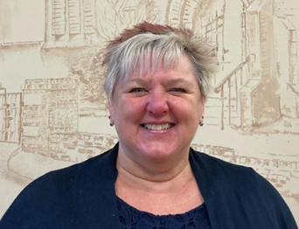

Church wardens at Christ Church Church warden at St. Luke’s

Tina Burrage and Ian Stanley Elizabeth Walton

# GALLERY CHRIST CHURCH

# A person standing next to a table with food on it Description automatically generated with low confidenceA picture containing decorated Description automatically generatedA picture containing grass, tree, outdoor Description automatically generatedA group of people in a room Description automatically generated with medium confidenceA group of people in a kitchen Description automatically generated with medium confidenceA picture containing person Description automatically generatedA picture containing altar Description automatically generatedGALLERY ST LUKES

Café Church at local School

Christmas crafts

Christingle

Cafe Church at Church Hall

Toddler Group

Jubilee celebrations

Summer Fair

Parish Assistant, Beryl Dickens

**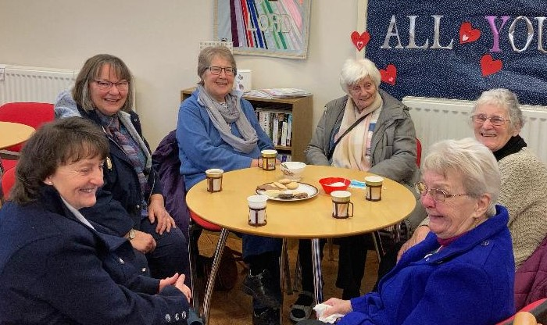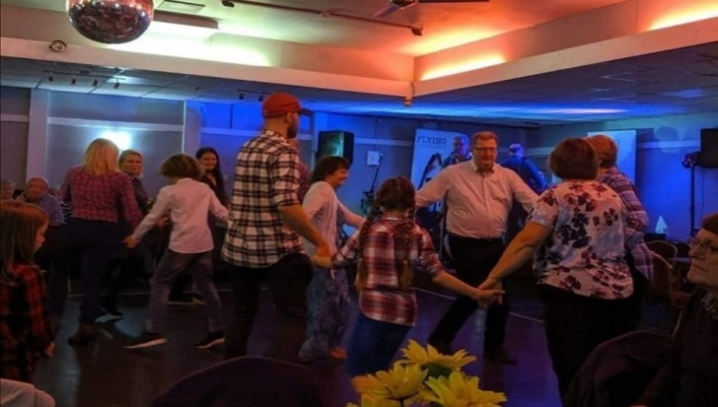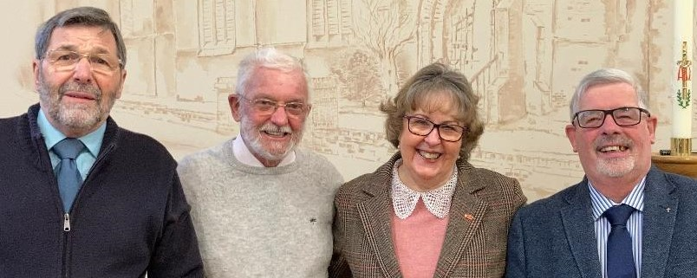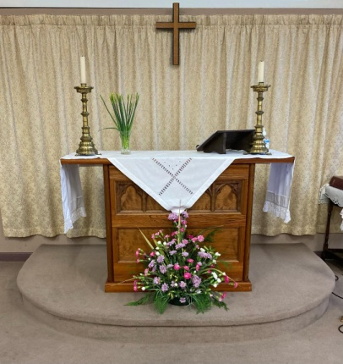** Ministry team: Ken Smyth, Jim Crawshaw, Sue Renshaw, Malcolm Evans.

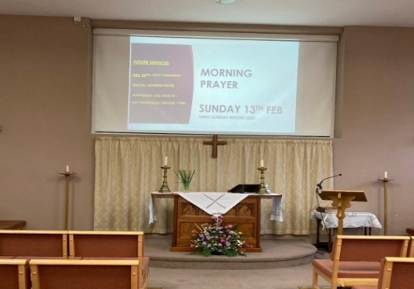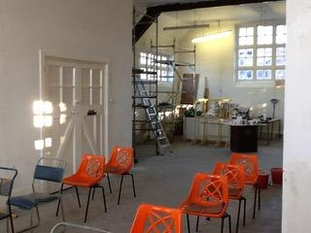 Fellowship

Before After

# Appendix

1. 

1. 

# Useful links

<https://www.chester.anglican.org>

https://www.barnton-pc.gov.uk

<https://www.christchurchbarnton.org.uk>

<https://www.facebook.com/Christchurchbarnton>

<https://www.facebook.com/groups/barntonlife>

<https://www.achurchnearyou.com/church/12682/>

<https://winningtonworks.co.uk/>