
Parish Profile
The Parish of St Oswald, Backford
Serving the townships of Backford, Caughall, Chorlton, Lea & Mollington
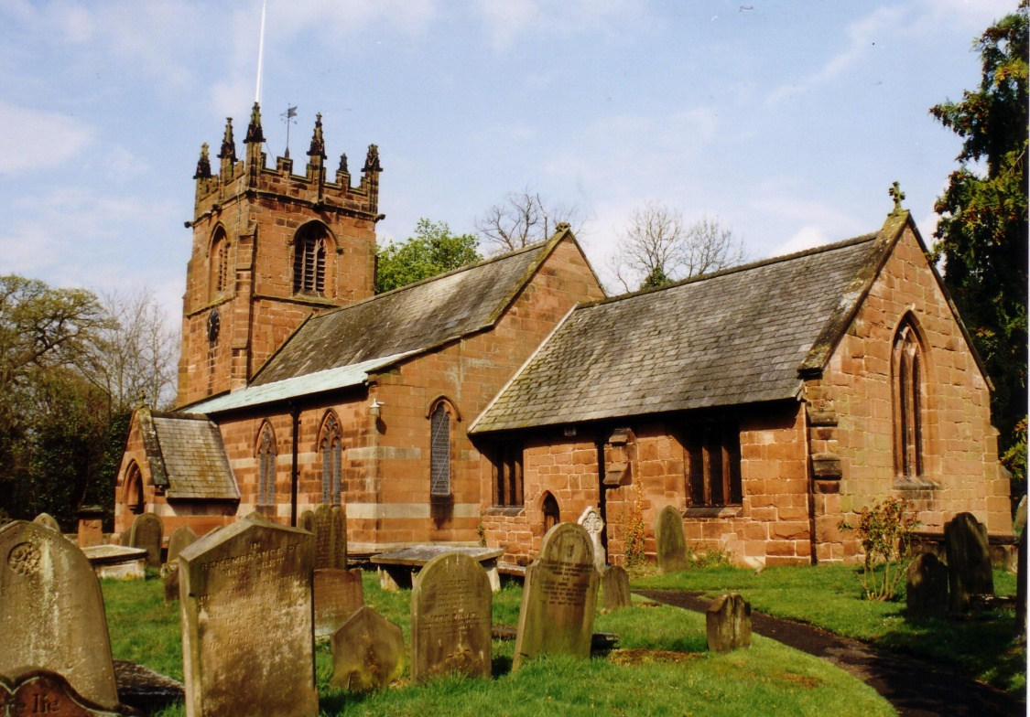

Church and Community,
Growing Together in Faith and Love

OUR IDEAL CANDIDATE

 |  |  | ENCOURAGES US TO
 |  |  | WORSHIP & BE
 |  |  | WITNESSES FOR JESUS
ENGAGES WITH PEOPLE OF ALL AGES &  ENCOURAGES THEIR PARTICIPATION IN  WORSHIP |  |  | ENGAGES |  |  | MAKES REGULAR VISITS TO
 |  |  | IN PASTORAL CARE |  |  | ST OSWALD'S SCHOOL &
 |  |  |  |  |  | MOLLINGTON PRE-SCHOOL
 |  |  | SUPPORTS US ON OUR
 |  |  | SPIRITUAL JOURNEY
 |  |  | EMPOWERS US TO USE OUR
 |  |  | TALENTS TO PLAY AN ACTIVE
 |  |  | ROLE IN WORSHIP &
 |  |  | PASTORAL CARE
 |  |  | ENGAGES WITH FAMILIES &
 |  |  | ENCOURAGES THEIR
 |  |  | PARTICIPATION IN WORSHIP
The PCC is supportive of the ministry of women at all levels in the Church.

Map of the Parish

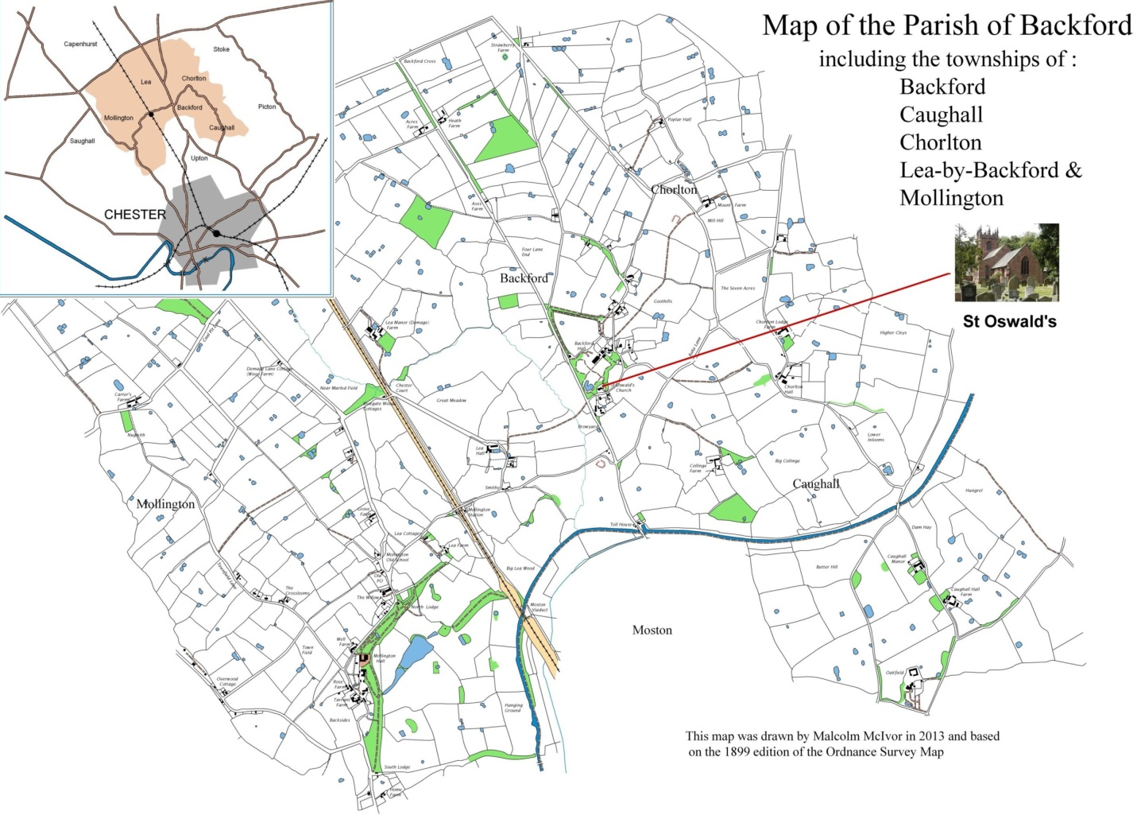

We are seeking a priest-in-charge for the benefice of Backford and Capenhurst. This is a part-time post, carrying a 15% stipend and house, in return for ministry on Sundays plus two days per week. Please see also the related parish profile for Capenhurst, which is uploaded alongside this profile.
The Person We Are Looking For
Our focus has always been community-orientated, with the incumbent involved in the social and civic aspects of the 5 Villages’ priorities. The new village hall offers great opportunities to further cement this relationship, which has a ‘knock-on’ positive effect on attendance. This is where our enthusiastic and committed small congregation needs a ‘focal point’, a leader who can give direction in going forwards through outreach and home groups.

We are praying for a new Vicar who:

- is outgoing and able to connect with people of all ages, backgrounds, and stages of their Christian faith, and can inspire church members to be outward looking.
- is willing and able to reach out and widen our links with the local community, rebuilding previous connections and building new ones.
- has the skills and experience needed to create and enhance the services and activities we provide to children, young people and their families – both within church and out in the local community.
- is open to trying new activities, even when previous ones have failed.
- listens, engages, and looks for opportunities for people to employ their gifts in the ministry of the parish.
- will encourage the congregation to live out their faith in daily life – Monday to Saturday, not just on a Sunday.
- leads worship in a way that is both contemplative and inspiring, with stimulating, thoughtful, scripture-centred sermons.
- can encourage and train others – supporting those who want to develop their spirituality, ministry and service and inspiring all members to feel engaged and involved in the life of the Church.

- has strong pastoral skills in helping people through changes, challenges, grief, and conflict.
- will encourage good safeguarding practice to ensure that the church is a safe space for everyone.

- will encourage parishioners in their stewardship of finances and giving.

Overall, we need a leader who can mobilise the energy and enthusiasm of a committed congregation to introduce others to turn and return to our Church family.

Introduction to the Parish
The parish, serving the townships of Backford, Caughall, Chorlton, Lea and Mollington lies to the north of the historic city of Chester and is mainly rural. The majority of houses are owner occupied and the population of 1,300 is fairly static. There is a new (2015) private estate of 44 dwellings behind the church, with some occupied by young families. There is little industry in the parish but there are 15 working farms. The Parish mostly comprises commuters to Manchester and Liverpool and there is a substantial proportion of retirees. A farm shop and ice cream farm serve particular needs but the nearest shopping areas are in Chester and Ellesmere Port.
Cheshire Oaks Outlet Village, the Blue Planet Aquarium and Chester Zoo (much of the zoo is within the Parish) attract many visitors. North Wales offers good walking and many opportunities for outdoor pursuits. Motorway networks are within easy reach as are both Manchester and Liverpool airports. However many parts of the area are poorly served by public transport.
The Hospice of the Good Shepherd lies close to the church, (in the former vicarage) and has undergone recent expansion. They have their own chaplain and have a strong relationship with the church. The Greater Grace Evangelical church operates from the former Backford School, just across the road from St. Oswald’s. St Oswald’s C of E School lies in Mollington, opposite the Vicarage. Mollington Pre-school and after-school club operate from The Mollington Old School, next door. A new (2021) ‘5-Villages’ Hall is only 500 metres away and is a focus for community activities, with much potential to use for social/Fund-raising activities.
We have strong links and a very good relationship with the parish of Holy Trinity Capenhurst, with which we form a united benefice.
Pattern of worship
11.15am Main Morning Worship
1st. Sunday: Morning Worship
2nd Sunday: All-Age Worship. 3rd,4th, Parish Communion.
5th Sunday – shared Communion (alternate, Capenhurst, St Oswald’s)
Being a rural parish we celebrate Plough Sunday, Rogation Sunday and Lammas as well as Harvest. Last year there were 4 baptisms, no weddings, 10 funerals and 1 memorial service following cremation. Traditionally services on Ash Wednesday, Maundy Thursday, Good Friday and Ascension Day have been joint services. 4 members of the congregation are able to assist in administering the chalice. There are committed teams of sidespersons, flower arrangers, bell-ringers, readers and after-service refreshment providers.
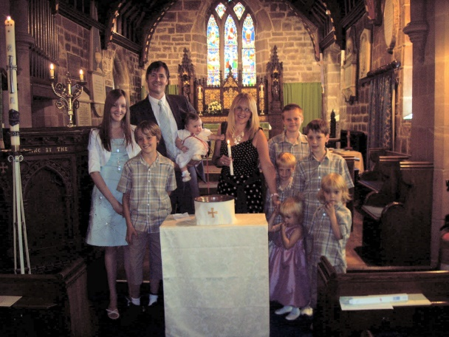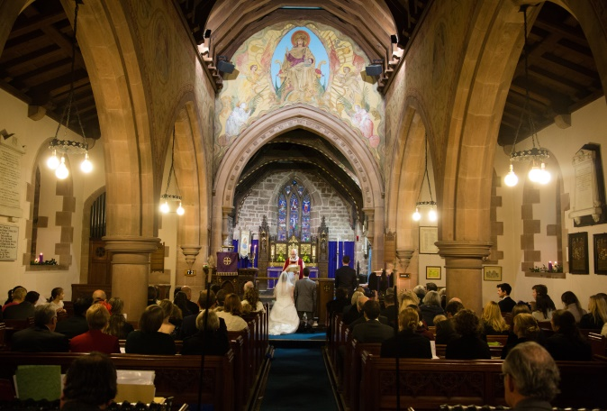
Joint weekday prayers may be an area to be developed by a new incumbent.
There are 74 people on our Electoral Roll, approx. half living outside the parish. An average Sunday sees 20 Worshippers, with All-Age worship boosting attendance through some families present. There is a PA/loop system available and although there is no regular organist, several organists play on a rota basis and this is supplemented by a music system.

Church Organisations
Mothers’ Union
There has been a branch at St Oswald’s for over 70 years.
We are a small branch of ten members, seven from St.Oswald’s and three from Holy Trinity.
Jo Pemberton from Capenhurst was ordained deacon in July 2022 and Sue Pearson is a churchwarden at Backford. We have close links with other branches in Wirral South Deanery, also with St.Thomas of Canterbury in Chester and regularly visit their meetings and events. We attend all Diocesan meetings and services. We make flower posies for Mothering Sunday and are involved in work with baptism families. We are always available to help and support our incumbent and parishes.

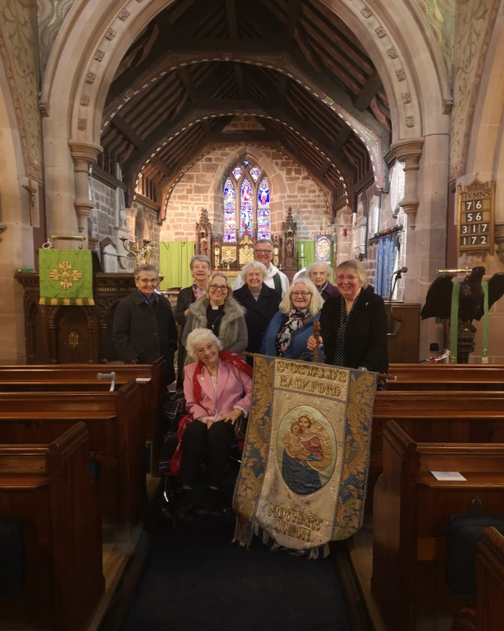
Bell Ringers There is an enthusiastic team of bellringers, who maintain this 500-year tradition at St Oswald's, ringing before the main Sunday service, and for weddings and funerals by arrangement, and for special occasions by request. A regular weekly practice is held. The ringers actively participate in the programme of training and other events organised by the Chester Branch of the Chester Diocesan Guild of Bellringers. There was no ringing at all for most of the first year of the pandemic but on returning to regular ringing in the spring of 2021, regular practices on Tuesday evenings and Sunday ringing for the 11.15 service each week have now resumed. Under new captain, Graham Atkin, long-standing ringers are helping several new starters gain confidence. Anyone who is interested in finding out more about is welcome to call in and visit.

PCC We have a strong PCC with active members working within an efficient structure whereby a worship group, pastoral group, finance and fabric committees manage specific issues within agreed remits and budgets and report back to the PCC.

Social/Fundraising
The new ‘5 Villages Hall’ opened in late 2021 and offers a great opportunity to enhance our Social and Fund-raising activities. The Christmas Draw and Afternoon Tea in the Village Hall provided evidence of this potential. The PCC will assist in developing these areas with the new incumbent.
In addition, we offer donation of harvest gifts to homeless hostels and donation of gifts to local foodbank as well as a donation to Royal British Legion following Remembrance Sunday Service.
Deanery/Diocese At the present time we have two representatives on the Deanery Synod.

Short History of St Oswald’s St Oswald’s was built in the late 13th century, but the only part of that first building to survive is the chancel. The nave was rebuilt in brick in 1728 with a flat roof, and then in 1878 the nave was completely rebuilt in the form we see today. On the upper walls of the nave and above the chancel arch are mural paintings by Edward Frampton, dating from 1890. Re-ordering of the rear of the church, with removal of the last three pews to create space for meetings, exhibitions etc, was completed at the end of 2012.
The tower was built soon after 1500 and is one of four in the Chester area built by the same team of masons. There are 6 bells, four of them dating from 1714. A major programme of restoration on the stonework of the tower was completed in 2005.
The churchyard around St Oswald’s has been used for burials within the parish since its creation. The earliest surviving gravestone is of 1717, but there is an earlier chest tomb known to have been dated 1586, which held a member of the noble Coventry family, far from their Worcestershire home.
The most recent additions to the church are the Royal coat-of arms over the door, painted by a local artist in 2000 and the stained glass window on the south of the chancel to mark the new Millennium and a memorial stained glass window on the North of the chancel.

Finance We have been unable to meet our parish share for several years. We are a small congregation in a small parish and within the wider parish community, there are at least four other charitable organisations, including the Hospice of the Good Shepherd & St Oswald’s School, each trying to fundraise from the same population. However, due to a generous bequest and a re-appraisal of assets, we look forward to being able to pay our parish share under the proposed new arrangement.

The Vicarage
The vicarage is a spacious, five-bedroomed, 1980s-built house at Mollington in Backford Parish.

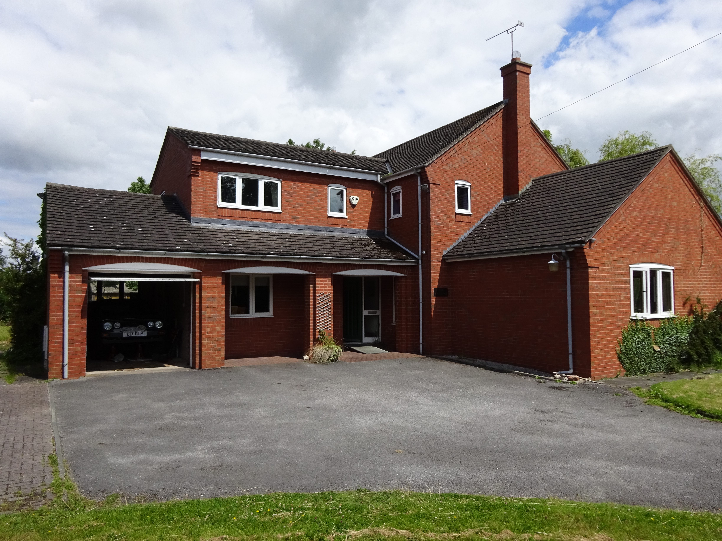

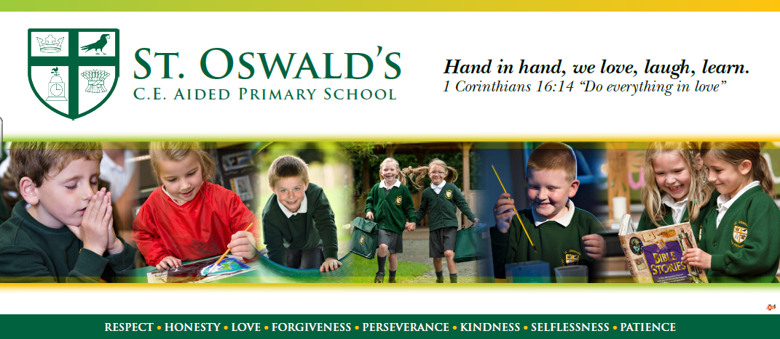
St Oswald’s C of E Primary School The link between church and school is very important to us and is an area we hope to see developed.
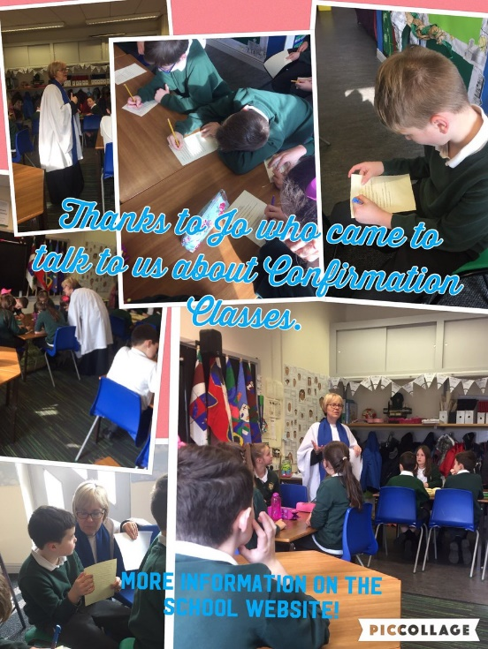

Current Headteacher, Dave Wallace, has been Headteacher since 2014 and describes the school as a “small school set in Mollington to serve the Parish and the 5 Local townships. Built and opened in 1997 to replace the former Mollington CE and Backford CE Primary Schools, it has provision for 140 pupils and is nearly full. The school is currently graded ‘Good’ by OFSTED (2020) and achieved a grade of ‘Outstanding’ at the last SIAMS inspection in 2016. The school has recently (March 2023) converted to Academy status and joined the Chester Diocese Academy Trust (CDAT) and works on various initiatives with other schools across the Diocese. The school motto “Hand in hand we love, laugh, learn” reflects the Christian vision rooted in biblical truths and is lived out through a focus on Christian values. We see the Christian distinctiveness as the school as the underlying foundation in driving school improvement forward and are determined that the children at St Oswald’s will be given the opportunity to develop skills for life as well as academic knowledge within an exciting learning environment that puts the emphasis on enjoying learning.
At St Oswald’s the emphasis is on loving our neighbour and recognising that our neighbour could be anyone, reflecting the realisation that the school lacks diversity so therefore there is a consistent drive to teach children about diversity and that EVERYONE is loved by God. Collective worship takes place in a variety of ways, but there is a need to work with a vicar who would fulfil the following:
- Welcome the parents and children into the church building regularly
- Support the drive to develop Christian distinctiveness across all areas of the SIAMS schedule
- Provide pastoral and well-being support to children, staff and families as needed
- Be an active School Governor
- Lead services as scheduled in the school.”

Finally…
God never promised that being a Christian would be easy. We put our trust in Him to find the right person for the job and look forward to working together to spread the Gospel of Christ in our communities.

