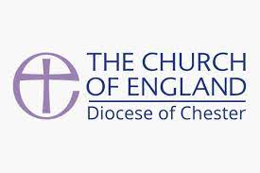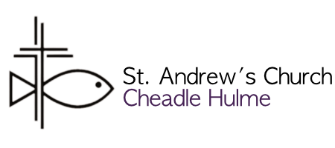

**NOTES FOR APPLICANTS**

Thank you for giving prayerful consideration to whether God may be calling you to serve as the next incumbent for St. Andrew’s Cheadle Hulme. This is a quick guide to application forms and process.

**Parish information**

**FIRST**, you will find attached a “**PARISH PROFILE – St. Andrew’s Cheadle Hulme**”. That will give you a feel for what the Parish is, and whether your gifts and calling may be a good match.

In addition, you will also find the “**PARISH FACT SHEET – St. Andrew’s Cheadle Hulme**” which give the demographic and contextual information, and the latest “**PARISH REPORT – Annual Report and Accounts 2021**” which will give you the latest information from the APCM.

On reflection, should you feel called to explore this further, the Application Forms are attached in 7 parts. The reason is that role descriptions and person specifications are used increasingly in appointments, to help all parties to be clear about what qualities and experience are being sought and on what basis a decision to appoint is made.

**Application Part 1 – The C of E Ministry Application Form**This standard form helps you to demonstrate your calling to the office, showing how your gifts, experience, skills and qualities match the criteria of the parish. It allows those making appointments to demonstrate their discernment of the successful candidate by assessing applicants against selection criteria in a structured way, avoiding bias. In completing the form you should ask yourself: “*What might I under God be able to bring to the needs of this office?*”

You are encouraged to complete the form electronically. This eases administration and allows interviewers to concentrate on the facts you are presenting rather than having first to read your handwriting.   
Tips: - Start with the most recent one first, when listing dates.  
 - Please complete each section fully. Saying ‘see CV attached’, for example, is not sufficient.  
 - Once you have completed the form, read it through and check you have shown how you  
 meet each of the criteria.

Particularly note **Section 6 – Personal Statement**, which allows you to explain why you are applying for this post and, using examples from your previous work and experience, why you are suited to it. Pull together the relevant information from other parts of the form.   
 - Don’t forget to include information about things you have done in your career before   
 ministry or relevant interests. Concentrate on facts, things your interests have caused you   
 to do, rather than mentioning a general interest in a particular subject.   
 - Don’t be too detailed, 2 pages of personal statement is enough. The interview gives the   
 opportunity to explore these areas further.

If there is a particular requirement about a post holder *(e.g. a PCC has passed a Resolution under the House of Bishops’ Declaration on the Ministry of Bishops and Priests, and a woman is therefore not an acceptable appointee, or someone remarried after divorce and with a former partner still living is not acceptable),* the person specification will need to have made this clear and if appropriate you need to address it in your personal statement.

Some requirements however are more general and will not be mentioned in the person specification. For example, the Ecclesiastical Offices (Age Limit) Measure 1975 does not allow the appointment of those over 70 unless in a fixed or limited term licensed appointment under regulation 29(1) (b). If you are in any doubt about your eligibility, you should ask those responsible for making the appointment before you complete your application.

**Application Parts 2-5**

These are confidential parts of the Application. which means only the person administering the process, the bishop and those who need to see it will have access to it. It means those interviewing you are not influenced by factors that are not relevant in making the appointment.

**Part 2 –**Asks for supplementary information on your ministry for the Patron, including a self-assessment and questions on your Ministry approaches to various pastoral issues.

**Part 3-** Asks for the names, occupations and addresses (including email) of three Referees, and other confidential information, kept separate from the main application *(for GDPR reasons)*.

**Part 4 –** Is a Clergy Recruitment Monitoring form to give information to the national Church on diversity. It will need to be returned direct to the Diocesan HR officer.

**Part 5 -**  Is a confidential Safeguarding Declaration Form as the post is subject to enhanced DBS monitoring.

In addition, the bishop may ask you questions about the confidential information at your private interview, because he or she has to assure himself or herself that your lifestyle is commensurate with a) priestly ministry and b) the person specification for the post.

If you are appointed, you will be invited to provide information about you and your family so the bishop has the information he or she needs to provide you with pastoral care.

When you have completed all the seven parts of the Application, please return them, preferably by email to: [patron@cheadle.org.uk](mailto:patron@cheadle.org.uk)   
*(or by post to: Rev Dr Rob Munro (Patron), Church Office, 11 Wilmslow Road, Cheadle, SK8 1DZ)*

**The Closing Date** for Applications is **SUNDAY 3rd July 2022.**

**Shortlisting** will take place on Tuesday 5th July, and notifications of outcomes will be delivered later that week.

Should you be Shortlisted, details about Interview Procedures will be included in that notification, but provisional dates for an **Interview** will be one of: **13th July and 19th July.**