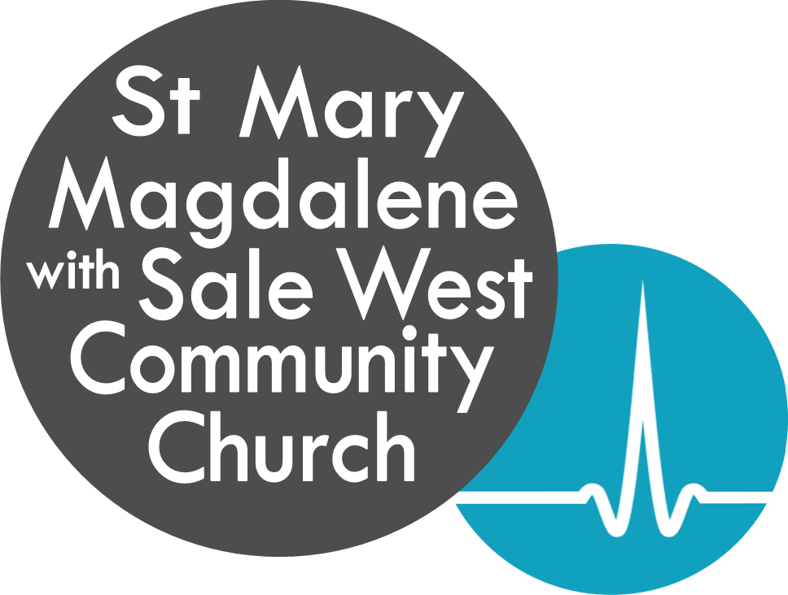
Role Description – Planting Associate

Job Title: Planting Associate Vicar
Responsible to: The Vicar of St Mary Magdalene, Ashton on Mersey
Term: 5-years, after which the applicant will move to the church plant

Overview
St Mary Magdalene is a large Anglican church based in Ashton on Mersey. We are a lively, growing and all-age-friendly church made up of four congregations. Within the parish we have a daughter church, Sale West Community Church, which meets on the Sale West estate

Our mission is to be a growing church both in width and depth, shaped by the great commission to make disciples and the great commandment to be a community of love.

We are currently looking for a full-time Planting Associate Vicar to join the senior leadership team to enable us to develop and deliver our discipleship vision, oversee training in the parish, work alongside the Vicar to bring extra leadership capacity and develop a team with a view to planting a church by the end of this 5-year term.

Key responsibilities
- As minister with overall responsibility for Discipleship & Training
- Develop Discipleship & Training across the parish
- Nurture individuals in ministry and encourage collaborative working
- Enable St Mary’s to be a Resource church for other churches
- Oversight and personal involvement in Discipleship Communities (Huddles, Clusters & Small Groups)
- Oversight of Training Events (eg. Discipleship Communities, Prayer Ministry, Parenting, Marriage)
- Oversight of Conferences & Retreats (eg. New Wine, CPAS, occasional day conferences)

- As an Ordained Minister
- Be a part of the Senior Leadership Team
- Take active part in the Staff Team & general parish ministry, including occasional offices
- Lead and preach across all 4 congregations
- Oversight of Pastoral Workers

- As a Planting Associate
The Planting Associate role will hold the vision of church planting: beginning with involvement in identifying, gathering and equipping a planting team, and working towards starting a new church by the end of the 5-year term. Key responsibilities during the Associate role will include:
- Working collaboratively with the church and the Bishop in identifying church planting opportunities
- Prepare the ground and establishing a team to lead a church plant
- Support the church community through change and enable creative thinking about church planting

Please note that the activities listed above are present priorities, but there is also room to develop other ministries according to gifts & experience.

Gifts, skills and experience
A successful candidate would have:
- A strong biblical worldview
- A missional approach to ministry
- Experience in evangelism and discipleship
- A heart for prayer
- Ability to motivate, train and encourage others
- Ability to minister to all ages and the different worship styles of the 4 congregations
- Commitment to teamwork and collaborative ministry
- A heart for church planting
- Experience in initiating and implementing new projects
- Initiative & leadership skills
- Good communication skills

Theological conviction
Applicants will need to be ordained within the Church of England, have satisfactorily completed (or be soon to complete) initial ministerial education.

- Open evangelical, committed to the inspiration and authority of the Bible
- Committed to Charismatic renewal and an ongoing personal encounter with the transforming work of the Spirit
- Committed to working within the Church of England and appreciative of the richness of its breadth and diversity.
- Able to communicate and work with a wide range of worship styles, with the ability to develop new ways of expressing church
- Highly relational – able to work across a mix of different congregations with a variety of ages, church traditions and spiritualities.

We are affiliated to the evangelical alliance and subscribe to their basis of faith and we would ask applicants to be in agreement with this.

Line management
This post is directly accountable to the Vicar as Line Manager and through him is answerable to the churchwardens and PCC. Attendance at PCC meetings is required.

The Planting Associate will be Licensed by the Bishop of Chester to the parish.

Stipend and hours
This post will be held under common tenure and will receive a stipend according to the appropriate scale for Incumbent Clergy within the Diocese of Chester, including membership of the Clergy Pension
Scheme.

This is a full-time post and in line with clergy guidelines and practice is based on a six-day working week. Annual leave is six weeks a year, to be taken at times agreed with the Vicar.

Housing
An attractive 5 Bedroomed semi-detached house with off road parking on Rydal Avenue, is provided by the PCC.

Safeguarding
Conditional offers will be made pending the successful completion of an enhanced DBS check which will be processed by the Diocese.

