St Mary Magdalene, Ashton on Mersey Parish Profile – May 2021

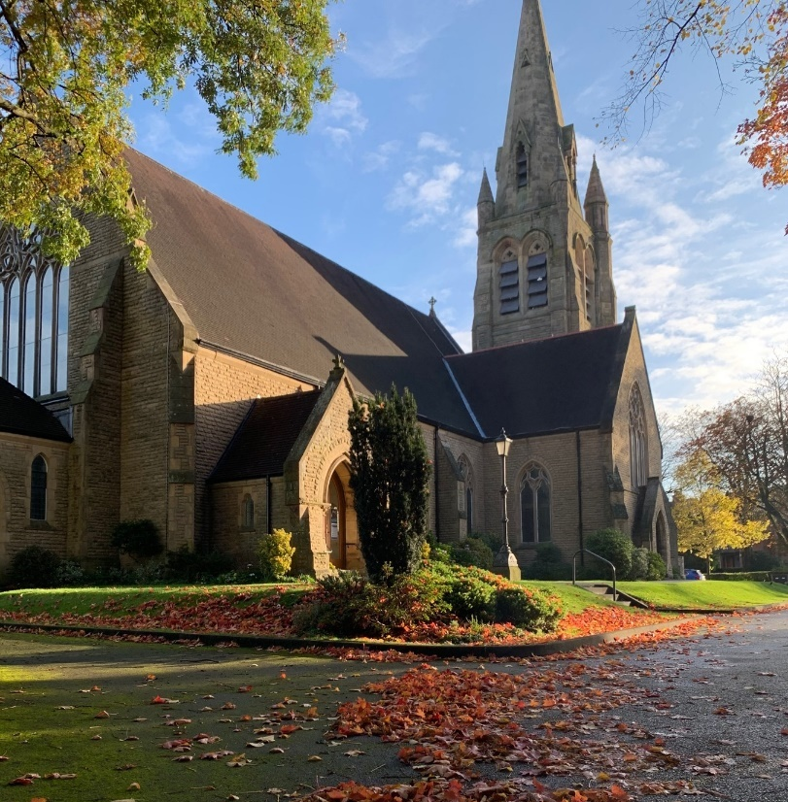
Overview – facts and figures

Parish: St Mary Magdalene, Ashton on Mersey
Deanery: Bowdon
Diocese: Chester

Number of CofE churches in the parish: 2
- St Mary Magdalene, 44 Moss Lane, Sale, M44 6GD
- Sale West Community Church, Community Centre, Newbury Avenue, Sale, M33 4QW

Incumbent: The Revd Steve Rankin
Associate Vicar: The Revd Jane Beaumont (retiring 31st August 2021)
Church wardens: Anne Keast & John Vaughan
Readers: Brian Macfaden & Outi Rankin
Pastoral Workers: Gill Hart, Mags Holt & Ann McBurney
Staff: The PCC employs a Head of Operations, Receptionist & Parish Administrator, Parish Finance Officer, Administration Assistant, Youth Pastor (this role became vacant in March 2020), Children’s Pastor, Café Manager, Church Centre Caretaker and ten staff to run the Pre-School Group.
Deanery Synod: 4 elected members
PCC: 12 elected members

Electoral Roll as recorded at the APCM 2021: 425
Number of adult contacts: 553
Number of children aged 0-11: 138 (March 2020)
Number of youth aged 12-18 46 (March 2020)

Website: www.stmarysaom.org
Facebook: www.facebook.com/stmarysaom
Youtube: www.youtube.com/stmarysaom

Who we are
St.Mary’s is one of the larger parish Churches in the Chester Diocese.
We are a lively, evangelical, all-age-friendly church in Ashton on Mersey, Sale a suburb of Manchester. Within the parish we also have a daughter church, Sale West Community Church.
We are committed to the whole family, from a solid children’s and youth work set-up to a pastoral care network for all those in need.
We pray for, and financially support, a number of Mission Partners at home and abroad.
We are affiliated to the Evangelical Alliance and are part of the New Wine network.

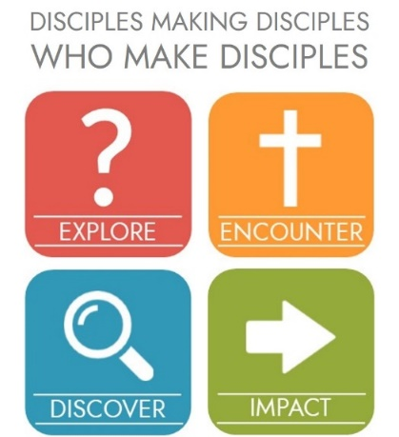
At St Mary's and Sale West we have a discipleship vision 'To make Disciples who make Disciples who make Disciples'
Our strategy for doing this is to:
- provide a clear path for spiritual growth.
- provide Discipleship Communities, Discipleship Courses and Serving Opportunities that are appropriate to every stage of maturity.
- encourage every church member to develop and commit to Personal Spiritual Practices.
- enable every church member to identify where they are in their journey with Jesus so that they can choose appropriate steps for their continuing growth.

This vision is based on the Great Commandment and the Great Commission
The Great Commandment - ‘Love the Lord your God with all your heart and with all your soul and with all your mind.’ This is the first and greatest commandment. And the second is like it: ‘Love your neighbour as yourself.’ (Matthew 22: 37-39)
The Great Commission - go and make disciples of all nations, baptising them in the name of the Father and of the Son and of the Holy Spirit, and teaching them to obey everything I have commanded you. (Matthew 28: 19-20)

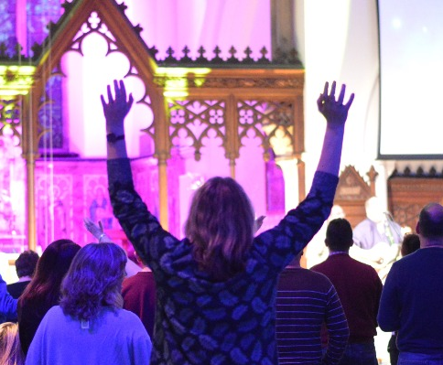
What we do

Regular worship services
- Sunday’s 9.30am family service at St Mary’s
- Sunday’s 11.15 traditional service at St Mary’s
- Sunday’s 7pm contemporary service at St Mary’s
- Sunday’s 4pm family gathering at Sale West Community Church
- Monthly 10am mid-week BCP Service at St Mary’s

Children and Youth
- Junior church alongside 9.30am family service at St Mary’s
- Junior church alongside 4pm family gathering at Sale West Community Church
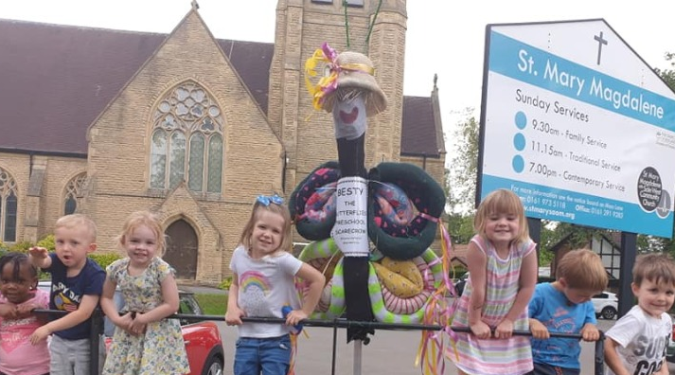
- Regular input at St Mary’s Primary School and links with other local primary schools
- Caterpillars parent and toddler group
- Butterflies pre-school group, ofsted registered early years childcare provision
- Parenting support through courses and resources
- Children and family events throughout the year including Messy Movies, Good Friday, Light Party, Christingles.
- Fuel Youth each Friday
- Link with local secondary school

Discipleship
- Discipleship Communities - Part of our strategy for discipleship is to provide Discipleship Communities appropriate to every stage of maturity:
- New Life Groups
New Life Groups are structured to help people explore and develop a personal faith in a personal God. Providing an introduction to basic personal spiritual practices, New Life Groups are a great way to develop friendships with others who are also exploring faith. We currently have 3 New Life Groups.
- Small Groups and Clusters
Small groups and Clusters provide opportunities to encounter and discover God with other believers, developing deeper relationships with others and supporting people to develop regular personal spiritual practices that will equip and help them to grow in faith. We currently have 17 Small Groups and 2 Clusters
- Huddles
Huddles help people to go deeper in biblical understanding and as they encounter God through personal spiritual practices. The aim is that lives will be impacted both inside and outside the church through evangelising, discipling, mentoring, interceding or teaching. We currently have 13 Huddles.
- Discipleship Courses - We have a range of Discipleship Courses to help people grow in faith and support the in life. Part of our strategy for discipleship is to provide Discipleship Courses appropriate to every stage of maturity:
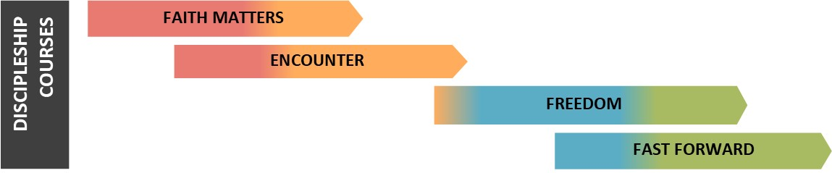
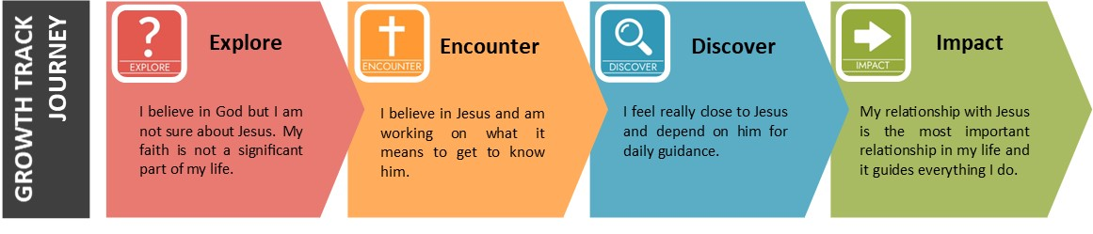

- Faith Matters – A 5-week course giving people time and space to Explore faith.
- Encounter - A 7-week course for anyone new to faith and for those wanting to refresh their faith
- Freedom – A discipleship course for church members focussing on our identity as Christians.
- Fast Forward – A 7-week course that studies theological aspects which will impact people’s missional effectiveness

Other courses
- Kintsugi – A 12-week discussion based course to improve self-understanding, permit people not to be ok at times and equip them to help others.
- The Bereavement Journey - A 6-week course guiding people through the most common aspects of grief.
- Exploring Marriage - for people getting married in the next year, a practical course exploring relationships.
- Money Budget Management Course – The CAP course helping people to plan their finances better.

Praying for the Nations – A regular prayer group, praying for different countries around the world.

Come Fly With Me – A monthly group for people who want to learn more about hearing the voice of God.

Mission Partners
Overseas partners: Church Mission Society, Overseas Missionary Fellowship, Operation Mobilisation, Open Doors, Philippines Outreach Centre, ACTS Education in Africa (Burundi).
UK Missions: Boaz Trust, Youth for Christ, Hope for Justice.

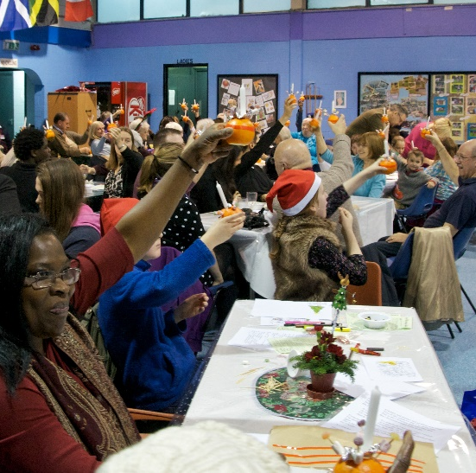
Heartbeat Café
The Heartbeat Café runs from the church centre every Tuesday and Thursday open to church members and the public. It’s a welcoming space where people can connect and enjoy some homemade treats.

Sale West Activities
We have 2 Children and Families Workers for Sale West and they are involved in a variety of projects including:
- Keep Calm and Craft a weekly craft group for vulnerable people who suffer from mental health issues, who feel lonely and marginalised.
- ROC Mentoring
- The Cave a weekly youth group for young people from the estate

Finances
Financial Summary 2020
Income
Regular giving £277,164
Pre-School Group £109,305
Church Centre lettings £20,266
Other income £23,625
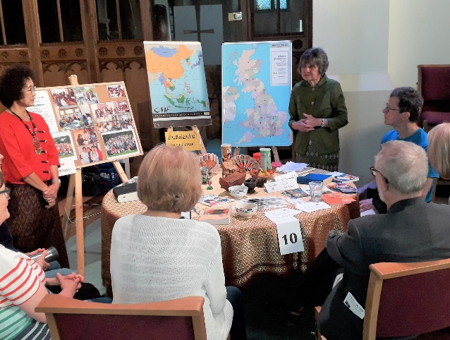
Total Income £430,360

Expenditure
Grants and home missions £38,775
Clergy and staff £220,858
Church activities and maintenance £42,456
Pre-School Group £88,541
Church Centre £18,893
Total Expenditure £409,523

Surplus of Income over Expenditure £20,837
Cash balance at end of 2020 £136,129

Mission Giving
As a church we donate 10% of the giving we receive to missions, both here in the UK and overseas. We see this as our stewardship, or good management, of the money we receive from God, just as we encourage church members to steward their income. In practice we donate 10% of our previous year’s giving, and in 2020 this amounted to £29,093.

History and location

Our history – St Mary Magdalene
Christians have worshipped God in Ashton-on-Mersey for hundreds of years. A settlement is mentioned in the Domesday Book and there are also indications of a Saxon Chapel. In 1304 the parish of St Martin's was founded.
Towards the end of the 19th Century there was a growing realisation of the need of a second church to serve Ashton on Mersey. The decision to build St Mary Magdalene was a bold and courageous step as the population had not yet arrived! There is evidence that the fields around the church were used for growing rhubarb. St Mary's was originally known as 'The Church in the fields'. Our predecessors were building for the future.
Ashton on Mersey and Sale were about to witness a huge population growth served by the Bridgewater Canal, the Roman Road (A56) and Flora the first engine on the Altrincham to Manchester railway line (now the Metro line).
Since St Mary's was founded in 1874, the church has never stood still; the ministry and worship have been constantly enhanced and extended. The vision, 'To be a growing church' is in our spiritual DNA.
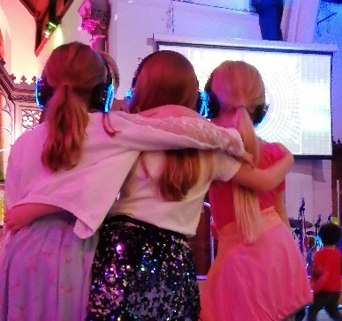
The churches impact on the community has been obvious through the work of the church schools; All Saints Mission Hall in Somerset Place; a Nursing Home in St Mary's Road (which later moved to Sandiway Road) and local almshouses. Over the years, the church also employed a community nurse and other full time staff to serve the locality. In 1968 the Church Hall was built and was of huge benefit to church and community.
Towards the end of the 20th century the Church Centre was added which has proved to be the catalyst for growth in the life of the church. Many community groups use the building and we are able to use the space for many mid-week ministries and activities.
In 2017 the church was reordered which saw the removal of the pews along with the creation of a prayer room and an extension to the dais, allowing for better access into the chancel. The reordering has enabled many events to take place using the space in creative ways.

Our history - Sale West Community Church
Sale West Community Church was established by a number of local churches of different denominations in 1971 as people were being relocated to the Sale West estate from central Manchester. St Mary's first provided a full-time worker for the church in 1974 and more formal links were developed in 2001. The church has continued to flourish in recent years and now has about 100 members.

Our location
Ashton-upon-Mersey was the original township in this area but is now a suburb of Sale in the borough of Trafford. We are six miles south-west of Manchester and close to the beautiful Cheshire countryside. It is close to several well-known amenities such as the Bridgewater Concert Hall, (home of the Hallé Orchestra), Lancashire Cricket Club, Manchester City and United Football Stadia, The Arena (a concert venue) and The Trafford Shopping Centre, all of which can be accessed using the Metro Link trams. There are several National Trust properties within easy
Reach and the newly opened RHS Bridgewater Garden. Ashton-upon-Mersey is well served by the motorway network and Manchester International Airport.
