Headteacher Wellbeing
Programme 2021-22

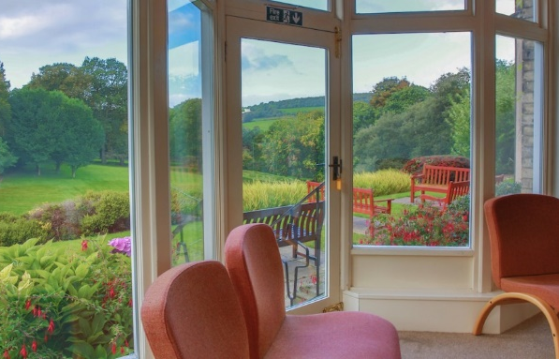
Wellbeing can be elusive to Headteachers/Principals who are juggling their daily workload and challenges of headship. This programme provides the opportunity to develop networks and practices that will help your own wellbeing and is aimed at enabling you to achieve a better work-life balance in your career.
We cannot remove the daily stresses of the job, but we can provide the time and space for reflection, a listening ear, practical support, discussion and encouragement aimed at helping to improve your wellbeing.
The programme has been designed to run over the course of the academic year and will include ‘face to face’ days, access to a mentor, visits to your school and peer to peer support. There will be two cohorts – ‘experienced’ and ‘recently appointed’. The cohort size will be kept purposefully small.
Content of the Course
The sessions will be tailored to the group’s needs and individual school circumstances and will allow time for reflection and partnership building. There will also be the option for external speakers to contribute to the programme.
Session One: Relationship Building
Experienced Headteachers: Friday 8 October 2021
Recently Appointed Headteachers: Thursday 14 October 2021
Session Two: Focusing on You
Experienced Headteachers: Thursday 18 November 2021
Recently Appointed Headteachers: Friday 3 December 2021
Session Three: Facing the Daily Challenges
Experienced Headteachers: Thursday 24 Mar 2022
Recently Appointed Headteachers: Friday 25 Mar 2022
Session Four: Keeping True to Your Vision
Experienced Headteachers: Tuesday 21 June 2022
Recently Appointed Headteachers: Friday 24 June 2022
Small Schools Session:
**NEW FOR 2021-22** Friday 4 Mar 2022
An extra session for those attending the full programme who are also heads of small schools to look at some of the specific challenges that arise from leading a small school.
You will also be allocated a mentor who will meet you once a term for a face-to-face meeting to check on your wellbeing.
Venue
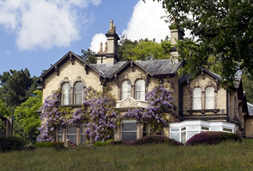
The course incorporates four ‘face to face’ days (plus an additional session if you are the headteacher of a small school) that will be held in the tranquil and beautiful setting of the Diocesan retreat centre at Foxhill, Frodsham.
Each day will be spent together with the course leader and delegates and will allow time and space with use of the chapel and grounds and includes a two-course lunch together.
Cost of the programme
The cost for the programme includes the ‘face-to-face’ days at Foxhill, course materials and resources, access to a mentor throughout the year, visits to your school and peer to peer support.
The cost for the year long programme is £250 for Family of Schools members.
___________________________________________________________________
Please submit your request by 30 Sept 2021 to book your place.
E-mail Charlotte Somers on charlotte.somers@chester.anglican.org

Please provide the following information:
Name:
School:
Email address:
Telephone Number:
Dietary Requirements:

