The Parish of St Martin, Ashton-upon-Mersey, Sale,

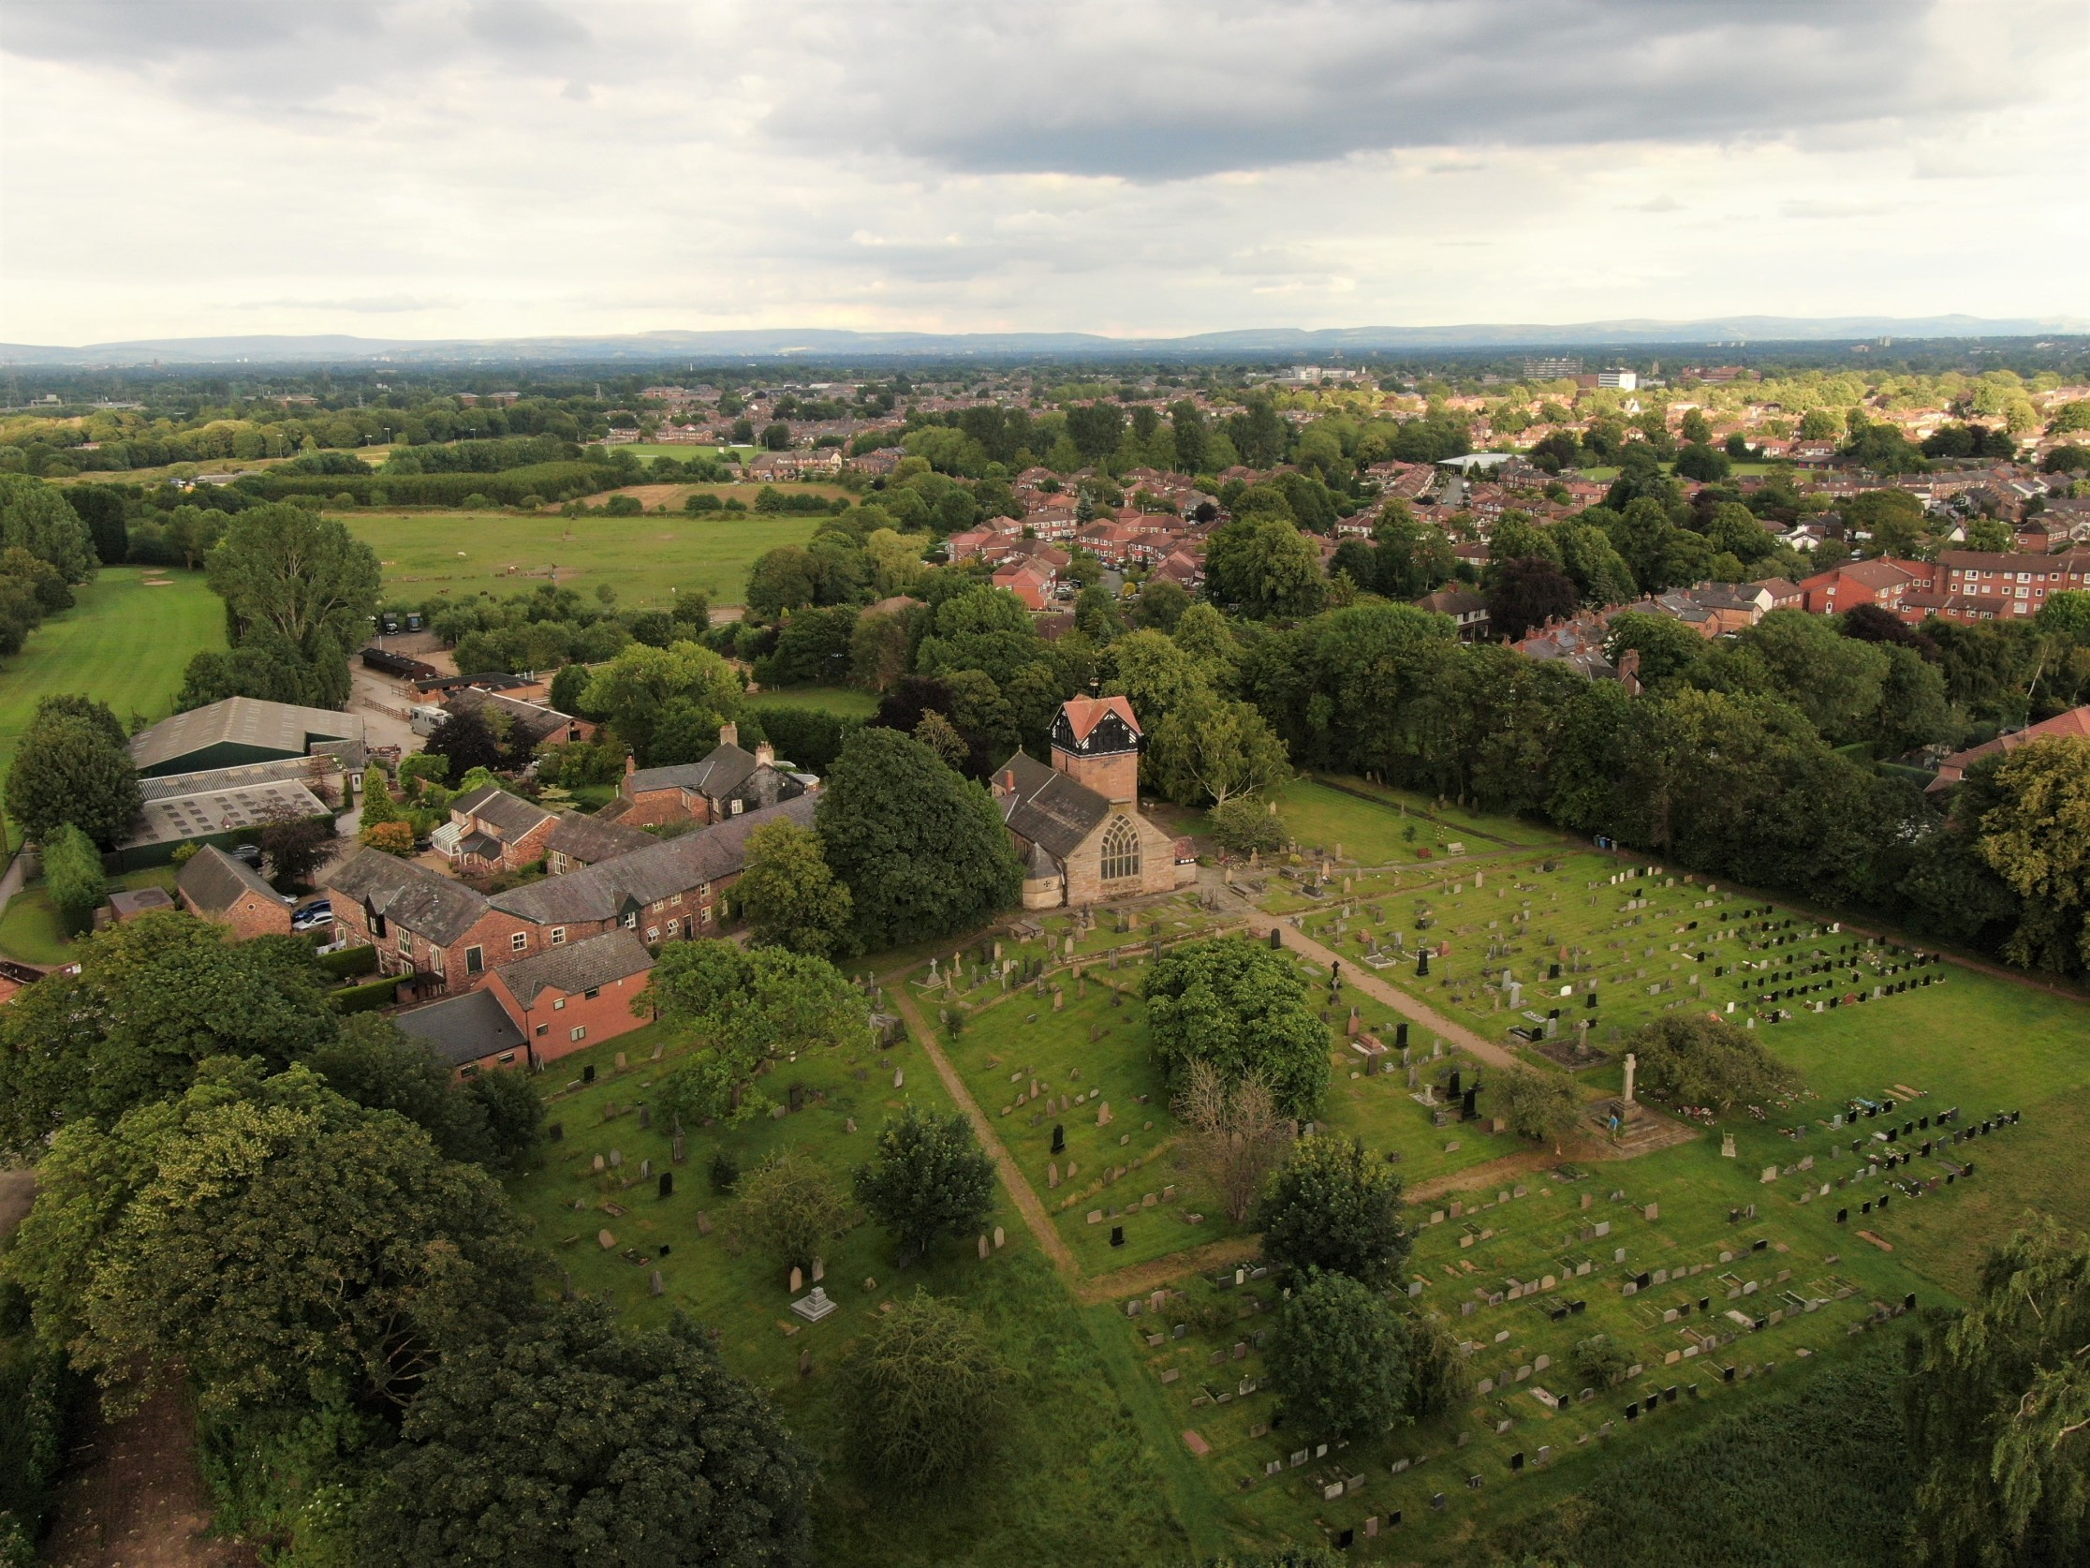

Parish Profile

Where are we?
Ashton-upon-Mersey was the original township in this area but is now a suburb of Sale in the borough of Trafford. We are six miles south-west of Manchester and close to the beautiful Cheshire countryside. It is close to several well known amenities such as the Bridgewater Concert Hall, (home of the Hallé Orchestra), Lancashire Cricket Club, Manchester City and United Football Stadia, The Arena (a concert venue) and The Trafford Shopping Centre, all of which can be accessed using the Metro Link trams. There are several National Trust properties within easy reach. Ashton-upon-Mersey is well served by the motorway network and Manchester International Airport.

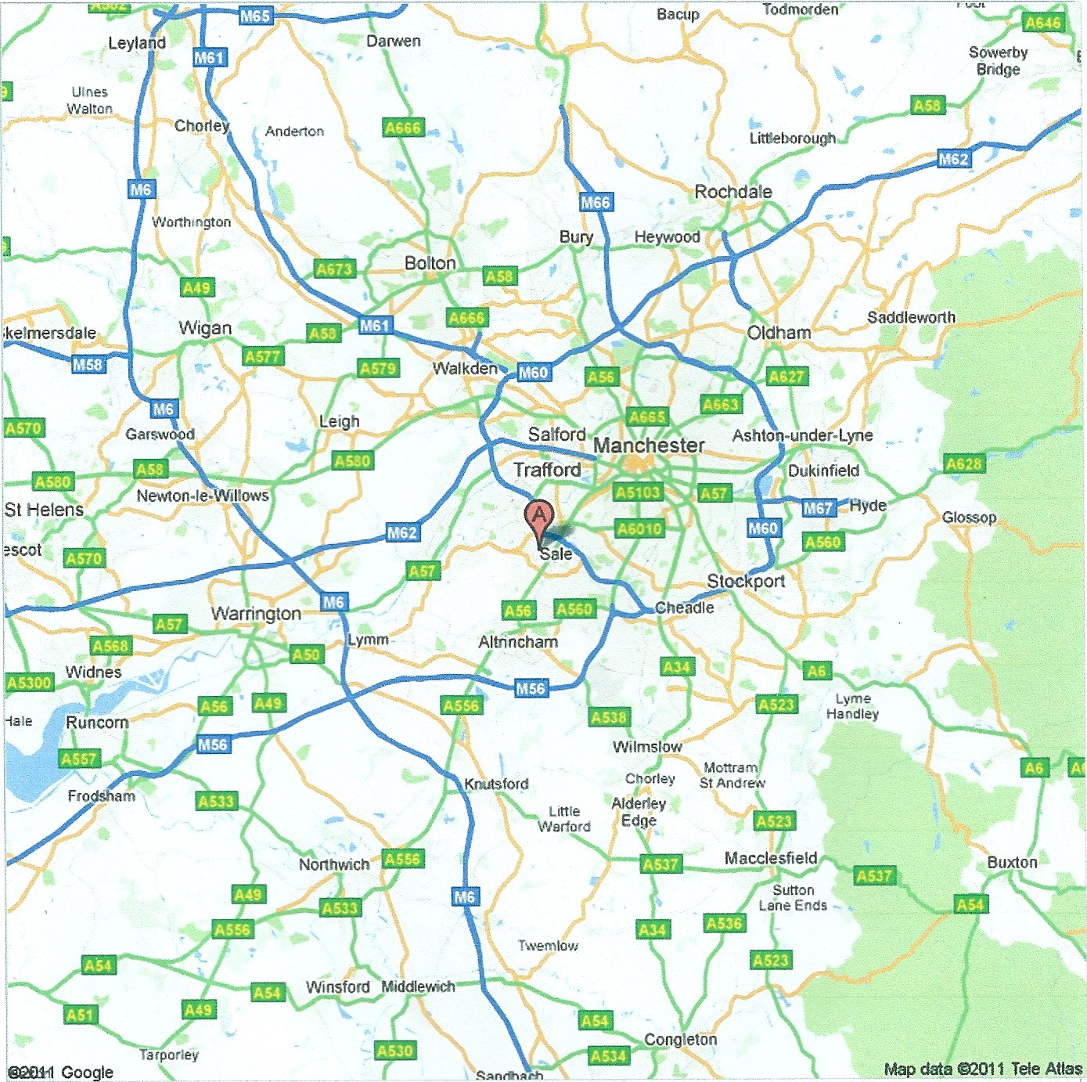

Parish Boundary
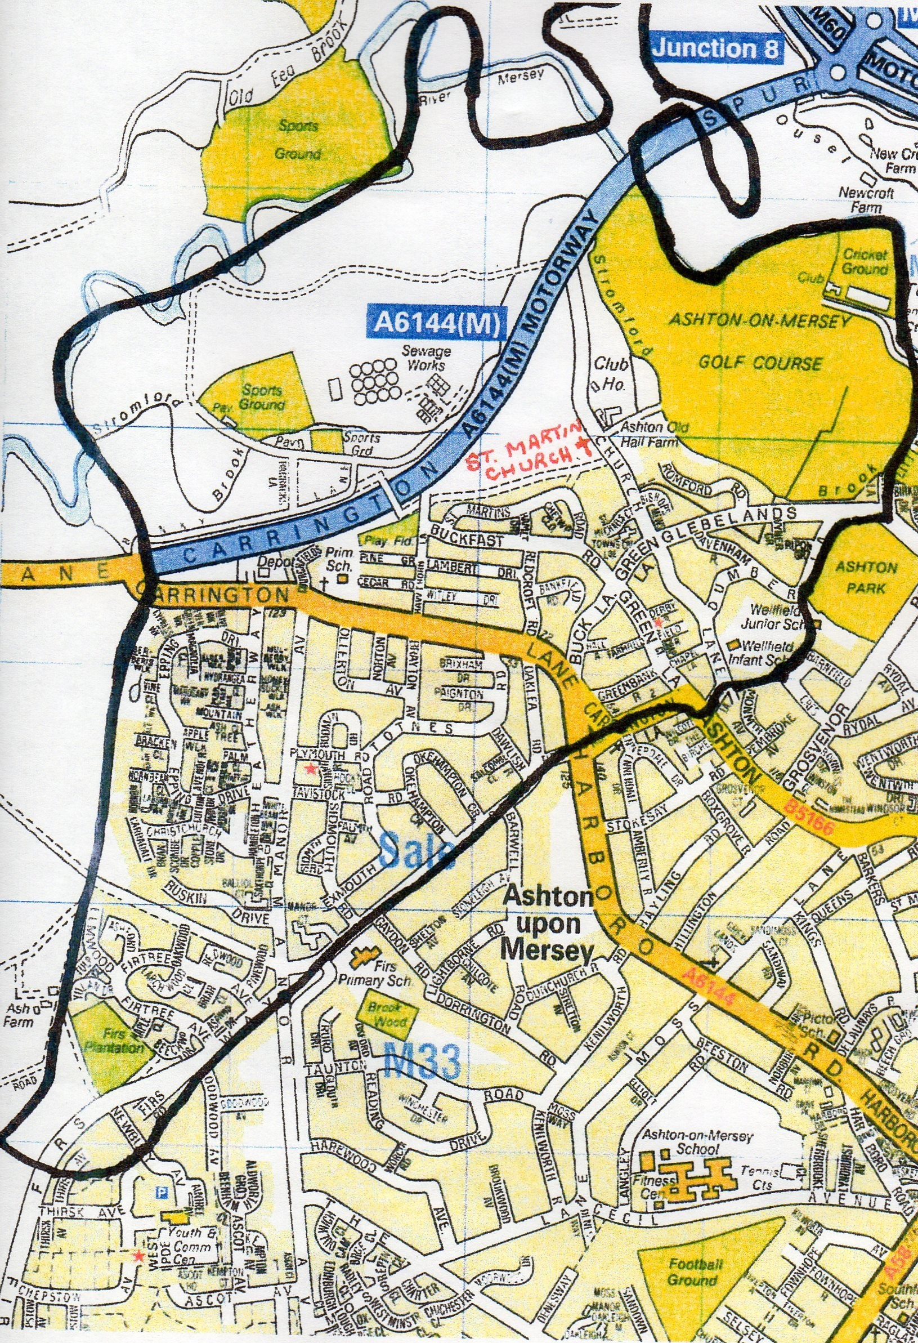

Our Community

Ashton-upon-Mersey is on the edge of the Cheshire countryside. It has a village feel although it has a population of approximately six and a half thousand. There is a thriving shopping area with two public houses, restaurants, two medium sized supermarkets and a variety of individual shops as well as business premises all of
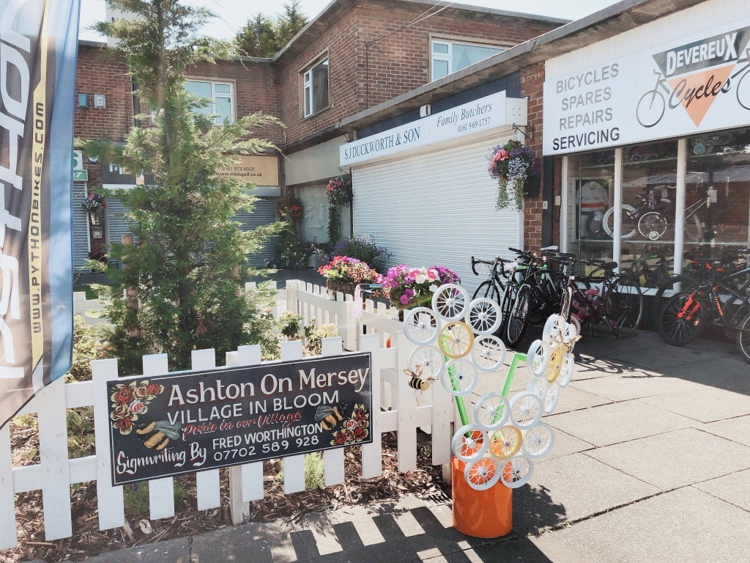
whom support our major fund raising events. The housing in the Parish is mostly privately owned but there is some social housing of which some have been bought. The
village has an infant school and a junior school both of which St Martin’s has links with. There is a church school in the next parish where some St.
Martin’s children go and where our previous incumbent took assemblies. Within easy reach there is a variety of outstanding secondary and further education establishments

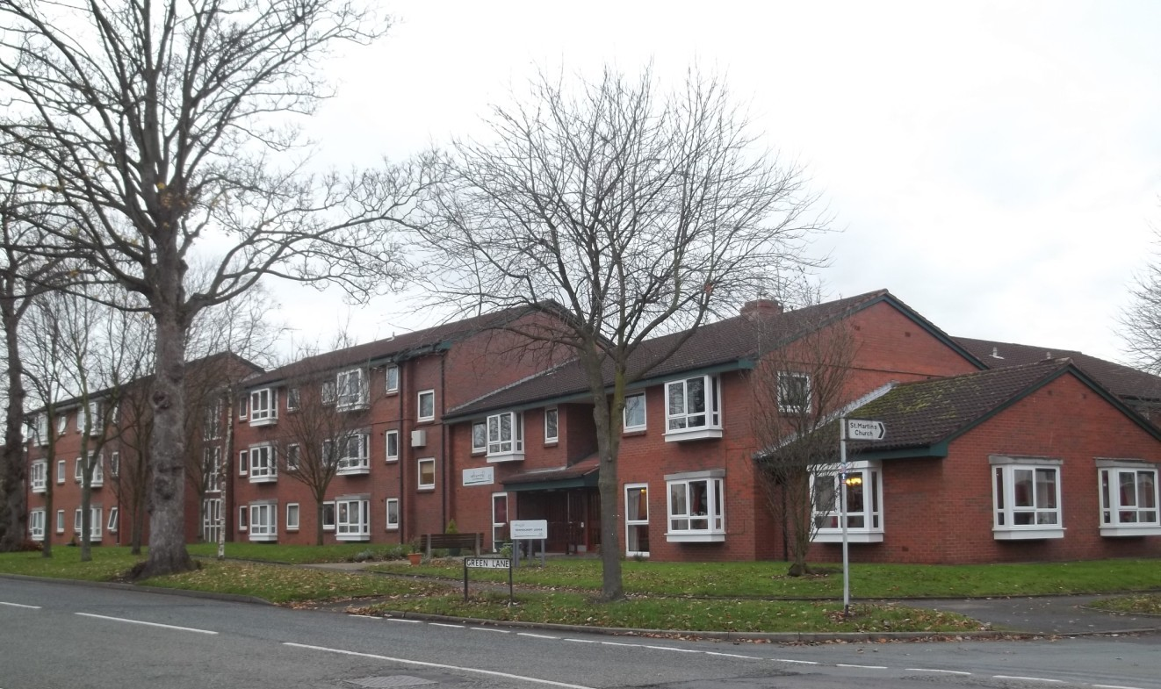
Townscroft Lodge and St Michael’s Court are close to the church and provide shel- tered housing for the eld-
erly. Also in the parish is Manor Court where our previous incumbent took monthly services which are being continued by members of the congre- gation. Each year for the Archbishops ‘Thy King- dom Come’ initiative we have had daily prayers at different locations in the parish supported by a number of members of the congregation

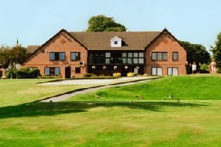
A short walk from the church leads you to Ashton-upon-Mersey Golf Club. Also nearby is the Rugby and Cricket club as well as an
F.A. Youth supported football club and the River Mersey, along which runs the Trans Pennine Trail.

There are riding stables and a large public park with play areas for children of all ages.
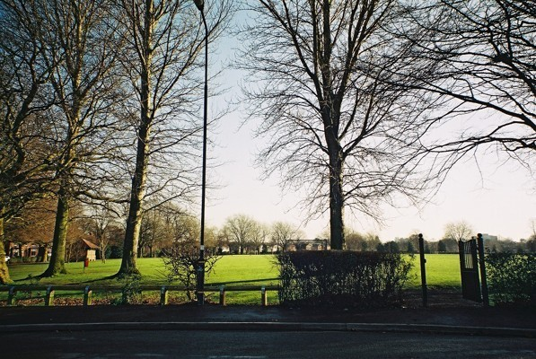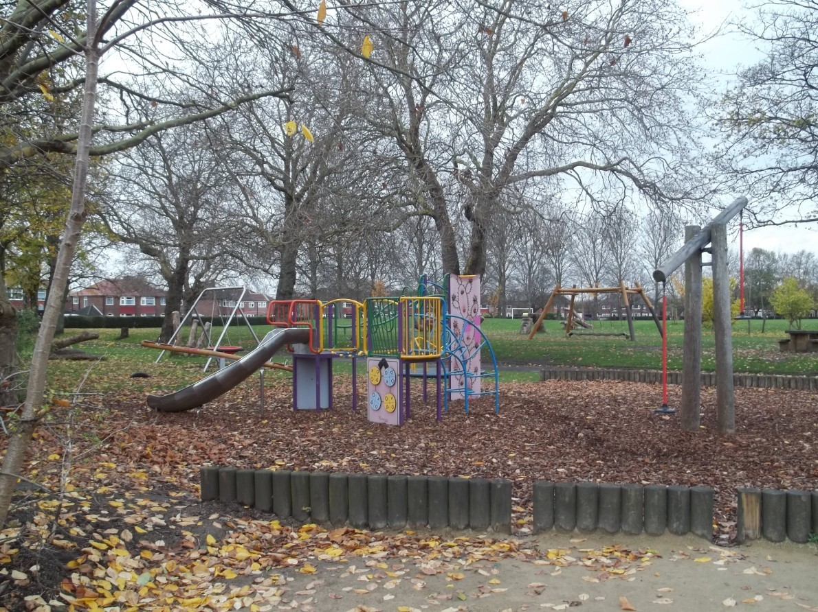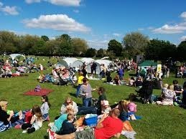

‘The Friends of Ashton Village’ are very active, organising things such as a street market each year in December and a Picnic in the Park in the summer with entertainment and stalls. Fund raising events are held to provide Christmas lights in the village including concerts in the church and each year they run ’Voice of
Ashton’ singing competition which is hosted alternatively by the two village pubs. This year they organised ‘Village in Bloom’ in which we won a Silver Gilt Award. The Local councillors are supportive of all church events and in creating a more cohesive local community.
In recent years St Martin’s has hosted the Mayor’s civic service and there are close links with the present Mayor.

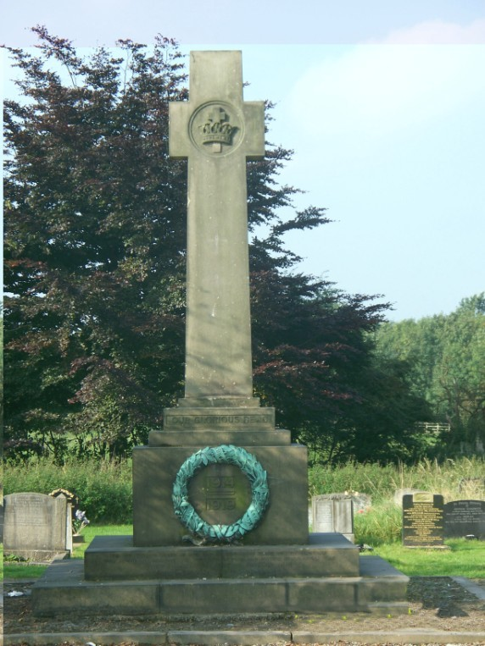
Our Church Building
St. Martin is the ancient mother church of the area being first recorded in 1304 on Anglo Saxon foundations. The present grade 2* listed building dates from 1714 with the Victorian addition of a tower built to celebrate the Golden Jubilee of Queen Victoria in 1887.

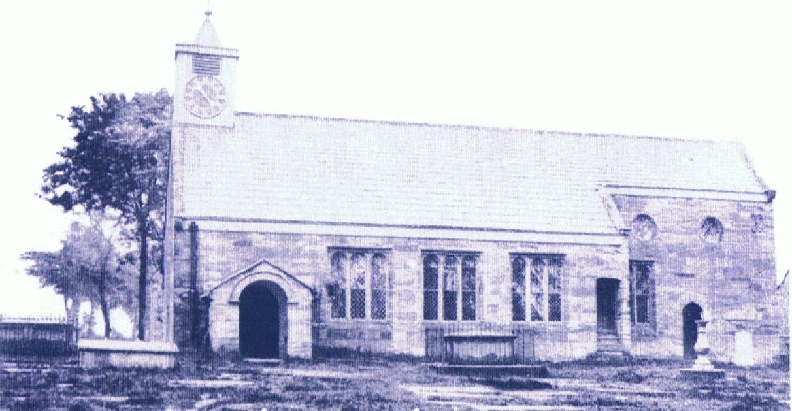
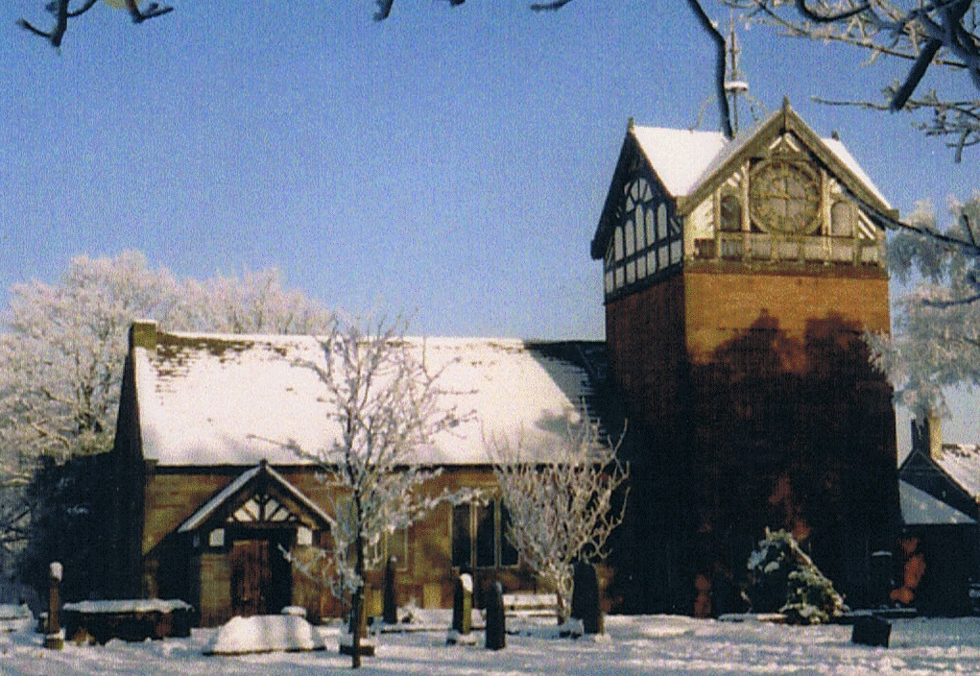

The church is approached through a timber framed grade 2 listed lych gate
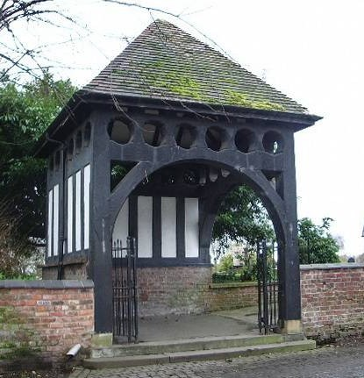
St. Martin’s is situated in a conservation area on the edge of the village in a rural setting with a large well maintained graveyard which is still in use. There is a cenotaph in the graveyard commemorating those who gave their lives in both world wars and an early nineteenth century stone sundial, both of which are grade 2 listed.
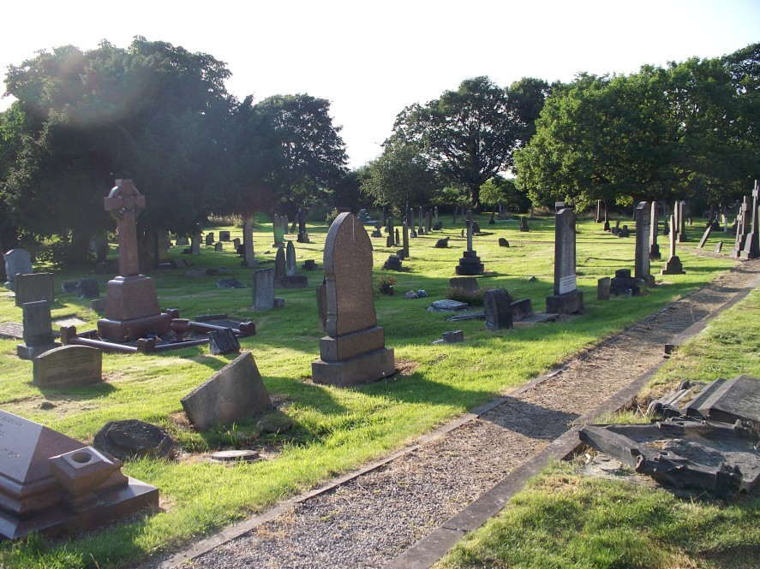

2012 saw the completion of major works to renovate and restore the tower which was shortlisted for the John Betjemin Memorial Award.

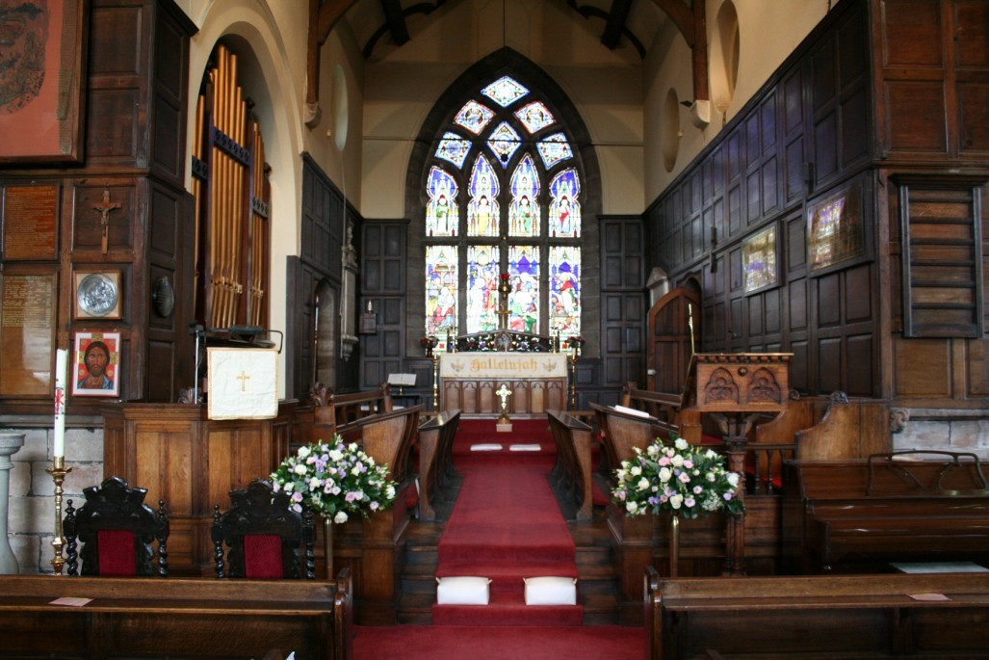
The inside of the church is traditional with oak pews, an 18th century balcony and a prayer chapel situated in the Victorian
Baptistry.

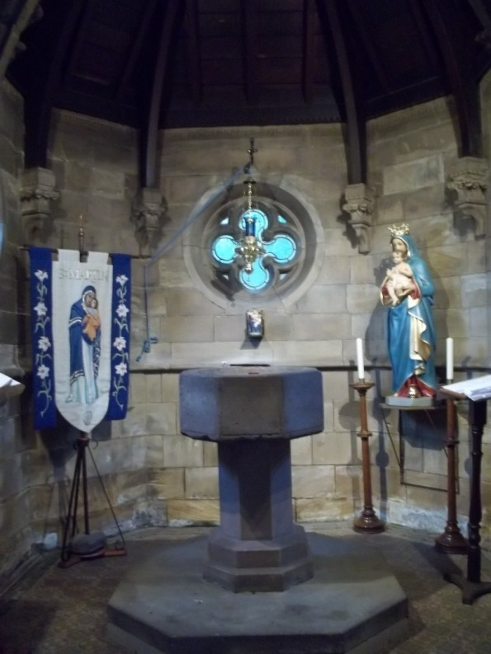

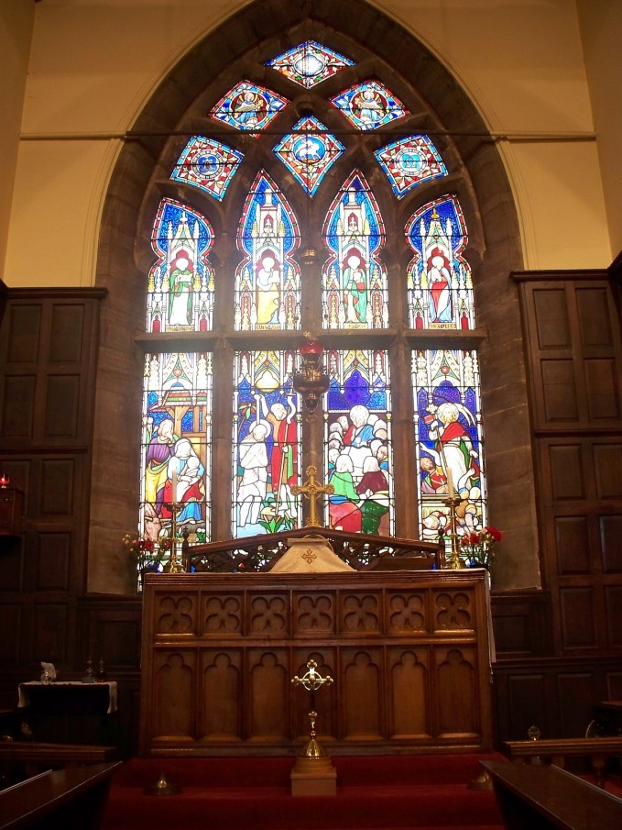
The stunning East window depicts the major events in Jesus’ life.
There are a number of other stained glass windows given in memory of local people.

If you think you have seen this beautiful church before it could be because you have watched various television programmes featuring St Martin’s including Coronation Street and Shameless.

Worship and Ministry at St Martin’s Church
St Martin’s is a friendly church offering traditional services with 121 on the electoral roll with an average attendance of 69 over both Sunday services and 15 at the Wednesday morning service.
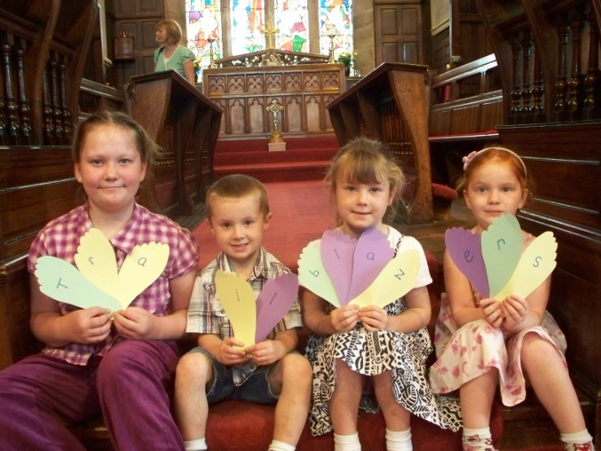
We have two Eucharistic services each Sunday - a said BCP service at 9.00am and a Choral Eucharist (Common Worship) at 10.15am supported by a robed choir (affiliated to the R.S.C.M.) using ‘Hymns Old and New’. Some settings for Eucharist were written by former members of the congregation. A small Sunday school (presently suspended) met during term time in the Church hall and came into church towards the end of the 10.15am Eucharist for a blessing and to tell the rest of the church what they have been learning.
On 2nd Sundays there is a more relaxed all age Eucharist which includes children and young people as much as possible.

There is a mid-week B.C.P. said Eucharist on Wednesday at 10.00am.
During Advent and Lent we have joint worship with the local Roman Catholic Church with whom we have a number of links. There has been regular contact between St. Martin’s clergy and the local Methodist circuit ministry.
There is a children led Christingle Service during Advent. Holy Week and Easter is fully observed with a range of worship and other major festivals (eg. Ash Wednesday,
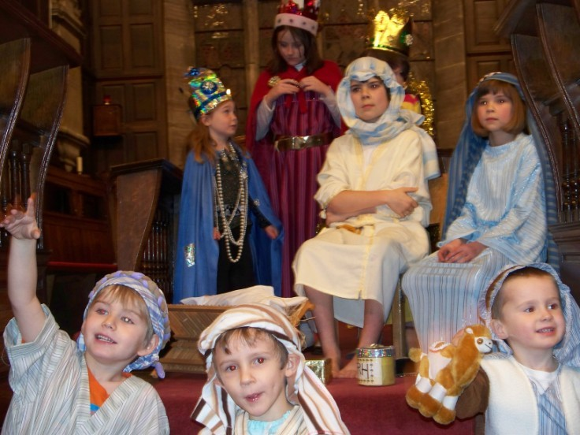
Ascension Day) are marked with a sung Eucharist.
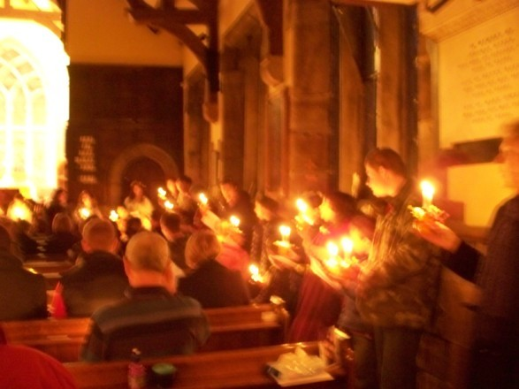

Vestments are worn at all services, which are now being continued under the guidance of a retired Rural Dean. St. Martin’s congregation includes a retired priest.

Baptisms are currently held on the first Sunday of the month at 12.00 noon, with 30+ each year.
The Parish Clerk/Verger, as well as looking after the grounds is involved in the administration of weddings (approximately 6 per annum) and funerals ( approximately 10 in church per annum and 20 at the crematorium per annum).

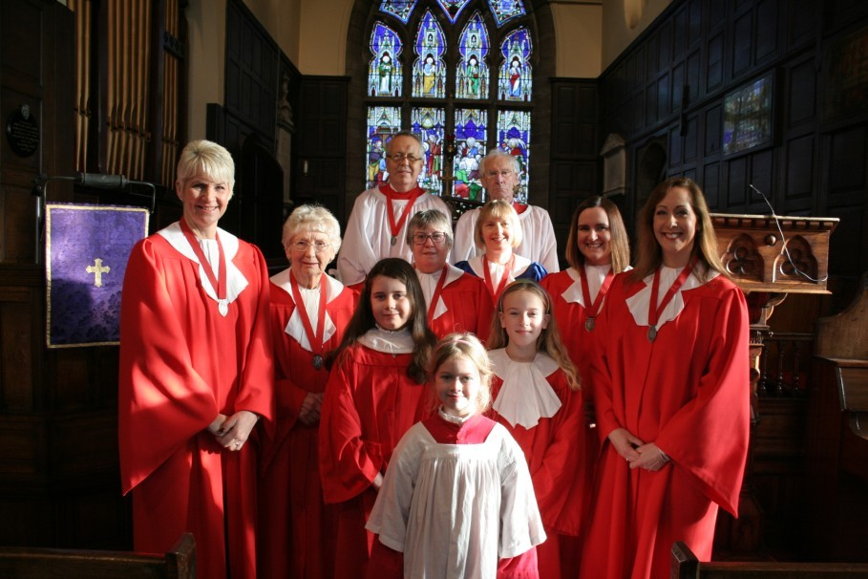
There is a good musical tradition which is led by the organist and choir director. The choir lead the 10.15am Eucharist as well as singing a communion psalm and at special services an anthem. We also have an auxiliary choir which sings at weddings and funerals. In recent years the choir have presented ’Supper with the Choir’ and ’Winter Wonderland’ concerts. Since 1991 the choir have sung Carols at the golf club before midnight mass.
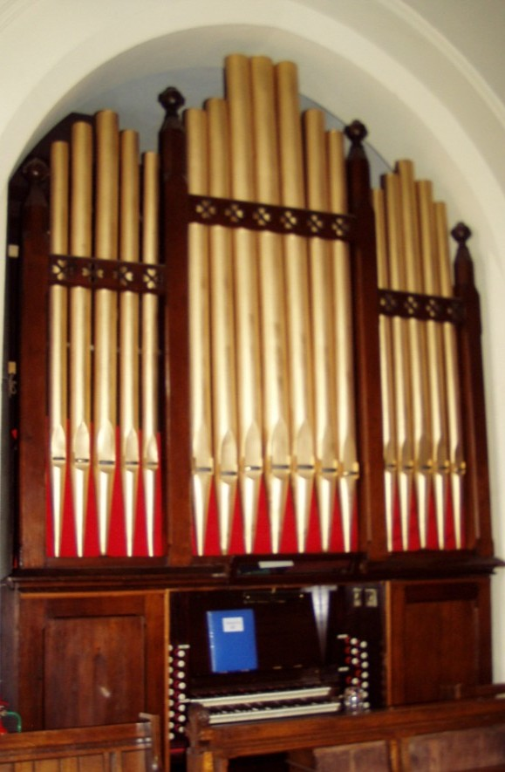
The choir is accompanied by a three manual Jardine organ, which is in good order and regularly tuned.

Members of the congregation contribute to the life of the church by reading the scriptures and leading the intercessions at the main Sunday service. We also have a friendly and welcoming team of sidespeople at both services. There is a small team of people who assist with the distribution of communion both in church and in people’s homes.
In the past two members of the congregation were ordained and are serving else- where in the diocese. Several people training for both ordained and lay ministries have undertaken placements of varying lengths at St. Martin’s church in recent years.

Parochial Church Council meets six times a year. There is a designated Parish Office in the church hall but it is not regularly manned at present. In addition to the regular P.C.C. Agenda items, we have discussed topics such as Friends of St.
Martin’s, Eco church, Christmas tree festival and other community outreach activities in the past couple of years.

The church also has designated health and safety, fire safety and safeguarding officers who are compliant with the relevant regulations.
In recent years, Electoral Roll Numbers have remained fairly static, but around a quarter of the current congregation have joined in the past 5 or 6 years, replacing many older members who have moved away or died. At this point in the congregations life we see this as a time of opportunity and change

Outreach and Mission
Over the past few years St. Martin’s has become more creative in seeking to connect with the local community and wider world and engage with the call of Christ to ‘love God and love our neighbour as our self’.
This has resulted in a number of one-off, occasional and regular initiatives including:

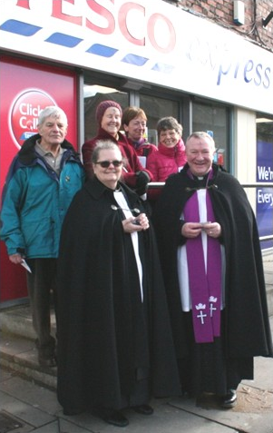
Pastoral and prayer visiting to the local shops and businesses around Advent and Christmas

Increased use of the church building/grounds/hall for community concerts and events (local history talks, ‘Elvis spiritual concerts, Unicorn Races, Candlelight Concerts in aid of the Friends of Ashton Village.

New leaflets: the history of the church: marriage in St. Martin’s, the use of Fair Trade products at church events and registering with A Rocha /Eco church

Imposition of Ashes on Ash Wednesday, shoe polishing
on Maundy Thursday in the local shopping area with St Paul’s C of E Church, Sale.

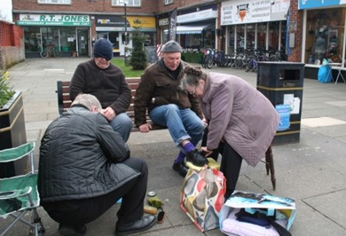

We are considering ways of overhauling our website and the use of facebook and other local social media sites for better communication and publicity of services, events etc.

What we want in our next Vicar!

- We are looking for a priest-in-charge who has an Inspirational and flexible approach to worship.

- We have a good community spirit in Ashton-upon-Mersey and St. Martin’s is a warm and welcoming church which needs a priest who is a visible and known presence in the parish.

- A priest who is aware of opportunities to connect through social media and video communication would be of benefit to the parish.

- Our new priest will enjoy spending time with children and will work with local schools to develop established links.

- A mature and enthusiastic outlook on life combined with a good sense of humour is essential.

- Our new priest should have a love for the Gospel and mission, be forward thinking and able to inspire, stimulate and grow our congregation.

- The smooth running of our parish depends on the leadership team having excellent organisational, time-management and communication skills which are qualities we are looking for in our new priest.

St Martin’s Hall and Rectory

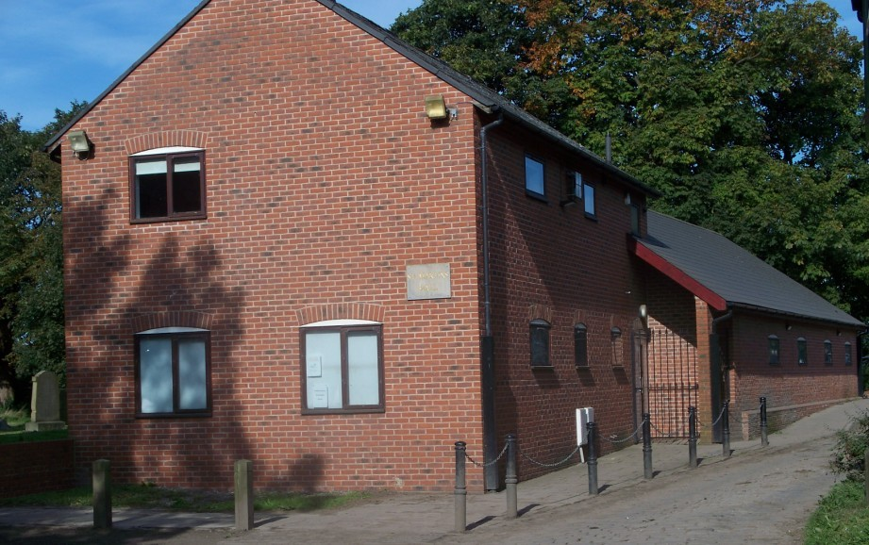
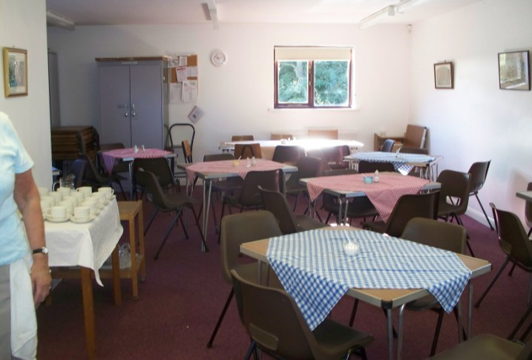
The adjacent modern hall was built in 1992 and extended in 2003. It is in good repair and comprises a meeting room, large hall (seating 100), kitchen, office, disabled toilet, gents toilet and store room on the ground floor and a small hall, kitchen and ladies toilet on the first floor.

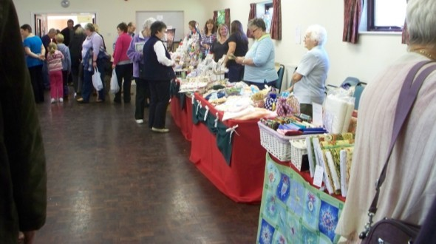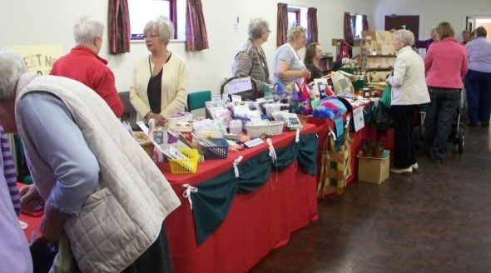
Large Hall

The small car park is situated between the church and
Small Hall

the hall and we have reciprocal arrangements with the nearby golf club to use their car park.

Refreshments are served in the hall after the 10.15am service on Sundays.

During the week many activities take place in the hall including: Rainbows, Brownies, Guides, two art clubs (who hold exhibitions during the year), pilates, as well as fund raising and social events run by members of the church. A local drama group hold exams in the hall twice a year. The hall is regularly hired for children’s and adult parties. It is well used for a variety of community and social activities eg.
Monthly Friendship Group meeting, annual winter, summer and craft fairs.

On the third Wednesday of the month we have a parish lunch which brings people from the congregation and wider community together in a relaxed social atmosphere.

The detached 1930’s brick built rectory is a short distance away and comprises of two floors. On the ground floor there is a study, dining room and lounge, large kitchen, and two toilets, one of which has disabled facilities. Upstairs comprises four double bedrooms, one of which is en suite, and a family bathroom. There is disabled access to one side of the house and a detached garage to the other. The enclosed rear garden is a good size.

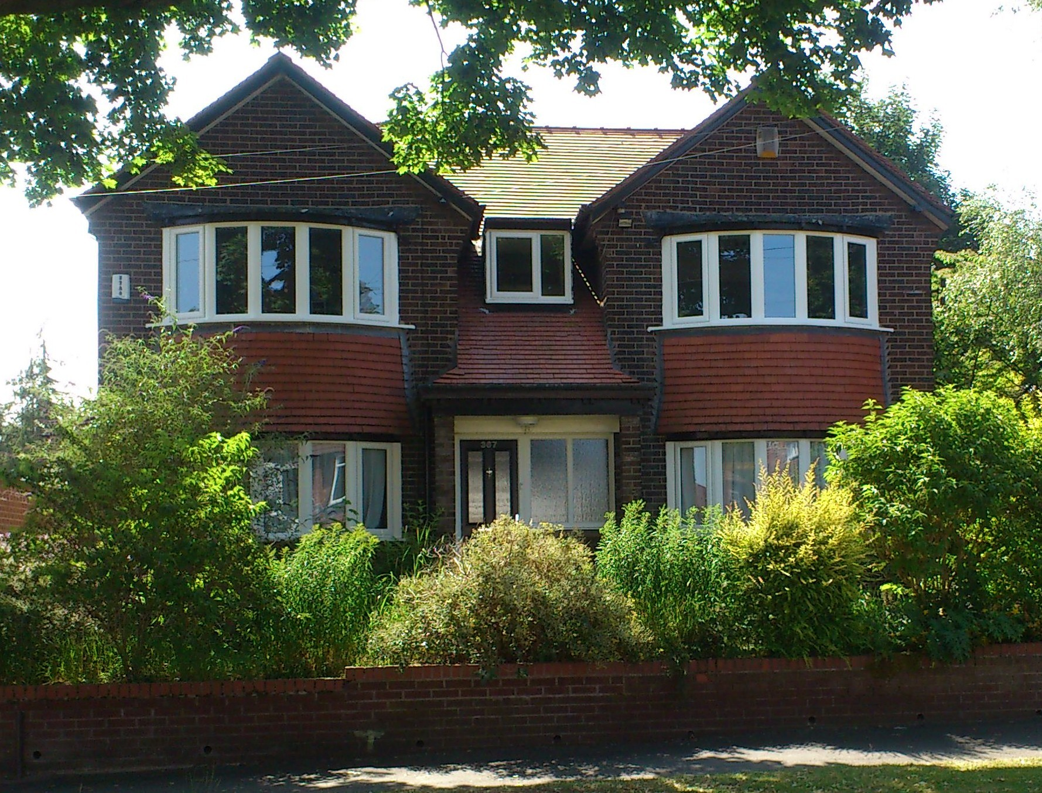

The Rectory was extensively refurbished in 2012.

Financial Overview

To increase our financial position, the congregation are encouraged to belong to a planned giving scheme, a total of £36739 in 2019, whereby the Gift Aid can be claimed back where possible. This along with cash on the plate and the use of pew envelopes from all the services amounted, in 2019, to a total income of £39,933.
This was less than in 2018 by some £2000 but a recently undertaken stewardship campaign has had some effect as our regular giving has shown some increase towards the end of the year.
Unfortunately over the last 4 years we have struggled to pay the full parish share, having only been able to pay some 85%/86% annually, and a shortfall of some
£30,000 has arisen over this period. Actually this is better than what we thought and we do try our best.

In 2019 a new heating system was installed and this was paid for through a combination of fund raising, legacy money and generous personal donations. Installing this new system was based on the need to replace an ineffective boiler and Victorian pipes and looking to decrease our bills and carbon footprint.

At St Martin’s we support Christian Aid, a local food bank and The Mustard Tree which is a Christian Charity whose mission is to “improve and rebuild the lives of homeless and marginalised people in Manchester”. By use of home collection boxes and Christingle Services support is given to the Children's Society. For the past few years we have supported Samaritans’ purse ‘shoe box’ appeal and from time to time support has been given to local and international appeals e.g.. Booth Centre, CMS girls education in Africa and mosquito nets.

—————————————————————————

Church members are spread throughout Ashton-upon-Mersey and Sale in a variety of key roles in organisations such as Guiding and Scouting, Mothers Union, Ashton- upon-Mersey Society of Artists, Sale Art Society, Probus, U3A, Sale Civic Society and Sale Male Voice Choir. These are not all demonstrably religious but they do support a general approach of forming relationships within the community.

