History of St Mark’s, Dunham Massey

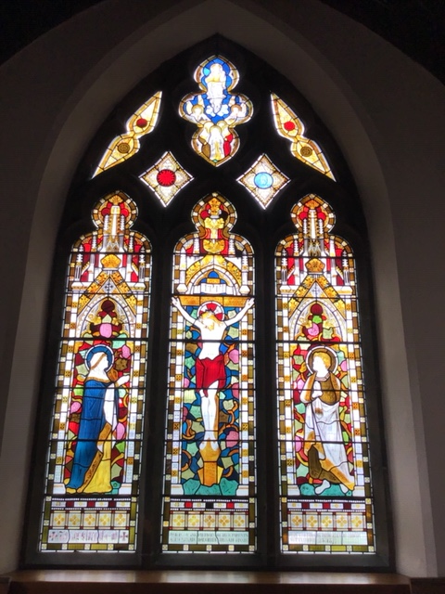

The church was built in 1866 as a daughter church of St Mary’s, Bowdon, at a cost of £1500 which was raised by public subscription. It was built on land given by the 7th Earl of Stamford. St Mark’s became a separate parish in 1873 when Rev J White (1873-1875) became the first vicar. Since that time there has been 13 ministers leading us in worship. The last vicar, Rev Jerry Sutton(2000-2019) went on to pastures new as an Army Chaplain in Stafford.
Many improvements have been made over the years, new organs, replacement of gas lighting for electric ones, new pulpit and pews from (1962) in memory of the Countess of Stamford, Elizabeth Louisa Penelope by her children, Roger, Earl of Stamford and his sister, Lady Jane Turnbull.
After the WW2, the three bomb damaged windows were replaced at a cost of £159.6s.8d which included the cost of brickwork to make good following bomb damage in 1940. The Philanthropist, Mr Berry, of Parklands a regular worshiper at St Marks paid for the refurbishment. He and all his family have been generous givers to our church.
In 1948, a new electric organ blower was installed in memory of Tom Weetman, the church organist who was killed in action in WW2.
In1951/2 the Bell tower was overhauled at a cost of £239.19s.3d.
1953 saw the first phase of roof insulation and a new bell hung in the tower from an anonymous donor.
In the 1980’s an extension to Church, the Geoffrey Seddon Room was completed and dedicated.
In 2005, the Bell Tower became unsafe and was replaced with a new fiberglass structure and electronic bell.
The War Memorial in the garden of church is in memory of the soldiers, sailors and airmen of the village who gave their lives in two world wars.
The Mission Room, St John’s, in Dunham Woodhouses was built in 1912 to fulfil the last will of William, 9th Earl of Stamford. It is now a private house, having been sold in1994.
The most recent work in church has been the renovation and cleaning of the east window and replacing the sound microphone system.

