**THE BENEFICE OF AUDLEM, DODDINGTON AND WYBUNBURY.**

The benefice was created in February 2010. Prior to that Doddington and Wybunbury were linked but Audlem was a single parish church. On the retirement of the incumbent at Wybunbury and Doddington, the benefice was created with the in situ incumbent for Audlem being appointed Vicar to the 3 churches. Since this time, the churches have retained their own identities, services and PCC’s but also work well together. People do support events at each of the churches. 2 Lay Readers work across all 3 churches, one retired priest supports services in Audlem, the other is at Doddington most weeks with occasional services in Wybunbury. It is located near to main line train services in Crewe, close to junction 16 of the M6.

**What we offer to our new incumbent**

* welcoming and supportive congregations and communities
* our prayerful support and encouragement
* our respect for your home life, your prayer life and encouragement and support to take holidays and regular time off each week
* the support of 2 retired Priests on a regular basis, 2 Lay Readers, strong PCC’s and experienced Church Wardens. Also many volunteers are willing to lead intercessions or read in church and a group take part in ‘open the book’ school worship.
* excellent and close links with 4 caring and effective C of E primary schools
* a church band at Wybunbury that enhances worship in a modern designed church. A singing group and musicians group at Audlem. Organists in each church.
* a large 4-bedroom modern purpose-built vicarage with good size garden adjacent to St. Chad's Church Wybunbury.

**We are praying for a priest who :**

* can keep our eyes fixed on God and his love in all we do, and will inspire us and help grow our churches
* is a good communicator, able to listen well and has an approachable and compassionate manner
* has the ability to lead worship and teach the Word of God with reverence and creativity, making the Gospel message meaningful for people of all ages and backgrounds
* ideally has experience of the demands of a multi-church benefice and meeting the challenges of rural ministry and empathises with the needs of the farming community
* is willing to be visible and active in all the villages and can demonstrate a strong pastoral commitment
* is keen to develop our ministry with children & young people; is willing & able to maintain and develop the work in our schools & has an understanding of governorship
* has a commitment to inclusiveness in every sense of the word
* values each person and can encourage and enable all individuals, including those with disabilities, to recognise and develop their gifts in the service of God
* is self motivated and can demonstrate effective organisational and leadership skills
* is outward looking, positive, flexible but focussed
* is willing to engage with and develop ecumenical relationships
* is still growing in their own faith and has a prayerful heart
* is able to recognise the things they cannot do and ask for support
* has a full driving licence and a car - essential to cope with the demands of this role

**AUDLEM ST JAMES THE GREAT PARISH PROFILE**

The Parish of Audlem is the most southerly Parish in the Diocese of Chester and located seven miles south of the Historic Town of Nantwich, Cheshire and roughly equidistant from Whitchurch and Market Drayton at the junction of the A525 and A529.

**Our Vision**

We are a community of people encouraging one another in growing in our experience and understanding of God’s Love. We still have much to learn and do not have all the answers, but we know that in the teaching and life of Jesus Christ we find something, and someone who has the potential to change us for the better.

Like all Christians, and all people, we make mistakes, but we believe in God’s forgiveness and a fresh start. We believe in sharing God’s love through our worship and our actions in everyday life. We have been part of the (Growth Action Planning) GAP initiative.

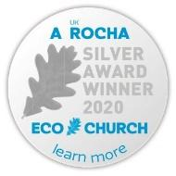

St James Church Audlem is committed to protecting the environment and minimising all harmful impacts. We take environmental concerns into account in our mission, worship, education, training, pastoral, and administrative work and in doing so will ensure the Fifth Mark of Mission is a central part of our life, work, and mission. We were recently awarded the A Rocha Eco Church Silver Award for our efforts so far.

We are part of the joint Benefice of St James’s Audlem, St Johns Doddington and St Chads Wybunbury and work closely with the Methodist and Baptist Churches in the village of Audlem. These links are important to our church community and we are always seeking ways to strengthen our working together sharing God’s love

Our 13th century Grade1 listed Parish Church, dedicated to St James the Great, is situated on raised ground in the heart of the village. The old Butter Market is in the foreground.

In 2019 the Building had some major structural work done to the tower, which has been paid for through a huge fundraising initiative over the past 3 years. Its significance at the centre of the village is supported by the wider community who responded generously during this period.

**Our services**

|  |  |  |
| --- | --- | --- |
| **Sunday** | **08.15 am** | **Holy Communion** |
| **Sunday** | **11.00 am** | **Family Communion,**  **All-age Service/baptism 2nd Sunday and**  **Morning Prayer 4th Sunday** |
| **Wednesday** | **11.00 am** | **Holy Communion or Morning Prayer** |
| **Thursday** | **09.30 Praise & Play** | **Worship For Pre School Children & their Carers** |

*(Tea and coffee served after all services except 8.15am)*

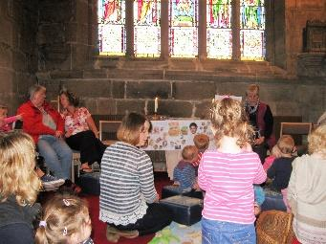

**Praise & Play-an important part of weekly worship**

**Special Services**

These usually take place at Harvest; Mothering Sunday; Easter, (including Maundy Meal and Good Friday service); Ascension Day, Christingle, and Crib Service. **Village Ecumenical Services** take place at Pentecost, Remembrance Day, All Souls Day, and a Carol Service**.**

**Joint Benefice Ascension Day**

**2019 Open Air Service**

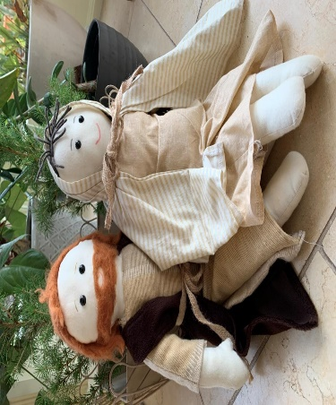

During Advent we have instituted a Mexican tradition called Posada when figures of Mary & Joseph visit homes and our school.

**Other Church Activities**

Mothers Union meets monthly 4th Thursday 2pm

Men’s Breakfast meets monthly Second Saturday 8.15am

Music Group-plays for all age worship

Singing Group rehearses weekly and supports our services

Audlem Voices Choir meet weekly in church

**Fund Raising Events**

**Jazz Concert Afternoon Tea**

**Working with our school**

The village school, Audlem St James CE Primary, is a place where everyone matters, and where everyone is helped to ‘Let your light shine.’ (Matthew 5:16). Two of our members are governors at the school.

The incumbent leads weekly worship except for once each half term when this is done by our ‘Open the Book’ team, but various forms of prayer and worship go on in school throughout the week. We also encourage exploration of faith by leading Prayer Spaces and other reflective activities, and the incumbent helps prepare Year 6 for their transition to secondary school via Moving Up talks.

The School comes to church for Easter, Harvest, Spring, Christmas and for a school leavers service, and are joined by family and friends of the pupils.

**Our village**

**Audlem Village Centre**

Audlemis a relatively small but thriving community. The village has a seven-hundred-year-old market charter and is set alongside the Shropshire Union Canal in the middle of agricultural land with dairy and mixed farming.

The shops and businesses, comprise a small well stocked supermarket, chemist, laundry, newsagents/general store, butcher, various café premises, cycle shop, gift shop, Post Office, and Fish & Chip shop, Indian Takeaway, hairdressers and three Public Houses all of which cater for meals. Collectively these provide most needs for those living in the area. The Audlem Medical Practice is situated adjacent to the Main Car Park (free), which provides care for a growing community. The village also boasts a Public Hall with new annexe and a Scout & Guide Hall, both of which host numerous village events and exercise facilities. There is a small but well-equipped gym in the Public Hall annexe with excellent changing facilities, also used by the Audlem Football Club. Other sports activity is provided by a Village Cricket Club, Tennis Club, and a Bowls Club. St James Primary School and ABC Nursery are also located in the village.

Church Members are active in village activities including Probus, WI, History Society, (ADCA)-Audlem & District Community Action providing Support to elderly and disabled, (AWEC) Audlem Wildlife & Ecology Group), (ADAPT)-encouraging sustainable living in the community and for individuals, (ASET)-Audlem Special Events Team, (ADAS)-Audlem & District Amenities Society and (ARS)-Audlem Ramblers Society.

The housing stock within the village and surrounds is a blend of older properties with newer housing developments, the most recent of which are still in development, providing the church with opportunity for outreach work. A short distance north of Audlem is the village of Hankelow and the parish also include hamlets of Buerton, Chapel End, Barnsley Bank, Kinsey Heath, and Cox Bank.

The Shropshire Union Canal passes through the village in an extended flight of 15 locks and is a busy thoroughfare for leisure and some commercial boats. Many take the opportunity for a stop over to use local facilities. Also, located next to the canal is Audlem Mill – an excellent book and craft outlet. Overwater marina and cafe are about a mile north of the village.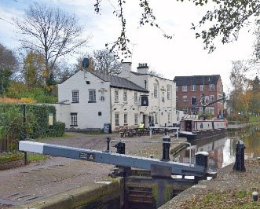

The Audlem village community is highly active with events occurring throughout the year including a Music and Arts Festival, Transport Festival, RNLI Festival and Party on the Park to name but a few.

There is also a Methodist and Baptist Church in the village with another Methodist Church in Hankelow, a mile away.

**SWOT ANALYSIS- What our members think**

|  |  |
| --- | --- |
| **Strengths**  Spiritual focus in all we do  Open to different types of worship  Inclusive of all people  Welcoming and friendly wonderful fellowship Pastorally strong  Offering Home Communion  Breath of experience of retired and lay ministers  Strong school links  Ecologically aware and minimising our impact  Flexible members, non-political and co-operative, ready to support  Strong PCC who work together  Embracing new technology in streaming services live/Facebook etc.  Beautiful Grade 1 building in central location  Children welcomed as part of the services, communion before confirmation and special liturgy booklets  Attractive to visitors-Open every day | **Opportunities**  A growing population in Audlem and district  An improving age demographic in the area  Ability to grow links with young adults/ teens  Developing our vision and GAP for the next 10 years  To expand our collective prayer life  Develop and empower lay members in their spiritual growth and work  Outreach – greater use of Church Leaflet and other means. Attracting more young family groups to worship  Greater use of technology. |
| **Weaknesses**  Aging demographic, less people to help in church organisation as a result  Financially vulnerable  Church marketing and promotion  House groups could be broadened  Technologically need to update our skills  Benefice stretches the incumbent in terms of time management and travel between them  Challenges of ancient building – maintenance, heating, | **Threats**  Lack of outreach to new residents  Diminishing number of people doing many things  Catchment requires personal mobility  and there are parking issues in village  Maintaining regular church income Increasing running costs Fabric and grounds maintenance |

**Useful links**

Church Web Site: [***www.audlemstjameschurch.org.uk***](http://www.audlemstjameschurch.org.uk)

Facebook: ***@audlemstjameschurch***

Village Web site: <https://www.audlem.org>

**ST JOHN THE EVANGELIST PARISH CHURCH OF DODDINGTON.**

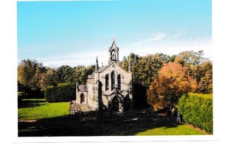

**Current**

In a recent informal survey members of the St John congregation were asked to describe their feelings towards our Church. The following words were used to describe the overall feel: “Uplifting, welcoming, supportive, friendship, cosy warm and comforting, beautiful peaceful location, great atmosphere, providing a real reason to worship. A ‘togetherness’ feeling of being part of a wide, spiritually and physically but local, family.

This says much about the Church atmosphere, albeit structurally the Church itself is small (max capacity circa 100). Services which are traditional are held each Sunday at 1100 hrs, with the first Sunday of each month devoted to Matins whilst the remainder are services of Holy Eucharist. In the main three out of four services are lead by the Revd David Marsh, a retired but very active priest who has been closely associated with St John’s for ten years or more. The fourth Sunday is lead by our Vicar Helen Chantry. ‘Special’ services are held over Easter and Christmas plus Commemorative and other significant days.

Some five years ago we introduced complimentary drinks, tea, coffee, biscuits etc which are offered to members of the congregation after each Sunday service. Three years ago following the acquisition of some old pews from St Mary’s in Nantwich a purpose built dispense area was created at the rear of the Church for refreshments. In 2011 the Church benefitted from a substantial financial legacy. With those funds the Church was able to carry out a total rewire, identified in past Quinquennial Inspections, and to create a disabled toilet facility which has been hugely welcomed.

The PCC has a number of enthusiastic Volunteers who seek each year to organise events which are in part fundraising, but also to allow non attendees to meet the more regular members of the congregation. Over the years these activities have been successful and the Congregation numbers have remained reasonably static where new members have replaced those who have passed away, are no longer able to attend or have moved to new locations. Apart from the genuine pleasure of meeting physically and in prayer, members of the Church work hard to maintain all aspects of the Church life, hence there are no administrative issues which are not dealt with promptly and maintenance is at a good level. The Church has an excellent organ and a dedicated organist and there is access to support organists should it occasionally be necessary. The joint Patron of the Church Lady Delves Broughton lives in London although she visits the area approximately once every six weeks or so and always makes a point of attending the services on the Sunday. She has considerable affection for the Church and mixes well with all members whilst also providing considerable financial support over the years.

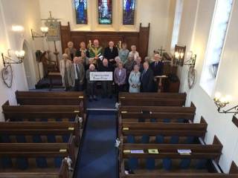

**A brief history of the church**

St John the Evangelist Church is a rural Church situate off Bridgemere Lane Doddington and on the edge of Doddington Park, the historical home of the Delves Broughton family. Built in 1837 it was a private Chapel for the family and the estate, however some fifty years later the Church was given to the Chester Diocese and became the Parish Church of Doddington. Underneath the Church is a vault where the remains of various members of the Delves Broughton family are interred and for which the present Lady Helen has a faculty of permission to use upon her demise. (the marriage between Lady Helen and Sir Evelyn Delves Broughton was dissolved many years ago and he subsequently married the present Lady Rona, now Dowager Lady Delves Broughton). At the rear of the Church is a private cemetery owned and managed by Lady Rona.

In the past the Church has never been hugely supported although the level of regular attendee numbers can be described as steady. Historically the congregation was made up of people in the local farming community, estate workers and a small number of resident families from the surrounding area, all of whom in the latter group require transport to the Church. Nowadays this is by car. Over recent years as a direct effect of the consolidation of farming and a reduction in people employed in this sector, the numbers of attendees has reduced somewhat with a present attendance of circa 17/22 people. Regrettably the age profile is towards the upper end and younger members attend rarely. The Church has a good relationship with the C of E Church Aided school of Bridgemere Primary and is referred to in the fact sheet. The PCC has over recent years arranged various events and activities which have been very successful by whatever means one measures, although there has been no significant long term recruitment of new members to the congregation.

Like so many Churches throughout the UK there are always issues relating to revenue although the Church has some small reserve balances. Fortunately there are no future major financial issues identified.

There is much more one could comment upon, but the foregoing is probably sufficient to give an overview of our Church and its current standing.

**St Chad's, Wybunbury Parish Profile**

**Our Church**

St Chad's lies in the Diocese of Chester and is a united Benefice with St James the Great Audlem and St John's Doddington.

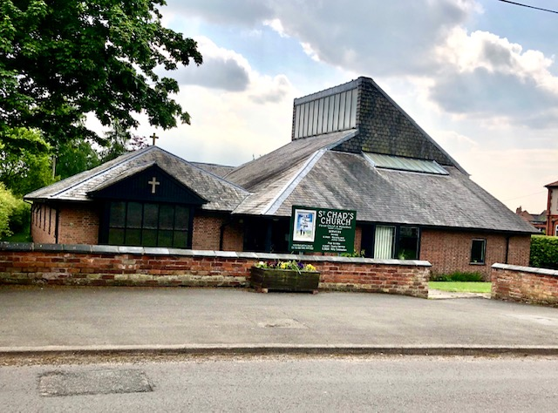We are very fortunate in Wybunbury in having a modern church, opened in 1978, replacing one that had to be demolished because of major structural problems.

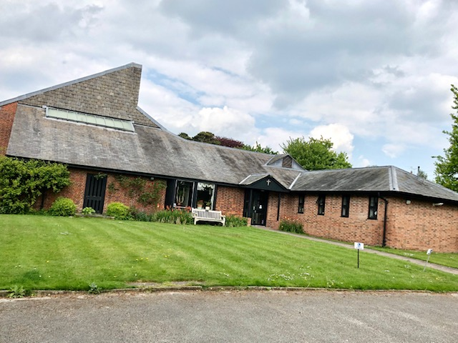There is a car park and level approach that enables step free access for all parishioners.

A warm welcome awaits everyone who attends our church and joins our services. Our regular congregation includes Christians of all denominations – Anglicans of all churchmanship, Methodists, Catholics and others. We have teams of volunteers undertaking music, sides duties, refreshments, flower arranging, and the various tasks that help the smooth running of a church community.

On the first Sunday of the month we hold an All age service where the aim is to include all age groups in our worship and activities - from small children to those in their second childhood. Baptisms are conducted as an integral part of these.

Children of all ages are welcomed at every Sunday service and appropriate activities are available for them.

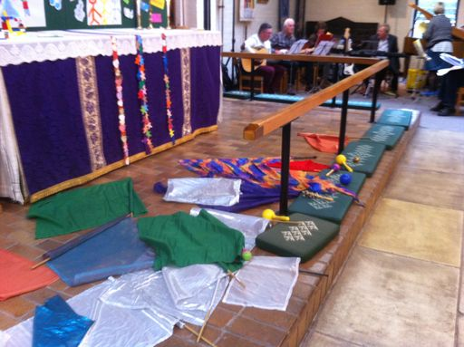

Other Sundays there is a Family Communion Service and occasionally Morning Prayer. A small group of dedicated musicians enhance our praise and worship.

Special services held through the Church Year include Christingle, Crib Service, Carol Service, Holy Week reflections, Harvest Festival, a Memorial service for our loved ones, and the Remembrance Sunday service. We usually join together for a reflective supper on Maundy Thursday.

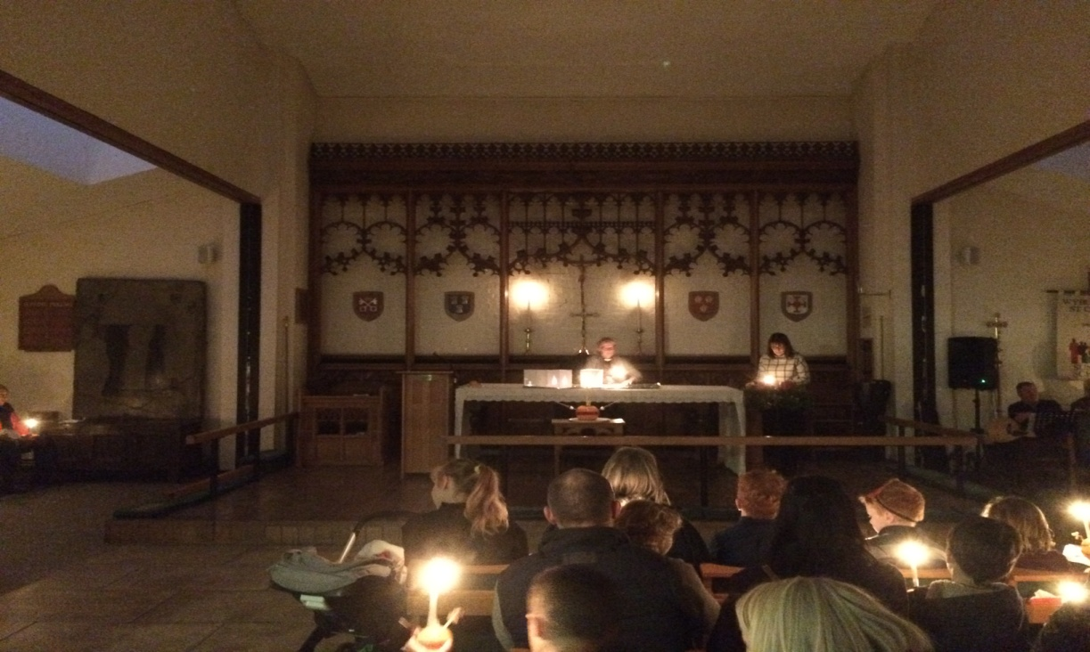

The new church has an adjacent hall with kitchen and toilets. The Mothers Union meets monthly and we hold a monthly village coffee morning and lunch that attracts a wider group of village residents. *First Steps* is a weekly drop in play session for preschool children and their carers.

Various fund raising events include a biennial Open Gardens weekend and concerts organised by musical church members.

Adjacent to the church is a modern vicarage with garden – a four bedroom detached house with an office separate from the general living area.

**Our Village**

Wybunbury is a village in South Cheshire mentioned in the Domesday Book. It is near to Nantwich and Crewe. Communications are good with the M6 5 miles, Crewe Station with its Inter City links 5 miles and major airports within easy reach.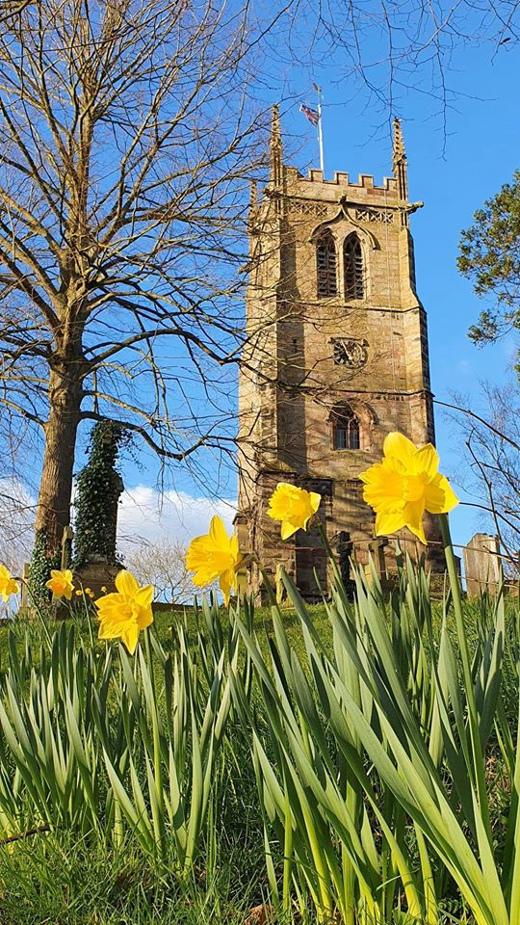

You could be forgiven for thinking this is our church. It was the church tower for the previous church that was demolished 45 years ago because it was unsafe. The tower is Grade 2 listed and is maintained by the Tower Preservation Trust, aided by English Heritage. It still leans and the method used for partially righting it was also used to correct the Leaning Tower of Pisa. It holds a peal of six bells rung by a dedicated group of bell ringers.

There is a Post Office cum village store and two excellent pubs, both of which serve food. The old school was converted to make a village hall that is used for a variety of social events including many organised by the local U3A. The local Scout Group has Scouts, Cubs and Beavers, all of whom meet here.

We have two excellent primary schools in the parish. Wybunbury Delves CofE Aided school is within walking distance. It has close links and holds services in church. Stapeley Broad Lane Controlled school is on the outskirts of Nantwich but still has strong links with St Chad's. The current incumbent takes Worship weekly in each school

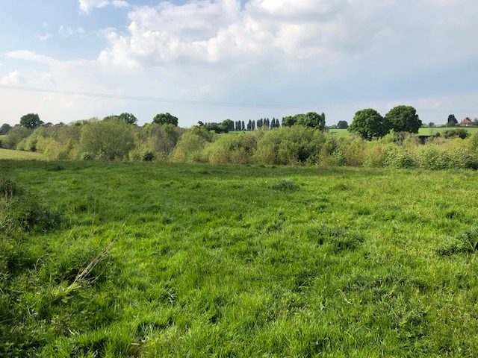A feature of the village is Wybunbury Moss which is a National Nature Reserve containing rare plants and insects. The Moss is a floating peat bog so entry is only permitted on a marked nature trail, but its perimeter makes a pleasant walk.

The parish covers a large area that contains several farms. Within the village is a variety of housing from small cottages to a modern estate accommodating many families.

Wybunbury is unique in holding its annual Fig Pie Wakes. The road downhill past the Tower is closed to permit the rolling of fig pies – made to a special recipe. The maker of the pie travelling the furthest is the winner.