# St Peter’s Crewe – Parish Profile

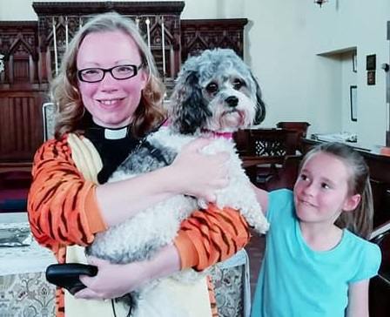

# Parish Profile – St Peter’s Crewe

## St Peter’s is a welcoming, inclusive church with a friendly, committed congregation all pulling together for the common good. Our PCC has always worked well with the incumbent and we have a strong ethos of lay involvement – virtually all the congregation are actively and substantially involved in mission and worship as well as in organising and attending social events throughout the year.

## 

## We have been blessed with an excellent lay reader and a creative, hard-working and enthusiastic curate who is already working across the three parishes of St Peter’s, All Saints’ and St Andrew’s, as is a recently appointed Community Development Worker. We are already working closely with All Saints’ and our labyrinth event formed part of the Love Crewe initiative in 2016 and 2017. We provide a wide range of children’s ministry ranging from Diddy Disciples for the youngest in our congregation, through to Karen’s Corner for those at the top end of primary school and we have a children’s corner for babies and toddlers used by families at weddings and baptisms. We also have an active and committed Rainbow and Brownie pack, who meet in our church hall and attend our regular all-age services, and strong links with local primary schools (see below). We recently held a pet blessing service – promoted in the local paper and on Radio Stoke - which saw a church full of people and animals including a chicken, some rabbits, a few dogs and some caterpillars. We have become much more adept at publicising our services lately with poster, flyers and a popular Facebook page all spreading the good news of what is going on at St Peter’s. The church also has a strong tradition of providing pastoral care to older members of the community including residents at Station House, a local care home. Our church community enjoys a Grade II listed church, now the closest to Crewe town centre and ideally placed to minister to the Grand Junction retail park.

## Worship

St Peter’s is a traditional Anglican church, celebrating Holy Communion every Sunday morning and using Common Worship with a traditional repertoire of hymns – we also hold a sung Evensong service once every two months. We are a liberal, inclusive parish and offer a positive welcome to everyone. While this is the core of our identity we are open to other styles of worship. We had a pet-blessing service recently and in 2016 and 2017 we had a labyrinth with prayer stations which proved very successful in encouraging people from inside and outside the parish to explore their spirituality and relationship with God. Children’s ministry caters to toddlers and younger children and is based on [Diddy Disciples](https://www.diddydisciples.org/) which aims to help children develop their own spirituality and to familiarise them with adult forms of prayer and worship at an appropriate level.

Regular Sunday morning worship is supplemented by our Wednesday services which we regard as an equally important part of our work. Our Wednesday morning services are open to all-comers and begin with Morning Prayer which includes a discussion of the Bible readings and open prayer. After Morning Prayer the church is open to visitors and we then celebrate Eucharist in a side chapel while the church remains open. We often find we have more people dropping into this service than we do to our Sunday morning one and the informal, friendly and inclusive nature of the service has reached people who would otherwise not have had the opportunity to take part in worship, including people with autism and dementia. Our current incumbent has worked hard to build relationships with local primary schools who hold Christmas and Harvest services in the church and there is a Rainbows and Brownies pack based in the church hall who come to all-age worship services, raise funds for the church and put on a nativity play at Christmas. Our current incumbent and curate also visit local secondary schools.

## Mission and Engagement

The church’s engagement takes a variety of forms including Coffee Stop and Crafty Natter on the first Saturday of the month – an open church drop-in where people are encouraged to bring their own craft projects or just drop in for a chat and a cuppa.

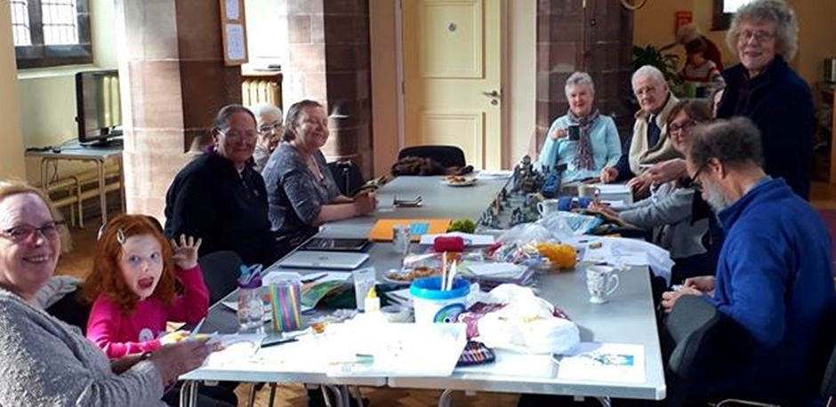

We rent the church out, after Sunday services, to the Redeemed Christian Church of God and our labyrinth (see above) formed part of the Love Crewe initiative. We have begun to promote our services more effectively with service cards delivered to local houses promoting – for example – our Mothering Sunday service, frequently refreshed posters outside the church to publicise services and a popular Facebook page which attracts interest from across the whole community. The church clearly enjoys affection in the local community – something reflected in the number of funerals and baptisms we carry out. We also collect for Christian Aid week and support the local food bank. The church hall provides facilities for a local nursery, a local Rainbows and Brownies pack, a stamp-collectors club and a local amateur dramatic group among others.

## Our Parish

St Peter’s is an urban parish and the closest church to Crewe’s town centre. The church also has the Grand Junction Retail Park on its doorstep with a huge number of people passing close to it every day. The parish contains two primary schools with which our current incumbent has built close links and a care home for adults with profound disabilities which we have had links with in the past

## Potential for growth includes:

* Developing our ministry among staff and shoppers at the nearby Grand Junction Retail Park. Last year, for the first time, we opened the church in the week before Christmas to encourage people to drop in and escape the busyness of secular Christmas preparations
* Developing our ministry to families with children coming for baptism and inviting them to attend all-age worship, Mothering Sunday, Christingle etc
* Developing our ministry to children and younger people
* A potential sale of our church hall building which could be used to finance ministry and redevelopment of the church to include community facilities
* Potential use of the church for civic occasions, events and concerts

## Challenges include:

* Declining numbers
* Stable, but precarious finances
* Retaining flexibility while establishing a consistent identity
* Continuing and developing pastoral care in the context of a small congregation

## What aspects of our church life do we want to develop over the next five years?

* Mission and outreach, including to the Grand Junction retail park
* Follow up with baptism families
* Grow the church, spiritually and numerically
* Continue to provide services outside Sunday morning
* Engage more with local community
* Develop a consistent identity for the church for publicity purposes
* Develop St Peter’s as Crewe’s civic church

## What attributes, skills and experience should we be seeking in the person who will become our next vicar?

* Rooted in prayer
* Visible in the wider community
* Ability to work alongside other Christian traditions
* Comfortable with liturgical worship and also more informal styles of worship
* Experience of and/or a vision for original uses of the Church space
* Ability and willingness to delegate
* Collaborative skills
* Church hall provides rental income – ability to manage this
* Experience in supervising a curate