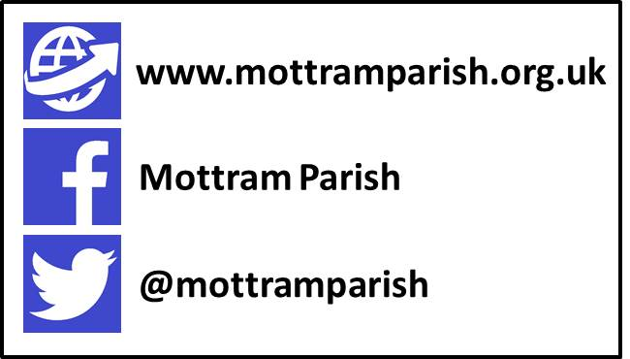

The Parochial Church Councils Year 2018-2019
This year we continued with the same pattern of meetings as in previous years with the full council meeting every other month, commencing in May, one extra meeting being held in November, a total of seven. The Standing Committee met once.

In May we reviewed and approved the minutes of the Annual Meetings and appointed the church officers. Finance, as always, was a concern but Brian, our Treasurer will expand on this in his report. We also agreed our planned giving for the coming year.
New legislation nationally was being introduced in respect of data protection, known as the General Data Protection Regulations (GDPR) and a team consisting of Kevin Hall, Tony Kershaw and Kate Best completed a data audit on the church's behalf and produced a Privacy Notice and consent forms, for PCC approval, in conjunction with advice received from the Church of England.
We discussed various aspects of our building strategy, including the Quantity Surveyors report. The condition of the external path was also raised and a way of improving this would be looked into by two members of the PCC.

On a warm Summer evening in July we discussed the forthcoming Heritage Open Days exhibition which aimed to show the changing face of our church over the past five hundred years, and our exciting plans for the future.
The safeguarding of our children, young people and vulnerable adults is, as always, a major priority and in order to comply with our duty under section 5 of the Safeguarding and Clergy Discipline Measure 2016 we held our annual safeguarding review. Various actions were recommended and the Council agreed to implement these. These included specific further safeguarding training for those volunteers on the Children and Youth ministries.

As Autumn approached we looked at ways at our September meeting where we could improve on what we do as a PCC and what we did well. More discussion would take place at future meetings on these points. Feedback on the Heritage Open Days had been very positive and a report was to be provided at a later date.

Taking on board points raised at our previous meeting about how we could improve on what we do, for our November meeting more detailed information was provided for the items on the agenda - everyone felt this enabled a better discussion. We also agreed that we may need to meet more frequently in future months.

A major item at this meeting was our budget for 2019. A considerable deficit was forecast and we decided that a meeting later in November to discuss this in more detail was required.
Earlier in the year we had been advised that we would be having a new Curate from June 2019 and the subject of housing had been discussed. Various options were considered. Sadly at our meeting in January we were told this was now not going to happen due to personal reasons. In the end we decided to find a new tenant for the house on Lower Market St.

At the extra meeting in November we discussed the various options for the Curate house as previously mentioned. Parish Finances was the main item and various ideas in which we may address the shortfall were put forward for the Standing Committee to discuss in further detail and to draft a plan to go forward.

The Standing Committee met on a chilly December evening and fine tuned the ideas put forward by the whole Council for tackling the deficit. These are some of the suggestions proposed:
A Stewardship Campaign - as 2019 was the year of a new Electoral Roll James would write to everyone outlining our current financial situation.
Fees for the hire of the Magdalene Centre to be increased
Churchyard Maintenance - a team of volunteers required rather than paying someone to do this
Fund raising - more effort needed in this area and a leader required from the PCC
Remove the telephone in the church vestry -the increased use of mobile phones made this unnecessary
Pcc to liaise with Tony more on all maintenance budgets

At our first meeting in 2019 we discussed and approved some of the ideas proposed by the Standing Committee for tackling the projected deficit. Sandra Gateley agreed to lead a fund raising team.

In March - our final meeting of this church year - we finalised the arrangements for the annual meetings. We also gave grateful thanks to God for the generosity shown by you - the congregation - from our "Pledge Sunday" - this was a truly amazing response. Thanks also were given to Alice who has to stand down as church warden this year having served six years.

We also:
Made preparations for "Thy Kingdom Come" - the Archbishops call to prayer between Ascension Day and Pentecost.
Re-appointed Ian Johnson, retired headteacher and member of St Johns Church, Dukinfield as a member of Mottram Schools governing body.
Reviewed our first "Holiday @ Home" and agreed that the four days had been a huge success. A regular lunch club and Christmas lunch were planned.
Agreed to James's request for a three month Sabbatical from late July to late October 2020
Marked the centenary of the end of World War I with a special "Festival of Remembrance" on the Saturday before Remembrance Sunday itself.
Discussed the possibility of hiring a coach to support Callum on Ordination Sunday

As you can see we have been very busy on your behalf as usual this year!

But foremost in our minds, as always, is that our principal role is to go forth and make disciples, to:

"Seek to know Christ and to make Christ known"

Kate Best
Secretary to the PCC
March 2019

