Kelsall Methodist Church

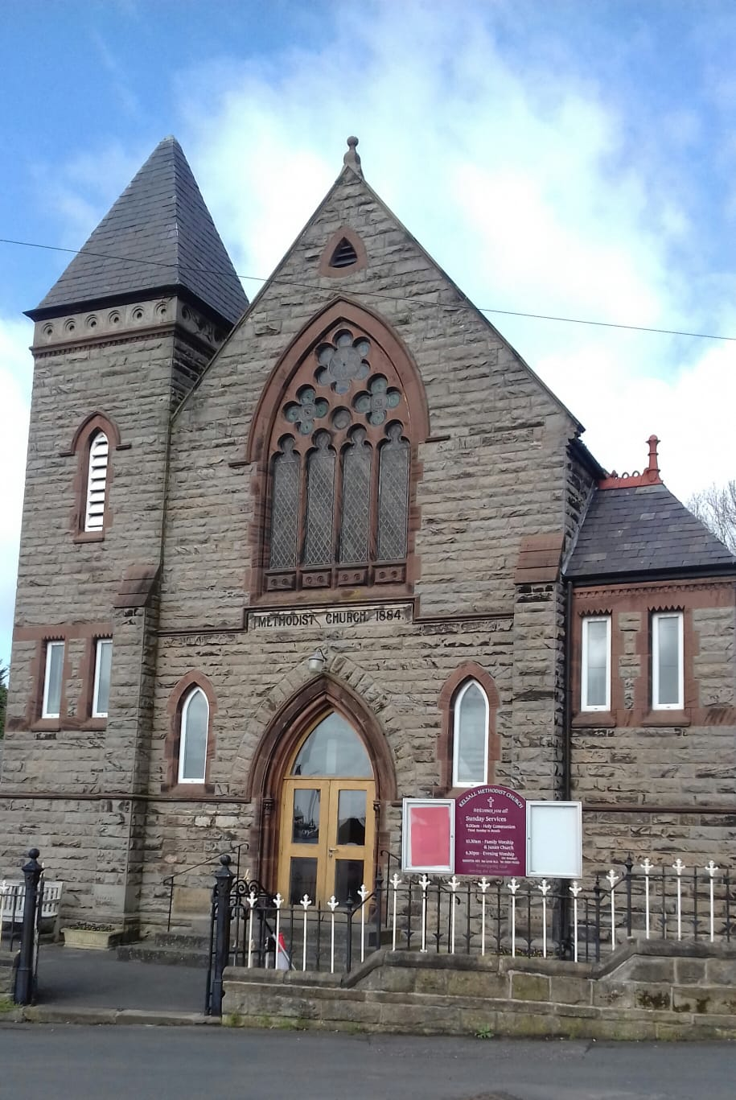

***All are welcome in this place***

Church Profile

Kelsall Methodist Church Profile

# Summary

## Who are we?

Kelsall is a village of 3-4,000 population situated on the Sandstone Ridge and close to Delamere Forest in central Cheshire. The city of Chester is 9 miles away, there are good links to the motorway network and 2 stations within 2 miles. It is a growing and developing community with amenities and services including: an outstanding primary school; a pre-school; 3 pub/restaurants; 2 doctor’s surgeries; a care home; 2 churches; a chemists and several shops and businesses. Kelsall also has a wide range of active community groups including: Women’s Institute (W.I.), OPAL Day Centre, Tennis Club, Gardening Club, Yoga and Pilates groups to name a few.

Kelsall Methodist Church (KMC) is located in the centre of the village. It is one of 22 churches in the Chester and Delamere Forest Circuit which is part of the Chester and Stoke on Trent District of the Methodist Connexion. There has been a Methodist church on its current site for over 200 years.

## The Challenges and Opportunities that lie ahead.

KMC completed a refurbishment of its worship area 7 years ago to provide a more flexible space. It also has a hall, a fully equipped kitchen and other ancillary rooms. The building provides plenty of opportunity for church use and is well used by several community clubs and organisations.

In recent years our membership has declined as elderly members are no longer able to attend worship or have died and some members have moved away to other areas. However, we do have a well-supported Junior Church and a strong group of young families. The church provides a weekly pre-school group, a monthly Messy Church, a monthly community lunch, a monthly film club as well as 2 monthly fellowship groups. The challenge for us is to encourage more to join us in regular weekly worship. We would also like to make stronger links with other user groups.

For many years St. Philip’s and KMC have had a good relationship, sharing in services at each other’s churches, taking services at the care home, assemblies at the local school, running the Holiday Club and Hope Journey sessions at KMC. More recently we have begun conversations to explore how we can increase our Christian witness in the village by becoming an Ecumenical Partnership, initially as two churches with one minister, recognising we need to find new ways of outreach and mission. This will be a fantastic opportunity and not without challenges as we seek to move forward with this vision.

## Who are we looking for?

Someone who is ecumenically minded, preferably with some experience of Methodism and is comfortable working in a village community. The person appointed would need to be a good communicator and able to connect with all age groups. They would also need to have good leadership skills, whilst having the ability to be a team player. The Circuit has appointed a new Methodist Minister, Rev. Jo Brown, who will have some oversight of KMC as well as seven other churches in this section from September 2019. We hope initially she and the new Ecumenical Minister will work together to support the process we are engaged in, we see this as an important step in developing our Ecumenical Partnership further. We and the Circuit are committed to sharing the Ecumenical appointment with St. Philips.

# Ministry and Leadership Team

|  |  |  |
| --- | --- | --- |
| Minister: Rev Anne Gibson  01829 733425 a.gibson@btinternet.com | | |
| Church Council Secretary: |  |  |
| Mrs Janice Aitken 01829752508  [janicea1uk@yahoo.co.uk](mailto:janicea1uk@yahoo.co.uk) |  |  |
| Church Stewards: |  |  |
| Mr Ian Johnson | Mrs Susan O’Connor | Mrs Avis Palmer |
| Local Preachers: |  |  |
| Mrs Avis Palmer | Mr Ian Johnson |  |
| Lay Worker for children: |  |  |
| Mrs Beth Ferrigno |  |  |
| Circuit Steward: |  |  |
| Mrs Ann Barnett  01829 752576  [ambarnett@hotmail.com](mailto:ambarnett@hotmail.com) |  |  |
| Circuit Representatives: |  |  |
| Mr Marshall Ryder | Mrs J Aitken | Mrs A Palmer |

# Our Church History and Buildings

In 2016 KMC celebrated 200 years of Methodism on its present site although there had been house meetings prior to that. The original building was replaced in 1884 by a large Victorian church and hall and a graveyard added to the grounds. In 1935-36 an extension was added for a further school room. The foyer area was added in 1970 and the hall and kitchen area were upgraded. Alterations to existing rooms provided new access corridors to new toilets, including one with disabled access.

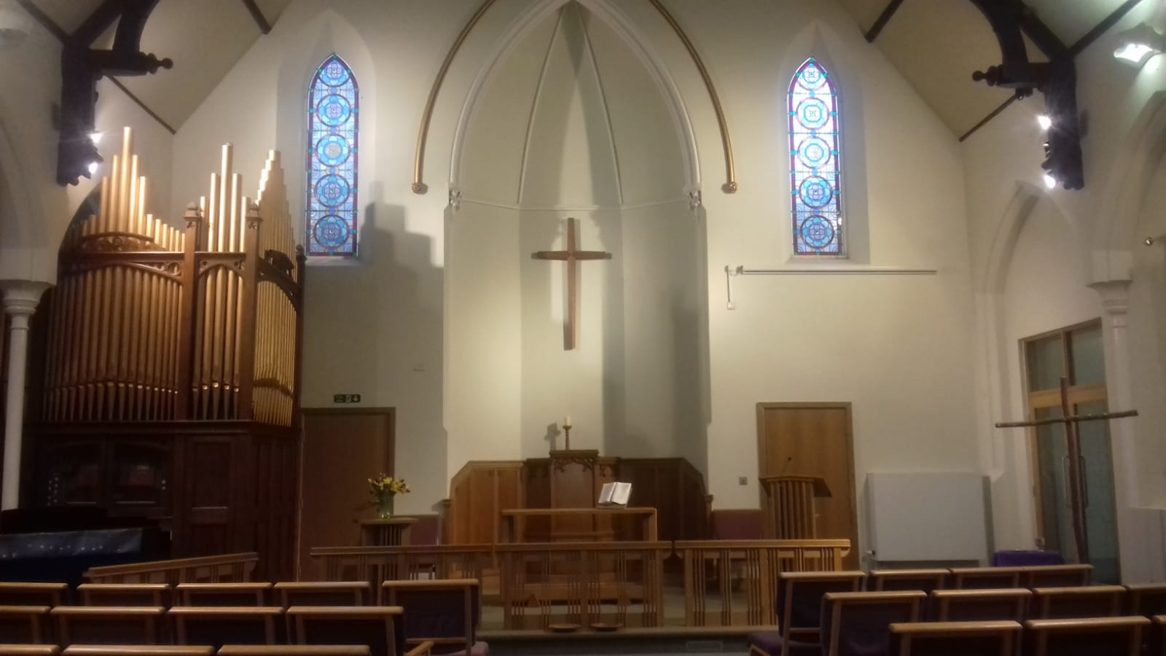In 2011 work began on a total re-ordering and refurbishing of the worship space from rafters to foundations and including the removal of the pews, the overhaul of the organ, removing walls and opening up access. The balcony was left intact. The church now provides a very flexible area for different styles of worship; café church; services “in the round”; Good Friday “Stations of the Cross” and user friendly mini-services for Barney’s Buddies and Messy church. It also means the area can be totally cleared for Holiday Club activities and worship. The space has been used for a Christmas Tree Festival, Village Art Exhibition, conferences, craft days and a range of concerts. For several years now it has hosted events for the Chester Folk Festival weekend in May. The total seating capacity of the worship space is approximately 180, the building also has a large hall which has a sliding door onto the worship space to provide extra capacity. The kitchen is next to the hall, there is also access to the “upper room” used by Junior Church. Other rooms include a store room, a large loft space and a flower room with a sink. Besides a main entrance there is a foyer entrance with room for displays, books etc.

# Church Services and other meetings

Our main and faithfully attended Sunday morning worship takes place at 10.30. Junior Church children and some of the Whatever Group are present for the first quarter of an hour and play their part by choosing the second hymn and being responsible for projection of the service on the A/V. The children are also included through a short age-appropriate address, often involving their participation. Members of Junior Church take up the offering and there is a prayer of blessing before they leave.

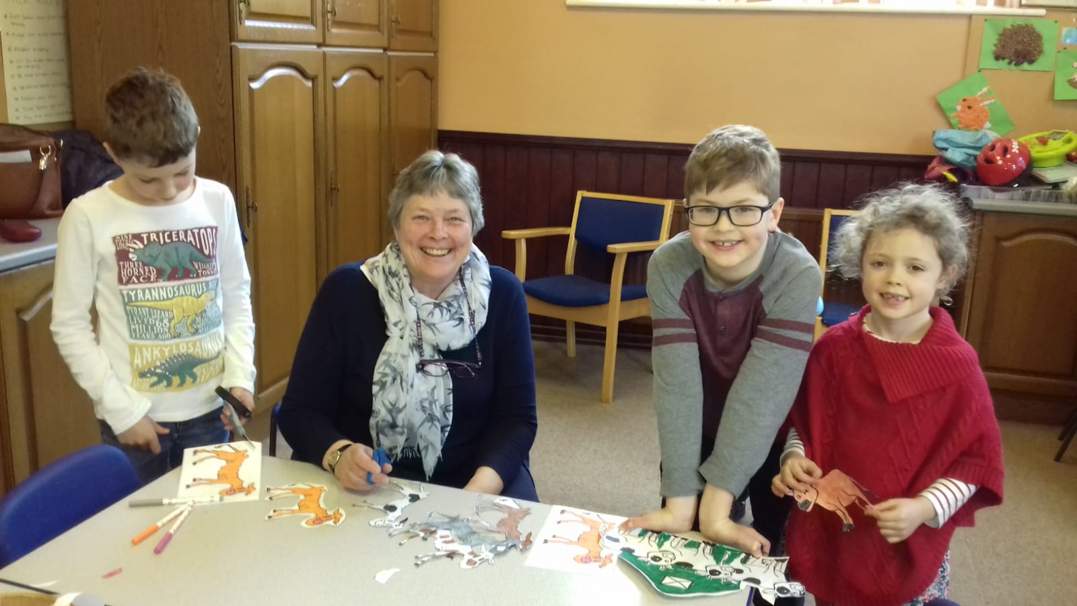Once a month the morning service includes Holy Communion. Early Holy Communion is also celebrated monthly and has a small regular number of participants.

As part of our doing more things together, KMC and St. Philip’s are now holding monthly joint Morning Worship, alternating venues with Ministers "swapping pulpits" and sharing in leading the service.

For many years, a small committed group has met for more informal worship once a month in the evening. This takes place in our Prayer Room and follows a pattern of shared liturgy and discussion.

A varying form of All Age Worship takes place on Mothering Sunday, and on selected Sundays throughout the year our service is Café Style. The seating is rearranged around small tables and refreshments are served as people enter. During the service craft activities and discussion are shared. These services are very popular, bringing in parents and children from our Barney’s Buddies and Messy Church outreach.

Themed Team Preaching occurs at Lent and Advent. During Holy Week, Maundy Thursday is celebrated in the form of a simple shared supper, participatory informal act of worship ending in a simple form of Holy Communion. Latterly Maundy Thursday worship has been shared with St. Philip’s, alternating the venue. We also share a Good Friday act of worship which has included a formal service at St. Philip’s followed by a walk of witness through the village ending at KMC where worship has been reflective and the worship area arranged imaginatively.

At Christmas our Junior Church Nativity is very well supported and enjoyed by all. As part of our desire to do more things together, recently, children from St. Philip’s families have joined our Junior Church. The ‘Whatever’ Group, comprising young people of secondary school age from both churches, meets each Sunday morning in our Prayer Room and is led by dedicated adults from St. Philip’s, the attenders are very keen!

Barney’s Buddies caters for babies and toddlers and pre-school children. It is a weekly event and runs throughout the year. The session lasts for an hour and a half during which time children play, enjoy a craft session helped by their parent or carer, enjoy a healthy snack and then go into church to listen to Bible stories and sing songs.

Messy Church is held once a month and caters for primary age children. Parents or carers accompany the children so that they share both the well-planned craft activities and a cooked meal. Each month follows a particular theme or event in the Christian calendar.

A Holiday Club is organised for the week after the children have broken up for the summer holidays. It takes place in the mornings and is aimed again at primary age children. Each year a theme is followed and the event is exceptionally well organised. The Holiday Club takes place at KMC, where the church is transformed to provide a set for the week’s adventure. Holiday Club is staffed by enthusiastic volunteers from both churches.

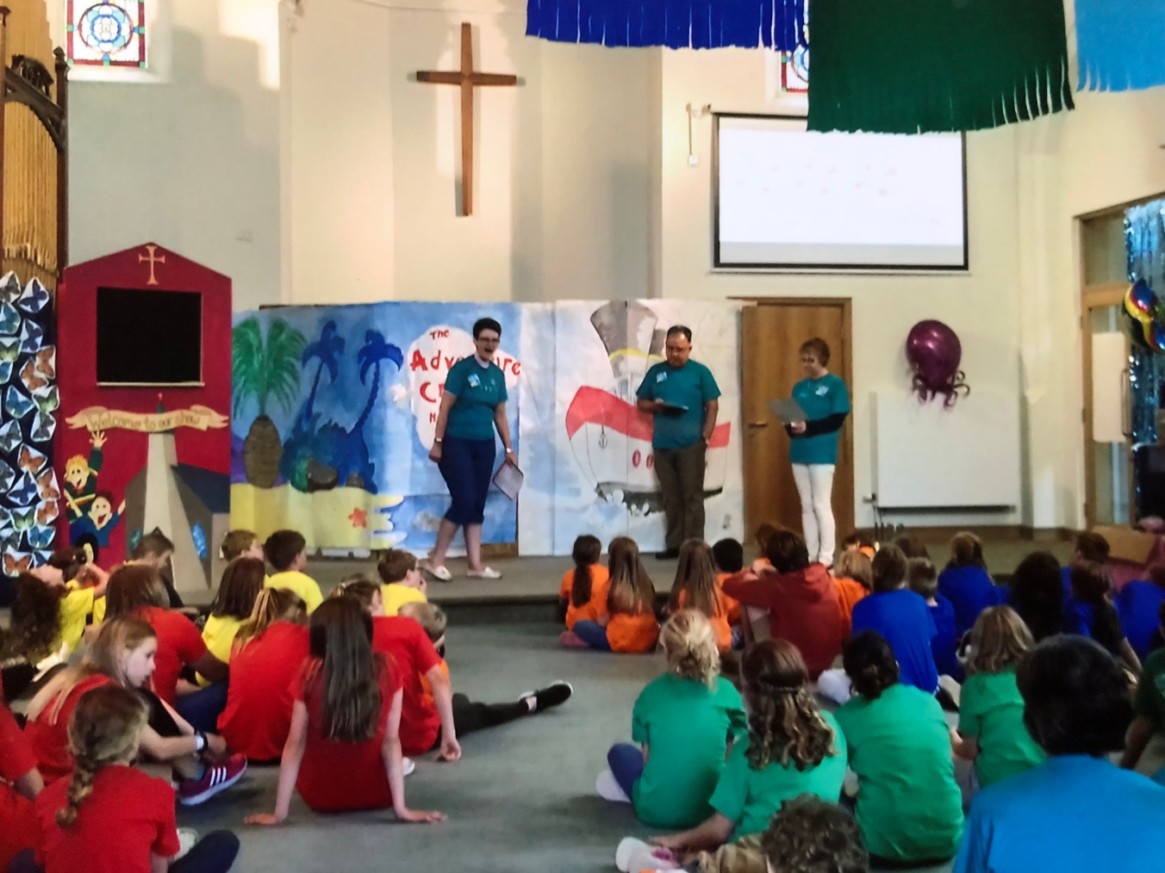

Hope Journey is staged 3 times a year, Christmas, Easter and Remembrance in October. The Christmas, Easter and Second World War stories are told by 6 sets of volunteers from both churches in different locations at KMC. Year 2, 5 and 6 children are invited from 3 or 4 local primary schools. The children are put into groups and travel to each location to be told a different aspect of the story. Approximately 300 children attend each year. The schools involved are very appreciative as costumes, scenery, props and photos are used to bring the stories to life.

The Sisterhood meets once a month. It is a friendly, informal meeting where ladies enjoy worship, the words of a speaker and a good chat over a cup of tea.

|  |  |  |  |
| --- | --- | --- | --- |
| Services at KMC | | | |
|  | 9am | 10:30am | 6:30pm |
| 1st Sunday |  | Morning Worship | Informal evening worship |
| 2nd Sunday | Early Holy Communion | Morning Worship |  |
| 3rd Sunday |  | Morning Worship |  |
| 4th Sunday |  | Morning Worship |  |
| 5th Sunday |  | Morning Worship |  |
| Holy Communion is celebrated once a month at a morning service, dependant on the Circuit Plan. | | | |

|  |  |  |
| --- | --- | --- |
| Average Attendance Sept 2017-Aug 2018 | | |
| 9:00am | Early Holy Communion | 8 |
| 10:30am | Sunday Morning Worship | 40 |
| 6:30pm | Informal Evening Worships | 6 |

N.B. 40 is the weekly attendance averaged over the year and includes special services i.e. Baptisms; Nativity. More usually the 10.30 service averages 25 adults + several children.

|  |  |
| --- | --- |
| In addition: |  |
| Barney’s Buddies | 15 children + parent/ carer |
| Messy Church | 18 children + parent/carer |
| Holiday Club | 40 children |
| Sisterhood | 10 ladies |

During this period there were 6 Baptisms and 7 funerals.

# Finances 2017-18

The figures below detail income and payments for the 2017/18 financial year (September 2017 - August 2018).

Figure 1: Income for the financial year 2017 -18

Figure 2: Payments for the financial year 2017 -18

# Lay Leadership and Ministry

Our current Minister will leave us in August 2019. From September 2019 the Circuit has appointed a new minister for the section of the Circuit which includes Kelsall and 7 other churches.

A number of services at KMC are taken by accredited Local Preachers, including two of our members. Local Preachers bring a variety of styles and experiences to our worship. Members of the congregation at KMC participate in our services with readings and prayers. We also have a team people willing to operate the A/V system.

We are fortunate at KMC to have three members who are our regular organists/pianists playing for our services on a rota basis. We mainly use the most recent Methodist hymn book, Singing the Faith, but enjoy different styles of worship songs including Mission Praise and songs and chants from The Iona Community and Taize. We are blessed by one of our members being a published hymn writer. She has written a number of hymns that reflect on our spiritual life and journey and enhance our worship.

Our work with children is supported by a paid circuit lay worker: Barneys Buddies, Messy Church, Holiday Club and Hope Journey. Several volunteers help with snacks, meals and craft activities on a regular basis. There is a team of helpers from KMC and St. Philip’s for Holiday Club and Hope Journey.

The joint Junior Church for children up to high school age meets on Sunday mornings during term time, and is run by a leader and three assistants from KMC. A joint churches group of young people also meets at the same time in the Prayer Room, it is led by volunteers from St Philip’s.

We have a team of pastoral visitors co-ordinated by the pastoral secretary. Each visitor has an allocated group of members to look out for and keeps in touch with members no longer able to attend church.

# Outreach and Mission

The banner in our foyer proclaims “All are welcome in this place” – not only to church events but also through using our building to meet needs and provide opportunities for the community.

KMC has been running several groups and events for a number of years now. They are open to everyone in the community and generally attendance is good. Through Barney's Buddies and Messy Church, as well as Junior Church, we seek to offer a safe and welcoming space to young families - one young mum says "My boys are happy and safe here, they feel they belong -and so do I". We also provide a Community Lunch, which is a 2-course hot meal, on the 3rd Thursday of each month, a meeting place for people to get together, eat and chat. The 1st Friday of each month is Film Night or “Flicks in the Sticks”, the range of films shown and the lovely cakes and coffee have proved a hit; it is always well attended averaging 35-50 people.

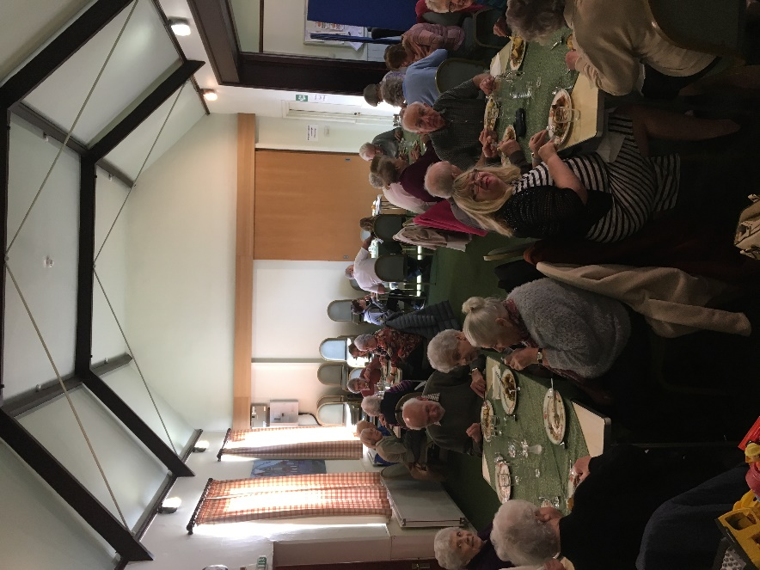 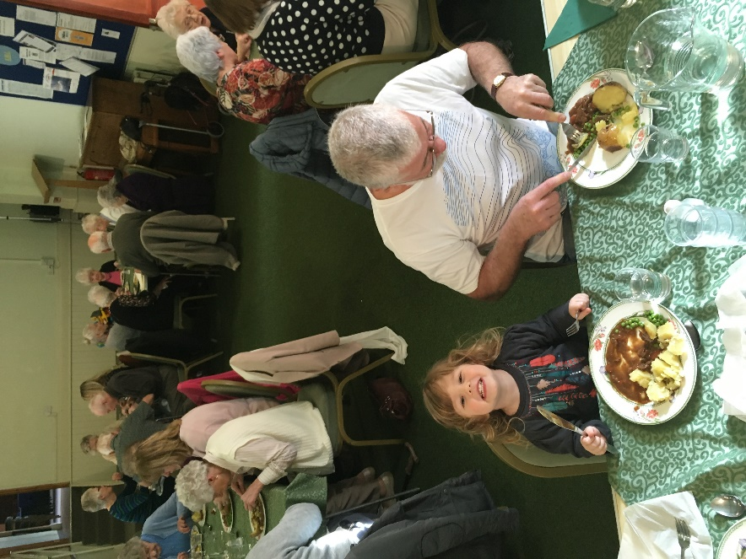

Where we can, we seek to make our rooms available for hire by community groups and classes. Currently there are 11 different user groups including:

|  |  |
| --- | --- |
| OPAL  Vale Royal Singers  WEA  Brownies  W.I. | Good Companions  Thursday Group  Gardening Club  Family History Group  Yoga Pilates |

Our Outward Giving includes regular support to Methodist Missions, Methodist Homes for the Aged, the Circuit chosen charity, Action for Children and we join with St Philip's in the Christian Aid street Collection each May. We often respond to Disaster Emergency Committee appeals as well as supporting local charities including Tarporley Hospital, the Wellbeing Hub and our Foyer is a collection point for the local Food Bank.

# Our Vision

Our vision is to move forward to an Ecumenical Partnership so that we can work together more effectively to become strong community church and be a better witness to God's Love in reaching out to our village and area. We are challenged by the question posed by a group of young Mums moving into a new housing development, “Why are there two churches, what is the difference between them?” The answer, of course, is “Not a lot” Recognising that we have more in common than difference.

The opportunity is to build on our commonality and to present a unified Church in our community.

In being one Church and church with greater resources, we seek to develop our outreach to young families and to the elderly and housebound. Looking at other ways and times for worship and fellowship, we want to find ways to meet the needs in our village recognising the changes in society which make this very necessary.

Currently, the village is involved in building a Hub to house doctors’ surgeries and other health related services with community space too. We anticipate that we can be involved in developments there. For the Church to have a lively presence bringing the love of Jesus to the people of Kelsall is our aim.

# The person

We are on an exciting but challenging ecumenical journey with St Philip’s and we feel that we are seeking someone with special qualities to fill this joint post. The relationship of the two churches is rooted in many years of friendship and working together and this vacancy offers the opportunity to move us on to a more formal partnership.

To this end, we seek someone who has the leadership and communication skills to relate to both churches in helping us to grow together, in order to make a credible witness to the gospel of God’s transforming love. The person appointed will need ecumenical sensitivity and experience and an understanding of the Methodist ethos. They will be prepared to work creatively and purposefully with us as Methodist partners.

The person we are looking for would be a leader who can draw out and develop the gifts of people in both churches. A commitment to pastoral work, though this responsibility would also be shared by others, and an ability to relate to a wide range of ages is important to us. We would welcome someone who is open to creative and innovative styles of worship but also able to lead more traditional worship. We also seek someone who is willing to become a part of the wider village community and who will enjoy playing an active part in its life.

