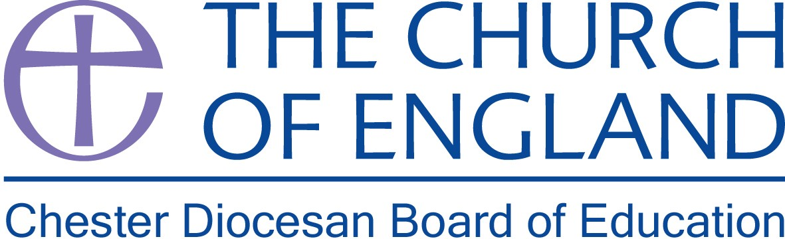

School Effectiveness Officer
Chester Diocesan Board of Education

Full Time – 35 hours*
Salary range £43,531 - £46,967

This newly created post provides an exciting opportunity to work as a key member of the Chester Diocesan education team and reflects the increased commitment and heightened profile of our work on school effectiveness with our Church schools and academies.

This high-profile role is focused on providing strategic leadership that promotes and delivers educational excellence and effectiveness across our Church of England schools and academies in the Chester Diocese.

This post is ideally suited to an experienced, senior leader who can demonstrate a proven track record in school improvement, with a particular focus on the primary phase and highly effective leadership. A Commitment to promoting Church schools and academies at the heart of the Church’s mission is essential.

*This is a full-time position for 35 hours per week, although a part-time role would be considered for an exceptional candidate. The role will be based at the offices in Daresbury Park, Warrington, with travel around the Diocese of Chester.

Further details and Application packs available from the Diocesan website

https://www.chester.anglican.org/schools/vacancies/

For further details or an informal discussion about this role, please contact Charlotte Somers, PA to the Director of Education on 01928 718834 or e-mail charlotte.somers@chester.anglican.org

Closing date: Friday 30th November 2018

Interviews: Monday 10th December 2018

An enhanced DBS Disclosure will be required.

