



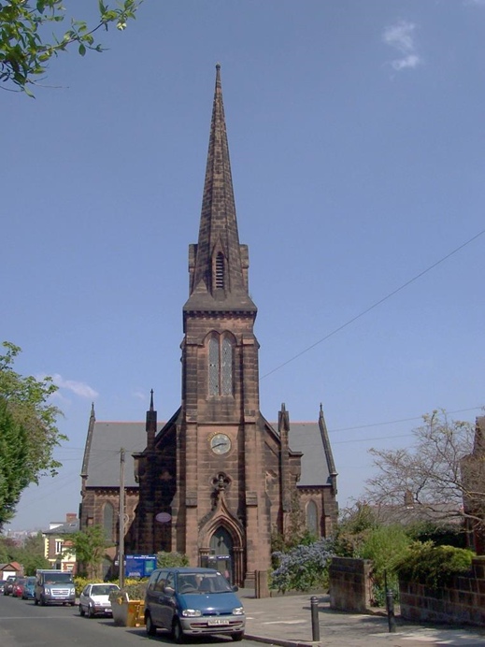

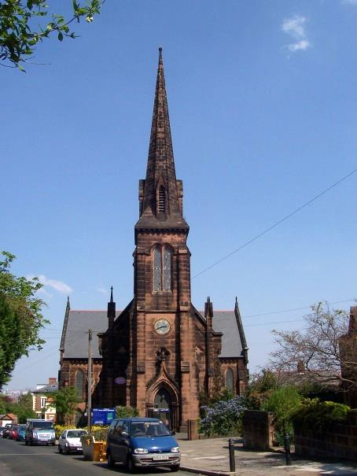

Introduction

We are delighted that you have asked for a copy of this profile of Christ Church, Birkenhead and we thank you for considering this opportunity to serve God with us.

We are a church committed to ‘Worshipping God, sharing Jesus, and serving the community’.

We have written this profile to give you an overview of who we are, what we do, and why we do it. God has blessed us so much through the few past years and in so many ways. We have had the joy of seeing people come to know Christ, and we enjoy fellowship together as we read God's Word and rejoice in it.

We prayerfully trust in the Lord to guide us and give us wisdom and discernment of His purpose for our church. Our prayer would be that this document would be helpful for you, as you discern God’s plan for your future ministry. Yours in Christ

PCC of Christ Church, Birkenhead

May 2018

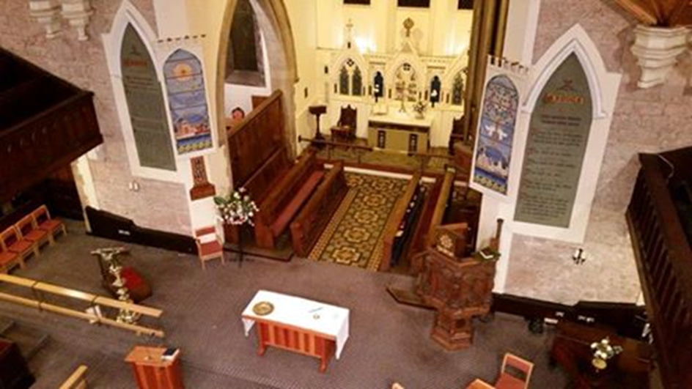

* LOCATION
* THE PARISH
* THE CHURCH
* OUR WORSHIP
* COMMUNITY ROOMS
* OUR SCHOOL
* THE VICARAGE
* OUR FINANCES
* OUR PRIEST

# C:\Users\jacqu\Documents\New folder\66.jpg

Location

Historically in Cheshire but now in Merseyside, Birkenhead is on the Wirral Peninsula, on the west bank of the River Mersey, opposite the city of Liverpool. Two road tunnels, a railway and a ferry provide excellent connections with Liverpool. Birkenhead itself is mixed: the medieval Priory, a shopping precinct, the oldest municipal park in the world, and areas of redeveloped dockland. The Wirral boasts two art galleries, the Lady Lever at Port Sunlight and the Williamson just a stone’s throw from the church. We are fortunate to be within easy reach of beautiful countryside, Country Parks at Thurstaston and Eastham, the seaside, New Brighton and West Kirby, and of course the hills of North Wales.

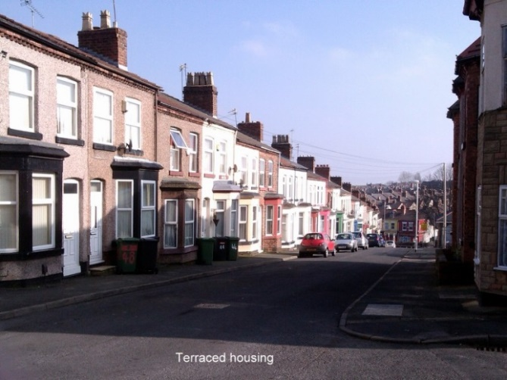 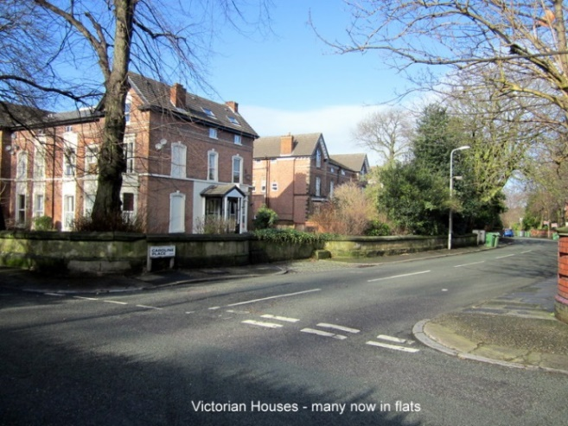

The Parish

Christ Church itself is located on the edge of the urban village of Oxton where there are pockets of affluence, and Birkenhead itself which has significant areas of deprivation. The CUF website concludes that the parish “is among the most deprived in the country”. The nearby village has a number of restaurants, shops and two pubs and is situated in a conservation area. The community hosts ‘ The Secret Gardens of Oxton’ every year and funds raised go towards helping local charities. The church is involved with this by providing refreshments and hosting two short organ recitals on our famous Willis organ. The parish has a number of mixed properties including large Victorian houses, smaller cottage type and modern houses of which 50% are owner occupied, 10% are local authority housing and 40% privately rented. A lot of the larger properties have been converted into flats and bedsits and there is also a large number of local housing association properties. There is high unemployment in the area, which can carry its own issues regarding alcohol and drug problems among its inhabitants. Due to changes in the benefit system there are agencies which assist those that struggle day to day living. There are a number of schools in the Parish, Christ Church Primary, Woodchurch Primary, Redcourt, St Anselms and Birkenhead School. There is a Health Centre and Art Gallery and Museum in the Parish and within a short walking distance from the Church a new Supermarket has just been opened.

Within the parish boundary there is the Wirral Christian Centre, a Friends Meeting House and a Carmelite Monastery; and just outside the boundary is the Wirral Deen Centre [Muslim] and the Buddhist Centre. The Parish consists of mainly 96% white Ethnicity, while there is just 4% Mixed Ethnicity.

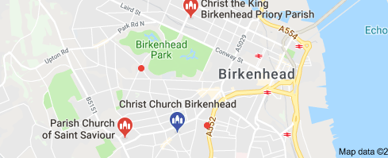 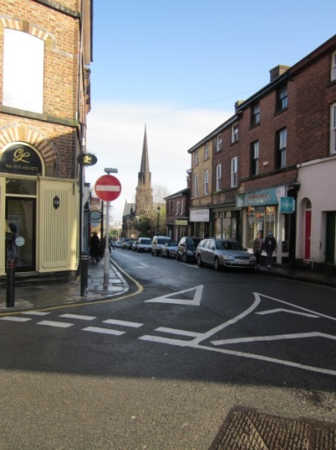

**The Church**

We see the church in the following words:

* Being a welcoming church family offering mutual friendship and support. A family that is committed to each other and to the entire parish. We are rooted in the love of the Lord and the teaching of the Bible.
* Taking part in Sunday and weekday services are reverential, prayerful, and worshipful, following the traditions of the Church of England.
* Offering a Christian-based outreach to children, families and the elderly; for example, through our Tots Spot, Fellowship group, Meet and Eat lunch club, and house groups.
* Having concern for mission: for the needs of the less well-off and disadvantaged in our town, our country and overseas, and making contributions as we are able.
* Engaging with and organising community activities such as Oxton Secret Gardens, Summer and Christmas Fairs, and Bible reading in the Green Community Shop.
* Being aware of the need to grow our numbers, both for the glory of God and to help us improve our finances. There is currently a suspension of the ‘Right to Presentation’ [SORP]. When the Parish manages to pay the full share and maintains this for a period of six months, then the suspension will be lifted. We are very close to achieving this goal.
* We are looking to be welcoming to all and have a fellowship that reflects the profile of the Parish.

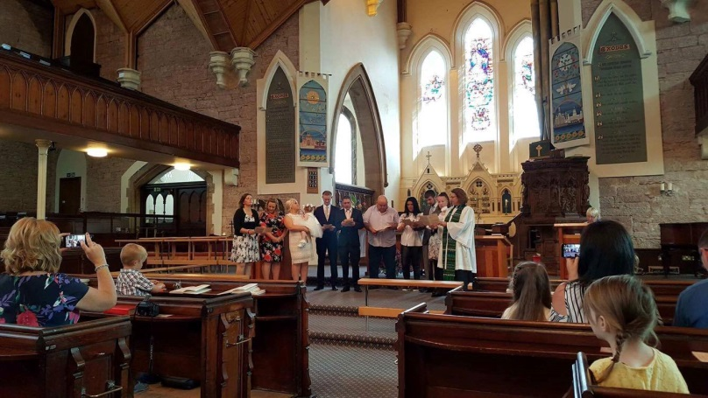

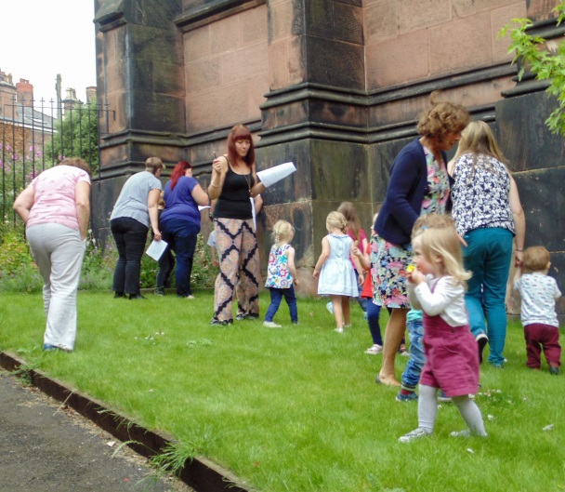 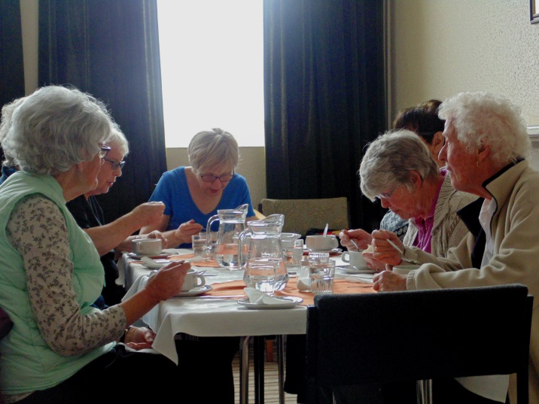

Christ Church has been used continually for worship since 1849. Originally built 'on spec' it was taken over some five years later by the Church of England and dedicated to 'the preaching of Evangelical and Protestant Truth in perpetuity.' The original 1209 sittings have now been reduced in number, and indeed our galleries are little used today. In the 1880s, the east end was extended and the historic Willis organ moved from the west gallery to its present position in the chancel. Beneath the church was a schoolroom that had accommodation for 760 children. It now forms our community rooms. The church was given a new roof in 1992 and had its imposing spire rebuilt after storm damage on Christmas Eve 1997.

Many eminent people have worshipped here at Christ Church, including Rev. R.P. Blakeney, founder of the ‘Church Association’, and Wilfred Owen, the War Poet. The longest serving Vicar was Rev. W.H.F. Robson who served here for 36 years and made many changes to the interior of the building. An orphanage and church school were started during his incumbency. This year sees the Commemoration of the end of WW1 and there is to be a ‘Songs of Praise’ service to be broadcast from our Church in November and also there will be a large focus on Wilfred Owen with various activities around our Church and Birkenhead in general. The present Ministry Team comprises of a Curate, two Readers, Pastoral Worker and Children and Families’ worker. Many of our congregation live outside the Parish and are mostly mature females. We have a core of dedicated volunteers that work within the Parish visiting the housebound and sick, and even undertake Bible reading in the local ‘Green Community shop’. We do lack young families and children within our congregation and have held ‘Teddy Bears Picnic’ and a Baptism Renewal service to try and encourage members of our Tots Group.

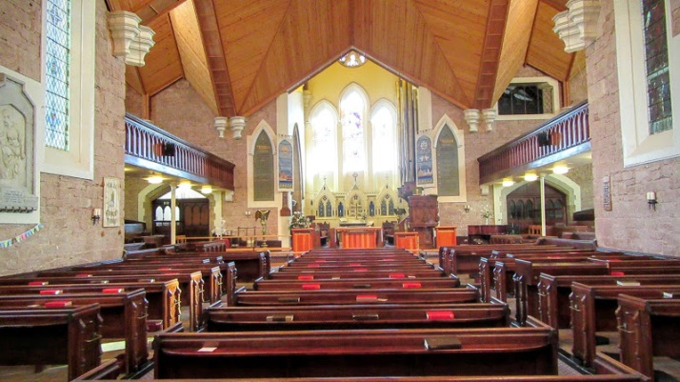 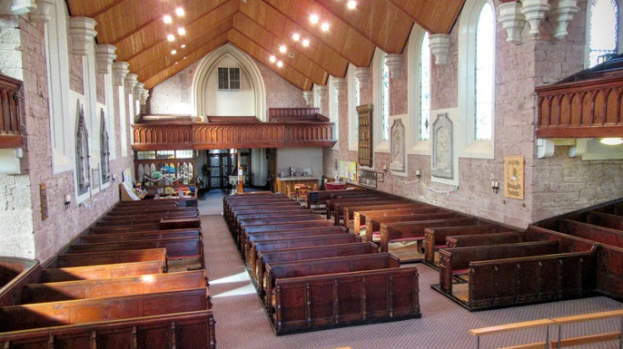

Our worship

**9am**. A traditional said Holy Communion service based on the Book of Common Prayer.

**10.30am.** A monthly sequence of Family Service, Holy Communion, and Morning Prayer using Common Worship. This is our main service in which we seek to balance the loveliness of the Church of England liturgy with innovation that is attractive to all. The readings and intercessions are taken by members of the congregation. We sing hymns to the accompaniment of our fine Willis organ, and are led by our small music group in singing choruses.

**6pm.** A fortnightly evening service following Evening Prayer [Common Worship], meeting in the lower vestry. This can be varied by using CDs in worship, the Iona service etc.

**On weekdays** Morning Prayer is said at 9am and on Saturdays at 10am in church. On Tuesdays mornings at 11am Morning Prayer is held in the lower vestry. This also can be varied week by week by the leader eg: a reflective service, discussions, and prayers for particular subjects etc.

We follow the Liturgical Calendar; and also have services for Healing, Christingle, the Crib, All Souls Remembrance and other occasions. Christ Church Primary School attends for end of term and leavers services, and outside organisations have used the church for other services eg: Edsential [Educational Service] for ‘Sing the Christmas Story’, Scouts services etc.

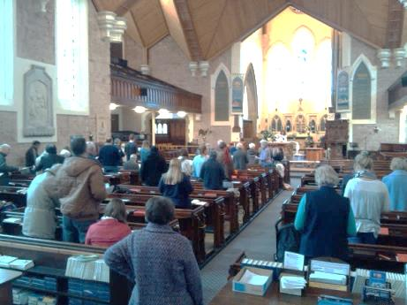 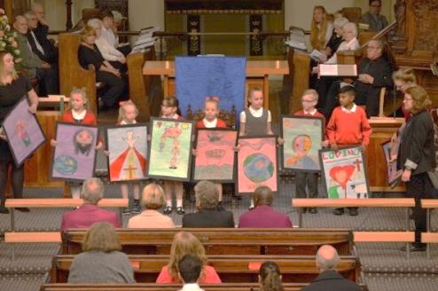

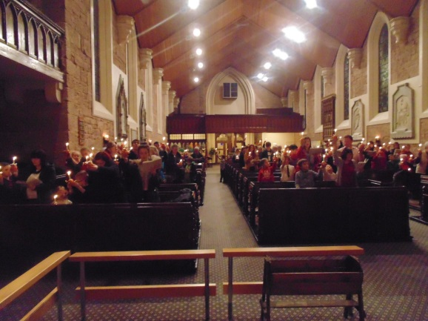 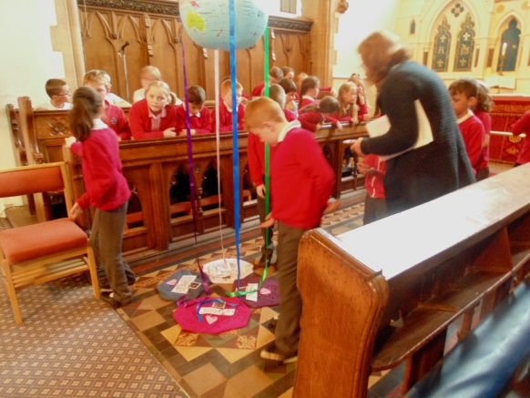

**The Community Rooms**

The former schoolroom in the crypt has been divided up into three community rooms. A fourth room is dedicated to the ‘Tots Spot’ group. The 'lower vestry' seats around twenty-five; the spacious main hall accommodates 70 for lunch, and St Michael’s Room provides an excellently-lit space with access to a pleasant south facing garden.

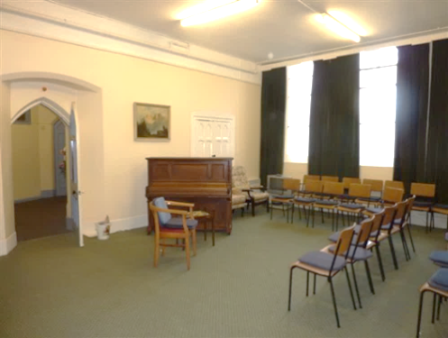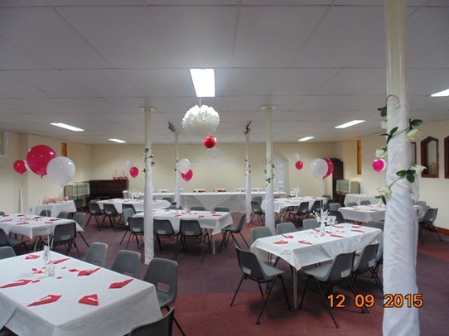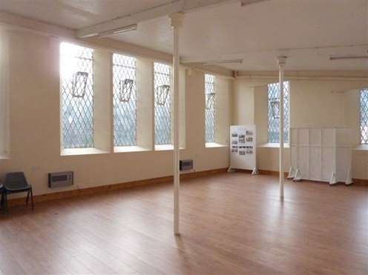

Lower Vestry Main Hall St. Michael’s Room

These community rooms provide accommodation for the Fellowship Group, which meets on the 2nd and 4th Tuesday of the month, the Meet and Eat lunch club, which meets on the 1st and 3rd Monday of the month, Kids Aloud [an after-school club], which meets on Fridays during term time. [This has been temporarily suspended.] Tots Spot meets on Wednesday and Thursday mornings during term time.

The Church uses the rooms for social occasions such as Christmas meals, Harvest suppers, Bring and Share events and the annual Agape meal. The twice-yearly Fairs [Summer and Christmas] take place here, and the rooms are rented out regularly to such groups as the Woodcraft Folk, Literary café, Oxton Keep Fit, First Aid, Art classes, Weight Watchers, Pilates, Yoga classes, Oxton History Fairs and for children's parties.

Our fully equipped kitchen enables us to host wedding receptions, baptism parties and funeral receptions. The rooms are also used yearly as a Polling Station.

The Church Office is also based downstairs and is staffed by the administrator for three days a week.

There is a small car park outside and on street parking nearby.

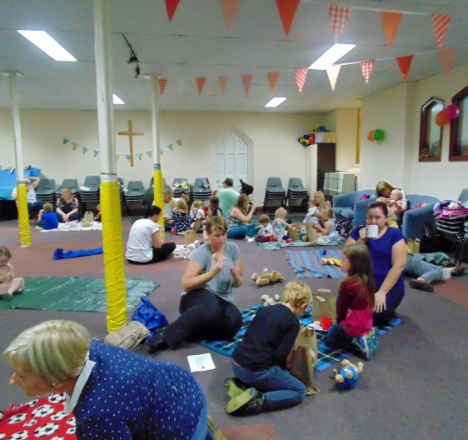 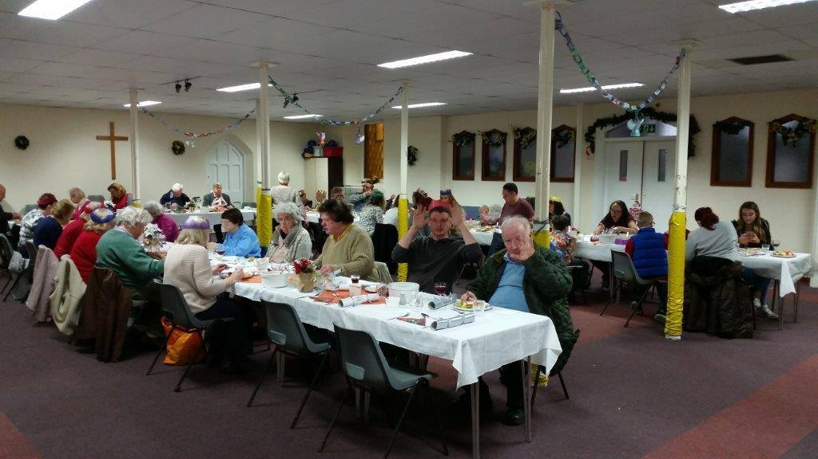

**Our School**

Christ Church Primary School currently has about 250 pupils and has done well in its inspections. The school has four foundation governors on its Governing body—including the vicar. Links with the church are lively and exist through assemblies, Kid’s Aloud, congregation members helping with remedial reading, individual class visits to church and whole-school services in church.

The school’s Mission Statement reads: *Christ Church School creates a firm foundation for individual growth through being a welcoming, caring and vibrant Christian community. We believe in nurturing talents, widening horizons, developing skills and creating aspirations for life as local, national and global citizens.*

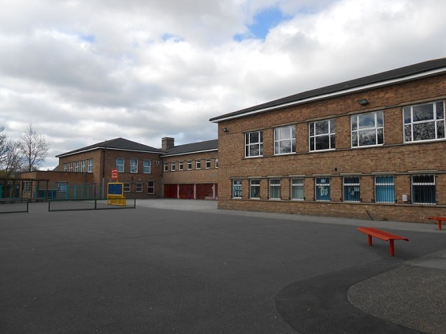 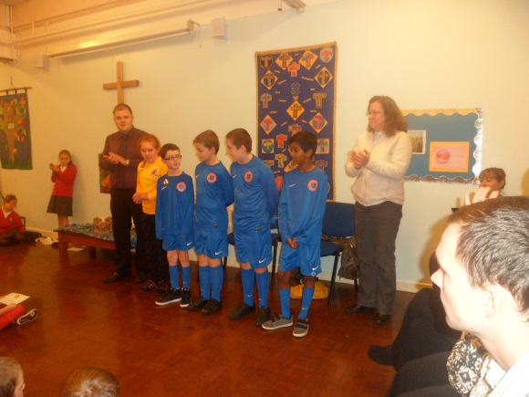

*Christ Church is a good school. Pupils are very happy and feel safe at school. This is reflected in their improving attendance. Their good behaviour creates a positive environment for learning. The majority of teaching is good or better. The teaching of reading is particularly effective and pupils achieve well in reading across the school.* OFSTED

*The distinct Christian vision and leadership of the head teacher and senior leaders inspires all who work within the school to strive to provide the very best opportunities for pupils*. SIAMS

The vicar is also a trustee of the Christ Church Children's Fund which makes grants to disadvantaged families with young children for basic items such as beds and white goods. It meets quarterly at the school.

 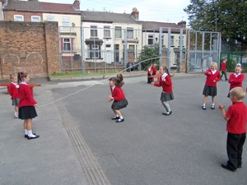

## 

**The Vicarage**

The vicarage is at 7 Palm Grove, some ten minutes’ walk from the church. There are five bedrooms, a study and two reception rooms. The garden is of a good size and there is off-road parking for two cars. It is in good order. New double glazed windows were installed a couple of years ago.

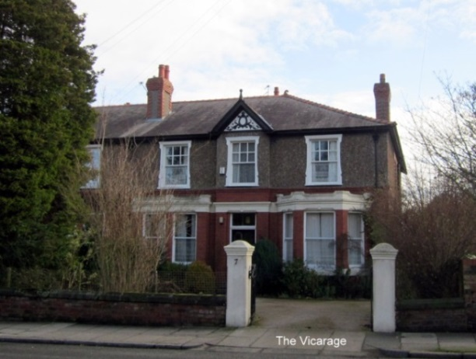

**Our Finances**

The Parish Fact Sheet and financial accounts provide details of our current position. This has improved greatly over the last couple of years due to an increase in parish giving and room hire.

Our Priest

We are seeking a priest with the following qualities:

|  |  |
| --- | --- |
| Leadership | * Able to offer an example of faith and discipleship which is inspiring to others and witnesses to the servant hood of Christ. * Able to affirm and support a culture of welcome and inclusion * Able to lead the church in mission with conviction and enthusiasm * Able to be decisive yet delegate to / engage others in the leadership of the church * Have the capacity to discern, along with others, the needs of the parish within the wider context of Mission |
| Working collaboratively | * Able to motivate collaborative working with the wardens, the PCC and the ministry team * Able to recognize nurture and release the gifts of the all in the church * Able to manage conflict and show an ability to negotiate difficult relationships. * able to demonstrate good interpersonal skills and awareness of boundaries between personal and professional life and within pastoral relationships |
| Communications | * Be able to communicate effectively in a range of settings : interpersonally, written word, social media * Have a functional level of computer literacy including use of social media |
| Parish management and organisation | * Able to lead, initiate and manage change * Able to delegate and devolve responsibility * Have good time-management and self-organisation skills * Ability to work in a team and on own initiative * Awareness of financial issues and procedures * Awareness of the need for parish procedures and policies |
| Outreach | * Able to show experience in outreach in a deprived inner city parish * Awareness of the challenge of articulating the good news of the Kingdom appropriately in such a context * Committed to working with other presences in the parish such as the school, ONCT, community groups * Committed to enabling others to develop their calling as witnesses of the good news. |
| Worship | * Able to lead formal liturgical worship such as BCP and Common Worship yet open to initiating creative fresh expressions * Commitment to the ministry of the whole people of God |
| Preaching | * Committed to biblically based preaching * Demonstrates depth and breadth of theological understanding. * Confident in formal preaching yet wanting to develop creative approaches to preaching |
| Teaching | * An effective communicator and teacher in a range of contexts; preaching, small groups and in conversation. |
| Pastoral Care | * A people-person with a strong pastoral instinct who will be active in the local community |
| Spirituality/ Personal Development | * Committed to developing their own spiritual discipline, which involves individual and corporate prayer and worship. * Able to show how their spiritual practice sustains and energises them in their daily life and ministry * Recognise their own development needs and able to strike a balance between rest and work |

**Looking Forward**

In April 2018, church members completed a questionnaire about their hopes and prayers for Christ Church’s future with 31 responses. Key development areas were:

* To maintain and strengthen the love within the church
* To engage further with the community and school
* To target children and families
* To run Inquirer courses
* To share Bible study and discipleship
* To follow up Baptism families

**Vision Statement**

Our vision is to see an effective Church, one that puts Christ first, focuses on its purpose, makes wise choices and does things well.