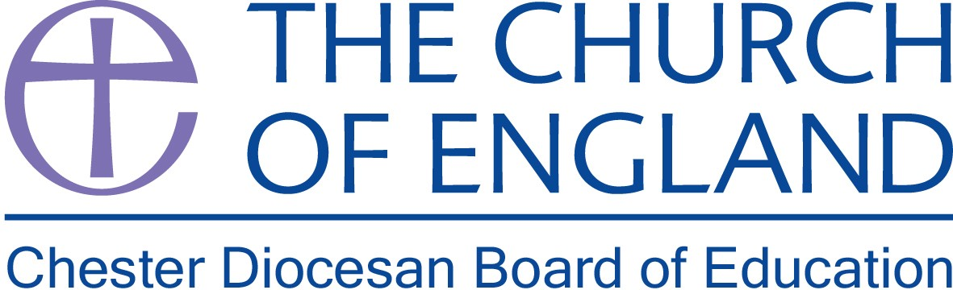

School Effectiveness Officer
Chester Diocesan Board of Education

Full Time – 35 hours
Salary range £43,531 - £46,967

This newly created post provides an exciting opportunity to work as a key member of the Chester Diocesan education team and reflects the increased commitment and heightened profile of our work on school effectiveness with our Church schools and academies.

This high-profile role is focused on providing strategic leadership that promotes and delivers educational excellence and effectiveness across our Church of England schools and academies in the Chester Diocese.

This post is ideally suited to an experienced, senior leader who can demonstrate a proven track record in school improvement and highly effective leadership. A Commitment to promoting Church schools and academies at the heart of the Church’s mission is essential.

This is a full time position for 35 hours per week. The role will be based at the offices in Daresbury Park, Warrington, with travel around the Diocese.

Further details and Application packs available from the Diocesan website

For further details or an informal discussion about this role, please contact Charlotte Somers, PA to the Director of Education on 01928 718834 or e-mail charlotte.somers@chester.anglican.org

Closing date: 4pm on Friday 21st September 2018

Interviews: Thursday 27th September 2018

An enhanced DBS Disclosure will be required.

