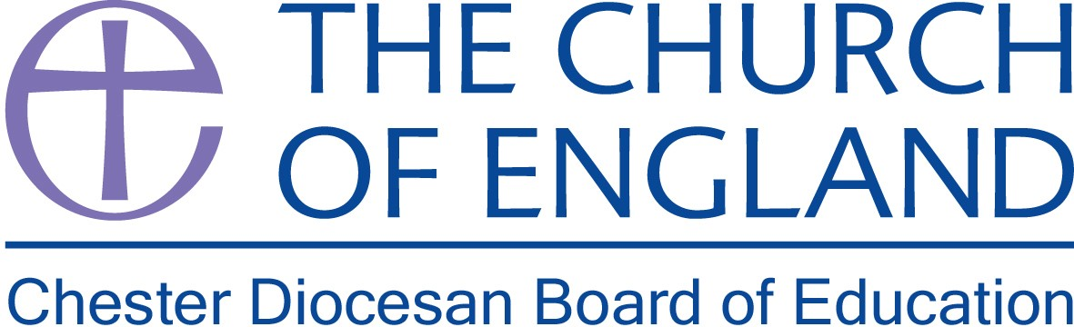

Christian Character & CPD Officer
Chester Diocesan Board of Education

Part-Time (0.4)
Salary £40,295 (FTE), £16,118 (actual)

This newly created post is an exciting opportunity to work as a key member of the Chester Diocesan education team and lead the strategic development of the Diocesan Board of Education’s vision for a deep and distinctive Christian character, identity and practice in our church schools. The successful candidate will also provide professional leadership, support and advice to headteachers, senior leaders and governors, including coordinating the programme and development of training and resources for schools.

This post is ideally suited to an experienced middle or senior leader who can demonstrate a strong personal commitment to promoting education with a Christian purpose, and has proven experience of leading successful professional development within a church school context.

This is a part-time position for 14 hours (2 days) per week. The role will be based at the offices in Daresbury Park, Warrington, with travel around the Diocese.

Further details and Application packs available from the Diocesan website

For further details or an informal discussion about this role, please contact Charlotte Somers, PA to the Director of Education on 01928 718834 or e-mail charlotte.somers@chester.anglican.org

Closing date: 12pm on Friday 21st September 2018
Interviews: Tuesday 25th September 2018

