History of St Alban’s Church 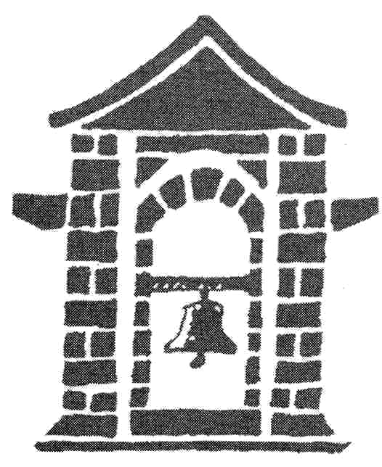
Imagine back to the 1700s the closest church in the area was St. Mary’s in Bowdon. The congregation had to hike across the fields from Broadheath, and back again, each Sunday. As the small community began to grow, a second church, St. George’s was built, in 1799. This still meant the folk in Broadheath had almost two miles to walk each Sunday.
In 1853, when the railway station opened, it was decided to set up a mission in Broadheath. But instead of a usual church building, services were held on a black and white canal boat, located where the Bridgewater Canal passes under Manchester Road.
Later, in 1871 as industry boomed in the area, a school was built on Sinderland Road. Services were moved from the canal boat, to the school. Around twenty years later in 1891, a chancel was added and the name St Alban’s Church School, was given to the building
It wasn’t until 1899 that work on the current building began. It was designed by architects Austin and Paley, of Lancaster. Services would once again move, for the final time, to the new church building – St. Alban’s Church, Broadheath. The church was officially opened on the 8th November 1900, although the west end was incomplete and a temporary wall had been built. It wouldn’t be until the year 2000, almost 100 years later, that work would start again, to extend the church to its planned size. Later in 1902, the vestry and bell tower were added to the church.
In January 1911, the church formed its own parish, the parish of St. Alban’s. The first Vicar, the Revd L W Thomas, was collated.
The church continued to grow through the coming years, with a steady increase in the congregation. It was decided in 1914, to build a Vicarage which is next to the church. This became the residence of the current vicar. In 1923 the church had electric lights installed.
In 1928, the land close to the church was made into a community area, this included a bowling green and tennis club. There is now a medical centre on this ground.
In 1935 the church hall was built. This hosted the Sunday School.

