Programme Pack A
“About your Programme” 2016-17
Developing Ministry

Graduate and postgraduate programmes leading to these awards:
Level 6  Graduate level  Level 7  Postgraduate |  | BTh in Practical Theology: Ministry Development  Postgraduate Diploma in Practical Theology: Ministry Development
Department of Theology and Religious Studies
and Centre for Christian Ministry

About these programmes
The modules that we offer come under the heading of “Practical Theology” and are designed to give students the opportunity to reflect on the practice of their ministry so that they develop confidence, competence and dispositions for effective ministry. All the modules demand and develop skills in theological reflection. For BTh and PGDip students two “Theological Reading & Ministry” modules are available. For curates the text will be chosen by the Bishop of Chester for his book groups and students will be expected to demonstrate the relevance (or otherwise) of that reading for their ministerial practice. For lay ministers the book will be chosen by their Director of Studies. Other modules will use case studies drawn from the students’ own experience. An alternative final module on the PGDip programme will prepare students for future ministry development and research (TH7119).
We are able to recruit for two awards:
- BTh in Practical Theology: Ministry Development
- Postgraduate Diploma in Practical Theology: Ministry Development
Those studying for the PGDip will complete six 20 credit modules over three years (usually two per year). Those studying for the BTh will complete four 20 credit modules (usually two per year for the first two years) and a dissertation module worth 40 credits (usually in their third year).

Entry Qualifications
- For the Postgraduate Diploma: a 2:1 degree in Theology or related discipline
- For the BTh: FdA or DipHE, or the equivalent certificated study, in theology and ministry

Contacts
Programme Leader:
Revd Canon David Herbert, Church House, 5500 Daresbury Park, WA4 4GE (07594 952551) email: david.herbert@chester.anglican.org
Associate Programme Leader:
Revd Liz Shercliff, liz.shercliff@chester.anglican.org
Module Leaders:
Professor Elaine Graham, e.graham@chester.ac.uk
Revd Canon David Herbert. david.herbert@chester.anglican.org
Revd Dr David Lamb, david.a.lamb@btinternet.com

University of Chester:
Revd Dr Robert Evans, Principal Academic Contact. r.evans@chester.ac.uk
NB. This contact is more typically for the teaching staff than for the students. Students should not normally make contact with the Principal Academic Contact at the University for advice on modules, assessment, progression or other aspects their programme. Normally the Principal Academic Contact will be approached by a member of academic staff at your college if their advice is needed. There will be opportunities during the academic year for representative students to engage with the Principal Academic Contact. Students should only approach the Principal Academic Contact if they need to make a complaint and after all other avenues of complaint within the student’s own institution have first been exhausted.
Fiona Hughes, Partnerships Administrator. f.hughes@chester.ac.uk
(01244 511032)

Programme Administrator:
Jane Hood, Church House, 5500 Daresbury Park, Daresbury, Warrington WA4 4GE
(01928 718834 ext 257) email: jane.hood@chester.anglican.org

Applications and Registration:

Applications should be made via the Programme Leader (David Herbert) if you wish to apply for admission to the validated IME Phase 2 programme. He will inform the University and a record will then be created for you. Students enrol online once that record has been created on the University system.

Portal
Portal is the University of Chester’s intranet. Once you have registered as a student, you will be able to access this service through any computer that has internet access. You can access it by going to the university’s website: www.chester.ac.uk and following the link to ‘portal’. You will be given a ‘login name’ and a ‘password’ that will allow you to use the service. You will receive a University of Chester email address and have access to the library catalogue and a range of resources to support your studies. Some of these resources are detailed in this document. Once you receive access to MOODLE (virtual learning environment), take time to find your way around it, so that you can make use of the advice and support it offers when you need it. If you need any help in using it, talk to the Programme Administrator.

Policies:

Up-to-date details of all relevant University policies (see later) are on Portal (the University intranet). All details in this handbook are subject to change. You should always check such details on Moodle to have the current information.

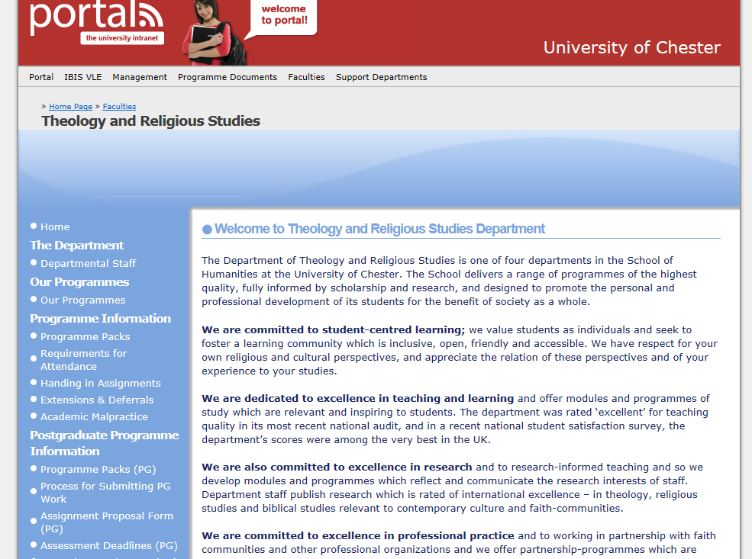

The homepage for the Theology and Religious Studies Department https://ganymede.chester.ac.uk/index.php?page_id=122534

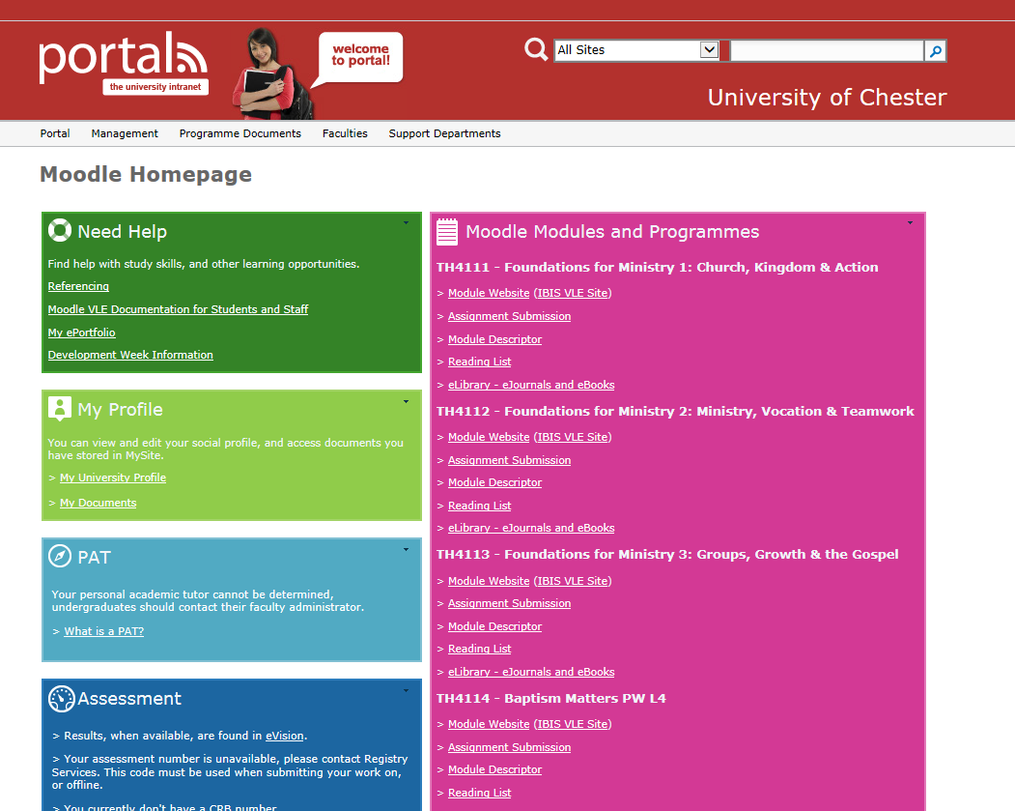
A Moodle homepage on which you will see the modules you are registered for
https://portal.chester.ac.uk/moodle/Pages/Homepage.aspx

Modules:
You must successfully complete all modules in order to receive your degree or diploma. Students will usually take the programme over three years.

Module descriptors are available online by clicking the e-learning tab on your MOODLE homepage. Within the descriptors are “Key References” (bibliography). Please note that these lists are illustrative. You will need to include up to date resources in your work and these should be properly referenced in the assignment and the bibliography.

Notes:
- While studying you should aim for at least three contact points with your tutor: for tutorial support (dates will be notified), for feedback on your Assignment Proposal Form and for feedback on your assignments.
- The (Ordained) Ministry Audit (TH6120 or TH7113) is a Parish Profile which corresponds to that being done by curates not having their work accredited or builds on a missional case study at level 5 written by Readers pre-licensing as part of their FdA.
- The Reflections on Ministerial Practice for ordained ministers (TH6112, TH7114, TH7116) corresponds to the case studies being done by curates not having their work accredited, and for lay ministers builds on the Human Development and Pastoral Care module taken as part of their FdA.
- The Theological Reading and Ministry modules are either based on the reading shared in the IME Book Groups attended by all curates in the Diocese or a Book Group for licensed Readers established in the Diocese.
- TH7119 is designed to support those students who are intending to go on to an MA dissertation module (TH7123) or other further advanced study, or who want to plan a next stage of research in ministry. TH7118 is an alternative for those who would prefer to complete a third module in theological reading and ministry.

Module details:
Module code | Title | Module Leader | Submission date | Word count
TH6120 | Ministry Audit | David Herbert | 26 February | 4000
TH6112 | Reflection in Ministerial Practice 1 | David Herbert | 26 February | 4000
TH6114 & TH6115 | Theological Reading and Ministry 1 and 2 | David Lamb | 17 May | 4000
TH6117 | Dissertation in Practical Theology | David Herbert | Tba | 8000
TH6118 | How adults learn, spiritually and theologically | Liz Shercliff | Tba | 4000 equiv
TH6119 | Preaching in pastoral context | Liz Shercliff | Tba | 4000 equiv
TH7113 | Ordained ministry audit | David Herbert | 26 February | 5000
TH7114 | Reflection on Ministerial Practice 1 | David Herbert | 26 February | 5000
TH7115 | Theological Reading and Ministry 1 | David Lamb | 17 June | 5000
TH7116 | Reflection on Ministerial Practice 2 | David Herbert | 26 February | 5000
TH7117 | Theological Reading and Ministry 2 | David Lamb | 17 June | 5000
TH7118 | Theological Reading and Ministry 3 | David Lamb | 17 June | 5000
TH7119 | Ministerial Development and Research | Elaine Graham | 17 June | 5000 equiv

Typical Pathway
Year | Lay Ministers (BTh) |  | Ordained Ministers (BTh) |  | Ordained Ministers  (PG Dip)
1 | TH6120 or TH6112: Reflection on Ministerial Practice 1 | TH6119: Preaching in Pastoral Context | TH6120: Ministry Audit: Mission & Evangelism in Context | TH6114: Theological Reading and Ministry 1 | TH7113: Ordained Ministry Audit: Mission & Evangelism in Context | TH7115: Theological Reading and Ministry 1
2 | TH6118: How Adults Learn | TH6114: Theological Reading and Ministry 1 | TH6112: Reflection on Ministerial Practice 1 | TH6115: Theological Reading and Ministry 2 | TH7114: Reflection on Ministerial Practice 1 | TH7117: Theological Reading and Ministry 2
3 | TH6117: Dissertation in Practical Theology |  | TH6117: Dissertation in Practical Theology |  | TH7116: Reflection on Ministerial Practice 2 | TH7119: Ministerial Development and Research, or TH7118: Theological Reading and Ministry 3

Assessment
- This validated programme leads to 120 credits at level 6 or 120 credits at level 7.
- Assessment guidelines are published on Moodle.
- Your assessed work will be graded with a mark out of 100.
- Marks will be given according to the extent to which you have fulfilled the learning outcomes for the module. Learning outcomes are listed in each of the module descriptors and in this Programme Pack (see below). Attention needs to be given to the learning outcomes throughout the module.
- Copies of Module Descriptors are published on MOODLE.
- Information on generic assessment criteria is contained in Programme Pack C.
- The guide to referencing and bibliographies (APA) is at https://ganymede2.chester.ac.uk/index.php?page_id=1553173

The Learning Outcomes
TH6120 | Students will be assessed on their ability to:  - demonstrate an understanding of the range of data sources within a parish context and an understanding of the key tool of social analysis and its importance for theological reflection  - select and justify an appropriate method of theological reflection for analysing the relationship between the resources and needs of church and community  - apply the method to make a coherent, critical and theological to the minister’s own role and practice with reference to a range of reading and practice
TH6112 | Students will be assessed on their ability to:  - identify an appropriate critical incident or ongoing situation, or project and assess the interrelated principles and practices operating in a selected context of ministry;  - demonstrate an ability to combine interdisciplinary perspectives, and interrelate experience and theological and other pertinent reading;  - demonstrate an ability to reflect theologically upon key experiences and relate them to the development of their ministry
TH6114 TH6115 | Students will be assessed on their ability to  - understand and critically analyse the key text and a range of other relevant reading,  - interact with significant issues raised by the text and present arguments in a coherent way supported by evidence,  - demonstrate how theological issues raised can be applied to Christian ministry today with practical implications for the student’s own situation,  - present material in an appropriate academic manner with attention to structure, spelling, grammar and referencing
TH6117 | Students will be assessed on their ability to:  - select and investigate a substantial amount of pertinent material available, appropriate to the chosen topic  - demonstrate detailed knowledge and critical understanding of the subject, with reference to advanced scholarship and with an appreciation of uncertainty and ambiguity  - apply to independent enquiry a range of skills or methods of study appropriate to the chosen topic (such as, philosophical, historical, systematic, dogmatic, phenomenological, linguistic, hermeneutical, empirical, speculative, and social scientific), to review, consolidate and extend their knowledge and understanding through their independent enquiry  - develop a dissertation which sustains and evaluates an argument, through independent enquiry, and which draw on a range of scholarly resources including research articles and primary sources
TH6118 | Students will be assessed on their ability to:  - give a detailed and coherent account of features of adult learning theory  - implement and critique different approaches in a ministerial context  - critically evaluate the role and importance of adult learning in discipleship within the context of the mission and ministry of the church  - demonstrate theological and pedagogical skills to create, implement and evaluate a resource in contemporary discipleship
TH6119 | Students will be assessed on their ability to:  - demonstrate a systematic understanding of key issues in contemporary preaching.  - engage in critical theological reflection on personal and/or ministerial/professional preaching practice.  - make theologically informed choices about exegetical, hermeneutic and homiletic methods  - manage their own learning, making appropriate use of scholarly sources to aid their reflection upon contemporary issues related to pastoral preaching
TH7113 | Students will be assessed on their ability to:  - identify and critically evaluate a range of data sources available for understanding the parish context  - interact in depth with the findings of the social analysis by using a range of scholarly resources (including research articles) and presenting findings in such a way that student’s learning is identifiable  - use a good range of appropriate theological resources to affect and inform the minister’s practice in relation to an identified feature of the local context  - show a professional approach to presentation, paying particular attention to accurate referencing and bibliography, following the recommended university guidelines
TH7114 | Students will be assessed on their ability to:  - identify an appropriate critical incident or ongoing situation, or project and assess the interrelated principles and practices operating in this selected context of ministry  - demonstrate an ability to combine interdisciplinary perspectives within theological reflection to review, consolidate and extend their knowledge and understanding  - demonstrate an ability to reflect theologically upon key experiences and relate them to the development of their ministry drawing on a wide range of scholarly resources, with evidence of originality in the application of knowledge and critical awareness
TH7115, TH7117 & TH7118 | Students will be assessed on their ability to:  - understand and critically analyse the key text using a range of scholarly resources, including research articles and primary sources (in original languages if appropriate). They should show evidence of broad reading and the ability to gather their own supportive data, using appropriate methodologies such as statistical analysis. They should demonstrate critical judgment in their ability to source and use relevant material.  - interact at depth with significant issues raised by the text and present arguments in a clear and coherent way, supported by findings drawn from recent scholarship and, where appropriate, their own research analysis. Evidence of original thinking will contribute to higher marks.  - Demonstrate how theological issues raised by the text and interaction with it can be applied to Christian ministry today, alongside an ability to critically reflect on the implications for the candidates’ own situations.  - Show a professional approach to presentation, using the correct academic style for structure, spelling and grammar. Particular attention should be given to accurate referencing and bibliography, following the recommended university guidelines.
TH7116 | Students will be assessed on their ability to:  - identify an appropriate critical incident or ongoing situation, or project and assess the interrelated principles and practices operating in this selected context of ministry;  - demonstrate an ability to combine interdisciplinary perspectives within theological reflection to review, consolidate and extend their knowledge and understanding  - demonstrate an ability to reflect theologically upon key experiences and relate them to the development of their ministry drawing on a wide range of scholarly resources, with evidence of originality in the application of knowledge and critical awareness.
TH7119 | Students will be assessed on their ability to:  - critically review, analyse and evaluate their ministerial practice within context  - show how theological sources, resources and traditions might engage critically and constructively with their context  - conceptualise, design and plan a focussed programme in practical theology  - consider the potential impact of their proposed programme of learning on their ministerial practice taking into account strategic and ethical considerations  - communicate ideas clearly and effectively and demonstrate the ability to argue logically and persuasively in support of their proposals  - Identify the importance of the proposed programme for personal and ministerial development

Recommended reading
The nature of some of the modules on this programme means that sometimes it is difficult to provide bibliographies or reading lists. Case studies and the subject matter for theological reading will vary from student to student and from year to year. Students will be responsible for resourcing their own learning by using books, journals and online resources. Tutors will be able to advise if help is needed with this.

Referencing and Bibliographies
It is important that the referencing conventions of the University of Chester are followed.
- All quotes should be acknowledged and referenced with the body of the assignment
- The work of others should be acknowledged and referenced within the body of the assignment
- There should be no endnotes or footnotes. All work that is referenced should be included in the bibliography as well as the background reading you have done for the assignment

Word counts
- The word count for Level 6 assignments is 4000 words (+10%).
- The word count for TH6117 is 8000 words (+10%).
- The word count for level 7 assignments is 5000 words (+10%).
- Excessive word counts are penalised according to the policy of the University of Chester.

Submissions
- Assignments need to be submitted on time through TURNITIN (on your MOODLE page) unless you have successfully applied for an extension from the Programme Leader. Late submissions will be penalised according to the policy of the University of Chester.
- Assignments must be WORD documents or PDFs.
- Early submissions can be revised through TURNITIN at any time up till the submission date.
- You will be required to vouch that your assignment is your own work when you do turn it in.
- Assignment Cover Forms are no longer required.
- Our programmes are exempt from the policy of anonymous marking.
- All marks are provisional till ratified by the Subject Assessment Board.

After you receive your work back
- Please contact your module leader if you want to respond to the feedback you have been given.

The External Examiner
- A new External Examiner will be appointed for 2016-17.
- The Examiner’s role is to confirm that processes are being followed: commenting on good and bad practice, areas for improvement and that marks given are comparable with other institutions.

Rules and Regulations
- For policy on Late Work and applying for mitigating circumstances refer to Programme Pack C.
- For policy on excessive word length, academic malpractice, including plagiarism, and guidelines on reassessment refer to the links in Programme Pack C.
- Please read these brief and important texts. If you are unable to access these for any reason, please request hard copy from the Programme Administrator.

Further Guidance
The following guidance to help you complete your studies is also available on Portal:
- Programme Pack B: Details of the Theology and Religious Studies Department
- Programme Pack C: Details on Assessments (including how your work is graded)
- Programme Pack D: Guidance for Study and Assessment
Take time to read this information by following the above links.
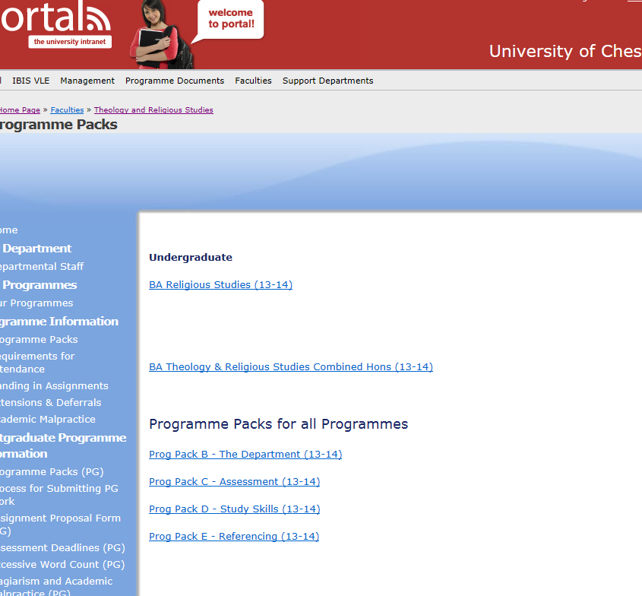
Revised November 2nd 2016

