**Parish Profile**

**The Parish of St Oswald, Backford**

Serving the townships of Backford, Caughall, Chorlton, Lea & Mollington

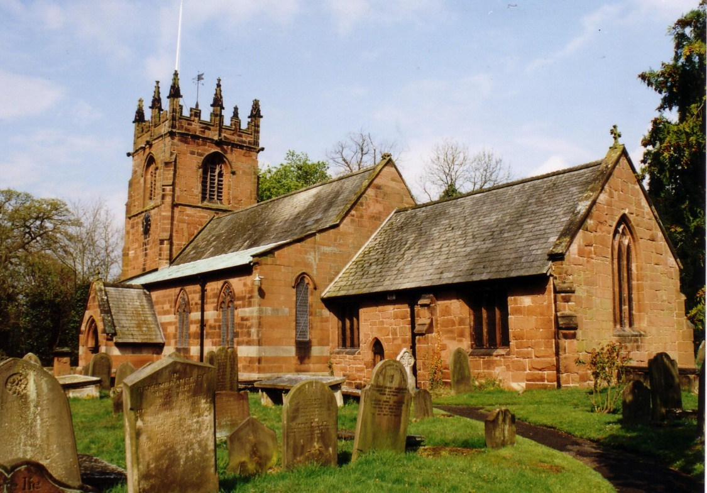

**Church and Community,**

**Growing Together in Faith and Love**

**OUR IDEAL CANDIDATE**

|  |  |  |  |  |  |  |  |
| --- | --- | --- | --- | --- | --- | --- | --- |
|  |  |  | ENCOURAGES US TO | |  |  |  |
|  |  |  | WORSHIP & BE | |  |  |  |
|  |  |  | WITNESSES FOR JESUS | |  |  |  |
|  |  |  |  |  |  |  |  |
|  |  |  |  |  |  |  |  |
| SEES OUTREACH AS A | |  | LOVES WITH A PASTOR'S | |  | MAKES REGULAR VISITS TO | |
| PRIORITY | |  | HEART & ENGAGES | |  | ST OSWALD'S SCHOOL & | |
|  |  |  | IN PASTORAL CARE | |  | MOLLINGTON PRE-SCHOOL | |
|  |  |  |  |  |  |  |  |
|  |  |  |  |  |  |  |  |
|  |  |  | SUPPORTS US ON OUR | |  |  |  |
|  |  |  | SPIRITUAL JOURNEY | |  |  |  |
|  |  |  |  |  |  |  |  |
|  |  |  |  |  |  |  |  |
|  |  |  |  |  |  |  |  |
|  |  |  | EMPOWERS US TO USE OUR | |  |  |  |
|  |  |  | TALENTS TO PLAY AN ACTIVE | |  |  |  |
|  |  |  | ROLE IN WORSHIP & | |  |  |  |
|  |  |  | PASTORAL CARE | |  |  |  |
|  |  |  |  |  |  |  |  |
|  |  |  |  |  |  |  |  |
|  |  |  | ENGAGES WITH FAMILIES & | |  |  |  |
|  |  |  | ENCOURAGES THEIR | |  |  |  |
|  |  |  | PARTICIPATION IN WORSHIP | |  |  |  |
|  |  |  |  |  |  |  |  |
|  |  |  |  |  |  |  |  |
|  |  |  | ENGAGES WITH YOUNG PEOPLE | |  |  |  |
|  |  |  | & ENCOURAGES THEIR | |  |  |  |
|  |  |  | PARTICIPATION IN WORSHIP | |  |  |  |
|  |  |  |  |  |  |  |  |
|  |  |  |  |  |  |  |  |
| The PCC is supportive of the ministry of women at all levels in the Church. | | | | | | | |

**Map of the Parish**

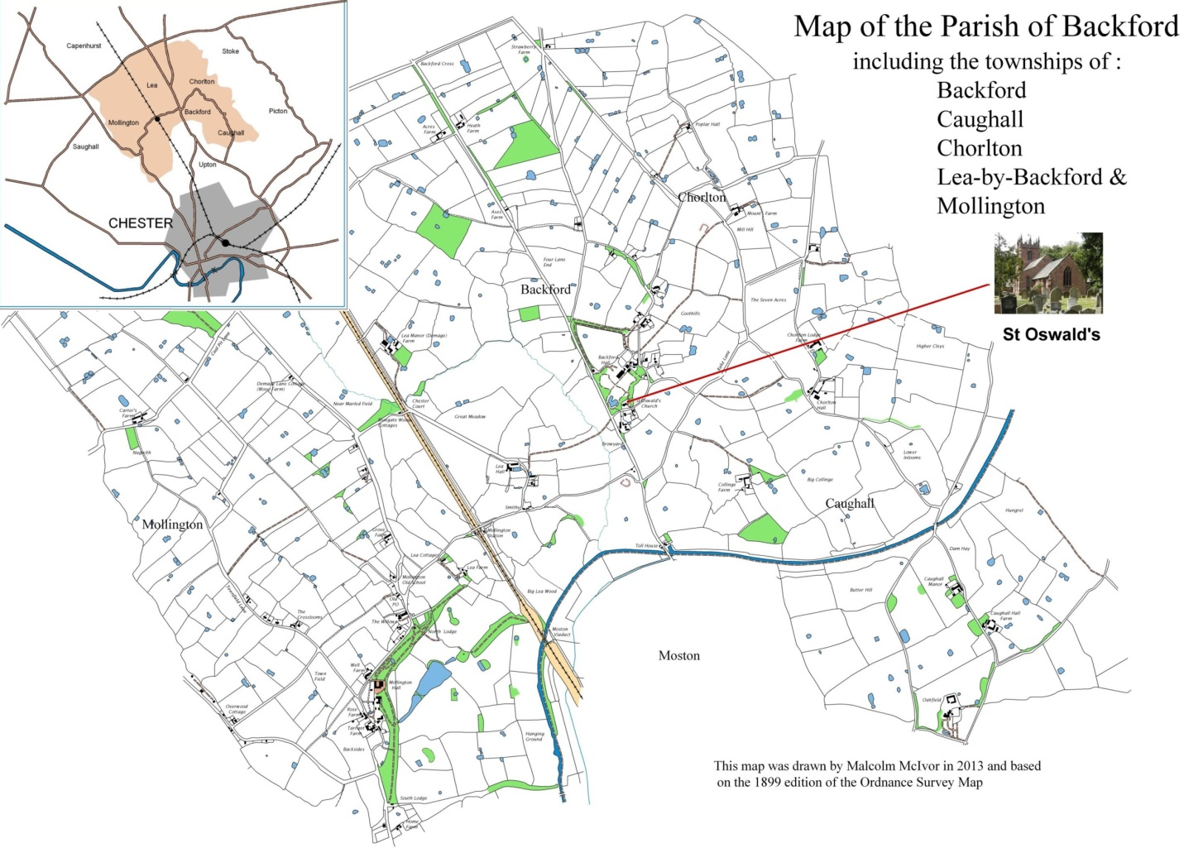

**Introduction to the Parish**

The parish, serving the townships of Backford, Caughall, Chorlton, Lea and Mollington lies to the north of the historic city of Chester and is mainly rural. The majority of houses are owner occupied and the population of 1,074 is fairly static. New building is going on behind the church, with 14 dwellings occupied, some by young families, and a further 30+ are planned. There is little industry in the parish, 15 working farms, commuters to Manchester and Liverpool and many retirees. A farm shop and ice cream farm serve particular needs but the nearest shopping areas are in Chester and Ellesmere Port.

Cheshire Oaks Outlet Village, the Blue Planet Aquarium and Chester Zoo attract many visitors. North Wales offers good walking and many opportunities for outdoor pursuits. Motorway networks are within easy reach as are both Manchester and Liverpool airports. However many parts of the area are poorly served by public transport.

The Hospice of the Good Shepherd lies close to the church, (in the former vicarage) and has undergone recent expansion. They have their own chaplain. The Greater Grace Evangelical School and church operates from the former Backford School, just across the road from St. Oswald’s. St Oswald’s C of E Aided School lies in Mollington, opposite the Vicarage. Mollington Pre-school and After school club operate from The Mollington Old School, next door. The incumbent has a trustee responsibility for this building. Backford and Mollington Village Hall is a focus for community activities and plans are being made for a renovation project.

**Pattern of worship** 8.00am Holy Communion (Said). 1st and 5th Sunday: 1662 Prayerbook. 2nd- 4th Sunday: Common Worship, Traditional Language.

11.15am Main Morning Worship 1st Sunday: Mattins. 3rd Sunday: All Age Worship. 2nd,4th,5th Sunday Parish Communion.

Being a rural parish we celebrate Plough Sunday, Rogation Sunday and Lammas as well as Harvest. Jo Pemberton is Lay Reader for both Holy Trinity and St Oswald’s. Towards the end of last year she organised a series of joint Bible studies in support of the YBible initiative. Last year there were 4 baptisms, 2 weddings, 8 funerals and 1 memorial service following cremation. Traditionally services on Ash Wednesday, Maundy Thursday, Good Friday and Ascension Day have been joint services. 5 members of the congregation are licensed to administer the chalice. There are committed teams of sidesmen, flower arrangers, bell-ringers, readers and coffee makers.

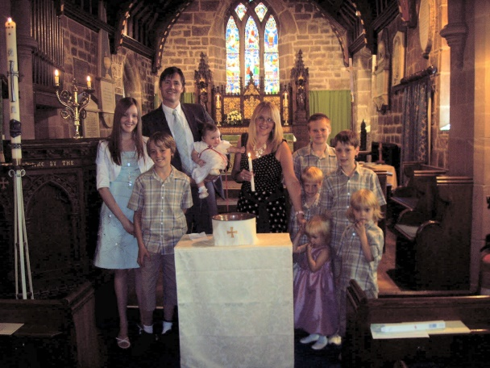 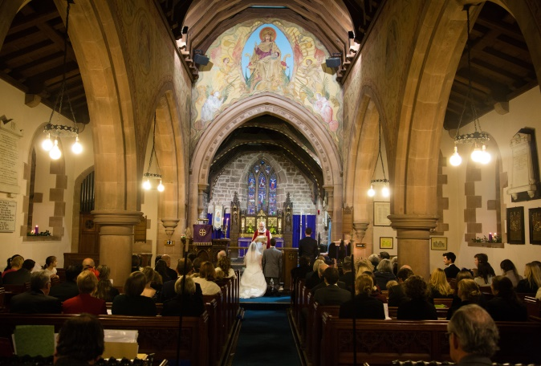

Open Table, communion followed by bible study, Curry and Compline, mainly for men and joint Monday morning prayers have all lapsed during the interregnum. These may be areas to be developed by a new incumbent.

There are 98 people on our Electoral Roll, approx. half living outside the parish. An average Sunday sees 34 worshippers over the 2 services. All Age worship is the best attended with several families often present. There is a PA/loop system available. At present there is no regular organist, however we have 2 ladies who play on an ad hoc basis and this is supplemented by a music system.

**Church Organisations**

**Mothers’ Union** There has been a branch at St Oswald’s for over 60 years. Current membership is 10 including 2 from Holy Trinity. Support for the church includes assisting with posy making for Mothering Sunday and Christingles, being present at baptisms and sending out baptism anniversary cards. We are involved in the Diocesan Virtual Baby project and Wedding Fairs and support worldwide projects. Last year we organised a display in church for National Marriage week and in the summer a display to highlight the Away from It All holiday scheme. This coincided with a very successful fundraising cake stall. At present one of our members is Wirral South Deanery Leader and another Deanery Secretary. We are always open to consider new ways in which we can further the mission and outreach of the church.

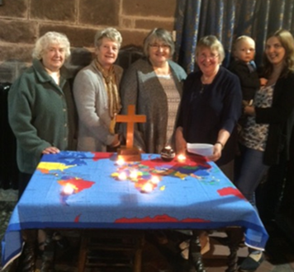

**Bell Ringers** There is a well established and enthusiastic team of bellringers, who ring before the main Sunday service, also for weddings and funerals by arrangement and for special occasions by request. A regular weekly practice is held. The ringers actively participate in the programme of training and other events organised by the Chester Branch of the Chester Diocesan Guild of Bellringers

**PCC**  Unfortunately our PCC has suffered several resignations recently and at present we operate without a secretary or treasurer. We are hopeful that members will come forward at the APCM. The worship group, pastoral group and fabric committee manage specific issues within agreed remits and budgets and report back to the PCC.

**Social/Fundraising** A bring and share lunch at the back of church after the service on Plough Sunday. A bring and share lunch at the back of church after the service on Lammas Sunday. Mothers’ Union cake stall in church with consequent donation to Mothers’ Union funds. A Harvest bring and share supper with quiz in the Village Hall, resulting in a donation to TearFund. Christmas Draw and Afternoon Tea in the Village Hall, monies for church funds. Donation of harvest gifts to homeless hostels and donation of gifts to local foodbank. Donation to Children’s Society from Christingle Service. Donation to Royal British Legion following Remembrance Sunday Service.

**Deanery/Diocese** At the present time we have no representatives on Deanery Synod. There has been regular contact with the Rural Dean during the interregnum and several retired priests from the deanery have led our worship. There has been on going dialogue with the Diocese in relation to finance, faculties, a boundary dispute and future plans.

**Short History of St Oswald’s** St Oswald’s was built in the late 13th century, but the only part of that first building to survive is the chancel. The nave was rebuilt in brick in 1728 with a flat roof, and then in 1878 the nave was completely rebuilt in the form we see today. On the upper walls of the nave and above the chancel arch are mural paintings by Edward Frampton, dating from 1890. Re-ordering of the rear of the church, with removal of the last three pews to create space for meetings, exhibitions etc, was completed at the end of 2012.

The tower was built soon after 1500 and is one of four in the Chester area built by the same team of masons. There are 6 bells, four of them dating from 1714. A major programme of restoration on the stonework of the tower was completed in 2005.

The churchyard around St Oswald’s has been used for burials within the parish since its creation. The earliest surviving gravestone is of 1717, but there is an earlier chest tomb known to have been dated 1586, which held a member of the noble Coventry family, far from their Worcestershire home.

The most recent additions to the church are the Royal coat-of arms over the door, painted by a local artist in 2000 and the stained glass window on the south of the chancel to mark the new Millennium.

**Finance**  We have been unable to meet our parish share for several years. We are a small congregation in a small parish and have become demoralised by the financial burden. Within the wider parish community, there are at least four other charitables organistations, including the Hospice of the Good Shepherd & St Oswald’s School, each trying to fundraise from a small population. This last year has been particularly difficult as we have had a bookkeeper but no treasurer and slip ups in administration have made it difficult to receive accurate information. We look forward to being able to pay a smaller parish share under the proposed new arrangement. We would look to our new priest for direction in stewardship.

**St. Oswald’s C of E Aided School** The link between church and school is very important to us and is an area we hope to see developed. Transport difficulties impact on the number of times children can be brought to church. There are 3 end of term services with Bibles being given to leavers. For the last 2 years the school has been responsible for organising the Christingle service. Mothers’ Union members visited school to assist with the Christingle making. In November the ‘Jesus and Me’ team of pupils prepared and led our All Age worship and the deputy head played the organ at the Christmas Eve Crib and Carol service.

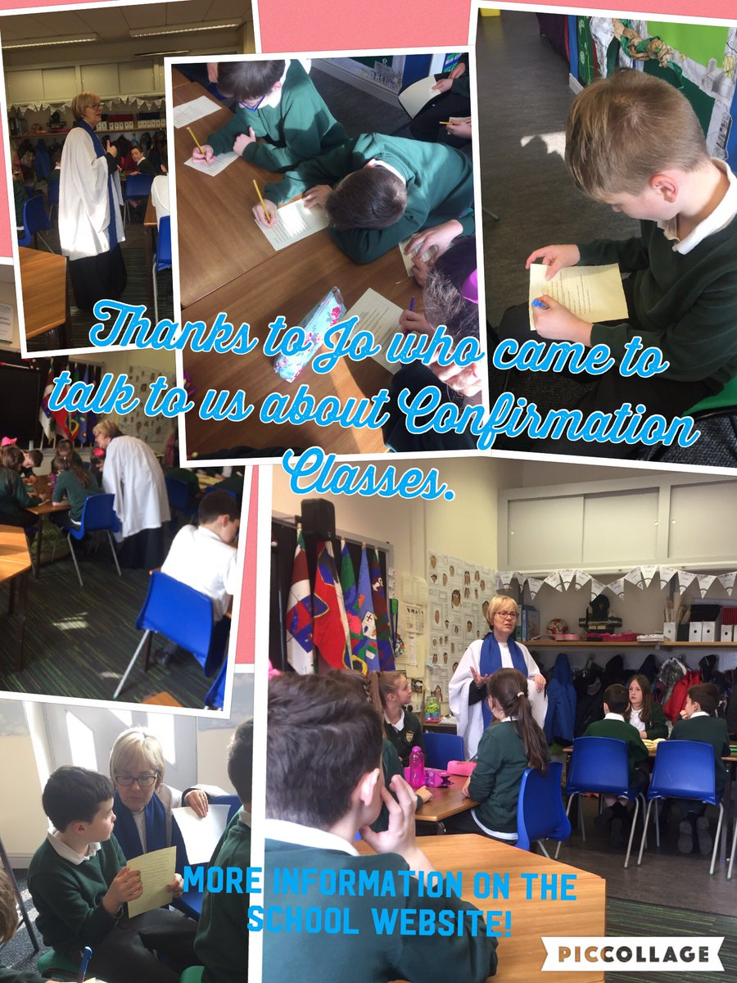

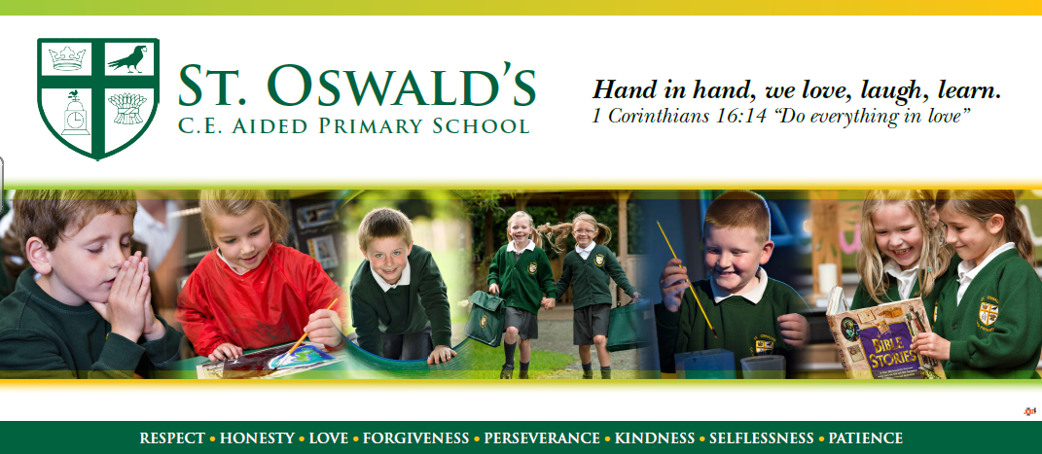

St Oswald’s CE Primary School is a lovely school and achieved a grade of outstanding at our last SIAMS inspection in 2016. Our school motto “Hand in hand we love, laugh, learn” is based upon one of the key messages of the Bible, the need to show love to all people at all times and underpinned by the well know bible verse from Corinthians. The school is driven by Christian values which form the themes for our collective worship. The values have created a welcoming and nurturing environment based on a strong community spirit. Children and staff understand what our values are, why we have them and how we show them in school and beyond. We have very positive relationships with our parents who are highly supportive of the school.

The headteacher Mr Wallace sees the Christian distinctiveness as the school as the underlying foundation in driving school improvement forward and is determined that the children at St Oswald’s will be given the opportunity to develop skills for life as well as academic knowledge within an exciting learning environment that puts the emphasis on enjoying learning.

Collective Worship is given a high priority in the school and we have a group of children known as the JAM (Jesus and Me) group who lead worship from time to time in school and have also planned family worship services in the church. We also enjoy working in collaboration with other church schools.

We would love an incumbent who would be willing to visit school regularly and get to know the children of St Oswald’s through having lunch in school and through leading worship in school. In particular we have enjoyed family communion services in school and would love to restart this practise. We look forward to an incumbent who is willing to work alongside the headteacher of the school to ensure that the Christian distinctiveness of the school and the links with the church and the parish remain strong and become even stronger.

St Oswald’s CE Primary School is a special place.

Dave Wallace, Headteacher

**Summary**  The recent months without an incumbent have been challenging, with many of the wider community perceiving the church as non-operational. The issues of an ageing congregation and uncertain financial situation need to be addressed with some urgency. We are looking for someone to be high profile in both church and community; someone who will inspire and motivate others and manage change effectively. A good organiser with a flexible, creative approach who will consult, communicate and collaborate to draw the three parishes together is essential.

God never promised that being a Christian would be easy. We put our trust in Him to find the right person for the job and look forward to working together to spread the Gospel of Christ in our communities.