Assessment and the Diocesan Syllabus
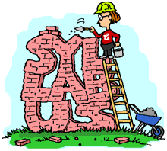

Venue: Church House, Daresbury
Date: 8th June 2018
Time: 9.30am -12.30pm

Cost: £75 per person for Family of Schools members/£100 per person for non-members

Leader(s): Sue Glover (RE Consultant) & Jane Brooke (Principal Consultant)

Information: This half day session is for any primary school teacher interested in improving their RE curriculum practice. The session will involve an introduction to good practice in ‘RE and Assessment’ based on a popular aspect of the RE syllabus. The activities will be based on the Diocesan guidance for assessment written in summer 2017 but added to over the course of this academic year. Teachers will discuss how to put guidance into practice and develop their own ideas and there will be opportunity to share good practice and raise areas of concern.

Booking Form
Please detach this portion of the form and return to:
Sandra Reynolds. Chester Diocesan Board of Education, Church House, 5500 Daresbury Park, Daresbury, Warrington, WA4 4GE
e-mail: sandra.reynolds@chester.anglican.org
*No later than: *25/05/2018 *

Name of event: Assessment and the Diocesan Syllabus

Venue: Church House, Daresbury
Date: 8th June 2018

Cost: £75 per person for Family of Schools members/£100 per person for non-members

School Name:

Contact Address:

Email address:

Name (s) of delegate (s):

Method of Payment (tick as appropriate)
Cheque made payable to Chester Diocesan Board of Education
Invoice

Please note that phone bookings must be accompanied by a booking form.

