Being a Governor of a Church School
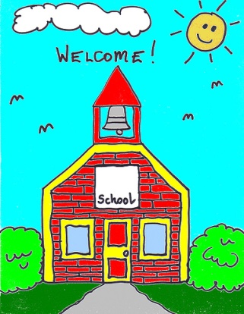

Venue: Church House, Daresbury

Date: 08/11/2018
Time: 10am -12.00pm

Cost: FREE to members of the family of schools/£50 for non-members

Leader(s): Sue Noakes (Deputy Director of Education)

Information: This is for new governors and experienced governors who would like to explore their role specifically in a church school. The session will look at the responsibilities of governors in a church school, how a church school should be distinctive and what can be done to ensure your school is an outstanding church school.
Booking Form
Please detach this portion of the form and return to:
e-mail: sandra.reynolds@chester.anglican.org
*No later than: *1/11/2018 *

Name of event: Being a Governor of a Church School

Venue: Church House, Daresbury
Date: 08/11/2018

Cost: FREE to members of the family of schools/£50 for non-members

School Name:

Contact Address:

Email address:

Name of delegate:

Method of Payment (tick as appropriate) for non-members
Cheque made payable to Chester Diocesan Board of Education
Invoice

