Preparing the SEF for a Church School
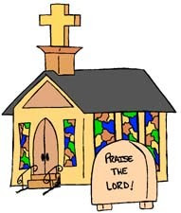

Venue: Church House, Daresbury
Date: 25/01/2018
Time: 9am -3.30pm

Cost: £100 per person for members of Family of Schools/£150 per person for non-members

Leader(s): Jill Kelly

Information: Practical advice and support in writing a SEF for a Church of England school. The course will be led by our diocesan consultant and retired former HMI, Brian Padgett.
Please be advised that numbers are limited for this course.

Booking Form
Please detach this portion of the form and return to:
Sandra Reynolds. Chester Diocesan Board of Education, Church House, 5500 Daresbury Park, Daresbury, Warrington, WA4 4GE
e-mail: sandra.reynolds@chester.anglican.org
*No later than: *18/01/2018 *

Name of event: Preparing the SEF for a Church School
Venue: Church House, Daresbury
Date: 25/01/2018

Cost: £100 per person for members of Family of Schools/£150 per person for non-members
We are a member of the Family of Schools (please tick)

School Name:

Contact Address:

Email address:

Name (s) of delegate (s):

Special dietary requirements:

Method of Payment (tick as appropriate) for non-members
Cheque made payable to Chester Diocesan Board of Education
Invoice

