The Friends of St. Alban’s Church Building Tattenhall
The idea of setting up a ‘Friends of St. Alban’s Church Building’ was first suggested by the Rector, the Revd Canon Lameck Mutete, to bring in fresh ideas and money to support the church building. For twelve months before the Friends was launched, a selection of information about Friends groups, and also a selection of literature produced by various Friends groups, was collected in order to gain an understanding of what Friends groups are all about.
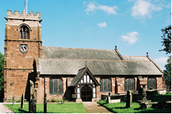
‘The Friends of St. Alban’s Church Building Tattenhall’ was launched in 2006 to repair, maintain and improve St. Alban’s Church building and grounds. The Friends group, which is separate from the PCC, is set up as an unincorporated association and is registered with the Charity Commission. The association is managed by a committee of six trustees, which takes all policy and executive decisions. Bob Blackhurst, the Chair of the Trustees, is a member of the PCC who approve all repair, maintenance and improvement works at the church.
The Friends group was launched with a ‘Sponsored Run’ from Chester Cathedral to St Alban’s Church. Letters about the Friends were also sent to all the villagers in Tattenhall. Membership of the Friends is by payment of an annual subscription, for which members receive regular high quality Newsletters that report progress of repairs and developments, details of events and activities taking place in the church and also articles of interest about the building. Since the launch, membership of the Friends has grown steadily.
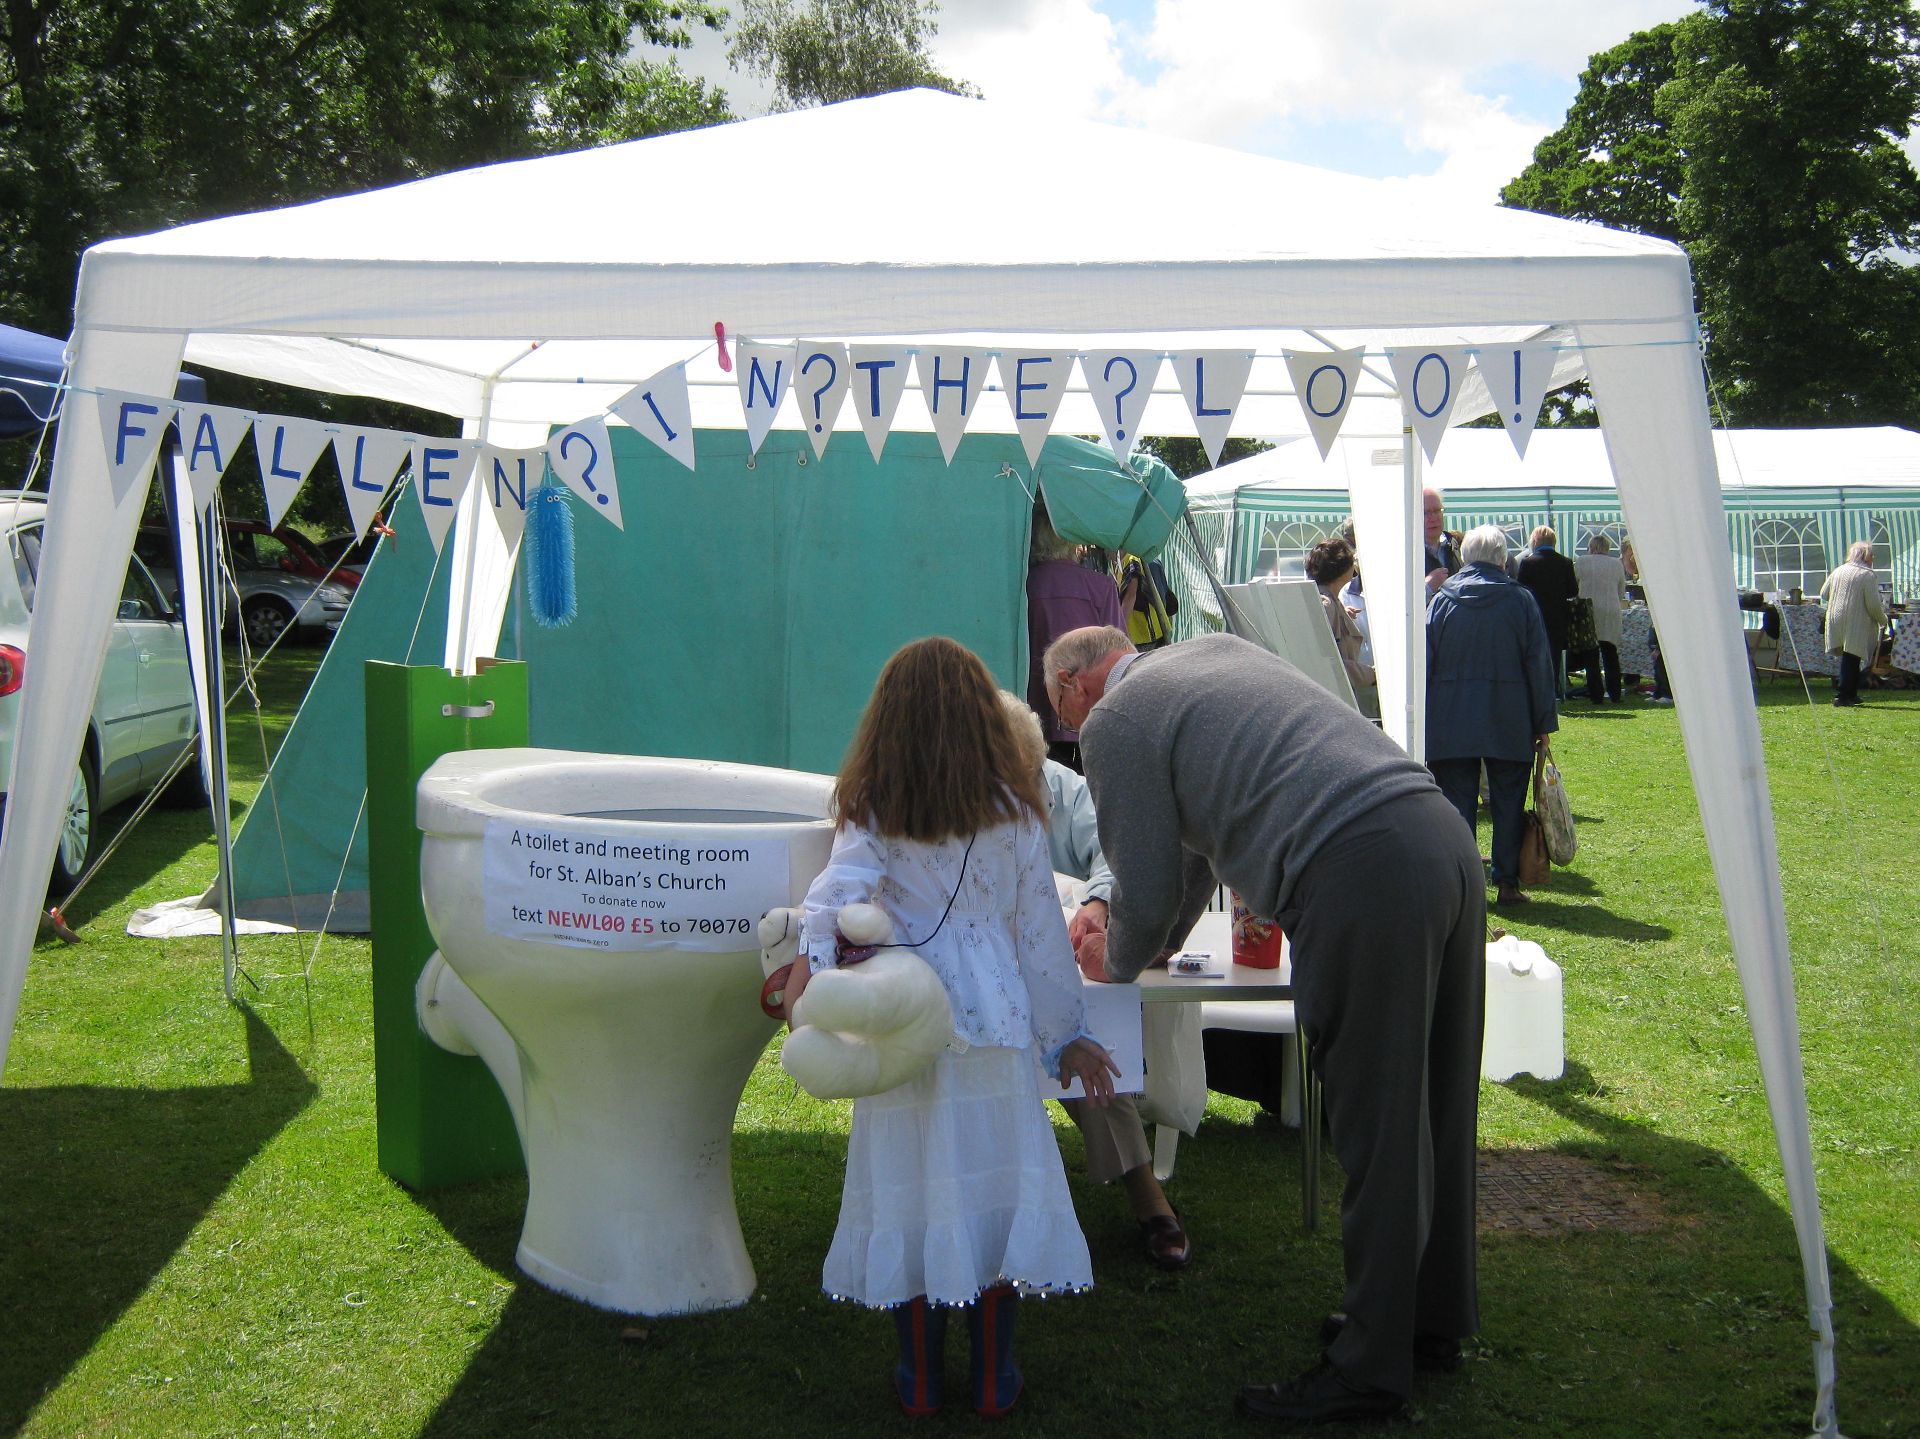
Membership continues to be promoted through literature in church, the church website and letters to all people who are new to the Village. The Friends also have a ‘Tent’ at the annual Village Fete.

Having a Friends Group has been beneficial to St. Alban’s Church. The funds generated have enabled it to embark on projects, both large and small, which help maintain the church building and the grounds. This has helped raise the profile of the Church within the local community, who see St. Alban’s as a thriving church.
Bob’s tips for churches considering a Friends Scheme are:
- Take time to do your research and don’t rush the writing of your Governance Document. The time invested does pay dividends.
- Do it and enjoy it – the Journey has been enjoyable!

