Genesis 1:27-28

So, God created humankind in his image, in the image of God he created them; male and female he created them.²⁸ God blessed them, and God said to them, “Be fruitful and multiply, and fill the earth and subdue it; and have dominion over the fish of the sea and over the birds of the air and over every living thing that moves upon the earth.”

I chose these verses as my family are very important to me and I had the privilege of reading this recently at my Grandson’s wedding.

The accompanying picture is of a sculpture by Andrea Roggi ,

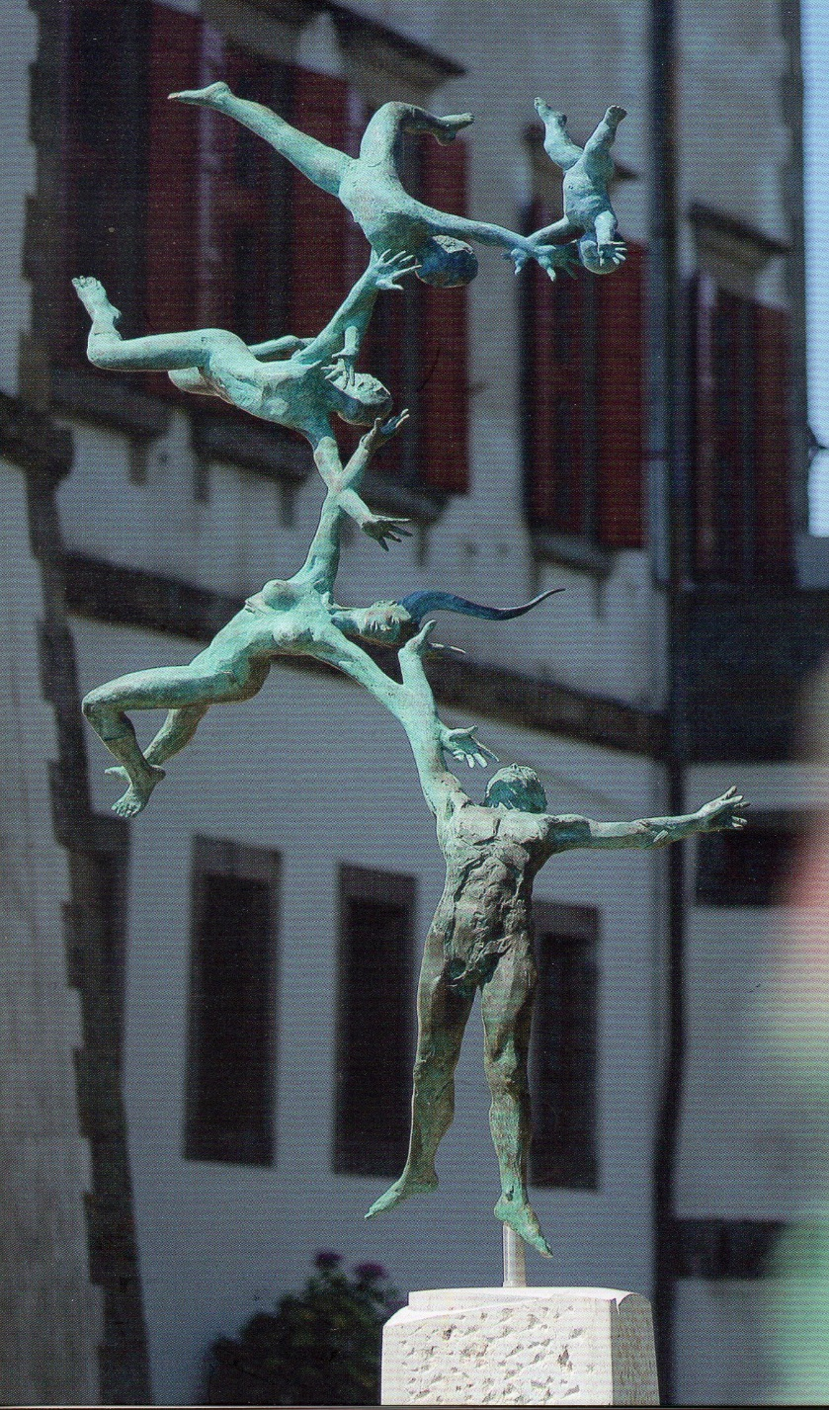
The caption is as follows:

FAMILY IN FLIGHT
In the ‘Family in flight’ the figures are portrayed while they are about to soar towards the sky. Their pose, as in a dance, gives extreme lightness to the bronze which seems to vibrate.
With their arms intertwined, the members of the family are elevating towards a goal which is perhaps the sky, perhaps the harmony of love, the only feeling able to change reality.

Berry Northen

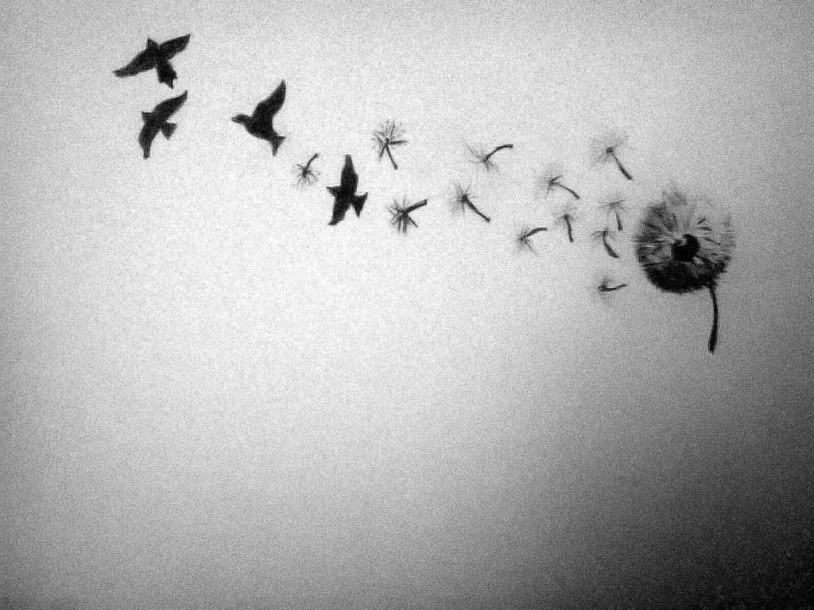

John 8:36
So, if the Son makes you free, you will be free indeed.

I have so many favourite verses it is hard to choose just one. For me, they are often dependent upon my mood, the day and how inspired I may, or may not be feeling! However, this verse in John Chapter 8, is perhaps one of the most significant verses to me and one that I come back to time and time again.

While this verse may essentially be interpreted by others as freedom from sin, to me it speaks of holistic freedom. It reminds me of the hope and strength I have through spiritual liberty and that with freedom in Christ, whatever I am bound by, Jesus can and will set me free. It gives me encouragement that whatever struggles I am going through, my Saviour is not a distant God who knows nothing of my plight; He knows, he cares and he comforts me. The price he paid for our freedom, helps me to keep my priorities in order and my life in Christ in a proper perspective.

Suzy Sawyer

