**Introduction to Assessment Guidance for Religious Education in Chester Diocesan Primary Schools**

**A Supplement to the Chester Diocesan Religious Education Syllabus**

*‘Assessment is at the heart of high quality teaching and learning. It is the means by which teachers evaluate progress and diagnose pupil needs. It provides the opportunity for students to recognise their progress and helps parents engage in their children’s educational journey. To put it simply, assessment helps teachers to teach and pupils to learn.’ ‘Report of the Assessment Review Group:’ Redressing the balance’’ Foreword January 2017*

To provide advice for assessing and measuring pupils’ progress in Religious Education it is important to have an idea of what we understand by assessment. RE Subject Leaders need to be clear about how to assess, when to assess and what to assess.

1. ***How to assess pupils in RE?***

Good assessment procedures recognise both ‘formative and summative’ assessment are fundamentally part of a cyclical process aimed to help teachers: support and develop learning; know where pupils are in their learning; establish clear learning goals and next steps for pupils.

**Assessment *of learning* (summative assessment)**

Assessment of Learning is any assessment, which summarises where learners are at a given point in time – it provides a snapshot of what has been learnt in terms of both attainment and achievement. E.g. ‘Formally’ set assessment tasks set against a set objective, (summative assessment). These are set over time for groups/ individuals/classes.

**Assessment *for* learning (formative assessment)**

Assessment for Learning (AfL) **informs** the next steps of learning. The key message is that AfL depends crucially on usingthe information gained. Any AFL is ongoing day-to-day assessment, which records progress, (formative assessment). E.g. It may be teacher thoughts recorded on short or medium term plans and is usually through day-to-day observations and records and/or it may be summative assessment tasks built into the learning process.

These two types of assessment in practice are often intertwined and can be indistinguishable. The SIAMS inspection process requires schools to make quantitative judgements about pupils’ attainment in RE which involves both formative and summative assessment. An efficient assessment process acknowledges the interrelationship between formative and summative assessment and identifies the informal and formal processes involved. This also relies on both RE units of work and lesson plans having specific pupil ‘I can’ learning outcomes written into them. Teachers and pupils alike need to understand what needs to be learnt and have the criteria to measure their pupil’s learning on a day to day informal basis.

**The process**

RE Subject Leaders must train staff to be familiar with the Diocesan Syllabus learning steps (*see Appendix 1 for a quick guide to the learning steps and definitions for each concept).* This includes recognising and understanding the *‘****emerging, expected and exceeding’ outcom*es** contained on every syllabus unit medium term plan. These should inform lesson planning. Teachers will need to adapt the suggested assessment tasks at the end of each unit which were designed with **‘expected’** outcomes in mind, to ensure any pupils working at an **‘exceeding’** level are given opportunity to meet that standard.

Assessment information collected at the end of each unit can in turn feed into the age-related expectations known as **End of Key Phase Statements,**

(see A*ppendix 2).* Examples of marked and moderated pupil’s work based on end of unit tasks can be found in *Appendix 5.* Pieces of work demonstrate how pupils might meet the end of unit ‘expected, emerging or exceeding’ standards*.* Other samples show how pupils might progress to the next standard of outcome. Of course, one piece of work does not demonstrate the whole of a pupil’s learning journey towards that end of unit outcome. *Appendix 6* gives examples of learning journeys based on a concept and unit plans. These samples will be added to over time. Identifying and addressing anomalies in pupil progression and teachers’ expectations of pupils from FS to Y6 are vital to raising standards in both teaching and learning in RE.

In order to raise standards, pupils can be encouraged to present their learning in creative ways and teachers given flexibility to find the most appropriate ways to gather evidence of pupils’ learning. This may be through self and peer assessment, recorded responses through dialogue, collaboration, focussed drama and role play.

1. **When to assess pupils in RE?**

Here are some possible assessment approaches that can be used over time which will give a clear picture of pupil attainment.

|  |  |  |
| --- | --- | --- |
| **Time scales** | **Classroom Practice** | **Progress and standards** |
| **Short-term**  Day-to-day | Assessment for learning in all lessons e.g. questioning, formative feedback/pupil response. Lessons have clear objectives built within them. | Evident in teaching and learning, in pupils’ ongoing work, response to feedback, marking  Teacher recording of pupil progress |
| **Frequent**  Basic knowledge and skills | Short written pupils work or verbal feedback from pupils, identified piece of homework. More in-depth marking. | Progress check can give you an idea of ongoing learning against end of unit objectives. |
| **Half/termly**  Conceptual, knowledge | Short summative task, problem-solving exercise, end of unit task. More in-depth marking of work. Peer/self- assessment | In depth marking and feedback.  Linked to end of unit outcomes and age-related end of key phase expectations. |
| **Long-term**  (Year/Key Stage)  Sustained conceptual development | A summative piece of work, e.g. enquiry, decision making exercise, extended writing, test. End of year: perhaps drawing learning together | As above, plus an opportunity to develop portfolio of RE work exemplifying and sharing standards and illustrating progress over time. |

*(Adapted from a ‘Assessment & Progression in RE Part 2: A New Framework for Assessment in RE’ RE Online 2016)*

Each school will need to be develop their own assessment approaches depending on their own school circumstances and situation.

It may be useful to RE Subject Leaders for the purposes of SIAMS self-evaluation to track the progress of a small group of pupils within a specific year group throughout the school, collecting work samples to support findings. Pupils could be chosen from a range of abilities and religious/non-religious backgrounds. Performance could be tracked against end of unit ‘I can’ statements for the units of work covered and evidence used to assess against the End of Key Phase Statements. These pupils could be interviewed on a regular basis using open ended questions or statements such as: What do you think RE is all about?

What do you like best about RE lessons? What makes it good? What would make it even better? Tell me about……...

**3. What to record when assessing in RE?**

**Recording Individual Pupil Attainment**

1. Assessment should be built naturally into teacher’s planning for **all lessons** with clear differentiated learning ‘I can’ outcomes identified. These in turn should feed into emerging, expected and exceeding **end of unit outcomes**. Opportunity for teachers and pupils to review outcomes should be given within lessons and at the end of each unit of work. Using a range of active learning strategies can be vital in assisting this process *(see Appendix 4).* Pupils should be encouraged to ask: ‘What have I learnt and what helped me to learn?’
2. More formal **‘summative assessment’** records of each pupil should be made regularly. These will be in the form of a recorded assessment task set against the expected outcomes at the end of a unit of work. *(See Appendix 5).* Work and records from these tasks should be kept and fed into the **End of Key Phase Statements** **(***see Appendix 2)***.**
3. Information collected through the informal ‘**formative assessments’** can take the form of teacher observations, pupils recalling and summarising their learning, oral feedback, Think/ Pair/Share techniques, marking feedback *(See Appendix 3*). Teachers could record information on planning in the first instance, e.g. using post its. Some schools keep individual pupil RE learning logs, individual golden books, portfolios of sampled work, some standardised examples of work, videos, diaries and photos. Work and records from this AfL should also be kept and feed into the **End of Key Phase Statements.**

Using an agreed school ***system of recording* for *both formative and summative RE judgements*** evidence and information can then be collected and fed into the **End of Key Phase** statements.

**4. What to report when assessing in RE?**

**Reporting on Pupil Attainment**

Dependent on each school’s individual approach reporting may take several forms. Information and records can be passed from each class teacher to the next to assist in tracking pupil progression throughout primary school life. Key Stage 2/3 transition is important and teachers may find it useful to identify the local RE Head of Department in the high school to hand records on to personally. Yearly reports to parents should contain a written description of current pupil progress.

*For further information see accompanying supportive documents:*

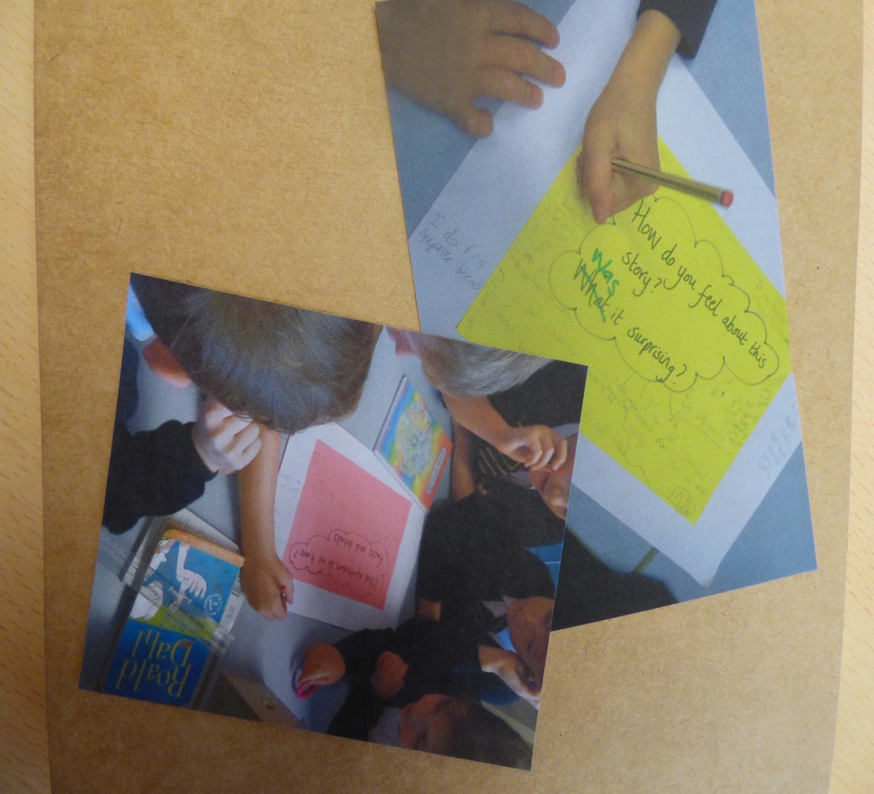

Appendix 1a: Learning steps & 1b. Definitions for each concept

Appendix 2: End of Key Phase Statements

Appendix 3: Examples of assessment techniques for developing pupil progress

Appendix 4: Active learning ideas

Appendix 5: Zip file of work samples of summative assessment tasks for end of units

Appendix 6: Examples of learning journeys towards end of unit outcomes

