WALLASEY DEANERY

PRAYING FOR THE NEXT GENERATION

PRAYING FOR THE NEXT GENERATION
‘we will tell the next generation the praiseworthy deeds of the Lord,
his power, and the wonders he has done.
He decreed statutes for Jacob and established the law in Israel,
which he commanded our ancestors to teach their children,
so that the next generation would know them,
even the children yet to be born,
and they in turn would tell their children.’
Psalm 78:4-6 (NIV 2011)
All churches have the responsibility of passing on to the next generation the good news of God’s love. Over the last year, Wallasey Deanery Synod have been thinking about how we can be doing this in our area.
This booklet is to help us to pray for that work. It is arranged over 8 days, with each day focussing on one of the parishes in our deanery. You will find details of the work the churches are already doing, but also details of the schools in each parish, because we want to be praying for opportunities to work with those schools, and to connect with the children attending them, for the sake of the gospel.
Each day will also have some prayers written by children in our churches and in schools we already work worth. They will show us the sort of things that are on children’s hearts – the issues that are important to them.
Alongside this, on Tuesday 10th February, we will be welcoming Sue Mayo, the Diocesan Advisor for church / school links, to a deanery meeting. This will be at 7.30 pm at St. Chad’s in Leasowe, and all are welcome.

SUNDAY 8th FEBRUARY, 2015
St. Chad’s, Leasowe
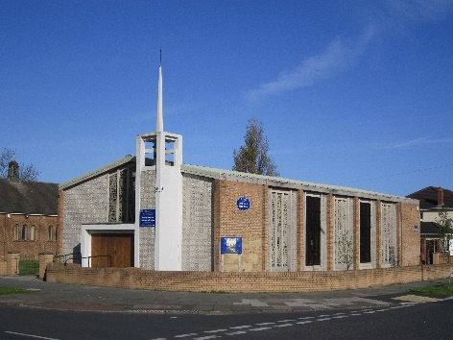

CURRENT WORK WITH CHILDREN / YOUNG PEOPLE
First steps – a short family service on Sundays
Youth Drop-in – at lunch times for children from Kingsway Academy and Clare Mount school.
SCHOOLS IN THE PARISH
Holy Spirit Primary School (Joint Roman Catholic / Anglican) – weekly involvement from Revd Aline Watts
Castleway Primary School
Leasowe Primary School
Kingsway Academy (secondary) – Revd Aline Watts is the chaplain.

Thank you Lord,
For the clothes we wear
For the friends we cherish
For the food we eat
For all natures gifts
For the ability to share with others
For all your love
Amen.

Dear Lord-Thank you,
For scrumptious food to eat
For your presents and gifts
For the beauty of your Earth
For a good education
For every little thing you do that touches our lives. Amen.

Thank you Lord,
For the wonderful flowers and trees
For our seasons
For the good health of my family and friends
For love and endless peace
And the biggest thank you of all:
Giving us your only son Jesus to look down on us and guide us through our wonderful lives
Amen.
MONDAY 9th FEBRUARY 2015
St. Mary’s, Liscard
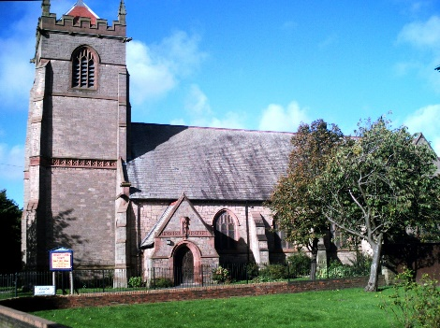
CURRENT WORK WITH CHILDREN / YOUNG PEOPLE
St Mary’s Mariners – Sunday school which runs during the main morning service each week.
Rainbows – weekly, attending parade service on the 1st Sunday of each month as well as special occasions such as Mothering Sunday
Open house – a drop in session for children with their parents/carers on Tuesday afternoons. Has a core group of 20-25 children who we would expect to see most weeks, nearly all of whom have no other church links. There are activities and games, an opportunity to sit and chat, refreshments and a short act of worship involving a bible story, some songs and interactive prayers.
SCHOOLS IN THE PARISH
Liscard Primary School
Somerville Primary School
Egremont Primary School
Sister Val Legg takes assemblies in Liscard & Somerville primaries
Dear God, thank you for my mum and dad and all they do for me and my sister. Please can they have a special day on their 8th anniversary. Amen

Dear God, please look after all the children who are not as lucky as me, those who don’t have a proper bed or a warm house. Amen

Dear God, thank you for all the animals, especially my pug. Pugs are lovely.
Amen

Please God can you stop ***** being a bully, because I don’t like it.
Amen

Dear God
I just want to pray for my best friend.
Amen
TUESDAY 10th FEBRUARY 2015
St. Thomas’, Liscard
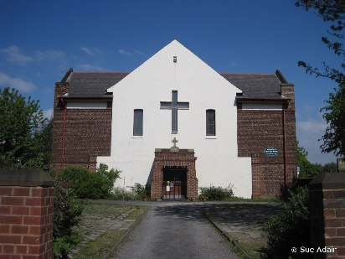
CURRENT WORK WITH CHILDREN / YOUNG PEOPLE
Special services for Christingle, Mothering Sunday, Harvest etc.
Children are regularly involved in services
Stay and Play group for the under-5’s and their parents

SCHOOLS IN THE PARISH
St. Alban’s Roman Catholic Aided Primary School

We thank you for our wonderful world. Without your help we couldn’t survive. Thank you for our church were we meet to tell you of our thanks. Thank you that all the people here from the oldest to the youngest can meet together to tell one another about the things we have and are going to do.
Amen

Dear Lord,
Please help me to do right things and not wrong things.
Help me to do what Jesus would do.
Amen
Dear God, please help me at everything I do. Amen.
Dear Lord,
Thank you for this very day
Thank you for the food we eat
Thank you for love to share with family and friends
Thank you for being there when I need you
Amen
WEDNESDAY 11th FEBRUARY 2015
St. James with Emmanuel, New Brighton
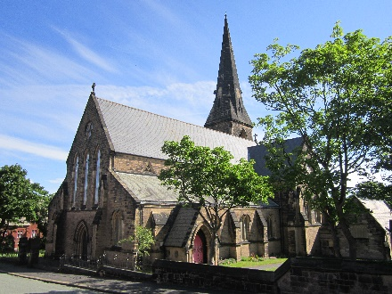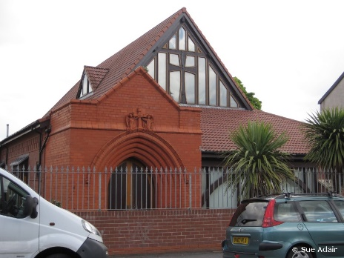
CURRENT WORK WITH CHILDREN / YOUNG PEOPLE
Sunday School at Emmanuel
Uniformed groups (Rainbows, Beavers, Cubs, Brownies, Guides, Scouts)
Mums and Tots (at St. James)
'Little Hands' (Parents and children at Emmanuel)
Monthly all-age worship at Emmanuel,
Special activities aimed at children : Christmas crafts and Good Friday crafts. (Workshops that usually get about 50 children at each),
Christingle
St. James with Emmanuel would appreciate prayer for knowing how best to create some groups for children/parents at St. James. Currently they have no children at St. James on a Sunday.
SCHOOLS IN THE PARISH
New Brighton Primary School
Sts.Peter & Paul Roman Catholic Primary

Thank you God for our world,
For the moon and the sun
And for lovely days. Amen
Thank you God for friends in school who play with me.
Thank you for presents
Help people who are ill and dying and help people who are being attacked.
Help me work with mum better. Amen
Dear Lord,
Thank you Lord for a family
Thank you for loving me
Thank you for wine and bread
Thank you for water to drink
Thank you for peace and love
Thank you for education
Thank you for being you our dear Lord
Amen
Amen
Dear Lord,
Thank you Lord for my life
For the love that shelters me
For transport and engineering
For our education
For the sun that warms us
For family and friendship
For the love that surrounds me all my days
. Amen
THURSDAY 12th FEBRUARY 2015
St. Luke’s, Poulton and St. Paul’s, Seacombe
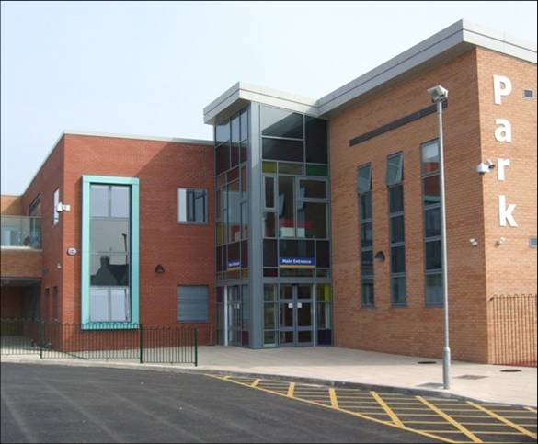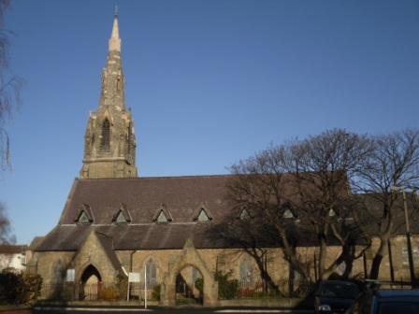
CURRENT WORK WITH CHILDREN / YOUNG PEOPLE
Supa-stars – Sunday children’s (up to 11 years old) group linked to morning service at St. Pauls. Also a small group of over 11’s
Rainbows, Brownies & Guides at St. Paul’s

SCHOOLS IN THE PARISH – St. Luke’s
Park Primary School. This is where St. Luke’s meet, and links with the school are being developed.
SCHOOLS IN THE PARISH – St. Paul’s
Riverside Primary School. The school have made visits to the church.
Kingsway Primary School
Please pray for Revd Peter Cooper as he begins his ministry at the 2 churches and seeks to build relationships with the schools.
Thank you Lord for giving us families so we won’t be lonely. Thank you for giving us food and water so we won’t starve or be thirsty. Please help people who are ill and dying. Help me to be nice and to be kind to others. Amen
Loving Father we thank you for our church. We thank you for all who lead our worship and those who worship here. Thank you for our vicar and his family. Thank you for our beautiful church. Amen
Dear Lord,
Thank you for the food we eat
Thank you for family and friends
Thank you Lord for special days
Thank you for our gifs and presents
Thank you for helping us get through tougher days
Thank you for a good education
Lord we will never forget what you do for us. Amen
Dear Lord,
We pray for those in need of help in the wars across the world
We pray for food, shelter and warmth for the homeless, especially in this cold weather
We pray for the safety of young people who are being exploited
We pray for happiness and peace in your wonderful world
Most of all we pray for forgiveness for the sins that we have caused. Amen

FRIDAY 13th FEBRUARY 2015
St. Hilary’s, Wallasey
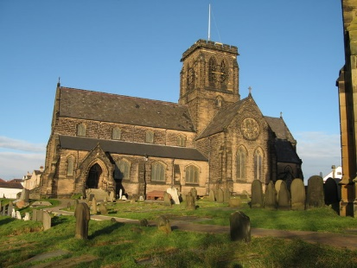
CURRENT WORK WITH CHILDREN / YOUNG PEOPLE
Sunday Club for ages 3-10 – during All Age Worship
Boys’ Brigade and Girls’ Association
St Hilary’s Rainbows & Brownies
20th Rainbows & Brownies
These groups attend parade services
Busy Bees Toddler Group – just started this term
Youth Club for age 9+
Messy Church monthly on a Saturday
SCHOOLS IN THE PARISH
St George’s Primary - regular assemblies, one-off events such as Experience Christmas/Easter, church visits. Local churches have just bought new Bibles for the school
The Mosslands boys school
Weatherhead High School for girls
assemblies and lunchtime Pulse Groups at both these schools
new opportunities through RE and PE at Weatherhead
Oldershaw Academy
St Mary’s Catholic College
Dear God,
Thank you for sending Jesus.
I don’t know what we would have done without him.
Amen.

Dear God,
Thank you for the life you have given me and for everything you’ve done in the world and for all the people in the world. Amen.
.

Dear God
Please bless my granddad
and help him to get better,
in Jesus’ name. Amen.
.

Dear Lord,
I thank you for all the friends I have made and the gifts I get at Christmas.
I am greatly thankful for my family and my pets and the food and drink that keeps us alive and is keeping the sick children alive in Africa.
Lord please shelter and protect my friends and family from anything bad ahead in life. Please forgive our sins as we do things wrong in our life.
Thank you for everything in my life.
Amen.
.

SATURDAY 14th FEBRUARY 2015
St. Nicholas, Wallasey

CURRENT WORK WITH CHILDREN / YOUNG PEOPLE
Open Door – Sunday afternoon ‘Messy Church’ type service.

Church choir – which has a number of children as regular members.

FAB (Faith And Belief) – group for 11-16 year olds.

SCHOOLS IN THE PARISH
Greenlees Primary School
Mount Primary School

Dear Lord,
I’m sorry for being nasty to my friends and hope they can forgive me.
Please will you forgive me as well. Amen.
Dear God
Thank you for my family,
Please watch over them
As sometimes I’m not looking
And I want them to be safe.

Please help Africa,
Please help the poor
Please stop cruelty
Please stop war.

Thank you for my friends,
Thank you for my school.
Everything I’m grateful for
I couldn’t ask for more.
Amen.

Dear Jesus,
We pray for all the poor people in the world.
Please bless all the people who help them.
Amen.
.

SUNDAY 15th FEBRUARY 2015
Christ Church, Moreton
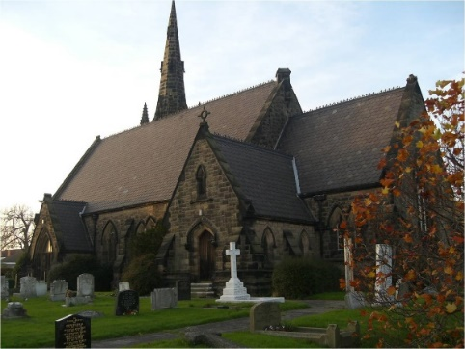
CURRENT WORK WITH CHILDREN / YOUNG PEOPLE
Sunday Club – for children 3-12 years old. Takes place during main Sunday service.
S.O.S. – after school on Tuesday afternoons, for children and their parents, with refreshments, games, craft, Bible story.
Parents and Toddlers – Monday and Tuesday mornings.

SCHOOLS IN THE PARISH
Christ Church (Church of England Aided) Primary. Weekly assemblies, service in church each term.
Sandbrook Primary – occasional assemblies and church visits
Lingham Primary – monthly assemblies
Eastway Primary
Sacred Heart (Roman Catholic Aided) Primary
Orretts Meadow Special School

God in heaven hear my prayer.
Keep me in your loving care.
Be my guide in all I do.
Bless all those who love me too.
Amen.

Dear Lord, thank you for all the nurses who took care of me when I was born and was so poorly.
Amen.

Dear God, thank you that you will always forgive us when we say we are sorry to you. Amen.

Dear Father
Thank you for my family, my mum, dad and sisters.
Thank you for my mum and dad because they care for me.
Thank you for my sisters because they are caring and never let me down.
I love my mum and dad because they provide me food, water, shelter, clothes and they give me gifts.
I love my sisters because they make me laugh and are helpful when I’m sad.
Amen.

